
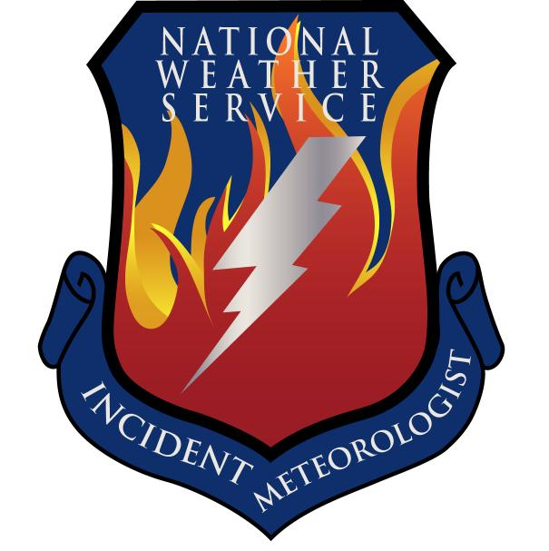
Fire Weather Forecast

FORECAST NO: 31 NAME OF FIRE: Texas Winter Fires 2008

PREDICTION FOR: Day/Night SHIFT UNIT: Granbury ICP

SHIFT DATE: Sunday Mar 09, 2008 SIGNED: Dan Byrd

TIME AND DATE Incident Meteorologist
FORECAST ISSUED: 1800 Mar 08, 2008
------------------------------------------------------------------------------------------------------------------------------------------------

*** ELEVATED TO CRITICAL FIRE WEATHER RISK TODAY FOR THE WESTERN PORTIONS OF WEST BRANCH***
***RED FLAG WARNING IS IN EFFECT FOR SOUTHERN SOUTH BRANCH***
WEATHER DISCUSSION:
A combination of gusty winds and low relative humidity’s will create elevated to critical fire weather conditions over west branch today, mainly west of a line from Midland to Sanderson. A red flag warning is in effect for the southern portions of south branch where the winds will be gusting to 30 mph. Moisture from the gulf will work its way north over the area today, thus higher relative humidity’s will prevail over the remainder of the area.

A cold front will begin to work its way south over Texas tonight and showers and thunderstorms will develop over the eastern half of the area into Monday.
------------------------------------------------------------------------------------------------------------------------------------------------

West Branch: Elevated to critical fire weather risk today. Gusty South winds will combine with relative humidity’s in the single digits for a critical fire weather risk today.

Sunday: TEMP Min RH 20 ft Wind Chance of Precip
Amarillo 56 34 E 15-20 G25 0%
Childress 60 30 NE 10-15 G20 0%
Lubbock 61 30 NE 10-20 G25 0%
Abilene 68 35 S 10-20 G30 0%
Midland 69 22 S 10-15 G20 0%
El Paso 62 16 NW 10-15 0%
San Angelo 72 32 S 15-20 G25 0%

Sunday Night: TEMP Max RH 20 ft Wind Chance of Precip
Amarillo 32 72 NE 10-15 G20 20% Rain/Snow Showers
Childress 34 70 NE 10-15 20% Rain Showers
Lubbock 38 67 NE 10-15 G20 20% Showers and Thunderstorms
Abilene 44 96 S 10-20 60% Showers and Thunderstorms
Midland 39 91 N 10-15 30% Showers and Thunderstorms
El Paso 35 44 N 10-15 0%
San Angelo 47 83 S 10-15 50% Showers and Thunderstorms

------------------------------------------------------------------------------------------------------------------------------------------------
“bcmg” means “becoming” “shftg” means “shifting” “ – “ means “to”

Continued on next page
Next day’s forecast on back of next page

Fire Weather Forecast – cont’d

North Branch: Partly to Mostly cloudy skies and warmer temperatures will prevail across the area today with breezy southerly winds.

Sunday: TEMP Min RH 20 ft Wind Chance of Precip
Gainesville 58 31 S 10-15 G25 0%
Granbury ICP 65 45 S 10-15 G20 0%
Waco 67 47 S 10-15 G20 0%

Sunday night: TEMP Max RH 20 ft Wind Chance of Precip
Gainesville 36 90 E 5-10 60% Showers and Thunderstorms
Granbury ICP 48 80 NE 5-10 60% Showers and Thunderstorms
Waco 52 83 NE 5-10 60% Showers and Thunderstorms

------------------------------------------------------------------------------------------------------------------------------------------------

Central Branch: Partly to Mostly cloudy skies and warmer temperatures will prevail across the area today with breezy southerly winds.

Sunday: TEMP Min RH 20 ft Wind Chance of Precip
Fredericksburg 71 48 S 10-15 G20 0%
Junction 71 46 S 10-15 G20 0%
Austin 70 51 S 10-15 G20 0%
LaGrange 72 51 S 10-15 0%

Sunday night: TEMP Max RH 20 ft Wind Chance of Precip
Fredericksburg 54 90 E 5-10 G20 60% Showers and Thunderstorms
Junction 55 88 E 5-10 G20 60% Showers and Thunderstorms
Austin 56 90 E 5-10 G20 60% Showers and Thunderstorms
LaGrange 57 90 E 5-10 G20 50% Showers and Thunderstorms
------------------------------------------------------------------------------------------------------------------------------------------------

South Branch: Red Flag Warning in effect for the southern portions of the area. Gusty South winds will combine with relative humidity’s in the upper 20 to low 30 percent range today for critical fire weather conditions. Partly cloudy skies will prevail through the day.

Sunday: TEMP Min RH 20 ft Wind Chance of Precip
Uvalde 74 30 SE 10-15 G20 0%
Corpus Christi 78 55 SE 10-15 G20 0%
Laredo 79 30 S 10-15 G30 0%
Brownsville 77 54 S 15-20 G30 0%

Sunday night: TEMP Max RH 20 ft Wind Chance of Precip
Uvalde 57 85 E 5-15 30% Showers and Thunderstorms
Corpus Christi 60 85 SE 10-15 G20 30% Showers and Thunderstorms
Laredo 56 84 SE 10-20 G25 30% Showers and Thunderstorms
Brownsville 65 92 SE 15-20 G25 30% Showers and Thunderstorms

===============================================================================
bcmg” means “becoming” “shftg” means “shifting” “ – “ means “to”

Next Day’s Forecast on next page

