
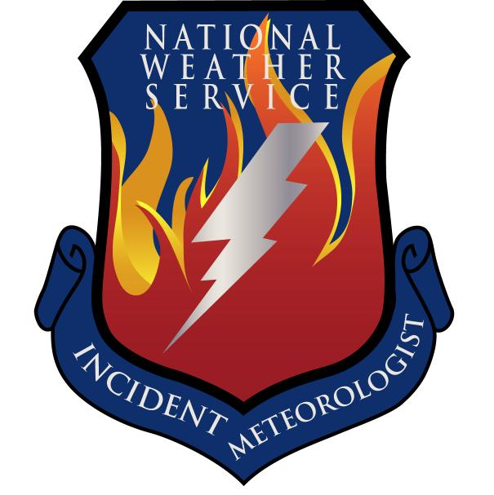
Fire Weather Forecast

FORECAST NO: 32 NAME OF FIRE: Texas Winter Fires 2008

PREDICTION FOR: Day/Night SHIFT UNIT: Granbury ICP

SHIFT DATE: Monday Mar 10, 2008 SIGNED: Mark Cunningham

TIME AND DATE Incident Meteorologist Trainee
FORECAST ISSUED: 1800 Mar 09, 2008
------------------------------------------------------------------------------------------------------------------------------------------------

*** ELEVATED FIRE WEATHER ACROSS WEST BRANCH***
***SHOWERS AND THUNDERSTORMS NORTH, CENTRAL AND SOUTH BRANCHES***
WEATHER DISCUSSION:
An upper level disturbance and increasing gulf moisture will bring showers and thunderstorms to much of the operations area Monday. The only exception will be across north and west sections of West Branch where rainfall amounts will be very light, and elevated fire conditions will persist. The showers and storms will move into East Texas Monday Night. Winds will be east to northeast at 10 to 20 mph with gusts to 25 mph across South Branch.
------------------------------------------------------------------------------------------------------------------------------------------------

West Branch: Showers and Thunderstorms across eastern sections. Direr west with relative humidity values less than 20 % around El Paso. Also…elevated fire weather across West Branch.

Monday: TEMP Min RH 20 ft Wind Chance of Precip
Amarillo 63 29 NE 5-10 bcmg SE 10-15 0%
Childress 61 32 N 5-10 bcmg E 10-20 10%
Lubbock 62 30 N 5-10 bcmg E 10-20 10%
Abilene 59 58 NE 10-20 50%
Midland 64 39 NE 10-20 20%
El Paso 64 18 NE 10-20 0%
San Angelo 61 59 NE 10-20 50%

Monday Night: TEMP Max RH 20 ft Wind Chance of Precip
Amarillo 34 60 S 5-15 0%
Childress 41 70 S 5-15 0%
Lubbock 37 73 S 5-15 0%
Abilene 42 90 S 5-10 10%
Midland 38 75 SE 5-15 0%
El Paso 35 40 SE 5-10 10%
San Angelo 41 90 SE 5-10 0%

------------------------------------------------------------------------------------------------------------------------------------------------
“bcmg” means “becoming” “shftg” means “shifting” “ – “ means “to”

Continued on next page
Next day’s forecast on back of next page

Fire Weather Forecast – cont’d

North Branch: Showers and Thunderstorms with locally heavy rainfall amounts.

Monday: TEMP Min RH 20 ft Wind Chance of Precip
Gainesville 57 60 NE 10-15 60%
Granbury ICP 59 60 NE 10-15 60%
Waco 58 70 NE 10-15 60%

Monday Night: TEMP Max RH 20 ft Wind Chance of Precip
Gainesville 43 90 E 5-10 20%
Granbury ICP 44 90 E 5-10 20%
Waco 45 92 E 5-10 30%

------------------------------------------------------------------------------------------------------------------------------------------------

Central Branch: Showers and Thunderstorms with locally heavy rainfall amounts.

Monday: TEMP Min RH 20 ft Wind Chance of Precip
Fredericksburg 65 58 NE 10-15 80%
Junction 62 58 NE 10-15 60%
Austin 64 68 NE 10-15 80%
LaGrange 66 70 NE 10-15 80%

Monday Night: TEMP Max RH 20 ft Wind Chance of Precip
Fredericksburg 45 85 N 5-10 30%
Junction 42 90 N 5-10 40%
Austin 50 88 N 5-10 40%
LaGrange 52 92 N 5-10 50%
------------------------------------------------------------------------------------------------------------------------------------------------

South Branch: Scattered showers and thunderstorms. Rainfall amounts lighter across much of this area. East winds 10 to 20 mph and gusty.

Monday: TEMP Min RH 20 ft Wind Chance of Precip
Uvalde 77 55 E 10-20g25 30%
Corpus Christi 70 70 E 10-20g25 70%
Laredo 81 50 E 10-20g25 30%
Brownsville 77 65 E 10-20g25 30%

Monday Night: TEMP Max RH 20 ft Wind Chance of Precip
Uvalde 59 90 N 10-20 30%
Corpus Christi 56 95 N 10-20 60%
Laredo 59 75 N 5-15 20%
Brownsville 60 95 N 10-20 30%

===============================================================================
bcmg” means “becoming” “shftg” means “shifting” “ – “ means “to”

Next Day’s Forecast on next page

