
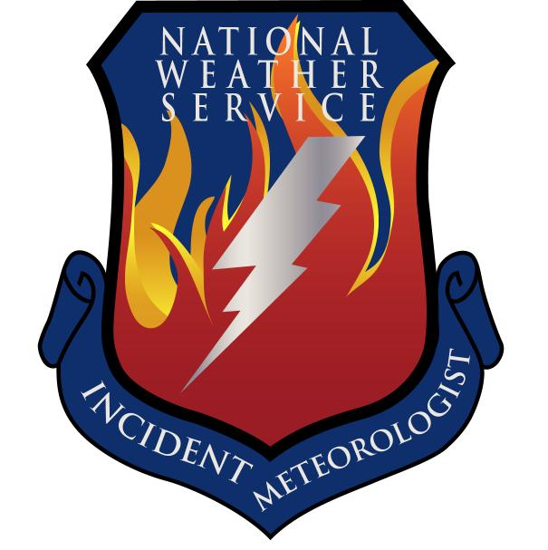
Fire Weather Forecast

FORECAST NO: 35 NAME OF FIRE: Texas Winter Fires 2008

PREDICTION FOR: Day/Night SHIFT UNIT: Granbury ICP

SHIFT DATE: Thursday Mar 13, 2008 SIGNED: Dan Byrd

TIME AND DATE Incident Meteorologist
FORECAST ISSUED: 1800 Mar 12, 2008
------------------------------------------------------------------------------------------------------------------------------------------------

*** CRITICAL FIRE RISK TODAY IN WEST BRANCH***
***CRITICAL TO EXTREME FIRE RISK ON FRIDAY OVER MOST AREAS***
WEATHER DISCUSSION:
A surface trough will move across the area today and with the westerly flow even warmer temperatures are expected across the area. Critical fire weather conditions are expected over the western portions of west branch as gusty winds will combine with very low relative humidity’s. Red flag warnings are already in effect for portions of this area. Elevated to near critical conditions will exist over the remainder of the west branch. Elevated fire weather conditions will also exist over the western portions of north and central branch.
------------------------------------------------------------------------------------------------------------------------------------------------

West Branch: Elevated to critical fire weather conditions due to West winds of 20 to 40 mph and relative humidity values less than 10 percent. Mostly Sunny.

Thursday: TEMP Min RH 20 ft Wind Chance of Precip
Amarillo 73 17 NW 15-20 G25 0%
Childress 76 19 NW 15-20 G30 0%
Lubbock 78 13 NW 10-15 G25 0%
Abilene 80 21 SW 15-20 G25 0%
Midland 82 8 W 15-20 G25 0%
El Paso 80 10 W 25-30 G35 0%
San Angelo 82 14 SW 15-20 G25 0%

Thursday Night: TEMP Max RH 20 ft Wind Chance of Precip
Amarillo 41 53 NW 10-15 0%
Childress 43 52 NW 10-15 0%
Lubbock 42 46 W 10-15 0%
Abilene 51 43 SW 10-15 G20 0%
Midland 45 23 SW 10-15 G25 0%
El Paso 52 22 W 10-20 G30 0%
San Angelo 51 31 SW 10-15 20 0%

------------------------------------------------------------------------------------------------------------------------------------------------
“bcmg” means “becoming” “shftg” means “shifting” “ – “ means “to”

Continued on next page
Next day’s forecast on back of next page

Fire Weather Forecast – cont’d

North Branch Elevated fire weather risk today over the western portions of the area. Mostly Sunny.

Thursday: TEMP Min RH 20 ft Wind Chance of Precip
Gainesville 80 38 S 15-20 G30 0%
Granbury ICP 80 42 S 15-20 G30 0%
Waco 79 48 S 15-20 G30 0%

Thursday Night: TEMP Max RH 20 ft Wind Chance of Precip
Gainesville 50 58 S 10-15 G20 0%
Granbury ICP 59 93 S 10-15 G20 0%
Waco 61 96 S 10-15 G20 0%

------------------------------------------------------------------------------------------------------------------------------------------------

Central Branch: Elevated fire weather risk today over the western portions of the area. Mostly Sunny.

Thursday: TEMP Min RH 20 ft Wind Chance of Precip
Fredericksburg 79 49 S 10-15 G20 0%
Junction 78 48 S 10-15 G20 0%
Austin 76 50 S 10-15 G20 0%
LaGrange 77 52 S 10-15 G20 0%

Thursday Night: TEMP Max RH 20 ft Wind Chance of Precip
Fredericksburg 62 82 S 5-10 0%
Junction 63 82 S 5-10 0%
Austin 64 82 S 5-10 0%
LaGrange 63 84 S 5-10 0%
------------------------------------------------------------------------------------------------------------------------------------------------

South Branch: Partly Cloudy and Dry.

Thursday: TEMP Min RH 20 ft Wind Chance of Precip
Uvalde 81 28 S 10-15 G20 0%
Corpus Christi 75 55 SE 15-20 G25 0%
Laredo 82 26 SE 10-15 G20 0%
Brownsville 81 60 SE 10-15 G20 0%

Thursday Night: TEMP Max RH 20 ft Wind Chance of Precip
Uvalde 58 64 S 10-15 G20 0%
Corpus Christi 65 85 SE 5-15 0%
Laredo 65 62 S 10-15 G20 0%
Brownsville 67 87 SE 10-15 G20 0%

===============================================================================
bcmg” means “becoming” “shftg” means “shifting” “ – “ means “to”

Next Day’s Forecast on next page

