
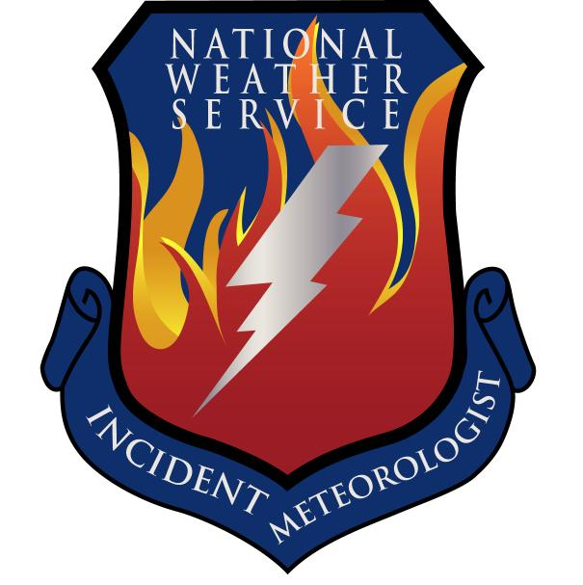
Fire Weather Forecast

FORECAST NO: 37 NAME OF FIRE: Texas Winter Fires 2008

PREDICTION FOR: Day/Night SHIFT UNIT: Granbury ICP

SHIFT DATE: Friday Mar 15, 2008 SIGNED: Dan Byrd

TIME AND DATE Incident Meteorologist
FORECAST ISSUED: 1800 Mar 14, 2008
------------------------------------------------------------------------------------------------------------------------------------------------
***CRITICAL TO EXTREME FIRE WEATHER RISK TODAY IN THE WESTERN PORTIONS OF WEST BRANCH***
WEATHER DISCUSSION:
A cold front will pushed through the area early this morning and strong high pressure is building in behind it over most of Texas. The cold front will remain to the east of the Guadalupe Mountains, so near critical fire weather conditions are likely again today, mainly over the western portions of west branch. The winds will gust to near 30 mph along with single digit RH’s this afternoon. Cooler temperatures and higher relative humidity’s will prevail over the remainder of the area today. The winds will swing around to the east then southeast tonight with gusty winds possible mainly over west branch during the overnight hours.
------------------------------------------------------------------------------------------------------------------------------------------------
West Branch: Near critical fire weather conditions due to Southwest winds of 20-25 mph with gusts from 30 and relative humidity values less than 10 percent. Skies will be partly cloudy through the day.

Saturday: TEMP Min RH 20 ft Wind Chance of Precip
Amarillo 61 24 N 5-10 0%
Childress 68 23 NE 10-15 0%
Lubbock 66 15 N 5-10 0%
Abilene 75 20 N 5-10 0%
Midland 76 9 N 5-10 0%
El Paso 75 10 W 15-20 G30 0%
San Angelo 79 12 NNW 5-10 0%

Saturday Night: TEMP Max RH 20 ft Wind Chance of Precip
Amarillo 37 79 SE 15-25 G30 0%
Childress 39 77 E 10-15 0%
Lubbock 40 62 SE 15-25 G35 0%
Abilene 52 54 SE 10-15 G20 0%
Midland 49 53 S 15-20 G30 0%
El Paso 51 21 SW 10-20 0%
San Angelo 52 50 SE 15-20 0%

------------------------------------------------------------------------------------------------------------------------------------------------
“bcmg” means “becoming” “shftg” means “shifting” “ – “ means “to”

Continued on next page
Next day’s forecast on back of next page

Fire Weather Forecast – cont’d

North Branch: Cooler conditions will prevail today. Skies will be mostly sunny through the day.

Saturday: TEMP Min RH 20 ft Wind Chance of Precip
Gainesville 70 26 N 10-15 G20 0%
Granbury ICP 73 24 N 10-15 G20 0%
Waco 78 24 N 10-15 G20 0%

Saturday Night: TEMP Max RH 20 ft Wind Chance of Precip
Gainesville 45 68 NE 5-10 0%
Granbury ICP 48 68 NE 5-10 0%
Waco 48 74 NE 5-10 0%

------------------------------------------------------------------------------------------------------------------------------------------------

Central Branch: Cooler conditions will prevail today. Skies will be mostly sunny through the day.

Saturday: TEMP Min RH 20 ft Wind Chance of Precip
Fredericksburg 78 22 N 5-10 0%
Junction 79 23 N 5-10 0%
Austin 79 24 N 5-10 0%
LaGrange 80 27 N 5-10 0%

Saturday Night: TEMP Max RH 20 ft Wind Chance of Precip
Fredericksburg 52 70 E 10-15 0%
Junction 51 70 E 10-15 0%
Austin 52 71 E 10-15 0%
LaGrange 56 74 E 10-15 0%
------------------------------------------------------------------------------------------------------------------------------------------------

South Branch: Very warm temperatures will occur once again today with relative humidity’s falling into the teens over the western portions of the area. Skies will be partly cloudy through the day.

Saturday: TEMP Min RH 20 ft Wind Chance of Precip
Uvalde 90 13 N 5-10 0%
Corpus Christi 90 25 N 5-15 0%
Laredo 95 8 N 10-15 G20 0%
Brownsville 90 30 N 10-15 G20 0%

Saturday Night: TEMP Max RH 20 ft Wind Chance of Precip
Uvalde 59 52 E 10-15 0%
Corpus Christi 64 70 E 10-15 G20 0%
Laredo 63 45 E 10-15 0%
Brownsville 66 78 E 10-15 G20 0%

===============================================================================
bcmg” means “becoming” “shftg” means “shifting” “ – “ means “to”

Next Day’s Forecast on next page

