
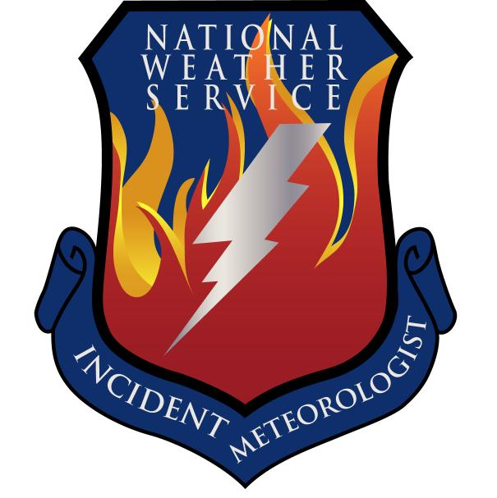
Fire Weather Forecast

FORECAST NO: 38 NAME OF FIRE: Texas Winter Fires 2008

PREDICTION FOR: Day/Night SHIFT UNIT: Granbury ICP

SHIFT DATE: Sunday Mar 16, 2008 SIGNED: Ken Schneider(T), Greg Murdoch

TIME AND DATE Incident Meteorologist
FORECAST ISSUED: 1800 Mar 15, 2008
------------------------------------------------------------------------------------------------------------------------------------------------

*** CRITICAL FIRE WEATHER ACROSS FAR WEST BRANCH TODAY***

WEATHER DISCUSSION:
A low pressure system and cold front will move into the West Branch Sunday night. Ahead of the surface low and front…strong and gusty southwesterly winds and low afternoon relative humidities can be expected Sunday afternoon over the western sections of the West Branch. Critical fire weather conditions are expected across the western sections of the West Branch Sunday. Abundant Gulf moisture will spread north and northwest ahead of the cold front across the North…Central…South and the remainder of the West Branch on especially strong southeasterly winds. This will keep relatives humidities higher during the day with good nighttime recovery. Scattered showers and thunderstorms will develop over the northern and central sections of the West Branch Sunday night including the Panhandle.
------------------------------------------------------------------------------------------------------------------------------------------------

West Branch: Mostly sunny…windy and dry extreme western sections Sunday…Partly sunny to mostly cloudy elsewhere. Mostly cloudy Sunday night. A chance of showers and thunderstorms Sunday night across the northern and central sections.

Sunday: TEMP Min RH 20 ft Wind Chance of Precip
Amarillo 63 40 SE 20-30G35 0%
Childress 68 48 SE 15-25G30 0%
Lubbock 68 34 SE 20-30G35 0%
Abilene 75 51 SE 15-25G30 0%
Midland 78 26 SE 20-30G35 0%
El Paso 75 11 SSW 20-30G35 0%
San Angelo 75 43 SE 20-30G35 0%

Sunday Night: TEMP Max RH 20 ft Wind Chance of Precip
Amarillo 41 97 SE 15-25G30 60%
Childress 52 85 ESE 15-25G30 60%
Lubbock 52 74 SE 15-25G30 50%
Abilene 61 93 SE 15-25G30 40%
Midland 52 61 SSE 15-25G30 50%
El Paso 46 38 WSW 15-25G30 0%
San Angelo 62 84 SE 15-25G30 30%

------------------------------------------------------------------------------------------------------------------------------------------------
“bcmg” means “becoming” “shftg” means “shifting” “ – “ means “to”

Continued on next page
Next day’s forecast on back of next page

Fire Weather Forecast – cont’d

North Branch: Increasing southeast winds will result in windy conditions with increasing
moisture. Skies will be partly cloudy through the day. There is an increasing
chance of thunderstorms Monday.

Sunday: TEMP Min RH 20 ft Wind Chance of Precip
Gainesville 65 58 SE 20-25 G30 5%
Granbury ICP 71 57 SE 20-25 G30 5%
Waco 72 59 SE 15-20 G25 5%

Sunday Night: TEMP Max RH 20 ft Wind Chance of Precip
Gainesville 57 90 SE 20 30% by morning
Granbury ICP 60 92 SE 20 30% by morning
Waco 65 92 SE 20 30% by morning

------------------------------------------------------------------------------------------------------------------------------------------------

Central Branch: Increasing southeast winds will result in windy conditions with increasing
moisture. Skies will be partly cloudy through the day. There will be an increasing chance of thunderstorms Monday.

Sunday: TEMP Min RH 20 ft Wind Chance of Precip
Fredericksburg 72 57 SE 20-25 G30 0%
Junction 78 48 SE 20-25 G30 0%
Austin 71 65 SE 15-20 G25 5%
LaGrange 75 60 SE 20-25 G30 5%

Sunday Night: TEMP Max RH 20 ft Wind Chance of Precip
Fredericksburg 67 85 SE 25 30% by morning
Junction 64 80 SE 20-25 30% by morning
Austin 63 93 SE 20 40% by morning
LaGrange 66 95 SE 25 30% by morning

------------------------------------------------------------------------------------------------------------------------------------------------

South Branch: Partly cloudy to mostly cloudy and windy. Isolated showers possible. Areas of fog developing Sunday night.

Sunday: TEMP Min RH 20 ft Wind Chance of Precip
Uvalde 71 47 ESE 10-20G25 10%
Corpus Christi 77 67 ESE 15-25G30 20%
Laredo 93 28 ESE 10-20G25 0%
Brownsville 89 67 SE 15-25G30 20%

Sunday Night: TEMP Max RH 20 ft Wind Chance of Precip
Uvalde 66 90 ESE 10-20G25 20%
Corpus Christi 70 90 SE 15-25G30 20%
Laredo 73 86 SE 15-25G30 0%
Brownsville 71 90 SE 15-25G30 20%

===============================================================================
bcmg” means “becoming” “shftg” means “shifting” “ – “ means “to”

Next Day’s Forecast on next page

