
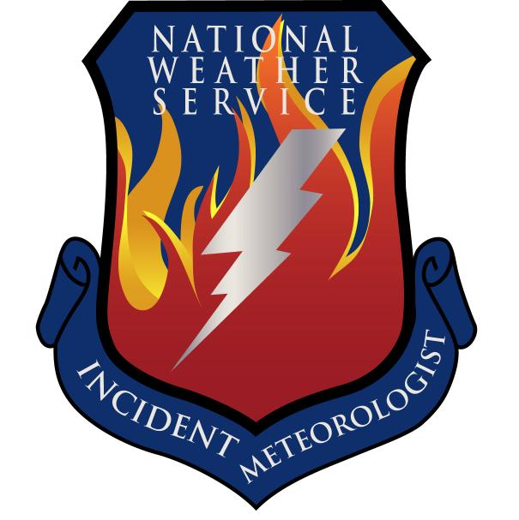
Fire Weather Forecast

FORECAST NO: 39 NAME OF FIRE: Texas Winter Fires 2008

PREDICTION FOR: Day/Night SHIFT UNIT: Granbury ICP

SHIFT DATE: Monday Mar 17, 2008 SIGNED: Ken Schneider(T), Greg Murdoch

TIME AND DATE Incident Meteorologist
FORECAST ISSUED: 1800 Mar 16, 2008
------------------------------------------------------------------------------------------------------------------------------------------------

*** NEAR CRITICAL FIRE WEATHER ACROSS FAR WEST BRANCH***

WEATHER DISCUSSION:
A surface low pressure system and frontal boundary will track slowly south and east across the West…North…Central…and South Branches through Monday night. The focus for showers and thunderstorms will be along and ahead of the frontal boundary across the eastern sections of the West Branch this morning but will shift eastward into the North…Central and South Branches by Monday night. Near critical fire weather conditions possible over western sections of the West Branch today as drier air moves into the region on gusty westerly winds behind the front.
------------------------------------------------------------------------------------------------------------------------------------------------

West Branch: Partly cloudy to mostly cloudy skies along with moderate west to southwest winds shifting
to the north and northwest by Monday night. Isolated to scattered showers and
thunderstorms can be expected mainly Monday and Monday night. Some thunderstorms
may be severe mainly across the eastern sections of the Branch with large hail…damaging
winds and isolated tornadoes possible.

Monday: TEMP Min RH 20 ft Wind Chance of Precip
Amarillo 68 20 SW 15-25 G30 20%
Childress 72 35 SW 10-20 G25 30%
Lubbock 73 15 W-SW 15-25 G30 10%
Abilene 75 55 S-SW 15-25 G30 40%
Midland 71 13 W 10-15 G20 0%
El Paso 58 21 W 10-20 G25 20%
San Angelo 77 43 SW 10-20 G25 30%

Monday Night: TEMP Max RH 20 ft Wind Chance of Precip
Amarillo 37 63 N-NW 5-15 10%
Childress 44 58 N-NW 5-15 30%
Lubbock 40 60 N-NW 10-20 G25 20%
Abilene 48 77 NW 5-15 80%
Midland 45 54 N-NW 5-15 30%
El Paso 40 39 W 10-20 G25 20%
San Angelo 49 77 N-NW 10-20 G25 80%

------------------------------------------------------------------------------------------------------------------------------------------------
“bcmg” means “becoming” “shftg” means “shifting” “ – “ means “to”

Continued on next page
Next day’s forecast on back of next page

Fire Weather Forecast – cont’d

North Branch: Gusty southeast winds will continue to bring moisture into the branches. The
chance of storms will increase through the day and into the night.

Monday: TEMP Min RH 20 ft Wind Chance of Precip
Gainesville 75 69 SE 20-25 50%
Granbury ICP 77 64 SE 20 G25 40%
Waco 77 61 SE 20 30%

Monday Night: TEMP Max RH 20 ft Wind Chance of Precip
Gainesville 57 85 SE 20 bcmg NW 15-20 80%
Granbury ICP 60 92 SE 20 bcmg NW 15-20 80%
Waco 64 96 SE 20 80%

------------------------------------------------------------------------------------------------------------------------------------------------

Central Branch: Gusty southeast winds will continue to bring moisture into the branches. The
chance of storms will increase through the day and into the night.

Monday: TEMP Min RH 20 ft Wind Chance of Precip
Fredericksburg 81 43 SE 20 20%
Junction 80 44 SE 15-20 20%
Austin 80 62 SE 20-25 20%
LaGrange 79 70 SE 25-30 G35 20%

Monday Night: TEMP Max RH 20 ft Wind Chance of Precip
Fredericksburg 60 60 SE 20 bcmg NW 20 70%
Junction 62 58 SE 20 bcmg NW 15-20 70%
Austin 65 90 SE 20 70%
LaGrange 67 98 SE 20-25 40%

------------------------------------------------------------------------------------------------------------------------------------------------

South Branch: Moderate to strong southeasterly winds ahead of the cold front will shift to the north once
the front moves through. Scattered showers and thunderstorms are expected across the
Branch mainly Monday night.

Monday: TEMP Min RH 20 ft Wind Chance of Precip
Uvalde 82 56 SE 15-25 G30 30%
Corpus Christi 80 67 SE 20-30 G35 30%
Laredo 92 41 SE 20-30 G35 0%
Brownsville 86 61 SE 15-25 G30 0%

Monday Night: TEMP Max RH 20 ft Wind Chance of Precip
Uvalde 61 92 ESE shftg N 15-25 G30 60%
Corpus Christi 69 95 SE 15-25 G30 30%
Laredo 68 98 SE shftg N 20-30 G35 40%
Brownsville 71 85 S 20-30 G35 20%

===============================================================================
bcmg” means “becoming” “shftg” means “shifting” “ – “ means “to”

Next Day’s Forecast on next page

