
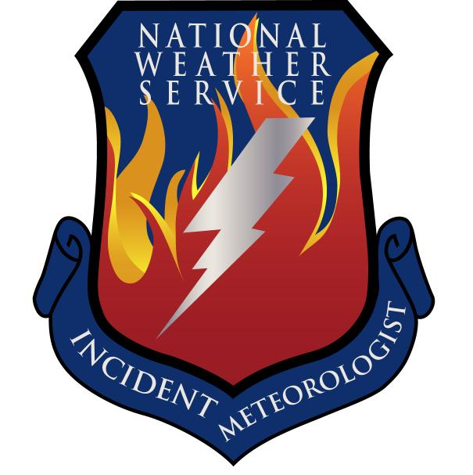
Next Day Fire Weather Forecast
For Tuesday March 18
------------------------------------------------------------------------------------------------------------------------------------------------

… FIRE WEATHER WATCH IN EFFECT ON TUESDAY FOR DEEP SOUTH TEXAS …

WEATHER DISCUSSION: A cold front will move off the Texas coast by late Tuesday with winds shifting from the south to the northwest and north across the eastern sections of the Central and South Branches behind the front. Critical fire weather conditions can be expected over the western sections of the South Branch Tuesday afternoon as strong northwest winds bring much drier air and lower afternoon humidities to this area. Near critical fire weather conditions will exist over the western sections of the West Branch on Tuesday. Otherwise…light to moderate north and northwest winds will prevail across the West…North…Central…and most of the South Branches. Isolated to scattered showers and thunderstorms can be expected mainly near the front Tuesday.
------------------------------------------------------------------------------------------------------------------------------------------------

West Branch: Light to moderate north and northwest winds can be expected. Low afternoon relative
humidities will result in near critical fire weather conditions over the western sections.
Partly cloudy skies will prevail through the day.

Tuesday: TEMP Min RH 20 ft Wind Chance of Precip
Amarillo 57 30 N 15-25 G30 0%
Childress 60 37 N 15-25 G30 30%
Lubbock 59 28 N 15-25 G30 20%
Abilene 52 64 N-NW 10-20 G25 30%
Midland 61 33 N 10-20 G25 20%
El Paso 64 17 WNW 10-20 G25 20%
San Angelo 60 57 NW 10-20 G25 30%

------------------------------------------------------------------------------------------------------------------------------------------------

North Branch: Northwest winds will continue to remain up with the chance of storms primarily early in
the day.

Tuesday: TEMP Min RH 20 ft Wind Chance of Precip
Gainesville 60 50 NW 15-20 80% early
Granbury ICP 63 51 NW 15-20 80% early
Waco 65 50 NW 10-15 70% early

------------------------------------------------------------------------------------------------------------------------------------------------

Central Branch: Northwest winds will continue to remain up with the chance of storms primarily early in the day.

Tuesday: TEMP Min RH 20 ft Wind Chance of Precip
Fredericksburg 67 49 NW20 60% early
Junction 65 42 NW 15-20 40% early
Austin 75 60 W 15 60% early
LaGrange 76 60 W15-20 60% early

------------------------------------------------------------------------------------------------------------------------------------------------

South Branch: Partly cloudy to mostly cloudy skies will prevail through the day. Moderate to strong
northwesterly to westerly winds over the western sections along with low relative
humidities will create critical fire weather conditions. A Fire Weather Watch is in effect
for the South Branch Tuesday. Widely scattered to scattered showers and
thunderstorms will be possible for the eastern sections.

Tuesday: TEMP Min RH 20 ft Wind Chance of Precip
Uvalde 73 36 N-NW 10-20 G25 30%
Corpus Christi 75 48 SE-SW 15-25 G30 60%
Laredo 80 16 W-NW 25-35 G40 20%
Brownsville 86 20 S shftg W-NW 10-20 G25 50%
==================================================================================

