
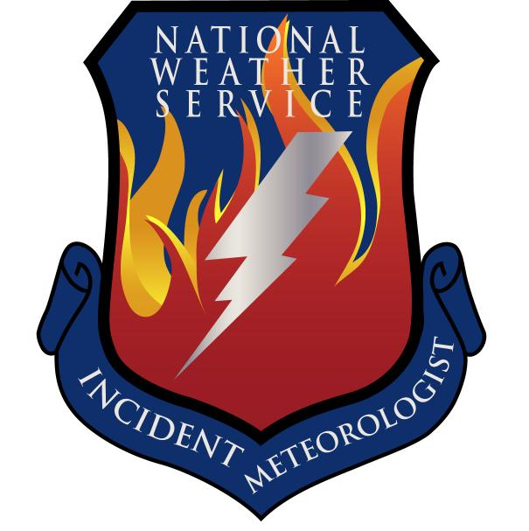
Fire Weather Forecast

FORECAST NO: 40 NAME OF FIRE: Texas Winter Fires 2008

PREDICTION FOR: Day/Night SHIFT UNIT: Granbury ICP

SHIFT DATE: Tuesday Mar 18, 2008 SIGNED: Ken Schneider(T), Greg Murdoch

TIME AND DATE Incident Meteorologist
FORECAST ISSUED: 1800 Mar 17, 2008
------------------------------------------------------------------------------------------------------------------------------------------------

*** RED FLAG WARNING FOR TUESDAY ACROSS SOUTH BRANCH ***

WEATHER DISCUSSION:
A surface low pressure system and frontal boundary will track north and east across the North…Central…and South Branches. Showers and thunderstorms will develop most sections except the western sections of the South Branch and much of the West Branch. Severe storms with possible flooding can be expected the North and Central Branches. Extremely critical fire weather conditions can be expected over the western sections of the South Branch where a Fire Weather Watch is in effect. Near critical fire weather conditions will be possible over portions of the West Branch as drier air moves into the region on northwesterly to northerly winds.
------------------------------------------------------------------------------------------------------------------------------------------------

West Branch: Partly cloudy to mostly cloudy skies along with moderate north to northwest winds.
Showers and thunderstorms will develop over the central and eastern sections.

Tuesday: TEMP Min RH 20 ft Wind Chance of Precip
Amarillo 56 28 N 15-25 G30 0%
Childress 58 35 N 20-30 G35 40%
Lubbock 58 30 N-NE 15-25 G30 30%
Abilene 57 45 N 15-25 G30 70%
Midland 61 20 N 15-25 G30 50%
El Paso 63 15 NW 15-25 G30 0%
San Angelo 58 47 N 15-25 G30 70%

Tuesday Night: TEMP Max RH 20 ft Wind Chance of Precip
Amarillo 32 75 N-NW 5-15 0%
Childress 36 60 N-NW 5-15 10%
Lubbock 35 75 W-NW 5-15 0%
Abilene 37 90 NW 10-20 G25 70%
Midland 40 75 NW 5-15 30%
El Paso 40 31 LGT & VAR 0%
San Angelo 38 82 NW-W 10-20 G25 40%

------------------------------------------------------------------------------------------------------------------------------------------------
“bcmg” means “becoming” “shftg” means “shifting” “ – “ means “to”

Continued on next page
Next day’s forecast on back of next page

Fire Weather Forecast – cont’d

North Branch: Thunderstorms will be moving through this morning and early afternoon
leaving cooler more moist conditions in their wake. Also gusty northwest
winds will develop as the associated cold front moves southeast across the state.

Tuesday: TEMP Min RH 20 ft Wind Chance of Precip
Gainesville 56 66 NW10 90%
Granbury ICP 60 68 NW15 90%
Waco 65 61 SW10 bcmg NW15 90%

Tuesday Night: TEMP Max RH 20 ft Wind Chance of Precip
Gainesville 46 91 NW 15 80% early
Granbury ICP 45 92 NW 15-20 80% early
Waco 49 94 NW15 80% early

------------------------------------------------------------------------------------------------------------------------------------------------

Central Branch: Thunderstorms will be moving through this morning and early afternoon
leaving cooler more moist conditions in their wake. Also gusty northwest
winds will develop as the associated cold front moves southeast across the state.

Tuesday: TEMP Min RH 20 ft Wind Chance of Precip
Fredericksburg 66 56 NW15 70%
Junction 63 56 NW15-20 70%
Austin 70 55 NW15 80%
LaGrange 75 60 S20 bcmg W15-20 80%

Tuesday Night: TEMP Max RH 20 ft Wind Chance of Precip
Fredericksburg 47 85 NW 15 40%
Junction 40 90 NW 15 40%
Austin 50 90 NW 15-20 50%
LaGrange 53 92 NW 15 40%

------------------------------------------------------------------------------------------------------------------------------------------------

South Branch: Moderate to strong southeasterly and southerly winds ahead of the cold front will shift to
the north and northwest and increase after the front moves through. Scattered showers
and thunderstorms…a few possibly dry…are expected with extremely critical fire weather
conditions.

Tuesday: TEMP Min RH 20 ft Wind Chance of Precip
Uvalde 71 31 NE-NW 20-30 G35 40%
Corpus Christi 73 36 SE-SW 20-30 G35 70%
Laredo 82 12 W-NW 25-35 G40 20%
Brownsville 86 35 S shftg NW 25-35 G40 30%

Tuesday Night: TEMP Max RH 20 ft Wind Chance of Precip
Uvalde 43 81 NW 15-25 G30 20%
Corpus Christi 48 60 W 15-25 G30 0%
Laredo 50 50 W-NW 20-30 G35 0%
Brownsville 54 50 W-NW 10-20 G25 0%

===============================================================================
bcmg” means “becoming” “shftg” means “shifting” “ – “ means “to”

Next Day’s Forecast on next page

