
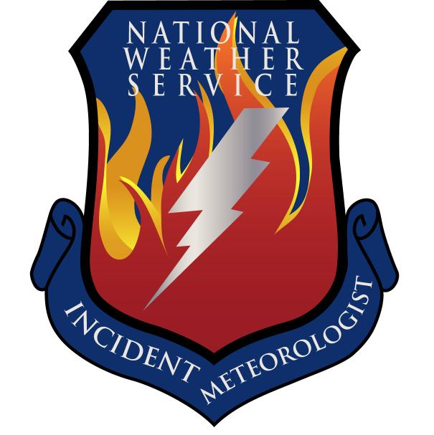
Fire Weather Forecast

FORECAST NO: 41 NAME OF FIRE: Texas Winter Fires 2008

PREDICTION FOR: Day/Night SHIFT UNIT: Granbury ICP

SHIFT DATE: Wednesday Mar 19, 2008 SIGNED: Ken Schneider(T), Greg Murdoch

TIME AND DATE Incident Meteorologist
FORECAST ISSUED: 1800 Mar 18, 2008
------------------------------------------------------------------------------------------------------------------------------------------------

***RED FLAG WARNINGS IN EFFECT TODAY FOR THE SOUTH BRANCH ***

WEATHER DISCUSSION:
A surface ridge will build in over the area today. A surface trough developing east of the Rockies will allow for the winds to become southwesterly over the West Branch. Warmer and much drier air will spread northeast into the West Branch resulting in lower relative humidities. Critical fire weather conditions can be expected over the South Branch due to low relative humidities and gusty northwesterly winds.
------------------------------------------------------------------------------------------------------------------------------------------------

West Branch: Sunny skies will prevail. Winds will be light and lower relative humidities can be expected.

Wednesday: TEMP Min RH 20 ft Wind Chance of Precip Rainfall Totals
Amarillo 67 17 W-SW 10-20 G25 0% None
Childress 72 19 W-SW 5-15 0% 0.13”
Lubbock 68 17 W-SW 10-20 0% None
Abilene 69 22 NW-W 10-20 0% 1.72”
Midland 71 20 SW-S 5-15 0% 0.02”
El Paso 74 10 LGT & VAR 0% None
San Angelo 70 24 W-NW 5-15 0% 2.92”

Wednesday Night: TEMP Max RH 20 ft Wind Chance of Precip
Amarillo 36 60 S-SW 10-20 0%
Childress 40 73 S 10-20 0%
Lubbock 40 57 S 10-20 0%
Abilene 43 76 S 5-15 0%
Midland 42 57 SE-S 5-15 0%
El Paso 44 28 LGT & VAR 0%
San Angelo 40 79 S 10-20 0%

------------------------------------------------------------------------------------------------------------------------------------------------
“bcmg” means “becoming” “shftg” means “shifting” “ – “ means “to”

Continued on next page
Next day’s forecast on back of next page

Fire Weather Forecast – cont’d

North Branch: Warming and drying trend will develop across the North Branch today as clouds clear
with increasing sunshine.

Wednesday: TEMP Min RH 20 ft Wind Chance of Precip Rainfall Totals
Gainesville 63 29 NW10 0% 1.53”
Granbury ICP 66 31 N10 0% 1.88”
Waco 67 36 N15 0% 0.57”

Wednesday Night: TEMP Max RH 20 ft Wind Chance of Precip
Gainesville 41 91 SE 5 0%
Granbury ICP 43 92 SE 5 0%
Waco 41 97 SE 5 0%

------------------------------------------------------------------------------------------------------------------------------------------------

Central Branch: Warming and drying trend will develop across the Central Branch today as
clouds clear with increasing sunshine.

Wednesday: TEMP Min RH 20 ft Wind Chance of Precip Rainfall Totals
Fredericksburg 69 23 N10 0% 0.60”
Junction 68 23 NW10 0% 0.81”
Austin 70 25 NW15 0% 0.35”
LaGrange 74 28 N15 0% 0.05”

Wednesday Night: TEMP Max RH 20 ft Wind Chance of Precip
Fredericksburg 37 85 N5 0%
Junction 36 85 N5 0%
Austin 37 90 N5 0%
LaGrange 42 90 N5 0%

------------------------------------------------------------------------------------------------------------------------------------------------

South Branch: Moderate northwesterly winds and low relative humidities will result in near critical and
critical fire weather conditions.

Wednesday: TEMP Min RH 20 ft Wind Chance of Precip Rainfall Totals
Uvalde 79 18 NW 15-25 G30 0% 0.01”
Corpus Christi 80 23 NW-N 20-30 G35 0% 0.10”
Laredo 85 14 NW-N 15-25 G30 0% None
Brownsville 84 21 NW-N 15-25 G30 0% None

Wednesday Night: TEMP Max RH 20 ft Wind Chance of Precip
Uvalde 42 82 NE 5-15 0%
Corpus Christi 47 80 NE 5-15 0%
Laredo 50 60 E-SE 5-15 0%
Brownsville 51 95 NE 5-15 0%

===============================================================================
bcmg” means “becoming” “shftg” means “shifting” “ – “ means “to”

Next Day’s Forecast on next page

