May 5, 2006

Gathering info for the 209 report:

There are a number of reports in IRSS to assist in gathering the numbers for the 209 report each day.

The canned 209 report cannot be used for two main reasons: First of all, the canned 209 report in IRSS does not know about tractor plows, so it doesn’t include them in the dozer count. Second, the overhead numbers are not reliable due to the fact that a number of engine and dozer crewmen were entered into the database as Overhead Resources rather than being rostered with their assigned equipment. Therefore, in order to get an accurate overhead count, the overhead reports all exclude Overhead Resources with the following Kindcodes, DZIA, DZOP, ENGB, ENOP, FFT1, FFT2, TPIA, and TPOP. Individuals with those Kindcodes who are listed as Overhead should be counted with the equipment to which they are assigned (see the following paragraph for a description of how that should work.)

Key to all of these reports working properly is the understanding that the reports assume that the Number of Personnel entered on the main data entry form for each dozer/tractor plow and engine is correct. The reports all use that number to calculate the number of personnel assigned as crew members to those resources. The reports (and the canned 209 report in IRSS) DO NOT check to see how many people are rostered with the equipment. If the number 2 is entered into the main data entry screen for an engine, and three crew members are rostered with the engine, the reports will not pick up that discrepancy. They will simply add up the number of personnel from the “Num Personnel:” field on the main IRSS data entry screen.

There are basically four sets of numbers that have to be generated for the 209 report (all of these numbers must be broken down by Agency with the understanding that all state resources get combined into a single number for all states combined:)

1. Count of Engines and Crew Members Assigned to those Engines
2. Count of Dozers/Tractor Plows and Crew Members Assigned to them
3. Count of Water Tenders and Crew Members Assigned to that equipment
4. Count of Overhead Resources by Agency

In addition, for this incident, Texas wants a count of Texas Forest Service personnel included at the bottom of the 209 in the remarks column, along with a list of all the states who are contributing people to this incident. Note that I have interpreted that to mean not only state resources such as the Virginia Division of Forestry but also Federal Resources from various states (if we have an overhead resource from Minnesota I include Minnesota on that list.)

Following is a detailed description of how each of these number counts is done. (Note that there are spreadsheets that you can use as as handy worksheet to do most of the math that the 209 requires. Those spreadsheets are in \Plans\RESL\209 worksheet 0505.xls) where the 0505 represents May 5th.)

1. Engines and Crew Members Assigned to those Engines

Run the report “209 Engine Summary Report”

You will get a report that looks like this:

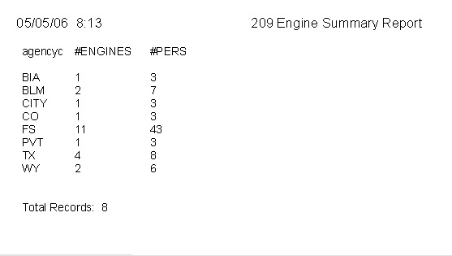

Again, this report couns the engines by agency and adds up the Number of Personnel in the “Num Personnel” field on the IRSS resource data entry screen.

Since this report breaks out the count by AgencyCode, each state is listed separately, so you have to manually combine the state numbers. In this example, you have 1engine from Colorado (CO), 2 from Wyoming (WY), and 4 from Texas (TX) so your total state count would be 7 engines and 17 personnel. The City engine would be counted as an Other on the 209.

If you want to get a detailed list of every engine that is checked in, run the report “209 Engine List” and you will get a report that looks like this:

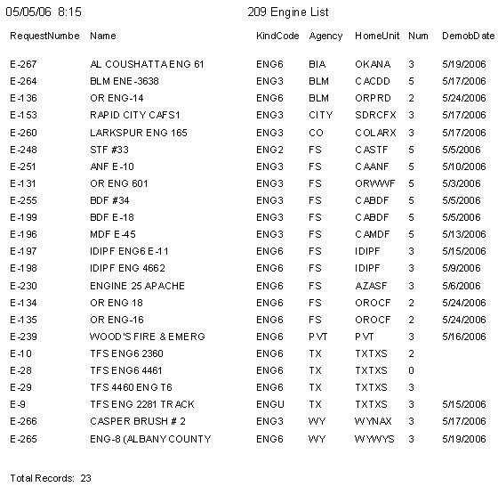

2. Count of Dozers/Tractor Plows and their crew members:

Run the report “209 Dozer Tractor/Plow Summary and you will get a report that looks like this:

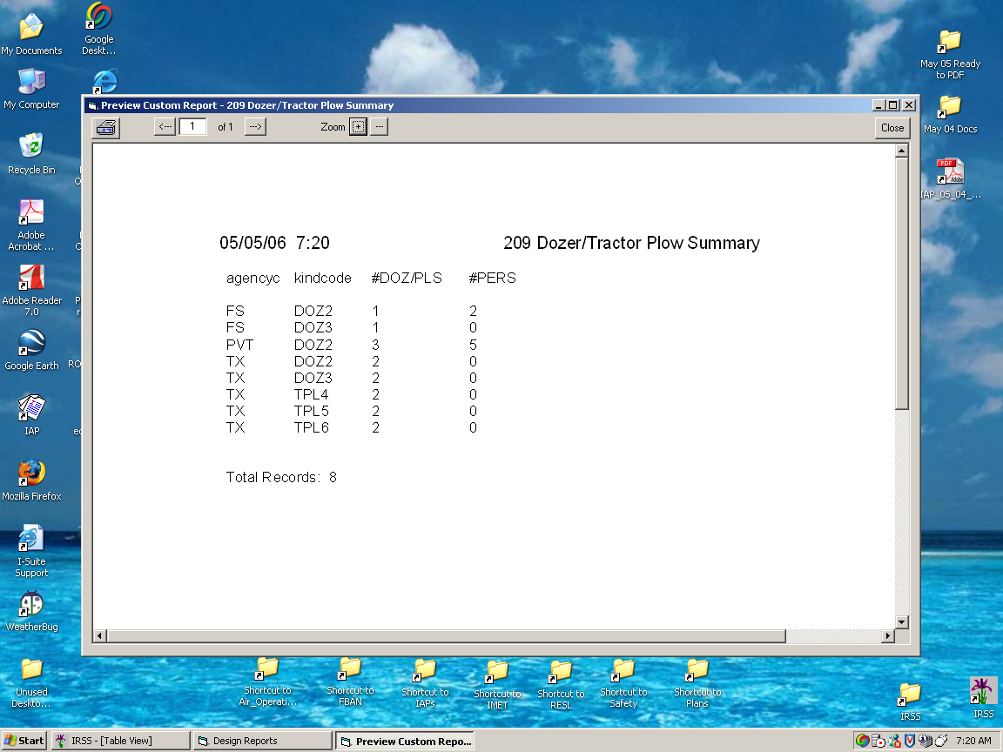

As with Engines, each state is listed separately, but in this case, you only have state dozers from Texas, so you just add up the Texas info (10 Dozers and 0 personnel).

As with Engines, if you want a detailed listing of every dozer, that is available as well by running “209 Dozer/Tractor Plow List” and you will get

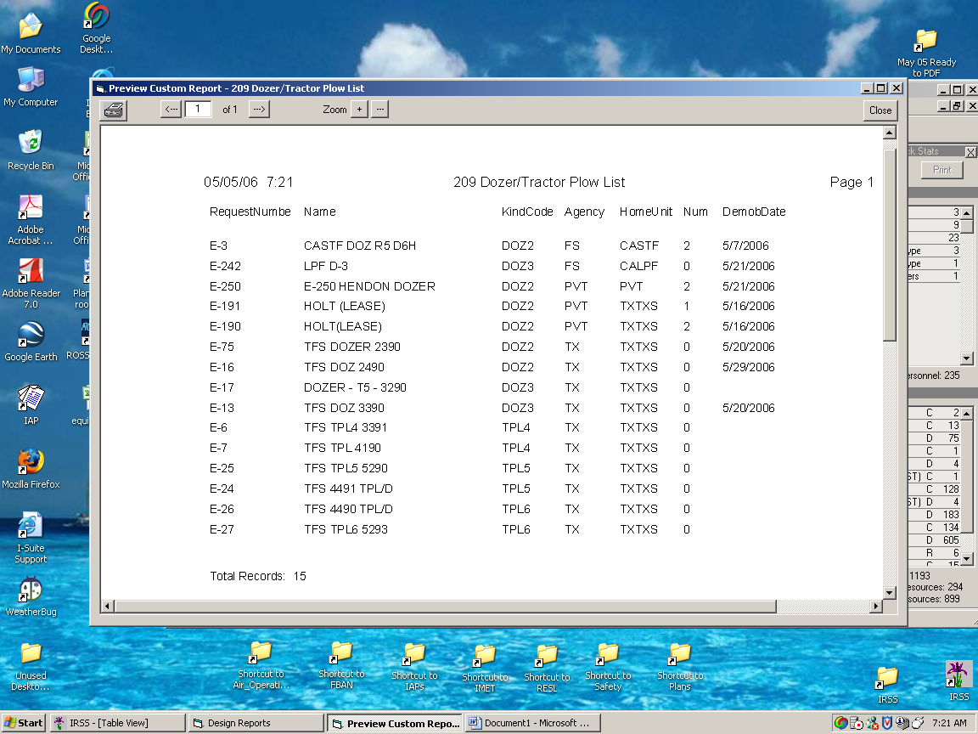

3. The Overhead counts work in a similar fashion:

To get all the overhead counts except for the states, run “209 Federal and Private Overhead” and you will get

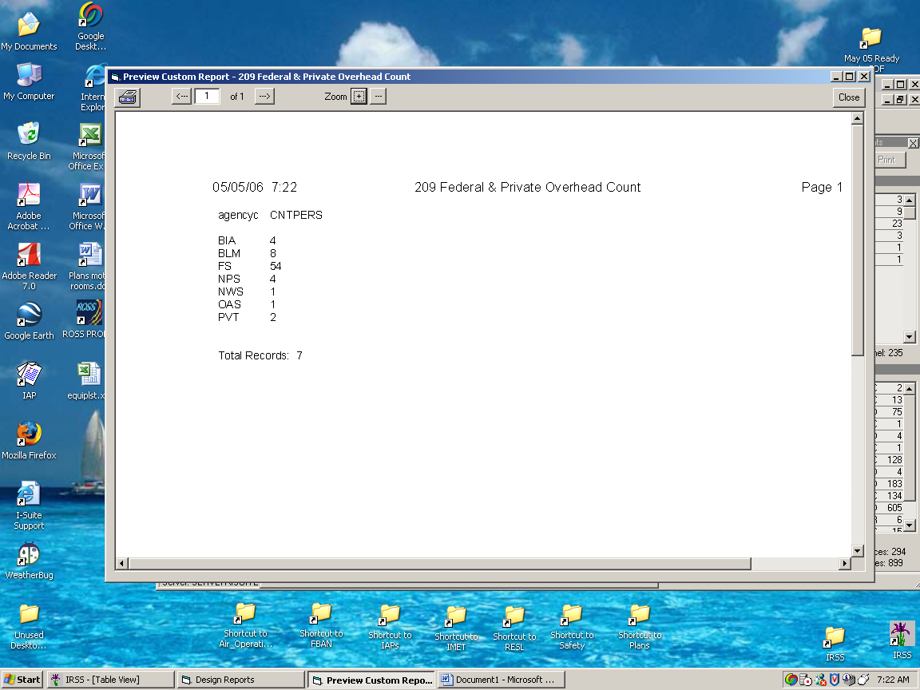

Again, as mentioned earlier, these counts exclude the following Kindcodes: DZIA, DZOP, ENGB, ENOP, FFT1, FFT2, TPIA, TPOP.

Similarly, to get a list of State Overhead Personnel, run “209 State Overhead Count” and you will get

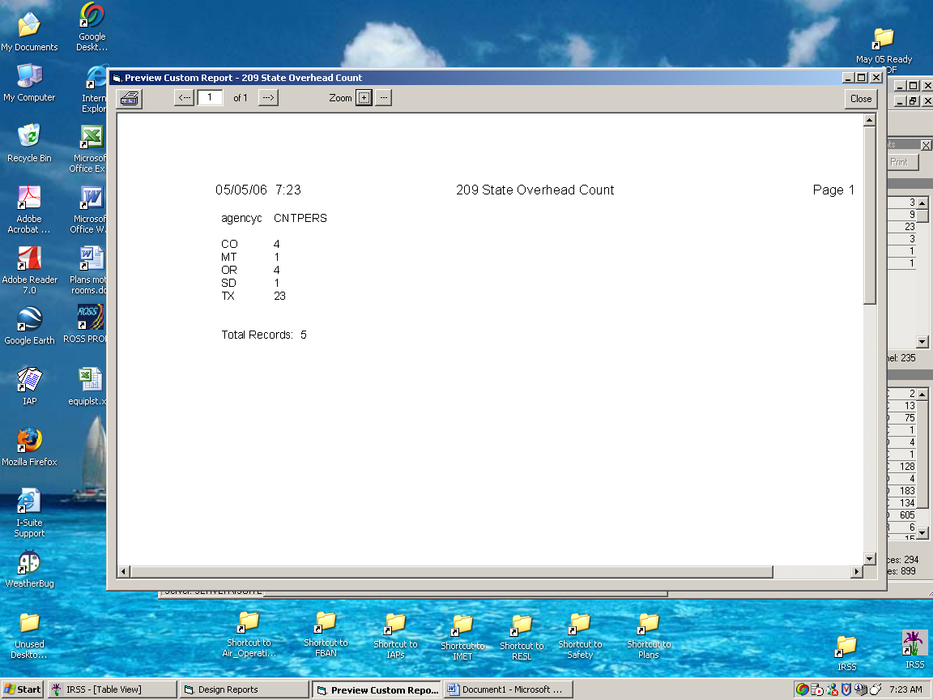

Of course, to get total Overhead Counts for the states on the 209, you will need to add these numbers of people up. In this case, the total is 33.

Finally, the last number that they want on the 209 is the total number of Texas Personnel. You cannot just count the number of people with TX as the Agencycode in IRSS because there are a number of Texas resources that are still in the database but are not actively working on the incident.

The most accurate number you can come up with is calculated by adding the number of Texas Overhead from the State Overhead Report (in this case, 23) to the number of personnel from Texas on Dozers/Tractor Plows (in this case, 0) to the number of personnel from Texas on Engines (in this case, 8), giving you a total number of Texas FS Personnel of 23 + 0 + 8 = 31.

Have fun!

