[The Hazards Data Distribution System (HDDS)](http://hdds.usgs.gov/EO/) provides imagery for use in disaster preparations, rescue and relief operations, damage assessments, and reconstruction efforts. HDDS supplies satellite and aerial images for analysis of disaster areas before, during, and after a disaster. The system is design to service and support first responders and other critical operations during a respond to national events and other national concerns. This site is provided by U.S. Geological Survey (USGS) Emergency Operations in support of the Department of Homeland Security.

**What to Expect:**

These data sources provided at HDDS should be regarded as additional data to current information collection systems or as a possible backup for when other data collection systems cannot be provided for the incidence. HDDS should not be considered to be a steady (day-to-day) source of information or a replacement for other established sources of data intelligence, such as the IRIN program. These limitations are due to clouds, haze, smoke, how often a satellite revisits a site and the angle of the sensor to name a few. Imagery can be posted 24 hours to two or more weeks after collection. Imagery can be posted within 24 hours after collect, but this is the exception.

In addition to satellite imagery, HDDS will post pre-events images referred to as baseline data.

**Ordering Imagery for Collection:**This will be the first year the southern region will offer imagery for operational intelligence for fire. To order imagery for your incident, contact Renee Jacokes-Mancini at [rjacokes@fs.fed.us](mailto:rjacokes@fs.fed.us), 404-347-2588. Not all imagery can be ordered due to national, regional priorities, smoke, weather conditions, and satellite scheduling.

**Imagery Uses:**

The array of imagery data can be confusing. Imagery should be selected based on resolution and the spectral capabilities to detect vegetation that has changed. Imagery that is “Pan” or panchromatic are high resolution displayed as black and white in one layered file; while “Multi” are multispectral with 3 to 10 or more bands, channels or layers and are normally displayed in color. Listed below are the most common sources of satellite imagery provided by HDDS.

|  |  |  |
| --- | --- | --- |
| **ID** | **Pan** | **Best Use (1 to 5 meter Resolution)** |
| IK  GE  WV  DG | Ikonos  GeoEye  Worldview  Digital Global | Background for vector layers.  Visual display of burned locations, structures, roads, vegetation and water |
|  | **Multi** |  |
| IK  GE | Ikonos (4 Bands)  GeoEye (4 Bands) | Background for vector layers.  Visual display of burned locations, structures, roads, vegetation and water  Classification for burned locations (possible burn intensity)  Location Change(two spatial matching images are required from different dates) |

|  |  |  |
| --- | --- | --- |
| **ID** | **Pan** | **Best Use (10 to 30 meter Resolution)** |
| SP  EO | SPOT  EO (1 Bands) | Background for vector layers.  Visual display of burned locations, large structures, roads, vegetation and water |
|  | **Multi** |  |
| SP  EO  LS | SPOT (4 Bands)  EO (4 Bands) Landsat (7 Bands) | Background for vector layers.  Visual display of burned locations, structures, roads, vegetation and water.  Classification for burned locations (possible burn intensity)  General location of Heat (Landsat) |

|  |  |  |
| --- | --- | --- |
| **ID** | **Multi** | **Best Use (50 to 500 m Resolution)** |
| AM | TERRA (14 Bands)  MODIS | General location of Heat.  Classification for burned locations (possible burn intensity) |

**Selecting and Downloading Imagery:**

Go To <http://hdds.usgs.gov/hdds2/> (Direct link to the graphical map)

For access to **restricted** imagery, you must login. Restricted imagery data are licensed to HDDS by private sector; therefore original raw data must not be widely distributed or sold. If you have never login, you must request access. Requests for access to restricted data normally requires a few hours, so it is important to plan ahead if time is an issue. Each event requires a request for new access. (Select Login at the top of the map interface on the right.)

1. Select an event in the pop-up list and a display of the footprint of the area of extent will be shown in green.
2. Select the event to continue the search
3. Select the **Include baseline data** or **ad-hoc data** options as needed.
4. Using the map interface on the right, select the area you want to search and display the available imagery (one point for a single location or two points for an area)
5. Select “**Search**” and the available imagery will display on the left as shown in the next examples.

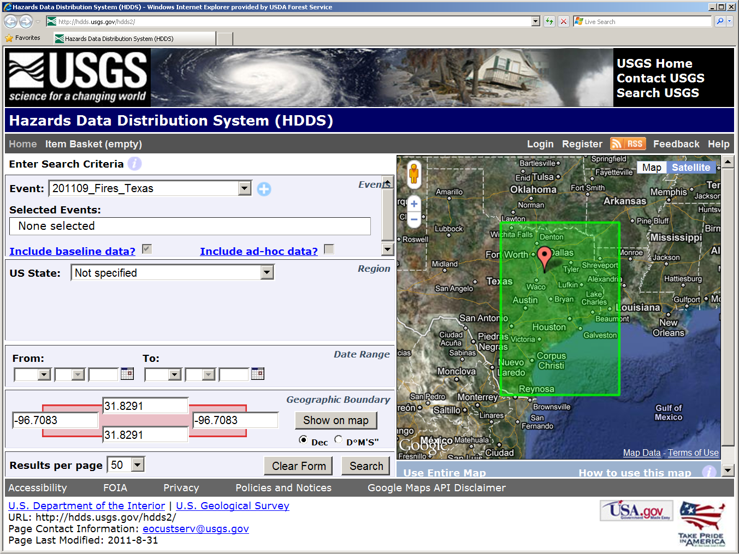

Step 5

Step 4

Step 3

Step 2

Login or Register for Restrictive Data

Step 1

1. To narrow the search, select “Show Additional Filters.”
2. To view the imagery in the map select **Browse**
3. To view the boundary area select **Footprint** .
4. To download one imagery scene, select the **Download** green circle arrow.
5. Select the required **Download** green circle arrow option (imagery resolution)
6. Select the imagery resolution.
7. The number of “Item Basket” with update as you select additional imagery.

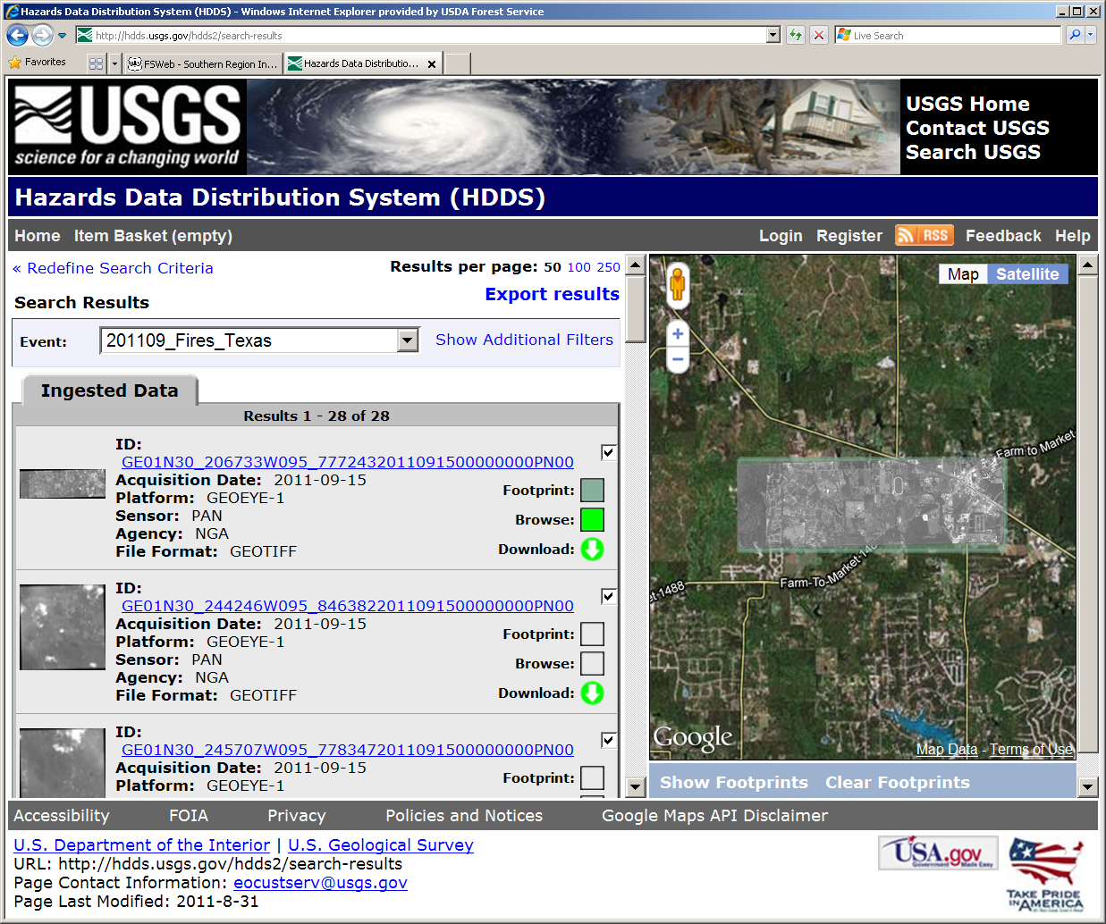

Step 7 7

Step 8

Step 6 (Optional)

Step 12 (Optional)

**Bulk Download**

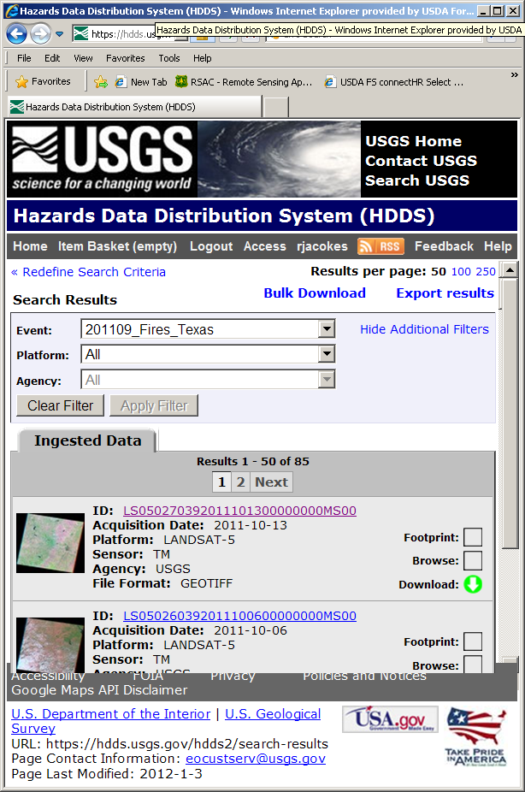Important: The Bulk Download Tool software must be installed and is only permitted with login account.

1. Select “Show Additional Filters” as show in step 6, then select the appropriate platform and agency.

Step 2

1. Select the “Bulk Download” option at the top of the Search Results.

Step 1

1. Select the imagery resolution.
2. Wait for the email that informs you that the file are ready for download.
3. Select the link in the email to download.
4. After receiving the email, select “**Get the Bulk Download Tool**.”
5. Register or Login to USGS EarthExplorer (Second login)
6. Install the Bulk Download Tool software on your hard drive.
7. Follow the instructions for installing and downloading.

**How to Read the File Name:**

In this example

Each source of imagery is identified by the first two characters; the second two characters are the platform, next

|  |  |  |  |  |  |  |  |
| --- | --- | --- | --- | --- | --- | --- | --- |
| Example | Platform | Platform # | Latitude | Longitude | Year | Month | Day |
| EO01N30_216333W095_83056020110914 | EO | 01 | N30_216333 | W095_830560 | 2010 | 09 | 14 |
|  |  |  |  |  |  |  |  |
|  |  |  |  |  |  |  |  |

|  |  |  |  |  |  |  |  |
| --- | --- | --- | --- | --- | --- | --- | --- |
| Example | Platform | Platform # | Path | Row | Year | Month | Day |
| LS050270392011101300000000MS00 | LS | 50 | N30_216333 | W095_830560 | 2010 | 09 | 14 |

**Processing the Imagery for ArcGIS:**

The imagery requires some basic processing before they can be used as a composite file, this is particularly true for multi spectral imagery. The ARC models provided are established image processing tools used for data preparation. These models for data preparation are for stacking, image enhancement, classification and change detection. These processes include stacking of single imagery files into one composite file. They are designed to provide quick and easy image processing workflows. Other image processing workflows and more advanced processes can be obtained in the art toolbox and the ark model maker. They do require some knowledge of image processing techniques.

Display Image as a IR.

To display the image as IR, open the display option in Arc, select band 2 for Blue, band 3 for Green, and band 4 for Red.

Stacking MultiSpectral

The imagery files are downloaded in single files not in a composite or layered file. Most ARC users are familiar with a raster composites files which are three or more layers in one file. In order to use these files like a composite file they must be “Stacked”.

Go to the ArcToolbox, select ERDAS Image Analysis Tool, select Utilities, and select Layer Stack. Select the image layers in the same numeric order as in the name of each file.

Merging high resolution and multispectral imagery

This image process is used to add color to high-resolution black-and-white imagery. The multi spectral imagery in the black-and-white imagery do not need to be in the same cell resolution. Both imagery sources must have the same projection. If they are not is recommended that the multi spectral image be re-projected to the high-resolution imagery, in order to retain the high-resolution data.

Feature Edge Enhancement

This process exaggerates the spectral contrast in black-and-white or multi spectral imagery. This enables the viewer to view objects that are spectrally different from their surroundings.

Classification using Unsupervised

This process is designed to quickly and easily categorize or groups cells that are spectrally similar. It is recommended that 12 or more categories are used. Grouping of categories can be done with other GIS functions.

Vegetation Change using NDVI

This process is used to show spectral differences in vegetation between the same platform using two different dates. This process should not be used with two different platforms; unless the bands are spectrally and spatially the same. An image before the incident is best to show overall change. Progression maps can utilize vegetation change based on before and after dates.

**RSS Feeds and Subscription**

Highly recommend selecting RSS Feeds. <http://hdds.usgs.gov/hdds2/feed/subscribe>

If you have Outlook 2010 and you are subscribed to RSS Feeds. The Really Simple Syndication (RSS) provides an easy way for you to read the latest postings to your favorite Web sites. Many Web sites offer RSS Feed subscriptions so that whenever new content is published, such as an updated news article, you receive a summary or the full article automatically in Microsoft Outlook 2010.

other information collection services. This service is provided by the USGS. Imagery is at no cost.



Select for RSS Feed Subscription