Integrating a FIMT geodatabase
with ArcGIS Online & Collector
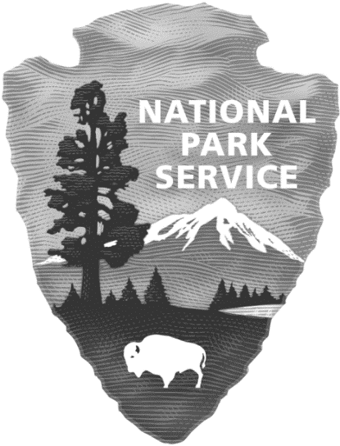

VERSION 2.0

February 2015

National Park Service - NIfc
3833 S. Development Ave.
boise, id 83705

Access the digital copy of this Workflow & supporting videos
Table of Contents
1 Introduction 5
1.1 Objective 5
1.2 Description 6
1.3 Target Audience 6
1.4 Requirements 6
1.5 QA/QC Process 6
2 AGOL :: Getting started 7
2.1 Get an AGOL Account: 7
2.2 Sign In to an Organizational account: Sign-In 7
2.3 Feature Service 7
2.3.1 Publish a feature service from ArcMap 7
2.3.2 Publish a feature service with a Service Definition file (.sd) 7
2.3.3 Modify Feature Service Settings 7
2.4 Creating AGOL Maps 8
2.5 Sharing / Groups 8
2.5.3 Embed a map into a website 8
2.5.4 Create Map Apps 8
2.6 Syncing 8
2.7 Additional Resources 8
3 Collector :: Getting started 9
3.1 Logging into Collector 9
3.2 Using the Maps 9
3.3 Additional Resources 10
4 Templates 10
5 Workflow Overview 11
5.1 GISS Workflow Overview: 11
5.2 Maps built in AGOL 11
6 Workflow 12
6.1 Getting Setup 12
6.2 Create the Feature Service 13
6.2.1 Option #1: USE A SERVICE DEFINITION FILE 13
6.2.2 Option #2: PUBLISH A NEW FEATURE SERVICE FROM ARCMAP 15
6.3 Feature Service in AGOL 18
6.3.2 Tour of a feature service – what you need to know: 18
6.4 Setting up Maps in AGOL 20
6.4.1 IncidentName – Operations. 20
6.4.2 IncidentName_CampOperations 22
6.4.3 IncidentName_Support 23
6.4.4 IncidentName Fire – Public Map 23
6.5 Sharing Maps for use in Collector 25
6.6 Syncing Data: Updating the FIMT gdb 26
6.7 Syncing data: Updating the feature service 27
6.8 Tile Packages (tpks) 30
7 Transition 31
8 Additional Information: 32
8.1.1 Request Assistance 32
8.1.2 Best Practices :: GPS & Preserving Battery Life 32
8.1.3 Attachments Workflow 32
8.1.4 Things to be aware of: 32
8.1.5 Problem Shooting 32
8.1.6 Location Tracking 32
8.1.7 My Favorites 32
8.1.8 Route/Direction Layer: 33
8.1.9 Dashboard 33
8.1.10 Explorer App 33
9 Glossary/Terminology: 34
10 Appendix 35
10.1 A zipped folder contains the needed templates 35
10.2 Features in the ‘Other’ feature dataset 35
10.3 GSTOP Compliant File Structure 36
10.4 Figure 8 Notes 36
10.5 Disclaimer 37

READ ME
It is strongly recommended to familiarize yourself with this workflow before using ArcGIS Online/Collector on an incident. Take your time going through the document start to finish. View videos before starting this document &/or throughout the process.
This document is not just a tutorial. It provides recommended steps for managing your incidents FIMT geodatabase, Other geodatabase, AGOL feature services and maps, and use of the Collector App. The workflow will help you keep data in sync between the different platforms. The templates you use while practicing this workflow will be used on an actual incident too. You will be introduced to key AGOL & Collector concepts. Self-motivation is required, if you don’t understand something, google it and dig deeper.
*When you are using this workflow as a tutorial, you need to make a ‘practice’ FIMT incident and make up your own fire data.

Introduction

Objective
This is a wildland fire mapping pilot-project that utilizes ESRI’s ArcGIS Online (AGOL), a web mapping platform, and Collector (10.2.7), an application for mobile devices (iOS 7 or later and Android 4.0 or later). The workflow in this document covers the steps on how to use a Fire Incident Mapping Tool (FIMT) geodatabase (gdb) with AGOL.
What this technology brings to the table:
- Offline Collection: The ability to view maps and collect data when there is no cellular service or WiFi. When a device establishes connectivity, changes in a map can be sent and received (synchronization/sync).
- Real-Time Data Sharing: Users of Collector will be able to share their data in a real-time manner in connected environments. This will be beneficial for the GIS Specialist (GISS) managing the maps & data and other Incident Management Team (IMT) members will benefit from being able to view these near real-time updates.
- Security: Permissions will be given to only select individuals to view and add spatial data to maps. AGOL accounts are required to use Collector and can be issued when needed.
- Paper Map & Printing Reduction: Being able to view the most up-to-date maps on a mobile device reduces the amount of paper maps needed.
This document contains a suggested workflow. The goal of this process is to develop a secure and seamless way to share maps with the different types of viewers & users (IMT personnel vs Public). It is also a workflow to allow the GISS to organize and manage: incoming data (QA/QC), the FIMT gdb, users, and permissions.

Description
There are two main parts to this document:

Getting started with AGOL & Collector - Section 2 & Section 3
- If you are not proficient with AGOL &/or Collector this is where you need to start. Watch the videos and read up on AGOL and Collector capabilities and processes.

Workflow - Section 6
- Here you will go through the process of how FIMT can be integrated and managed with AGOL and Collector.

Target Audience
GIS Specialists on wildland fire incidents

Requirements

Need to be an experienced user of ArcMap
- ArcMap version 10.1 or higher

Experienced using the Fire Incident Mapping Tool (FIMT)
- Download the tool and documentation here
- FIMT contains many features that are not necessary for map creation in this workflow. The features that will be used from the FIMT gdb are: FirePolygon, FirePoint, FireLine, & AssignmentBreaks

AGOL Organizational Account
- This is different from the free-Public Account that anyone can get (more details: Section 2.1)

Templates folder (Appendix 9.1)
- Save in the documents folder
*This workflow was developed with ArcMap 10.2. It should work with 10.1, but issues may be encountered in 10.1 and not 10.2. My only suggestion is to upgrade or improvise.

QA/QC Process

Work with your Situation Leader (SITL) to develop the process of how data is approved and integrated into the FIMT gdb as it is Collected.

Integrate GSTOP standards into this process. GSTOP page 57 - Communications

AGOL :: Getting started
This section will show the steps that will be necessary to create a map in ArcGIS Online (AGOL). These maps will be able to be shared and used with Collector in connected and disconnected (Offline) environments.
*Overview Video of this Workflow

Get an AGOL Account:
- This account is different from the free Public Account you may have used before.
- How can the user request an account? Coming soon.
- Video: Join an organization (start at 59secs)
  - Some of the steps mentioned may not be necessary. This will give you the general idea.

Sign In to an Organizational account: Sign-In
- Video: Join an organization (start at 59secs)
  - Some of the steps mentioned may not be necessary. This will give you the general idea.

Feature Service
“The feature service authoring process involves setting up a map document to define the data and symbology that will be exposed by the service” (ESRI Resources). Once this map document (mxd) is published as a feature service it can be utilized to create AGOL maps. Think of the service as the layers in ArcMap, you are bringing these symbolized layers from ArcMap into AGOL.

Publish a feature service from ArcMap
- Videos:
- Video: (start at minute 5:30) OR
- Publishing a Feature Service: (start at minute 6:24 through ~minute 12)

Publish a feature service with a Service Definition file (.sd)
- Another method on how a feature service can be created
- A service definition can be uploaded to AGOL to create a new feature service

Modify Feature Service Settings
- Section 6.3 for details
- Enabling a map to go offline: Take maps offline

Creating AGOL Maps
You will create a new map (My Content > Create Map). Add the feature service you published to this new map (Add > Search for Layers [In: My Organization]). Next you will modify the item details, pop-ups, & sharing. (Section 6.4)
- Video: Create a Map
- Tutorial: Create and Share a Collector Map

Sharing / Groups
Maps can be shared as a map in Collector and as a Web Mapping Application. You can share maps with groups, your organization, or the public. Share the map with a group. Then make sure all the Collector users that you want using this map have been invited to the same group. If necessary create a group.

Videos
  - Groups: Invite Others to Join Your Group
  - Sharing: Share Maps & Aps with your Org

Tutorials
  - Groups: What is a Group
  - Sharing: Share Maps

Embed a map into a website
- This is how you copy the map applications html code for sharing

Create Map Apps

Syncing
When edits are made in an Offline map, syncing will need to occur to share those changes and receive updates. These synced edits will be viewable in your AGOL map.
- Section 6.6 for more details
- Tutorial: Go Offline
- This is a good read to show different ways of getting feature services back to ArcMap.

Additional Resources
- Videos
- Tutorials (Explore: Use, Create, & Share sections)

Collector :: Getting started
In this section you will learn how to use the maps you create in AGOL with the Collector App. The interface differs slightly between iOS and Android.
*Quick Reference *Overview Video of this Workflow
Install the Collector Application
- Go to an App store on your device and search Collector for ArcGIS. Install.

Logging into Collector
- Open Collector. Enter your username & password. (You must have an AGOL Organizational Log In to use Collector, see section 2.1)

Using the Maps
- The GISS must first share the map with a Group in AGOL. Only the members of the Group can view the map in Collector. If necessary, create a new group.
- Viewing maps: Once logged in, you will be able to browse for a map. Tap the map to open.
- Downloading maps for Offline use: Maps that have had their settings configured correctly will have the option to download for Offline use. In All Maps tap: Download (Android) or (iOS), for the map you choose.
  - Pick a Basemap and the level of map detail. Video (start at 25:09)
  - You will need to select:
    - the Work Area: the box identifying your bounding N/S/E/W extent
    - and Choose Map Detail: the largest scale you can view (e.g. 1:18,000 is the largest scale for a Topo map and Ortho is good to about 1:4,000)
- Collecting data and editing:
  - You can add a new feature by using the Collect New tool. By default the feature is placed at your current location. Tap the map symbol to view and move the new feature to a different location in the map. Fill out the Collect Attributes table, then tap Done (Android) or Submit (iOS).
- Video
- Tutorial
- Lines can be collected while moving using the Streaming option. Tap ‘Collect a new feature’. Select a line type to add, go to your map, tap STREAM. Collection parameters can be adjusted with the Collect settings icon. When collection is complete tap Done or Submit.
- Syncing
  - When connectivity is established go to the All Maps page and tap the Sync button to send your edits and receive any updates. You will see the number of changes next to Sync₍₆₎ (in Android) and (in iOS) this represents the number of edits/changes you performed.

Additional Resources
- Overview of using Collector with iOS: video
Tutorials (Explore: Create Maps & Collect Data)

Templates
This workflow utilizes an incident’s master FIMT geodatabase, an OTHER geodatabase, ArcGIS Online, and Collector. The GISS will keep the hosted feature service in AGOL synchronized with the layers in the master FIMT and Other geodatabases.
- You will start this workflow by downloading a copy of the templates folder (you should have these already since you are reading this document). Need a universal location to store data that anyone can access. The folder contains:
2014_GSTOP_Folder_Template – File directory structure required by GSTOP
LayerFiles – Unique symbology used in AGOL
Tools – Automation tools used throughout the workflow (See Appendix 10.5 for details)
Tutorials – Additional ESRI materials for familiarizing yourself with AGOL & Collector
YYYY_IncidentName_IncidentNumber_OTHER_Arc10.gdb – Template file geodatabase that can be copied and store non-FIMT fire related data
AGOL_PUBLICservice_YYYY_IncidentName_IncidentNumber.mxd – Template mxd that can be used to create a Public feature service
AGOL_IMTservice_YYYY_IncidentName_IncidentNumber.mxd – Template mxd that can be used to create an IMT service
AGOL_IMTservice_YYYY_IncidentName_IncidentNumber.sd - File that can be added to your AGOL account to create a feature service
Workflow-v2.pdf – This document
Workflow – FlowChart.pdf (needs to be created) – Flow chart of steps involved in this workflow

Save the templates folder to the incident documents folder.
The mxds and gdb are setup in WGS84. Feel free to change the projection to your local one.

Workflow Overview
These are the main steps that you will be completing.
Steps completed in ArcMap are highlighted throughout the workflow so it’s clear when you are working in ArcMap or AGOL

GISS Workflow Overview:
- Before leaving for a fire you can complete steps 2-7 (this will allow Operations folks to start collecting fire data immediately)
- Log In to AGOL
- Create feature service by uploading the service definition (AGOL_IMTservice_YYYY_IncidentName_IncidentNumber.sd)
- Update the feature service item details with specific fire information
- Make IncidentName_Operations map for folks heading to the fire
- Add whatever spatial data you may have (fire location from Resource Order)
- Save & Share
- Check Groups to make sure everyone is added that needs access
- Arrive to the fire/ICP
- Create FIMT geodatabase
- Add a copy of the Other geodatabase in the incident_data folder
- Run TOOL01
- Keep the master gdbs (FIMT & Other) in sync with the feature service
- Create other AGOL maps as time allows

Maps built in AGOL
These are the maps that you can create in ArcGIS Online. As time allows, you can start by creating maps in Phase I and continue to Phase III.
Phase I: Two distinct Operations Groups
- Operations (Line Operations – group that can edit/add features in Collector)
- CampOperations (Viewers only, won’t have edit rights)
Phase II:
- Support (Medical, Communications and Ground Support)
Phase III:
- Public

Workflow

Getting Setup

You will need to have the file directory structure set up now. A template is provided: 2014_GSTOP_Folder_Template

Save CollectorPilot_Workflow_Templates into the documents folder. (Figure 1)

If you have not already created the master FIMT gdb for your incident, create one now.

Run the called TOOL01. Find this in the Tools folder that you downloaded:
(WorkFlow_Tools.tbx > TOOL01). It will do a few minor modifications to the FIMT gdb schema.

Edit/add fire data to the FIMT gdb

Make a copy of the Other gdb template: YYYY_IncidentName_IncidentNumber_OTHER_Arc10.gdb Rename and save in your incident_data folder.

Make copies of the following (& rename), save in the incident_data folder:
  - AGOL_IMTservice_YYYY_IncidentName_IncidentNumber.sd
- Make a copy, save in the projects folder, and rename:
  - AGOL_IMTservice_YYYY_IncidentName_IncidentNumber.mxd
  - AGOL_PUBLICservice_YYYY_IncidentName_IncidentNumber.mxd
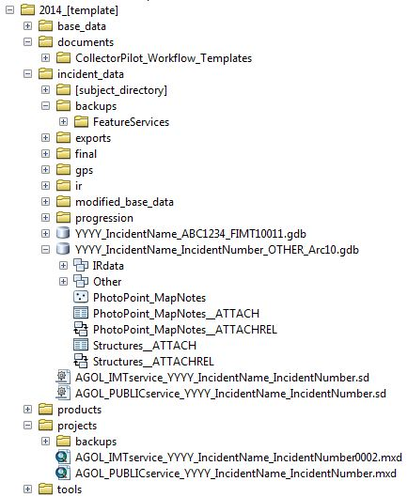  Figure 1 | < Incident Directory Catalog File Names (example)

Create the Feature Service
There are two ways to create a feature service. I recommend creating your feature service with the service definition file (6.2.1). The other option is to use ArcMap to create the feature service (6.2.2). If you want to add additional layers to AGOL, you can publish them this way. You should know how to do both options.

Option #1: USE A SERVICE DEFINITION FILE TO CREATE A NEW FEATURE SERVICE
- In a web browser, Log In to your AGOL account.
- Go to MY CONTENT > 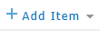> From my computer > Browse to the (.sd) file: AGOL_IMTservice_YYYY_IncidentName_IncidentNumber.sd
- While the .sd file is uploading a feature service is automatically created from it.
- Next, update the feature service information – Go into its item details and update the Title, Summary, Description, Tags….
- Once the feature service is created you will populate it with data to it via ArcMap.
- In ArcMap, Sign In to your ArcGIS Online Account
- Add the layers from the incident OTHER and FIMT gdbs to the map
- Open the Catalog window > My Hosted Services > Drag and drop your feature service into ArcMap
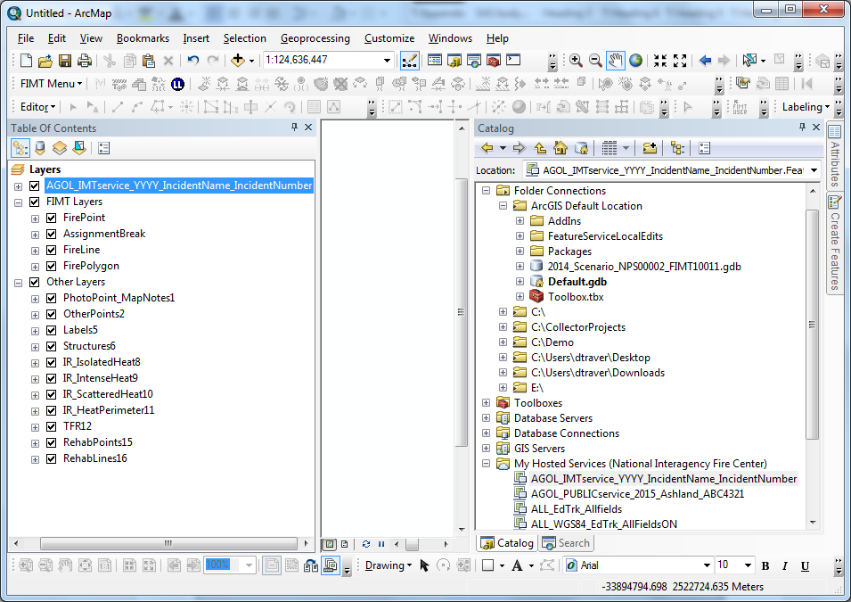
1-Drag & Drop
2-Service appears in the TOC
Figure 2
- In the Table of Contents (TOC), right click the group header of your feature service > Edit Features > Create Local Copy for Editing (Figure 3)
- Right click the group header again: Edit Features > Start Editing. Copy & Paste the new features from the FIMT gdb to the feature service
  - Use the last_edited_date field to help you identify the changes that need to be added
  - If you want to query with ‘Select by Attribute’ this is the format you would use: "last_edited_date" > date '2015-02-06 16:26:11'

Figure 3: First you will Create a local copy for editing. Then make all of your edits. | Figure 4: Once all the edits have been completed, you will Synchronize Local Edits with Server
- Save and Stop Editing
- Synchronize Local Edits with Server (Figure 4)
- Once you are done editing, continue on at section 6.3.1

Option #2: PUBLISH A NEW FEATURE SERVICE FROM ARCMAP
- Open AGOL_IMTservice_YYYY_IncidentName_IncidentNumber.mxd
- Repoint layers to your master FIMT & OTHER geodatabases
- Fill out/modify the Map Document Properties (Figure 5 & Figure 6)
Figure 5: Access Map Document Properties | Figure 6: Fill in Map Document Properties Form

Publish a new service through ArcMap:

In ArcMap, Sign In to your ArcGIS Online account

Figure 7: “Sign In” to your AGOL Account. Enter your Username & Password when prompted.
For Sign In issues see Appendix 8.1.5

- Publish your feature service: Figure 8 thru Figure 15 (Your mxd needs to be in Data View not Layout View)
Figure 8: In the mxd you just set up:  File > Share As > Service… | 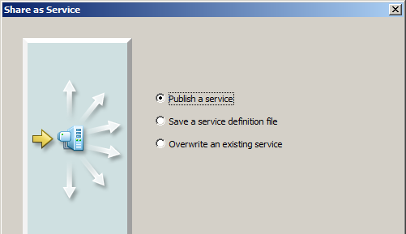  Figure 9: For a new feature service, choose “Publish a service”. Click Next.
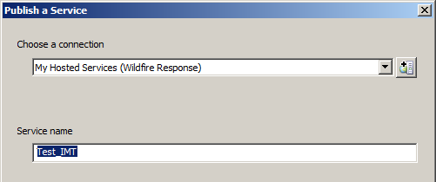  Figure 10: Name the service (default is the name of the mxd). Click Continue. | Figure 11: Select Feature Access and UNCHECK Tiled Mapping
Figure 12: Under Feature Access check:
Create, Update, Delete, Query, and Sync (Appendix 10.4 for details about Operations Allowed)
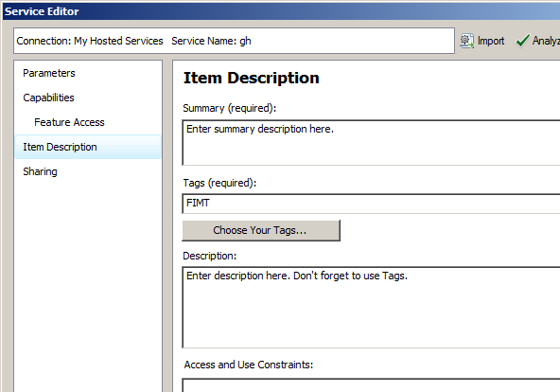  Figure 13: Enter Summary, Tags, & Description. Information already included comes from Map Document Properties (Figure 5). |  |  | Figure 14: Sharing with groups can be now or later in AGOL.
Figure 15: Analyze & Publish the feature service. It is ok to ignore warnings. warnings need to be addressed.

Feature Service in AGOL
View and modify settings for the new feature service in ArcGIS Online.

Sign In to your AGOL Organizational Account: Sign-In (More information: Section 2.1)
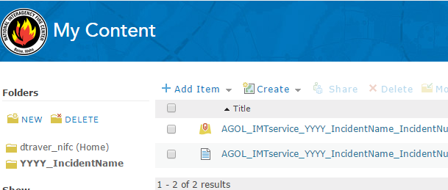  Figure 16 | Feature services you create initially appear under the My Content section of your AGOL account.  Create a new folder (YYYY_IncidentName) and move the new IMT service there.  If you create a Public service, don’t move it. It needs to stay where it is so it can be overwritten.

Tour of a feature service – what you need to know:
Figure 17: Access the feature service item details via the arrow, ‘View Item Details’. | 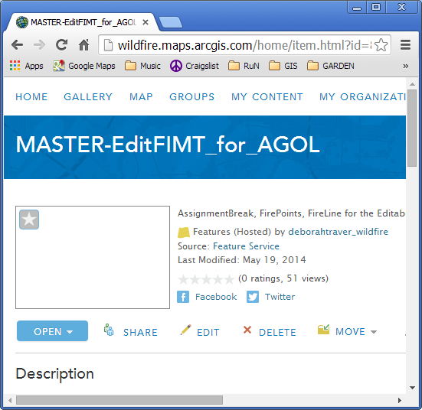  Figure 18: Share with the appropriate Groups.

Edit the Service  Figure 19: You can edit the Title, Summary, and Description. | 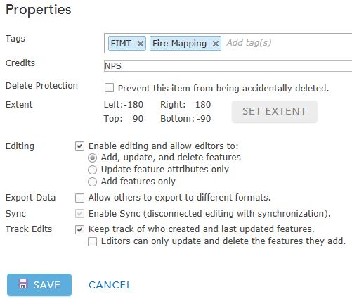  Figure 20: This is where you can enable or disable ‘Editing’ & ‘Sync’. There must be one layer in a map with Sync enabled in order for it to go Offline in Collector.
Figure 21: This is how you enable or disable attachments in AGOL.

In AGOL modify your feature service Item Details:

My Content > IncidentName_service
Modify Item Details for the feature service:  - Access the Item Details (Figure 17) > Enable Editing & Sync.  - Share with the appropriate group(s). Create a group if necessary.  - Track Edits should already be enabled  NOTE: An AGOL map must have at least one layer sync-enabled to be used Offline in Collector. | 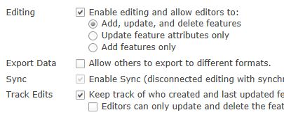  Figure 22: Enable Editing & Sync

Setting up Maps in AGOL
Once a feature service is created and configured you will be ready to create an AGOL map.

IncidentName – Operations – The first AGOL map you will create.

This map is intended to be shared with an Operations group in which members can add data in Collector.

Go to My Content. Click Create Map

Add: “AGOL_IMTservice_YYYY_IncidentName_IncidentNumber” to the map
      - Remove any layers you do not wish to use
      - Add one additional Basemap as a layer: Add > Search for Layers [In: ArcGIS Online] > Find: USA Topo Maps (for export)

Select: Imagery with Labels as the Basemap

Rename Layers (Drop the first part of the name), so they look nice in the table of contents

Reference the table below and incorporate suggestions

Add bookmarks so users can easily navigate to different extents of the fire (e.g., different Divisions or areas of interest)
    - Save As and Name your map (IncidentName_Operations)

Note: Any unnecessary layers can be removed from an AGOL map once the feature service is added.

- Ordering & Settings for Contents (TOC) in AGOL:
Layers (Note some are checked off by default) | Disable Editing | Transparency | Source & Other Options
FirePoint |  |  | IMT Service, Create Labels
PhotoPoints_MapNotes |  |  | IMT Service
OtherPoints |  |  | IMT Service
AssignmentBreak |  |  | IMT Service
FireLine |  |  | IMT Service
Labels | X |  | IMT Service , Hide in Legend, Remove Pop-Up
Structures |  |  | IMT Service
IR Isolated Heat | X |  | IMT Service
IR IntenseHeat | X |  | IMT Service
IR ScatteredHeat | X | 25% | IMT Service
IR HeatPerimeter | X |  | IMT Service
TFR | X |  | IMT Service, Remove Pop-Up
FirePolygon | X | 50% | IMT Service, Remove Pop-Up
OtherPolygon | X |  | IMT Service
RehabPoints |  |  | IMT Service, Create Labels
Rehab Lines |  |  | IMT Service
Retardant Avoidance | X |  | AGOL Layer
USA Topo Maps (for Export) |  |  | AGOL Layer
Imagery w Labels |  |  | Basemap
**Maps cannot go offline with the US Forest Service Aerial Fire Retardant Avoidance Areas layer in it. Add the layer into you feature service. Be careful with adding a Directions layer too, when in a map it may disable it from going Offline. Provide feedback of your experience.

- Share map with Operations group (or other appropriate group(s))
Figure 23: Click the 'Share' button and select the groups to share with.
- Check the settings of the map and make sure it is set for Offline use
Figure 24
- Optional: Add Directions
- Optional: Add: US Forest Service Aerial Fire Retardant Avoidance Areas
note: this layer disables maps from going Offline
- Optional: Set a refresh interval for any of the layers in the map.
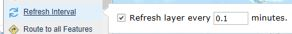

IncidentName_CampOperations

This map is for ‘Camp Operations’ group, viewers of all of the IMT data. These are other individuals that are part of the IMT that will have viewing rights, but no editing rights, and are able to view the map in Collector and go Offline.
- Make a copy of the Operations map. Save As: IncidentName_CampOperations
- Disable editing on all of the layers but the PhotoPoints_MapNotes
- Share with the Viewer Group
- Make a web map app (Section 2.5.4). Some folks will want to view the map on their computers. Share with ‘Operations & Support Group’ too?

IncidentName_Support

This group’s primary use of the map is to assist in navigating around an incident. A transportation map.
- Make a copy of the Operations map. Save As: IncidentName_Support
- Use the table below to make adjustments to the map layers
- Share with the Support Group
Ordering & Settings for Contents (TOC) in AGOL:
Layers (Note: some are checked off by default) | Disable Editing | Transparency | Source
FirePoint | X |  | IMT Service, Create Labels
OtherPoints | X |  | IMT Service
AssignmentBreak | X |  | IMT Service
FireLine | X |  | IMT Service
Labels | X |  | IMT Service , Hide in Legend, Remove Pop-Up
PhotoPoints_MapNotes |  |  | IMT Service
Structures | X |  | IMT Service
TFR | X |  | IMT Service, Remove Pop-Up
FirePolygon | X | 50% | IMT Service, Remove Pop-Up
OtherPolygon | X |  | IMT Service
World Street Map (for Export) |  |  | AGOL Layer
USA Topo Maps (for Export) |  |  | AGOL Layer
Imagery w Labels |  |  | Basemap

IncidentName Fire – Public Map - (Give an intuitive name) Viewing map for the public.
- Open the map template provided:
AGOL_PUBLICservice_YYYY_IncidentName_IncidentNumber.mxd
- Repoint the layers to your gdbs
- Publish the feature service
  - For the Feature Access option (Figure 12) only check: Query
- Once the service is published go to your AGOL account and create a new map
- In AGOL Add: AGOL_PUBLICservice_YYYY_IncidentName_IncidentNumber
- Disable pop-ups for all layers except FirePolygon (this pop-up could show the fire name & date). Re-enable pop-ups you see useful or create labels.
- Choose a Basemap (Topographic or Streets)
- Optional: Imagery / Topo (add as layer)
- Sharing: Everyone (Public)
- Create a web mapping App & share URL (Section 2.5.3 & 2.5.4)
Ordering & Settings for Contents (TOC) in AGOL:
Layers | Transparency | Source
Controlled Fire Line |  | IMT Service
Uncontrolled Fire Edge |  | IMT Service
Closure Points |  | IMT Service
OtherPolygon | 25-50% | IMT Service
FirePolygon | 50% | IMT Service
Streets |  | Basemap
- Updating the public feature service:
  - Use the same mxd you used to create the public feature service
  - As the master FIMT & Other gdbs are updated, republishing the public feature service will be necessary
  - Open the public mxd > File > Share As > Service….
  - The ‘Share as Service’ window will come up. Choose the third option ‘Overwrite an existing service’ (Figure 25)
  - Select the existing service to overwrite (Figure 26)
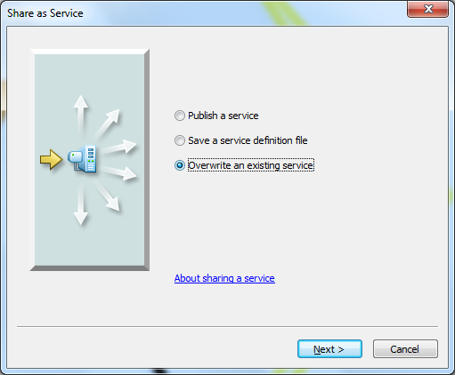  Figure 25 | 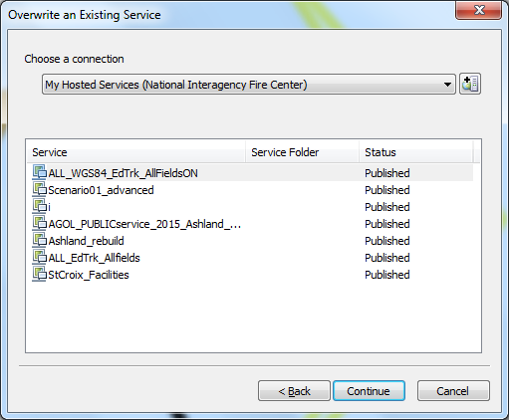  Figure 26
- The feature service in your public map should now be updated
- Repeat this process as often as necessary

Sharing Maps for use in Collector
Refer to Section 3 for more details.
- AGOL map is shared with a Group. Collector users must be invited to the same Group to be able to view the map.
- With Editor Tracking enabled through ArcCatalog, editor names and dates are automatically recorded.
- Plan on giving a 5 minute tutorial to new Collector users.
- Have Collectors use their maps in Offline mode so that they will have labels.

Syncing Data: Updating the FIMT gdb
How to sync your incident FIMT gdb with the AGOL changes.
A tool is being created that will automate some of the steps here in sections 6.8 & 6.9.

Open (create) an mxd setup for editing:
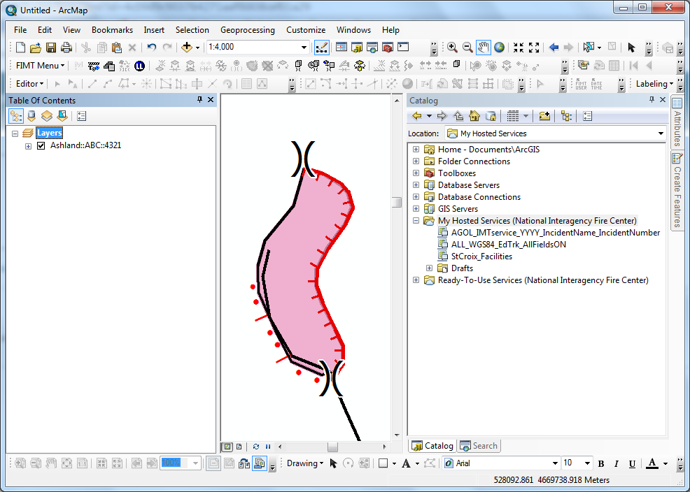
Add the master FIMT gdb and Other gdb.
Then drag and drop your feature service here.

Figure 27: IncidentName_edits_wAGOL.mxd

The following steps show how to add the new data/changes to the FIMT gdb (Figure 28-Figure 33).
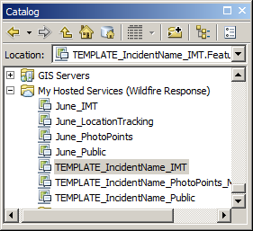  Your Feature Service  Figure 28: Add your feature service to ArcMap. Do this by dragging and dropping from the ArcCatalog window > My Hosted Services, into ArcMap. | Figure 29: Edit the Incident through the FIMT toolbar. | Figure 30: Open the table for the FirePoints feature service. Sort by last_edited_date to see what is new. Select new records. If there are multiple layers with the same names are confusing, give one set a unique name.
Figure 31: With the editor arrow you will right click the highlighted items in the Data View.  Figure 32: Copy & Paste.  Select FirePoint as your target. [OK] | Figure 33: AssignmentBreaks: Add new Breaks manually.  1.Select one new AssignmentBreak at a time & zoom to it.  2.Use the Floating AssignmentBreak FIMT tool to add the new Break. | The sequence used to add the new FirePoints (Figure 26-28) will be used to add new FireLine.
- When you copy-paste using the FIMT button , the PTType attribute comes across as UNKNOWN, and you have to manually change each field or will have to add each point manually using the FIMT ‘Copy to FirePoints’ button. Using the steps above (Figure 27-32) allow you to bulk copy-paste.

Syncing data: Updating the feature service
In the last section edits that were made in AGOL/Collector were brought into ArcMap and added to the FIMT gdb. This section shows how to add the changes that were made in ArcMap – in the master FIMT & Other gdbs to the feature service.
Before you edit the feature service as a local copy create a backup. The steps follow (A & B). | 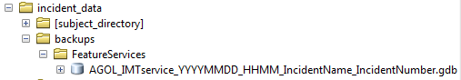  Figure 34

Right click the group header of your feature service > Edit Features > Create Local Copy for Editing
- Navigate to your ArcGIS folder:
C:\Users\<Current User>\Documents\ArcGIS\FeatureServiceLocalEdits (If you can’t find it, click the ’Default Geodatabase Icon’ on the Catalog window in ArcMap) You will see a folder: FeatureServiceLocalEdits. This is where you can get a copy the feature service gdb. (Figure 34)
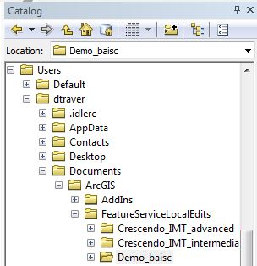
Figure 35: Archiving a copy of the feature service:
Export service to a dated backup folder.

- Save the copy to the backups folder (Figure 33). Rename with a date and time stamp.

One last thing to do before you start updating the feature service, is to populate all of the Latitude/Longitude fields in both gdbs (FirePoint, AssignmentBreak, Structures, OtherPoints, RehabPoints) TOOL is under construction to complete this.

Now, right click a layer in your feature service > Edit Features > Start Editing
- Use the last_edited_date field to find the most recent edits
- Copy & Paste the new features from the FIMT gdb to the feature service
- Copy & Paste the new features from the Other gdb to the feature service (except the FireLine, FirePoint, AssignmentBreak, & FirePolygon)
Figure 36: First you will Create a local copy for editing. Then make all of your edits. | Figure 37: Once all the edits have been completed, you will Synchronize Local Edits with Server

Once all of the syncing is complete Save & Stop Editing

Synchronize Local Edits with Server (Figure 37)

Repeat these steps as often as necessary

Tile Packages (tpks)

Create tpks using Collector or ArcMap in advance. Side load these on to a Collector user’s device.

Create a tpk using Collector
  - Make a map in AGOL. Open it in Collector and download for Offline use. During the download process:
    - Download a new basemap
    - Choose your work area: Eye-ball a ~50x50mi area around the fire (or your best judgment according to the direction the fire is burning).
    - Choose map detail (topos go to about 1:18,000 & ortho to about 1:4,000)
  - Once the map is done downloading you will need to connect the device to your computer to retrieve the basemap:
    - For iOS use the iTunes Store
    - For Android, load them to the Collector folder, like your device is an external drive.
  - Rename the tpks
  - Load the basemaps to other devices with the same procedure as when you were retrieving them.
  - Note: Tile packages are supported from ArcGIS 10.1 for Desktop onwards. Tile package will fail to open with older ArcGIS for Desktop versions (10 or older).
  - More details: Using Your own Basemaps layers with Collector

Create a tpk through ArcMap.
The only map service you can create a TPK with through ArcMap is OpenStreet. You will need your own DRG or Ortho rasters.
- Add the raster of your choice to ArcMap
- In ArcMap enable: Customize > ArcMap Options > Sharing Tab > Enable ArcGIS Runtime Tools.
- Add your imagery or layers to ArcMap
- File > Share As > Tile Package… (Figure 38)
- Tile Package: where to Save; Tile Format: Tiling Scheme, Tile Format, Level of Detail; and Item Description: Summary, Tags, Description (Figure 39)
Figure 38 | 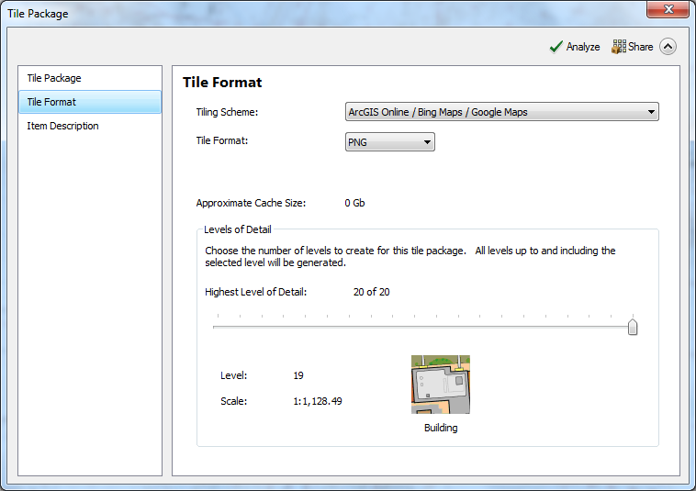  Figure 39

Transition

A plan needs to be made with how AGOL will be transitioned between teams.
When the transition happens (even if the new team is using AGOL) copies should be made of the hosted feature services and they should be placed in the incident data folder. The new GISS should be added to the correct groups for the fire even if they don’t currently plan to use AGOL. This gives them the flexibility to work with it in the future. Changes in services between teams happens all of the time in fire (especially the PIO shop) so this won’t be out of the ordinary.

Additional Information:

Request Assistance:
- http://www.esri.com/services/disaster-response

Best Practices :: GPS & Preserving Battery Life
- It is recommend that people turn off location settings for everything except Collector and the camera and that they review fetch/push settings for things like mail, dim the brightness, and turn off notifications.
- Reference these links:
- http://www.pcmag.com/article2/0,2817,2367542,00.asp
- http://ipod.about.com/od/iphone3g/tp/iphone-battery-life.htm
- http://www.zdnet.com/pictures/31-ways-to-improve-your-iphones-battery-life/
- http://www.cnet.com/how-to/how-to-get-better-battery-life-on-android/

Attachments Workflow:
  - Attachments will only be enabled on PhotoPoints_MapNotes. (a GlobalID field is included in this feature)
  - How do I download attachments out of AGOL? [ArcGIS for Desktop 10.2 will support "Creating a local copy" of the service that will also contain the attachments. (ESRI Help)]
  - Python script available to download multiple attachments.

Things to be aware of:
- If you have downloaded a map on your mobile device and you need to update it with the AGOL copy, go to your main My Maps page in Collector and re-sync to get updates.
- If you are out of service and are forced to re-sign back in, you may not be able to.

Problem Shooting:
- Sign out of Collector App and sign back in.
- Restart App &/or mobile device.
- Issues logging into AGOL:
  - http://support.esri.com/en/knowledgebase/techarticles/detail/40178
  - And Icon in task bar: http://gis.stackexchange.com/questions/108365/arcgis-online-and-sign-in-options-are-greyed-out-in-arcmap-10-2-2

Location Tracking:
      - Create a Location Tracking feature using the ‘Create Layer’ option
      - Add to a map and disable its Editing
      - You can enable how often it tracks in the settings for the map.

My Favorites:
- Save different services that you frequently use or that interest you.
- Item Details – Add to Favorites
- Consider adding: basemaps (for export), other layers, and templates so you can quickly add them to any map.
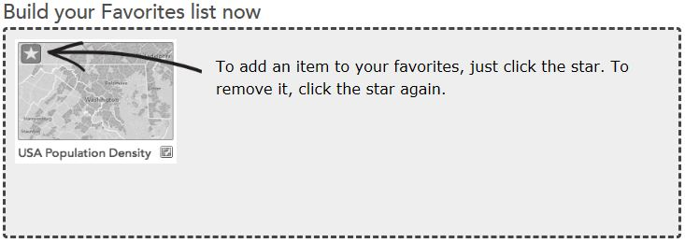

Route/Direction Layer:
If you are signed in with an organizational account, you can use the map viewer to get directions and add the route as a layer in your map. You must have privileges to create items in order to save the map with the route layer. You can configure the layer, create a route map, and perform analysis on the route. Your route map is like any other map you create with the map viewer—you can configure it, share it through a web app, story template, blog, and so on, and use it in a map client such as an iOS device, Android phone, and ArcGIS for Desktop.
- Open the map viewer and click Directions to display the Directions panel to the left of the map.
- Get directions by adding an origin and one or more destinations.
- Once you get your directions, click Add as Layer.
- To add an additional route, create a new set of directions and add that layer to your map. Each route appears as a layer in the Contents of your map.
- If you have privileges to create items, save your map.
The route layer is stored in the map; it is not an independent layer you can reuse in other maps. If you perform analysis on the route, you create a hosted feature layer as a result of the analysis. This hosted feature layer is an independent layer you can reuse in other maps.

Dashboard – discover more at: http://doc.arcgis.com/en/operations-dashboard/windows-desktop/author/create-a-map.htm

Explorer App – discover more at: http://doc.arcgis.com/en/explorer/

Glossary/Terminology:
- AGOL: ArcGIS Online
- FIMT: Fire Incident Mapping Tool, http://gis.nwcg.gov/links_tools.html
- GISS: Geographic Information Systems Specialist
- GSTOP: GIS Standard Operating Procedure, http://gis.nwcg.gov/gstop_sop.html
- IMT: Incident Management Team
- Hosted Feature Service: also referred to as ‘feature service’ or ‘service’
- Local Copy: feature service in ArcMap after you right click the header and create a Local Copy (Figure 2)
- Rest End Point
- Service Definition

Appendix

A zipped folder contains the needed templates:

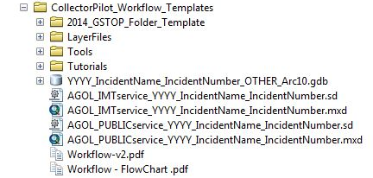
Figure 40: Screen shot of templates folder that will be downloaded.

Features in the ‘Other’ feature dataset:
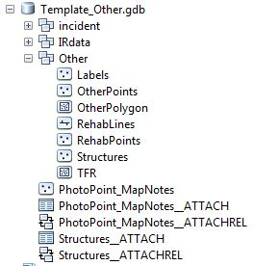 | 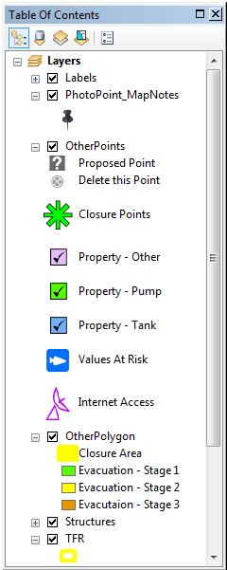 | This structures layer is for collecting structure information on an incident. Structure datasets acquired from other sources would be separate from this.  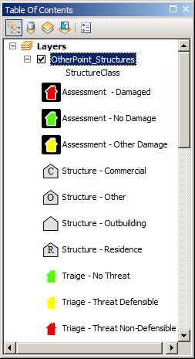

GSTOP Compliant File Structure
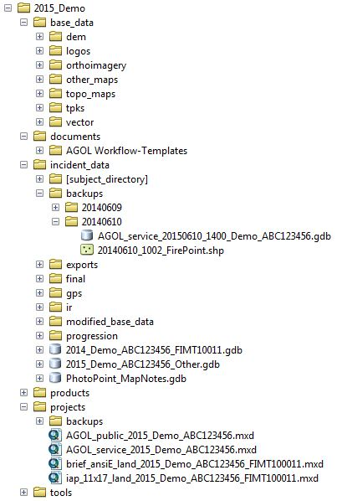
Backup of feature service
Map documents used to create feature services
Template_Other.gdb
Where to save the templates folder you downloaded
TilePackages

Figure 8 Notes
Choose what level of access connecting users should have to the features in the feature service. You can choose as many of the following options as apply:
  - Query: Connecting users can view and select features from the feature classes in the feature service.
  - Create: Connecting users who have the necessary database privileges can add features to feature classes in the feature service.
  - Delete: Connecting users who have the necessary database privileges can delete features from feature classes in the feature service.
  - Update: Connecting users who have the necessary database privileges can edit existing features in the feature classes in the feature service. (ESRI Resources)

Tools
Tools
Attachments-arcgis-rest-toolbox-master
DownloadAttachments_fromAGOL.pyt
Pull Attachments: this tool can be run to batch download attachments from AGOL
Replicate Feature Service: this will download a copy of your feature service as gdb in a zipped folder
ExportAttachments_from_FGDB.tbx
ExportAttachments: this will pull the attachments out of a file geodatabase stored locally and put copies into a folder of your choice
WildfireGISS_Tools
WildfireGISS_Tools.tbx: view the document ‘WildlandFire Mapping Toolkit.pdf’ for more information
Batch – Change Source of GDB
Batch Acreage Change
Batch Change Source of GDB
Batch Date Change
Batch Export MXDs to PDF
Wildland Fire Mapping Toolkit.pdf
Workflow_Tools: tools specifically created to automate parts of this workflow
SubModel: a submodel that does not get ran. It is a component of TOOL01
TOOL01: this tool is ran to modify the FIMT gdb schema at the beginning part of the workflow
RehabLine.csv

Disclaimer
This is an example of a Sensitive Data Map Disclaimer. It may be duplicated for use or modified to meet the needs of the incident.

PROTECTED INFORMATION - NOT FOR PUBLIC RELEASE
This map contains information about historic and/or prehistoric cultural resources that may be withheld under section 304 of the National Historic Preservation Act of 1966, or under section 9 of the Archaeological Resources Protection Act of 1979. Do not copy or distribute this information. Abuse may result in fines and/or imprisonment.

gis.nwcg.gov/links_tools.html
https://drive.google.com/folderview?id=0B9_PM0mqid5sX3FwNzJLMTdObFk&usp=sharing
https://drive.google.com/folderview?id=0B4FY6Y_ZXT8tOGxBcHFJQnRxX0U&usp=sharing
http://video.arcgis.com/watch/1338/joining-an-organization
http://www.arcgis.com/home/signin.html
http://video.arcgis.com/watch/1338/joining-an-organization
http://www.youtube.com/watch?v=uhE3Jx9MKwQ
http://www.youtube.com/watch?v=K19U_HFdooc
http://doc.arcgis.com/en/collector/ios/create-maps/offline-map-prep.htm#ESRI_SECTION1_BB7CFF5BFBC847DEA31610A38A510679
http://video.arcgis.com/watch/253/create-a-map
http://doc.arcgis.com/en/collector/ios/create-maps/create-and-share-a-collector-map.htm
http://video.arcgis.com/watch/251/invite-others-to-join-your-group
http://video.arcgis.com/watch/1341/share-maps-and-apps-with-your-organization
http://doc.arcgis.com/en/arcgis-online/share-maps/groups.htm
http://doc.arcgis.com/en/arcgis-online/share-maps/share-maps.htm
http://video.arcgis.com/watch/249/embed-a-map-in-your-website
http://doc.arcgis.com/en/arcgis-online/create-maps/create-map-apps.htm
http://doc.arcgis.com/en/collector/android/collect-data/offline-use.htm
https://esriaustraliatechblog.wordpress.com/2014/05/30/bringing-your-data-from-the-cloud-back-to-earth-how-to-extract-your-data-from-arcgis-online/?blogsub=confirming#subscribe-blog
http://doc.arcgis.com/en/arcgis-online/reference/videos.htm
http://doc.arcgis.com/en/arcgis-online/
http://doc.arcgis.com/en/collector/ios/collect-data/quick-reference.htm
https://drive.google.com/folderview?id=0B4FY6Y_ZXT8tOGxBcHFJQnRxX0U&usp=sharing
https://itunes.apple.com/us/app/collector-for-arcgis/id589674237
http://training.esri.com/Courses/ts_OfflineDataColl/player.cfm
http://video.arcgis.com/watch/2194/collector-for-arcgis-damage-assessment-survey
http://doc.arcgis.com/en/collector/ios/collect-data/collect-tutorial.htm
https://www.youtube.com/watch?v=5nmkHKNs0Ek
http://doc.arcgis.com/en/collector/ios/create-maps/create-maps.htm
https://drive.google.com/folderview?id=0B9_PM0mqid5sX3FwNzJLMTdObFk&usp=sharing
http://www.arcgis.com/home/signin.html
http://blogs.esri.com/esri/arcgis/2014/03/23/using-your-own-basemap-layers-with-collector-for-arcgis/
http://doc.arcgis.com/en/arcgis-online/share-maps/item-details.htm
http://doc.arcgis.com/en/arcgis-online/use-maps/get-directions.htm
http://doc.arcgis.com/en/arcgis-online/use-maps/get-directions.htm
http://doc.arcgis.com/en/arcgis-online/use-maps/perform-analysis.htm

