**COW CANYON**

INCIDENT ACTION PLAN

Sunday - Tuesday

October 25, 2020 – October 27, 2020

0600-2030

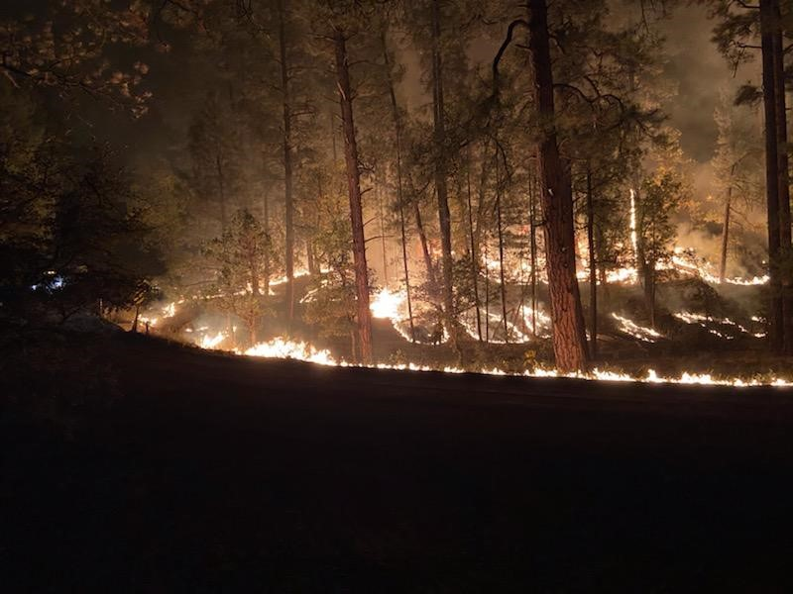

**https://ftp.nifc.gov/public/incident_specific_data/southwest/GACC_Incidents/2020/2020_Cow_Canyon/**

**Alpine Ranger District**

**Apache-Sitgreaves N.F.**

**AZ-ASF-000819 P3NM3P (0301)**

PLEASE TURN IN YOUR SIGNED CTR’S AND SHIFT TICKETS TO THE EMAIL BELOW!

[2020.cowcanyon.finance@firenet.gov](mailto:2020.cowcanyon.finance@firenet.gov)

|  |  |  |  |  |  |  |  |  |  |
| --- | --- | --- | --- | --- | --- | --- | --- | --- | --- |
| **INCIDENT OBJECTIVES** | | | 1. Incident Name  COW CANYON | | | 2. Date  10/25-27/2020 | | | 3. Time  0600 |
| 4. Operational Period  0600-2030 hours Day Operational Period | | | | | | | | | |
| 1. General Objectives for the Incident (include alternatives)   1. Provide for firefighter and public safety.  2. Protect structures along County road 67004  3. Prep County road 67004 and FS Rd 232 AZ and NM  4. Protect cultural resources  5. Protect Range/ Recreation and other resource improvements  6. Protect TEP KV Lines and NEC powerlines.  7. Confine the fire to:  a. East of the Blue River, South of Pueblo park road, West of NM180 and North of Winters Trail | | | | | | | | | |
| 6. Weather Forecast for Period | | | | | | | | | |
| 1. General Safety Message  * **Reassess LCES throughout the day. Pre-identify multiple escape routes and safety zones.** * **Do not get complacent.** * **When driving dirt roads, be sure to provide an extra margin of separation for dusty and/or slippery conditions.** | | | | | | | | | |
| 8. Attachments (mark if attached) | | | | | | | | | |
| **X** | Organization List - ICS 203 | **X** | | Air Ops Summary – ICS 220 | | |  |  | |
| **X** | Div. Assignment Lists – ICS 204 |  | | Incident Maps | | |  |  | |
| **X** | Communications Plan - ICS 205 | **X** | | Weather Forecast | | |  |  | |
| **X** | Medical Plan – ICS 206 | **X** | | Unit Log – ICS 214 | | |  |  | |
| 9. Prepared by  Francesca Chavez | | | | | | 10. Approved by (Incident Commander)  EVERETT PHILLIPS | | | | |

|  |  |  |
| --- | --- | --- |
| ORGANIZATION ASSIGNMENT LIST | | |
| 1. Incident Name   **COW CANYON** | | |
| 2. Date  10/25-27/2020 | | 3. Time  0600 |
| 4. Operational Period  **10/25-27/20 Day, 0600-2030** | | |
| Position | Name | |
| 5. Incident Commander and Staff | | |
| Incident Commander | **(O-56) EVERETT PHILLIPS 928-719-1595**  **(O-39) Tim Hill (T) 928-245-8712** | |
|  |  | |
| Safety Officer | (O-60) JOHN MCGEE | |
| Information Officer | (O-1) STEVE JOHNSON 928-339-5000 steven.m.johnson@usda.gov | |
|  |  | |
|  |  | |
|  |  | |
| 6. Agency Representative | | |
| Agency | Name | |
| ASF Agency Administrator | (O-4) PAUL HANCOCK | |
| Resource Advisor | **(O-79) GABE PARTIDO 575-590-7166, (O-22) MATTHEW TALIAFERRO (archeologists)** | |
| Administrator | **ALISSA TANNER 928-339-5010 alissa.tanner@usda.gov** | |
| District Rangers | **ERICK STEMMERMAN (Glenwood) 575-654-3278** | |
| District Rangers | **ED HOLLOWAY (Clifton) 575-590-7843** | |
| Az State Forestry | **ROY HALL** [rhall@dffm.az.gov](mailto:rhall@dffm.az.gov) | |
| Tucson Electric Power | **GREG WILDMAN 520-904-5750 gwildman@TEP.com** | |
| 7. Planning Section | | |
| Chief | **(O-41) CHRISTINA BRANNON (t) 480-221-7690 christina.brannon@usda.gov** | |
| Resources Unit |  | |
| Situation Unit |  | |
| Documentation Unit |  | |
| Status Check-in Recorder |  | |
| Long Term Fire Analyst | (O-3) SHELLY CROOK 575-313-6837 | |
| Fire Behavior THSP |  | |
| Air Resource Advisor | (O-2) DIONISIO SILVA 575-574-2580 [dionisio.silva@usda.gov](mailto:dionisio.silva@usda.gov) | |
| Air Resource Advisor | RON SHERRON Environsherron@gmail.com | |
| GIS Specialist (T) | (O-69) MARYELLEN KOMNATH 928-215-1523 | |
| 8. Logistics Section | | |
| Chief | (O-20) GENE BEAUDOIN 928-358-9141 | |
| Food Unit Leader | (O-44) DEAN MCALLISTER | |
| Cache Assistant |  | |
| Facilities Unit Leader | (O-57) GARY HAMILTON 928-242-3794 | |
| Communications technician |  | |
| Radio Operator |  | |

|  |  |  |  |
| --- | --- | --- | --- |
| 9. Operations Section | | | |
| Chief | (O-17) BILL TAVARES 928-200-8044 / (O-78) JOSHUA MILLER 928-812-2974(O-48) JIMMY NICHOLAS (t) 520-237-3405 | | |
| Deputy |  | | |
|  |  | | |
| a. Branch I- Division/Groups | | | |
| Branch Director |  | | |
| Deputy |  | | |
| Division/Group | ALPHA | | (O-53) DURAND JARAMILLO |
| Division/Group | NOVEMBER | | (O-10) TY OLIVER 575-388-7978 |
| Division/Group | ROMEO | | UNSTAFFED |
| Division/Group | INDIA | | (O-63) DANIEL RUEBUSH/ (O-64) MATT SIGG (t) |
| Division/Group |  | |  |
| THSP |  | |  |
|  |  | |  |
|  |  | |  |
| b. Branch II - Division/Groups | | | |
| Branch Director |  | | |
| Deputy |  | | |
| Division/Group |  |  | |
| Division/Group |  |  | |
| Division/Group |  |  | |
|  |  |  | |
|  |  |  | |
| c. Branch III – Division/Groups | | | |
| Branch Director |  | | |
| Deputy |  | | |
| Division/Group |  |  | |
| d. Air Operations Branch | | | |
| Air Operations Branch Director | | **(O-5) MARK EMPEY** | |
| Air Attack Supervisor | |  | |
| Air Support Supervisor | |  | |
| Helicopter Manager | |  | |
| Air Tanker Coordinator | |  | |
| 10. Finance Section | | | |
| Chief | | **(O-13) LUCY BUCKLIN (virtual)** [**lucy_bucklin@firenet.gov**](mailto:lucy_bucklin@firenet.gov) **928-242-0175** | |
| Time Unit Leader | |  | |
| Personnel Time Recorder | |  | |
| Cost Specialist | | **(O-18) CHARLES JOY** | |
| Prepared by  Francesca Chavez  Jim Anderson | | | |





|  |  |  |  |  |  |  |  |  |  |  |  |  |  |  |  |  |  |
| --- | --- | --- | --- | --- | --- | --- | --- | --- | --- | --- | --- | --- | --- | --- | --- | --- | --- |
| **DIVISION ASSIGNMENT LIST** | | | | | | 1. Branch | | | | | | | | 2. Division/Group  ALPHA | | | |
| 3. Incident Name  COW CANYON | | | | | | 4. Operational Period  Date: 10/25-27/2020 Time**: 0600** | | | | | | | | | | | |
| 5. Operations Personnel | | | | | | | | | | | | | | | | | |
| Operations Chief | | Bill Tavares | | | | Task Force Leader | | | | | | | **Durand Jaramillo | | | | |
| 6. Resources Assigned this Period | | | | | | | | | | | | | | | | | |
| Strike Team/Task Force / Resource Designator | | | Leader | | | | Number Persons | | Last Work Day | Drop Off PT./Time | | | | | | Pick Up PT./Time | |
| E-16 Chase 613 | | | Dan Trujillo | | | | 3 | | 10/23 | Alpine RD / 0700 | | | | | | 2030 | |
| ** E-5 WT 1-1 | | | Jorge Hernandez | | | | 1 | | 10/28 | Alpine RD / 0700 | | | | | | 2030 | |
| E-27 CHIPPER | | | Kyran Walker | | | | 1 | | 10/27 | Alpine RD / 0700 | | | | | | 2030 | |
| ** O-42 SOF2 | | | Charles Christensen | | | | 1 | | 10/28 | Alpine RD / 0700 | | | | | | 2030 | |
| O-70 Taylor/Snowflake Medical | | | Russ Turner 208-599-3760 | | | | 2 | | 11/4 | Alpine RD / 0700 | | | | | | 2030 | |
| ** E-28 ENG 662 | | | Andrew Zimmerman | | | | 6 | | 10/31 | Alpine RD / 0700 | | | | | | 2030 | |
| E-30 JTS WT 4 | | | Kent Larson | | | | 1 | | 11/05 | Alpine RD / 0700 | | | | | | 2030 | |
|  | | |  | | | |  | |  |  | | | | | |  | |
|  | | |  | | | |  | |  |  | | | | | |  | |
|  | | |  | | | |  | |  |  | | | | | |  | |
|  | | |  | | | |  | |  |  | | | | | |  | |
| 7. Control Operations   * Scout around structures in the Blue River Corridor. * Prep structures along Blue River * Prep Range improvements * Burnout as needed. * Prep FS RS 232 (Pueblo Park road) | | | | | | | | | | | | | | | | | |
| 8. Special Instructions   * **\*\**Designated IA Resource for the GILA working under TFLD Ty Oliver*** * **\*\**Designated IA Resource for the A-S working under TFLD Caleb Shutz***   Blue Admin Site (928) 339-4466 | | | | | | | | | | | | | | | | | |
| 9. Division/Group Communication Summary | | | | | | | | | | | | | | | | | |
| Function | Frequency | | | | System | Channel | | Function | | | | Frequency | | | | System | Channel |
| Tactical  1 | RX/TX 167.550 RX  /TX  168.675  (N) | | | |  | 9 | | Air to Ground 47 | | | | Rx: 167.725 (NB)  Tx: 167.725 (NB) | | | |  | 14 |
| Apache  Repeater | Rx:170.575 (NB)  Tx: 163.1625 (NB)  Tone 08 (103.5) | | | |  | 2 | | Air Guard | | | | Rx: 168.625 (NB)  Tx: 168.625 (NB) | | | |  |  |
|  |  | | | |  |  | |  | | | |  | | | |  |  |
| Prepared by  **Francesca Chavez** | | | | Approved by (Incident Commander) | | | | | | | Date | | | | Time | | |

|  |  |  |  |  |  |  |  |  |  |  |  |  |  |  |  |  |  |  |
| --- | --- | --- | --- | --- | --- | --- | --- | --- | --- | --- | --- | --- | --- | --- | --- | --- | --- | --- |
| **DIVISION ASSIGNMENT LIST** | | | | | | 1. Branch | | | | | | | | 2. Division/Group  NOVEMBER | | | | |
| 3. Incident Name  COW CANYON | | | | | | 4. Operational Period  Date: 10/24-27/2020 Time**: 0600** | | | | | | | | | | | | |
| 5. Operations Personnel | | | | | | | | | | | | | | | | | | |
| Operations Chief | | Bill Tavares | | | | Task Force Leader | | | | | | | **TY OLIVER | | | | | |
| 6. Resources Assigned this Period | | | | | | | | | | | | | | | | | | |
| Strike Team/Task Force/ Resource Designator | | | Leader | | | | Number Persons | | Last Work Day | Drop Off PT./Time | | | | | | | Pick Up PT./Time | |
| ** O-7 FFT1 | | | Richard Ortiz 575-574-8845 | | | | 1 | | 10/22 | DIV N / 0700 | | | | | | | 2030 | |
| ** O-42 SOF2 | | | Charles Christensen | | | | 1 | | 10/28 | Alpine RD / 0700 | | | | | | | 2030 | |
|  | | |  | | | |  | |  |  | | | | | | |  | |
|  | | |  | | | |  | |  |  | | | | | | |  | |
|  | | |  | | | |  | |  |  | | | | | | |  | |
|  | | |  | | | |  | |  |  | | | | | | |  | |
|  | | |  | | | |  | |  |  | | | | | | |  | |
|  | | |  | | | |  | |  |  | | | | | | |  | |
|  | | |  | | | |  | |  |  | | | | | | |  | |
|  | | |  | | | |  | |  |  | | | | | | |  | |
|  | | |  | | | |  | |  |  | | | | | | |  | |
|  | | |  | | | |  | |  |  | | | | | | |  | |
|  | | |  | | | |  | |  |  | | | | | | |  | |
| 7. Control Operations   * Monitor fire behavior. * Protect range improvements * Repairs on the private inholdings | | | | | | | | | | | | | | | | | | |
| 1. Special Instructions  * **\*\**Designated IA Resource for the GILA working under TFLD Ty Oliver*** * **\*\**Designated IA Resource for the A-S working under TFLD Durand Jaramillo***   Blue Admin Site (928) 339-4466 | | | | | | | | | | | | | | | | | | |
| 9. Division/Group Communication Summary | | | | | | | | | | | | | | | | | | |
| Function | Frequency | | | | System | Channel | | Function | | | | Frequency | | | | System | | Channel |
| Tactical  3 | RX/TX 168.775 RX  /TX  168.675  (N) | | | |  | 11 | | Air to Ground 47 | | | | Rx: 167.725 (NB)  Tx: 167.725 (NB) | | | |  | | 14 |
| Apache  Repeater | Rx:170.575 (NB)  Tx: 163.1625 (NB)  Tone 09 (100.0) | | | |  | 2 | | Air Guard | | | | Rx: 168.625 (NB)  Tx: 168.625 (NB) | | | |  | |  |
|  |  | | | |  |  | |  | | | |  | | | |  | |  |
| Prepared by  **Francesca** | | | | Approved by (Incident Commander) | | | | | | | Date | | | | Time | | | |

|  |  |  |  |  |  |  |  |  |  |  |  |  |  |  |  |  |  |
| --- | --- | --- | --- | --- | --- | --- | --- | --- | --- | --- | --- | --- | --- | --- | --- | --- | --- |
| **DIVISION ASSIGNMENT LIST** | | | | | | 1. Branch | | | | | | | | 2. Division/Group  INDIA | | | |
| 3. Incident Name  COW CANYON | | | | | | 4. Operational Period  Date: 10/25-27/2020 Time**: 0600** | | | | | | | | | | | |
| 5. Operations Personnel | | | | | | | | | | | | | | | | | |
| Operations Chief | | Bill Tavares | | | | Task Force Leader | | | | | | | DANIEL RUEBUSH/ MATT SIGG (t) | | | | |
| 6. Resources Assigned this Period | | | | | | | | | | | | | | | | | |
| Strike Team/Task Force/ Resource Designator | | | Leader | | | | Number Persons | | Last work Day | Drop Off PT./Time | | | | | Pick Up PT./Time | | |
| C-2 NAVAJO SCOUTS 1 | | | Matthew Curleyhair/ Augustine Sectero (t) | | | | 13 | | 11/06 | Alpine RD / 0700 | | | | | 2030 | | |
| ** E-10 Engine 632 | | | Lathan Beaver | | | | 5 | | 10/28 | Alpine RD / 0700 | | | | | 2030 | | |
| ** O-42 SOF2 | | | Charles Christensen | | | | 1 | | 10/28 | Alpine RD / 0700 | | | | | 2030 | | |
| ** O-37 Greer Line Medics | | | RJ Carnright 928-225-7356 | | | | 2 | | 10/28 | Alpine RD / 0700 | | | | | 2030 | | |
| ENG 612 | | | Berkeley Krueger | | | | 2 | | 10/28 | Alpine RD / 0700 | | | | | 2030 | | |
| (O-49 thru O-51) Coronado 642 | | | Brady Becker | | | | 3 | | 10/29 | Alpine RD / 0700 | | | | | 2030 | | |
| E-29 ENG 623 | | | Brendon Nelson | | | | 8 | | 11/2 | Alpine RD / 0700 | | | | | 2030 | | |
| E-3 NESBITT 313 W/EMT | | | Vas Naiker | | | | 2 | | 10/29 | Alpine RD / 0700 | | | | | 2030 | | |
| **E-2 J3 Engine 14 (CAFS) | | | Curtis Pumphrey | | | | 3 | | 10/31 | Alpine RD / 0700 | | | | | 2030 | | |
| E-6 **Chase 642 | | | Butch Oglesby | | | | 7 | |  | DIV I / 0700 | | | | | 2030 | | |
| C-7 Inbound LLC | | | Wes Nettleship 541-972-0155 | | | | 20 | |  | Alpine RD/0700 | | | | | 2030 | | |
|  | | |  | | | |  | |  |  | | | | |  | | |
| 7. Control Operations   * Monitor fire behavior * Prep FS RS 232 (Pueblo Park road) * Burnout as needed. * Go direct off the 90 Trail when the opportunity presents itself. Scout black fire edge | | | | | | | | | | | | | | | | | |
| 8. Special Instructions   * **\*\**Designated IA Resource for the GILA working under TFLD Ty Oliver*** * **\*\**Designated IA Resource for the A-S working under TFLD Durand Jaramillo***   Greer Incident Medical Team, Line medics with UTV  Blue Admin Site (928) 339-4466 | | | | | | | | | | | | | | | | | |
| 9. Division/Group Communication Summary | | | | | | | | | | | | | | | | | |
| Function | Frequency | | | | System | Channel | | Function | | | | Frequency | | | | System | Channel |
| Tactical  2 | RX/TX 168.675 RX  /TX  168.675  (N) | | | |  | 10 | | Air to Ground 47 | | | | Rx: 167.725 (NB)  Tx: 167.725 (NB) | | | |  | 14 |
| Apache  Repeater | Rx:170.575 (NB)  Tx: 163.1625 (NB)  Tone 09 (100.0) | | | |  | 2 | | Air Guard | | | | Rx: 168.625 (NB)  Tx: 168.625 (NB) | | | |  |  |
|  |  | | | |  |  | |  | | | |  | | | |  |  |
| Prepared by  **Francesca Chavez** | | | | Approved by (Incident Commander) | | | | | | | Date | | | | Time | | |
| **DIVISION ASSIGNMENT LIST** | | | | | | 1. Branch | | | | | | | | 2. Division/Group  ROMEO | | | |
| 3. Incident Name  COW CANYON | | | | | | 4. Operational Period  Date: 10/25-27/20 Time**: 0600** | | | | | | | | | | | |
| 5. Operations Personnel | | | | | | | | | | | | | | | | | |
| Operations Chief | | Bill Tavares | | | | Task Force Leader | | | | | | | UNSTAFFED | | | | |
| 6. Resources Assigned this Period | | | | | | | | | | | | | | | | | |
| Strike Team/Task Force/ Resource Designator | | | Leader | | | | Number Persons | | Last work Day | Drop Off PT./Time | | | | | Pick Up PT./Time | | |
|  | | |  | | | |  | |  |  | | | | |  | | |
|  | | |  | | | |  | |  |  | | | | |  | | |
|  | | |  | | | |  | |  |  | | | | |  | | |
|  | | |  | | | |  | |  |  | | | | |  | | |
|  | | |  | | | |  | |  |  | | | | |  | | |
|  | | |  | | | |  | |  |  | | | | |  | | |
|  | | |  | | | |  | |  |  | | | | |  | | |
|  | | |  | | | |  | |  |  | | | | |  | | |
|  | | |  | | | |  | |  |  | | | | |  | | |
|  | | |  | | | |  | |  |  | | | | |  | | |
|  | | |  | | | |  | |  |  | | | | |  | | |
|  | | |  | | | |  | |  |  | | | | |  | | |
|  | | |  | | | |  | |  |  | | | | |  | | |
|  | | |  | | | |  | |  |  | | | | |  | | |
|  | | |  | | | |  | |  |  | | | | |  | | |
| 7. Control Operations   * Monitor fire behavior by flight. * Preparing a plan as fire presents off Horse Mesa. | | | | | | | | | | | | | | | | | |
| 8. Special Instructions   * __________ is IA resource.   Blue Admin Site (928) 339-4466 | | | | | | | | | | | | | | | | | |
| 9. Division/Group Communication Summary | | | | | | | | | | | | | | | | | |
| Function | Frequency | | | | System | Channel | | Function | | | | Frequency | | | | System | Channel |
| Tactical  2 | RX/TX 168.675 RX  /TX  168.675  (N) | | | |  | 10 | | Air to Ground 47 | | | | Rx: 167.725 (NB)  Tx: 167.725 (NB) | | | |  | 14 |
| Apache  Repeater | Rx:170.575 (NB)  Tx: 163.1625 (NB)  Tone 09 (100.0) | | | |  | 2 | | Air Guard | | | | Rx: 168.625 (NB)  Tx: 168.625 (NB) | | | |  |  |
|  |  | | | |  |  | |  | | | |  | | | |  |  |
| Prepared by  **Francesca Chavez** | | | | Approved by (Incident Commander) | | | | | | | Date | | | | Time | | |

|  |  |  |  |  |  |  |  |  |
| --- | --- | --- | --- | --- | --- | --- | --- | --- |
| **INCIDENT RADIO COMMUNICATIONS PLAN** | | | | 1. Incident Name  COW CANYON | | 2. Date/Time Prepared  10/25-27/2020 | | 3. Operational Period Date/Time  10/25/20  Day 0600 - 2000 |
| 4. Basic Radio Channel Utilization | | | | | | | | |
| Assignment | Channel | Function | Frequency/Tone | | Function | | Remarks | |
| Command | 1 | Apache Primary | RX/TX 170.575 (N) | | Forest Net Line of Sight | | Tone 110.9 Escudilla/Promontory | |
| Command | 2 | Apache Repeat | RX 170.575 (N)  TX 163.1625 (N) | | Forest Net Repeater | | Tone 123.0 Rose Peak/Gentry | |
|  | 3 | Sitgreaves Primary | RX/TX 169.950 (N) | | Forest Fire Net Line of Sight | | Tone 131.8 Reno/Juniper Ridge | |
|  | 4 | Sitgreaves Repeat | RX 169.950 (N)  TX 162.225 (N) | | Forest Fire Net Repeater | | Tone 136.5 Greens Peak/Greens Peak | |
|  | 5 | Engineer/Host | RX/TX 172.375 (N) | | Common user | | 146.2 Big Lake/Lake Mt. | |
|  | 6 | Gila North | RX/TX 169.975 (N) | | Mutual Aid | | Tone 156.7 Mitchell Pk/Deer Springs | |
|  | 7 | FTA Fire Rpt | RX 172.675 (N)  TX 166.3625 (N) | | Ft. Apache Fire | | Tone 167.9 South Mt/Chev Butte | |
|  | 8 | Weather | RX 162.525  TX 0 (N) | | Wx Stations | | Tone 103.5 Bear Mt/Diamond Pt. | |
|  | 9 | Tac 1 | RX/TX 167.550 (N) | | Tactical | | Tone 100.0 Saddle Mt/Heber Sub | |
|  | 10 | Tac 2 | RX/TX 168.675 (N) | | Tactical | | Tone 107.2 Porter Mt. | |
|  | 11 | Tac 3 | RX/TX 168.775 (N) | | Tactical | | Tone 114.8 Guthrie | |
|  | 12 | Travel | RX/TX 168.350 (N) | | Travel | | Tone 127.3 Portable | |
|  | 13 | Air-Ground 1(34) | RX/TX 167.175 (N) | | Primary Air-to-Ground | |  | |
|  | 14 | Air-Ground 2(47) | RX/TX 167.725 (N) | | Secondary Air-to-Ground | |  | |
|  | 15 | VMED 28 | RX/TX 155.340 (N) CG 156.7 | | Medical Air-to-Ground | |  | |
|  | 16 | Air Guard | RX/TX 168.625 (N) CG 110.9 | | Emergency | | Tone 110.9 | |
| 5. Prepared by (Communications Unit) | | | | | | | | |

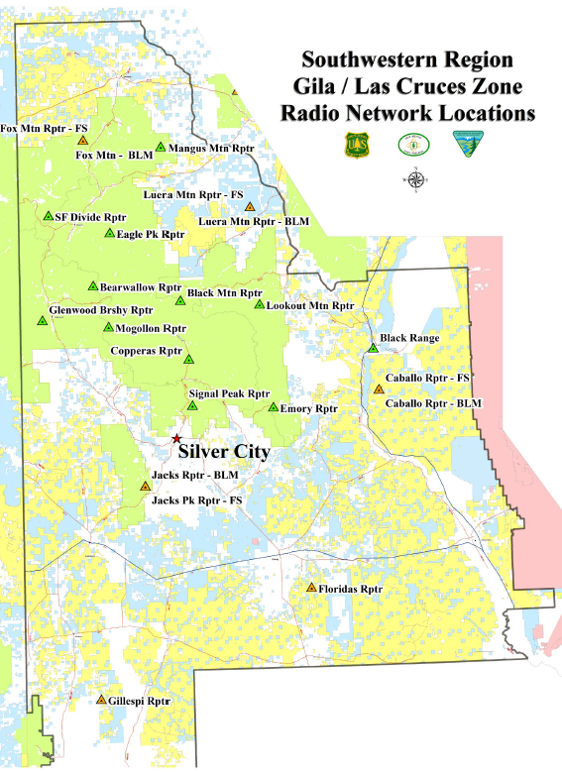

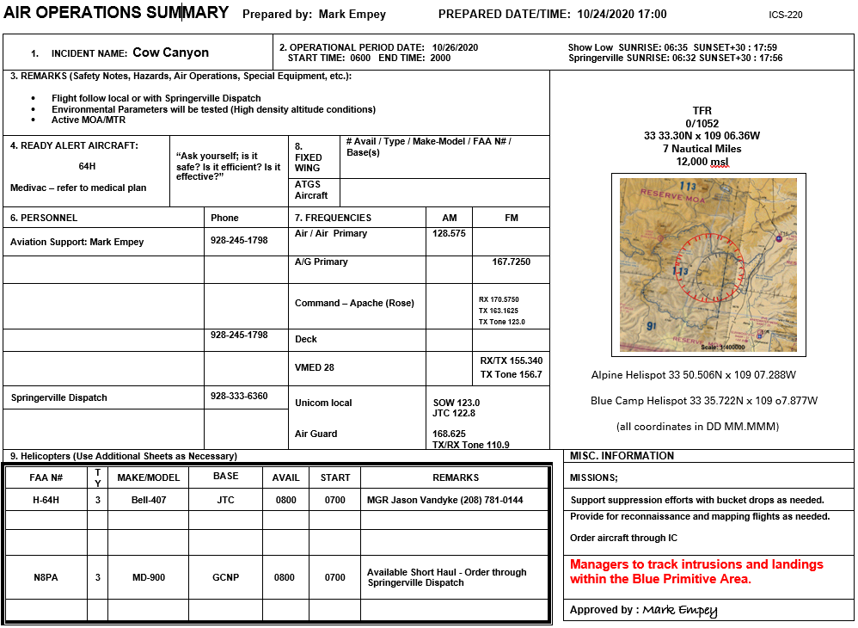



|  |  |  |  |  |  |  |  |  |  |  |  |  |  |  |  |  |  |  |  |
| --- | --- | --- | --- | --- | --- | --- | --- | --- | --- | --- | --- | --- | --- | --- | --- | --- | --- | --- | --- |
|  |  | | | | | |  | |  | | | |  | | | | | | |
| **MEDICAL PLAN** | **COW CANYON** | | | | | | **10/25-27/20** | |  | | | |  | | | | | | |
| **5. Incident Medical Aid Station** | | | | | | | | | | | | | | | | | | | |
|  | | |  | | | | | | | | | | | | Paramedics | | | | |
| Medical Aid Stations | | | Location | | | | | | | | | | | | Yes | | | | No |
| Alpine Fire Department | | | 42688 US HWY 180  Alpine, AZ 85920 (928) 339-4814 | | | | | | | | | | | |  | | | | **X** |
| **6. Transportation** | | | | | | | | | | | | | | | | | | | |
| A. Ambulance Services | | | | | | | | | | | | | | | | | | | |
|  | | | |  | | | | | | |  | | | | | | Paramedics | | |
| Name | | | | Address | | | | | | | Phone | | | | | Yes | | | No |
| **White Mountain Ambulance** | | | | **Springerville, AZ** | | | | | | | **Show Low Dispatch or 911** | | | | | **X** | | |  |
| **Medical Heliopter** | | | | **Show Low, AZ** | | | | | | | **Show Low Dispatch or 911** | | | | | **X** | | |  |
| B. Incident Ambulances | | | | | | | | | | | | | | | | | | | |
|  | | | | |  | | | | | | | | | | | | Paramedics | | |
| Name | | | | | Location | | | | | | | | | | | | Yes | | No |
| **N/A** | | | | | **Springerville Dispatch/911** | | | | | | | | | | | |  | |  |
| **7. Hospitals** | | | | | | | | | | | | | | | | | | | |
|  | |  | | | | Travel Time | | | |  | | Helipad | | | | | | Burn Center | |
| Name | | Address | | | | Air | | Grnd | | Phone | | Y | | N | | | | Y | N |
| **White Mountain Regional Medical Center** | | **118 S Mountain Ave, Springerville, AZ 85938** | | | | **0:55** | | **2:00** | | **928-333-4368** | |  | | **X** | | | |  | **X** |
| **Summit Healthcare** | | **2200 E Show Low Lake Rd**  **Show Low, AZ 85901** | | | | **1:15** | | **2:45** | | **928-537-4375**  **928-537-9944**  **800-300-0361** | | **X** | |  | | | |  | **X** |
| **University Medical CenterTucson level 1 Trauma** | | **1501 N Campbell Tucson, AZ 85719** | | | | **1:30** | | **4:30** | | **520-694-7547** | | **X** | |  | | | | **X** |  |
| **8. Medical Emergency Procedures** | | | | | | | | | | | | | | | | | | | |
| ***Minor emergency:***  ***Notify supervisor. Provide First Aid. Assess need for transport.***  ***Major Emergency:***  ***Notify Divison/Taskforce Leader. Provide First Aid. Establish incident commander for medical emergency. Notify Dispatch of emergency and request appropriate assistance. Stabilize and prepare patient for transport.*** | | | | | | | | | | | | | | | | | | | |
| 9. Prepared by | | | | | | | 10. Reviewed by | | | | | | | | | | | | |
| **Christina Brannon** | | | | | | |  | | | | | | | | | | | | |

**SAFETY MESSAGE**

**Cow Canyon Fire**

**October 25 Thru 27, 2020**

|  |  |  |  |  |  |  |  |
| --- | --- | --- | --- | --- | --- | --- | --- |
| **Within the wildland fire environment, five basic safety hazards confront the firefighter:**   * Lightning and winds from thunderstorms, driving or riding in a vehicle, fire-weakened snags, rolling rocks, entrapment by running fires, and air operations   Each firefighter must know the interconnection of LCES -   * lookouts * communications * escape routes * safety zones   LCES should be established before fighting the fire: Select lookouts, ensure you have good communications, choose escape routes, and select safety zones.  LCES functions sequentially - it's a self-triggering mechanism. Lookouts assess -and reassess - the fire environment and communicate threats to safety; firefighters use escape routes to safety zones. All firefighters should be alert to changes in the fire environment and have the authority to initiate communication. If you have doubts about what is happening around you speak up. Learn to listen to your inner voice. It’s a built in self-preservation mechanism! Remember to look up for snags, listen for rolling rocks, face the danger and stay alert for changes in the weather. | | | |  | | | LCES is built on two guidelines:  * Before safety is threatened, each firefighter must know the LCES system will be used, * and LCES must be continuously reevaluated as fire conditions change. |
|  |  |  |  | |  |

**Driving hazards** – Drive at or below the speed limit. Drive defensively at all times. Keep it safety slow. When in doubt, yield the right of way to other vehicles. Never read or send tex messages while driving. If you need to talk on the cell phone and you don’t have hands free, pull off the road. Don’t be a distracted driver.

Use air resources wisely. Stay clear of all water and retardant drops. Avoid transferring unnecessary risk from the ground to the air.

**Personal Care –**Drink lots of water. If you are not urinating at least once every 3 hours, you are not drinking enough fluids. The first function that is affected by lack of fluid in the body is your ability to think clearly. Avoid energy drinks while on assignment. They are diuretics and reduce the water content of your body. Manage your core temperature. Use an occasional sports drink to replenish electrolytes lost through perspiration.

**\*\*\* COVID-19 Mitigation Actions and Leader’s Intent\*\*\***

* **Assigned resources will practice social distancing and be in alignment with the “module of one concept.” When interacting outside of the “module of one,” face-coverings are required; this includes ICP, established business within town limits, fireline interactions outside of the “module of one”.**
* **Without compromising firefighter safety, social distancing should be practiced to the extent possible.**
* **Reduce the number of briefing participants to only module leaders or those deemed necessary.**





Hunting Tags have been issued Beware of hunters trying to scout in the area.

# Cow Canyon fire (gila National Forest) repair AND REHABILITATION Standards

**PRIOR to REPAIR AND REHABILITATION**

Please record the following during all fire operations and submit to READ as actions occur on a daily basis:

**Retardant drops** – Record number of gallons and locations dropped.

**Bucket drops** – Record location and source of dip site, number of gallons and location dropped

**Roads, Trails, and Fence lines** – Record all roads trails and fence lines used as fire lines

**Roads, Trails, FiRELINE AND FeNCES**

General standards are to replace any boulders, gates, and/or barriers on closed roads opened for fire access as determined by the Gila NF Motor Vehicle Use Map.

**Roads:** For all roads used as actual or proposed fire line ***TBD with OPS***

Improve and re-establish drainage ditches, lead out ditches, repair of gullies, rutted areas, areas holding water due to lack of drainage on all roads used or proposed as fire lines ***List roads used coordinate with Situation and OPS***

Install rolling dips and water bars where needed. Distance specifications in Table 1 on page 3.

Clear culverts to improve or restore functionality caused by suppression actions. Please report the location of other damaged and non-functioning culverts to READ. Also, please note the locations of CCC culverts (culverts that have rock boxes or armored with rock work) and notify READ.

Dozer rip Road Braids (Go Arounds) that deviate from the main road to a depth of 2-4 inches.

Seed ripped areas with READ approved seed mixture and cover ripped area with available woody debris / slash to a depth of no more than 24 inches.

Activity Slash on Forest Roads will be scattered to a maximum height of 24 inches. Slash on treatments on level 2 roads and below will be determined on case by case basis depending on FOBS/READ observations and District needs.

Ensure all activity slash as a result of using roads as fire lines is treated as follows:

For large material (generally 8 inches in diameter or greater):

* Cut material to 1 - 2 ft. lengths.
* Stack cut material to a maximum height and width of 4 feet (4’ x 4’ x4’)
* Stack cut material on flat to gentle slopes (15% maximum slope)
* **Do not place material in stream channels or flood plains**

For single trees:

* Lop and scatter limbs to a depth of less than 24 inches and 50 - 100 feet from either side of the road.
* Ensure all activity slash as a result of using roads as fire lines, is not scattered or piled on or adjacent to live trees greater than 6 inches in diameter and snags larger than 9 inches in diameter.
* **Pull back material that is in drainages, flood plains, and road drainages ditches 50 feet.**

**RECORD WHEN EQUIPMENT IS USED (CHAINSAWS INCLUDING NUMBER OF SAWS, DOZERS, AND CHIPPERS) ARE USED WHEN WORKING IN MEXICAN SPOTTED OWL PACS IN ALL DIVISIONS.** Consult READ for PAC locations and tracking forms. (***Work with Plans and GIS to Create Map for all divisions)***. READ will work with Plans to identify and determine where work must be tracked and Provide incident personnel with the “Silver City Ranger District – Natural Resource Concerns and Management Areas Map” to identify resources of concern.

**Trails**

The following standards will be utilized for the Continental Divide Trail (CDT) and trails within the fire area (***Get info from OPS)***:

Ensure all activity slash as a result of using the trail as a fire line, is lopped and scattered to a depth of less than 12 inches and 100 feet from trail (please check both sides of trail, green and black).

Restore trails used as fire lines to original trail tread and width.

For fire lines that intercept or are tied to the within 100 feet up the fire line cut stumps flush or as close to the ground as possible.

**Fire Lines (Hand and Dozer) DO NOT START OPERATIONS UNTIL READ APPROVED SEED MIXES ARE ON SITE**

***List all Hand / Dozer Line locations and verify with OPS and FOBS***

Please implement the following standards on all fire lines.

LOG ALL TIME EQUIPMENT (CHAINSAWS INCLUDING NUMBER OF SAWS, DOZERS, CHIPPERS) ARE USED WHEN WORKING IN MEXICAN SPOTTED OWL PACS IN DIVISIONS. Consult READ for PAC locations and tracking forms. (***Work with Situation and GIS to Create Map for all divisions)***. READ will work with Situation Unit Leader and OPS/FOBS to identify and determine improvements damaged due to suppression actions and Provide incident personnel with the “Glenwood Ranger District – Natural Resource Concerns and Management Areas Map” to identify resources of concern.

Scatter seed into all exposed soil. Coverage and seed amount will be determined by READ.

Pull all side cast and berm material created by suppression activities back into disturbed areas to restore natural appearance.

Place rocks, woody debris (logs, activity slash), and berm material onto exposed soil of fire line to reduce erosion, discourage vehicle use and camouflage fire line.

Construct water bars using the standard in Table 1 below. Water bars should be constructed at an angle so that the drainage is not directly down slope. This will prevent gullies and erosion on slopes.

* 1. Water bar height 6 inches to 1 foot
  2. Angle water bar 30 to 40 degrees so water will not drain directly down hill
  3. Water bar spacing will be dependent upon slope. Follow spacing distances listed in Table 1 below

|  |  |
| --- | --- |
| **Table 1.** Distance needed between water bars | |
| Grade (percent) | Distance (feet) |
| 2 | 250 |
| 5 | 135 |
| 10 | 80 |
| 15 | 60 |
| 20 | 45 |
| 25 | 40 |
| 30 | 35 |
| ___________ Source: Kochenderfer 1970, p. 28 | |

**Camps, DROP POINTS, Staging areas and HELISPOTS**

***Identify all camps, DP’s staging areas and helispots with FOBS and OPS***

The following standards are for all camps, Drop Points Staging Areas, and helispots

1. Scarify and seed all bare soil areas used seed mixture approved by READ
2. Lop and scatter slash and woody debris at all sites to less than 12 inches.
3. Return drop point to pre-fire size by replacing logs and rocks removed from site.
4. Replace any boulders, gates, and/or barriers on closed roads opened for fire access according to Gila NF Motor Vehicle Use Map.
5. All hazardous waste (chemical, fuel, other) spills shall be promptly reported and properly cleaned up in accordance with the Forest’s Hazmat Plan (Copy will be provided by READ).
6. Scarify all areas with bare ground and apply READ approved seed mix.
7. Scatter slash piles and woody debris along and onto open areas. Lop and scatter all slash to a maximum height of 18 inches to provide better micro climate to grass and forb growth.
8. Place rocks, logs and slash on all newly created foot paths. Discourage future use and camouflage entrance points – pull slash onto paths and construct water bars where needed.
9. Pick up all trash in these areas.

**SAFETY ZONES AND SAFETY AREAS**

If constructed please use the following standards.

1. Scatter slash piles at all safety zones and areas. Lop and scatter all slash to a maximum height of 18 inches.
2. Scarify all bare ground and apply seed on all disturbed soil that is currently exposed soil. Location, rate and seed mix to be determined by Resource Advisor.

**Range / WILDLIFE improvements**

Inventory and provide locations of all range and wildlife improvements that were **damaged by fire suppression activities,** improvements include:

* Fences
* Tanks
* Drinkers
* Springs with developments
* Water pipelines above ground
* Corrals

READ will work with Plans and Ops to identify and determine improvements damaged due to suppression actions and provide incident personnel with the “Silver City Ranger District – Natural Resource Concerns and Management Areas Map” to identify resources of concern.

It is recommended that the fence be repaired / replaced with a fence that is wildlife friendly. A wildlife-friendly fence should include:

* Minimum of 12 inches between the top 2 wires.
* Smooth bottom wire at least 16 inches from the ground.
* Maximum height of 42 inches.

**heritage sites**

Consult with READ/Archeologists prior to starting work in and around cultural resource sites. All work in these areas will be directed by an archeologist on site. Any trees or slash felled within historic site perimeters utilize same guidelines as above and additional standards will be issued.

|  |  |  |  |  |
| --- | --- | --- | --- | --- |
| **UNIT LOG** | | 1. Incident Name   **COW CANYON** | 1. Date Prepared | 1. Time Prepared |
| 4. Unit Name/Designators | | 5. Unit Leader (Name and Position) | | 1. Operational Period |
| 7. Personnel Roster Assigned | | | | |
| Name | | ICS Position | | Home Base |
|  | |  | |  |
|  | |  | |  |
|  | |  | |  |
|  | |  | |  |
|  | |  | |  |
|  | |  | |  |
|  | |  | |  |
|  | |  | |  |
|  | |  | |  |
|  | |  | |  |
|  | |  | |  |
|  | |  | |  |
|  | |  | |  |
|  | |  | |  |
|  | |  | |  |
|  | |  | |  |
| 8. Activity Log | | | | |
| Time | Major Events | | | |
|  |  | | | |
|  |  | | | |
|  |  | | | |
|  |  | | | |
|  |  | | | |
|  |  | | | |
|  |  | | | |
|  |  | | | |
|  |  | | | |
|  |  | | | |
|  |  | | | |
|  |  | | | |
|  |  | | | |
|  |  | | | |
|  |  | | | |
|  |  | | | |
|  |  | | | |
|  |  | | | |
| 1. Prepared by (Name and Position) | | | | |
|  | | | | |
| **UNIT LOG** | | 1. Incident Name  **COW CANYON** | 2. Date Prepared | 3. Time Prepared |
| 4. Unit Name/Designators | | 5. Unit Leader (Name and Position) | | 6. Operational Period |
| 7. Personnel Roster Assigned | | | | |
| Name | | ICS Position | | Home Base |
|  | |  | |  |
|  | |  | |  |
|  | |  | |  |
|  | |  | |  |
|  | |  | |  |
|  | |  | |  |
|  | |  | |  |
|  | |  | |  |
|  | |  | |  |
|  | |  | |  |
|  | |  | |  |
|  | |  | |  |
|  | |  | |  |
|  | |  | |  |
|  | |  | |  |
|  | |  | |  |
| 8. Activity Log | | | | |
| Time | Major Events | | | |
|  |  | | | |
|  |  | | | |
|  |  | | | |
|  |  | | | |
|  |  | | | |
|  |  | | | |
|  |  | | | |
|  |  | | | |
|  |  | | | |
|  |  | | | |
|  |  | | | |
|  |  | | | |
|  |  | | | |
|  |  | | | |
|  |  | | | |
|  |  | | | |
|  |  | | | |
|  |  | | | |
| 9. Prepared by (Name and Position) | | | | |

|  |  |  |  |  |
| --- | --- | --- | --- | --- |
| **UNIT LOG** | | 1. Incident Name   **COW CANYON** | 1. Date Prepared | 1. Time Prepared |
| 4. Unit Name/Designators | | 5. Unit Leader (Name and Position) | | 1. Operational Period |
| 7. Personnel Roster Assigned | | | | |
| Name | | ICS Position | | Home Base |
|  | |  | |  |
|  | |  | |  |
|  | |  | |  |
|  | |  | |  |
|  | |  | |  |
|  | |  | |  |
|  | |  | |  |
|  | |  | |  |
|  | |  | |  |
|  | |  | |  |
|  | |  | |  |
|  | |  | |  |
|  | |  | |  |
|  | |  | |  |
|  | |  | |  |
|  | |  | |  |
| 8. Activity Log | | | | |
| Time | Major Events | | | |
|  |  | | | |
|  |  | | | |
|  |  | | | |
|  |  | | | |
|  |  | | | |
|  |  | | | |
|  |  | | | |
|  |  | | | |
|  |  | | | |
|  |  | | | |
|  |  | | | |
|  |  | | | |
|  |  | | | |
|  |  | | | |
|  |  | | | |
|  |  | | | |
|  |  | | | |
|  |  | | | |
| 1. Prepared by (Name and Position) | | | | |
|  | | | | |