PHOTOS – SOIL AND WATERSHED

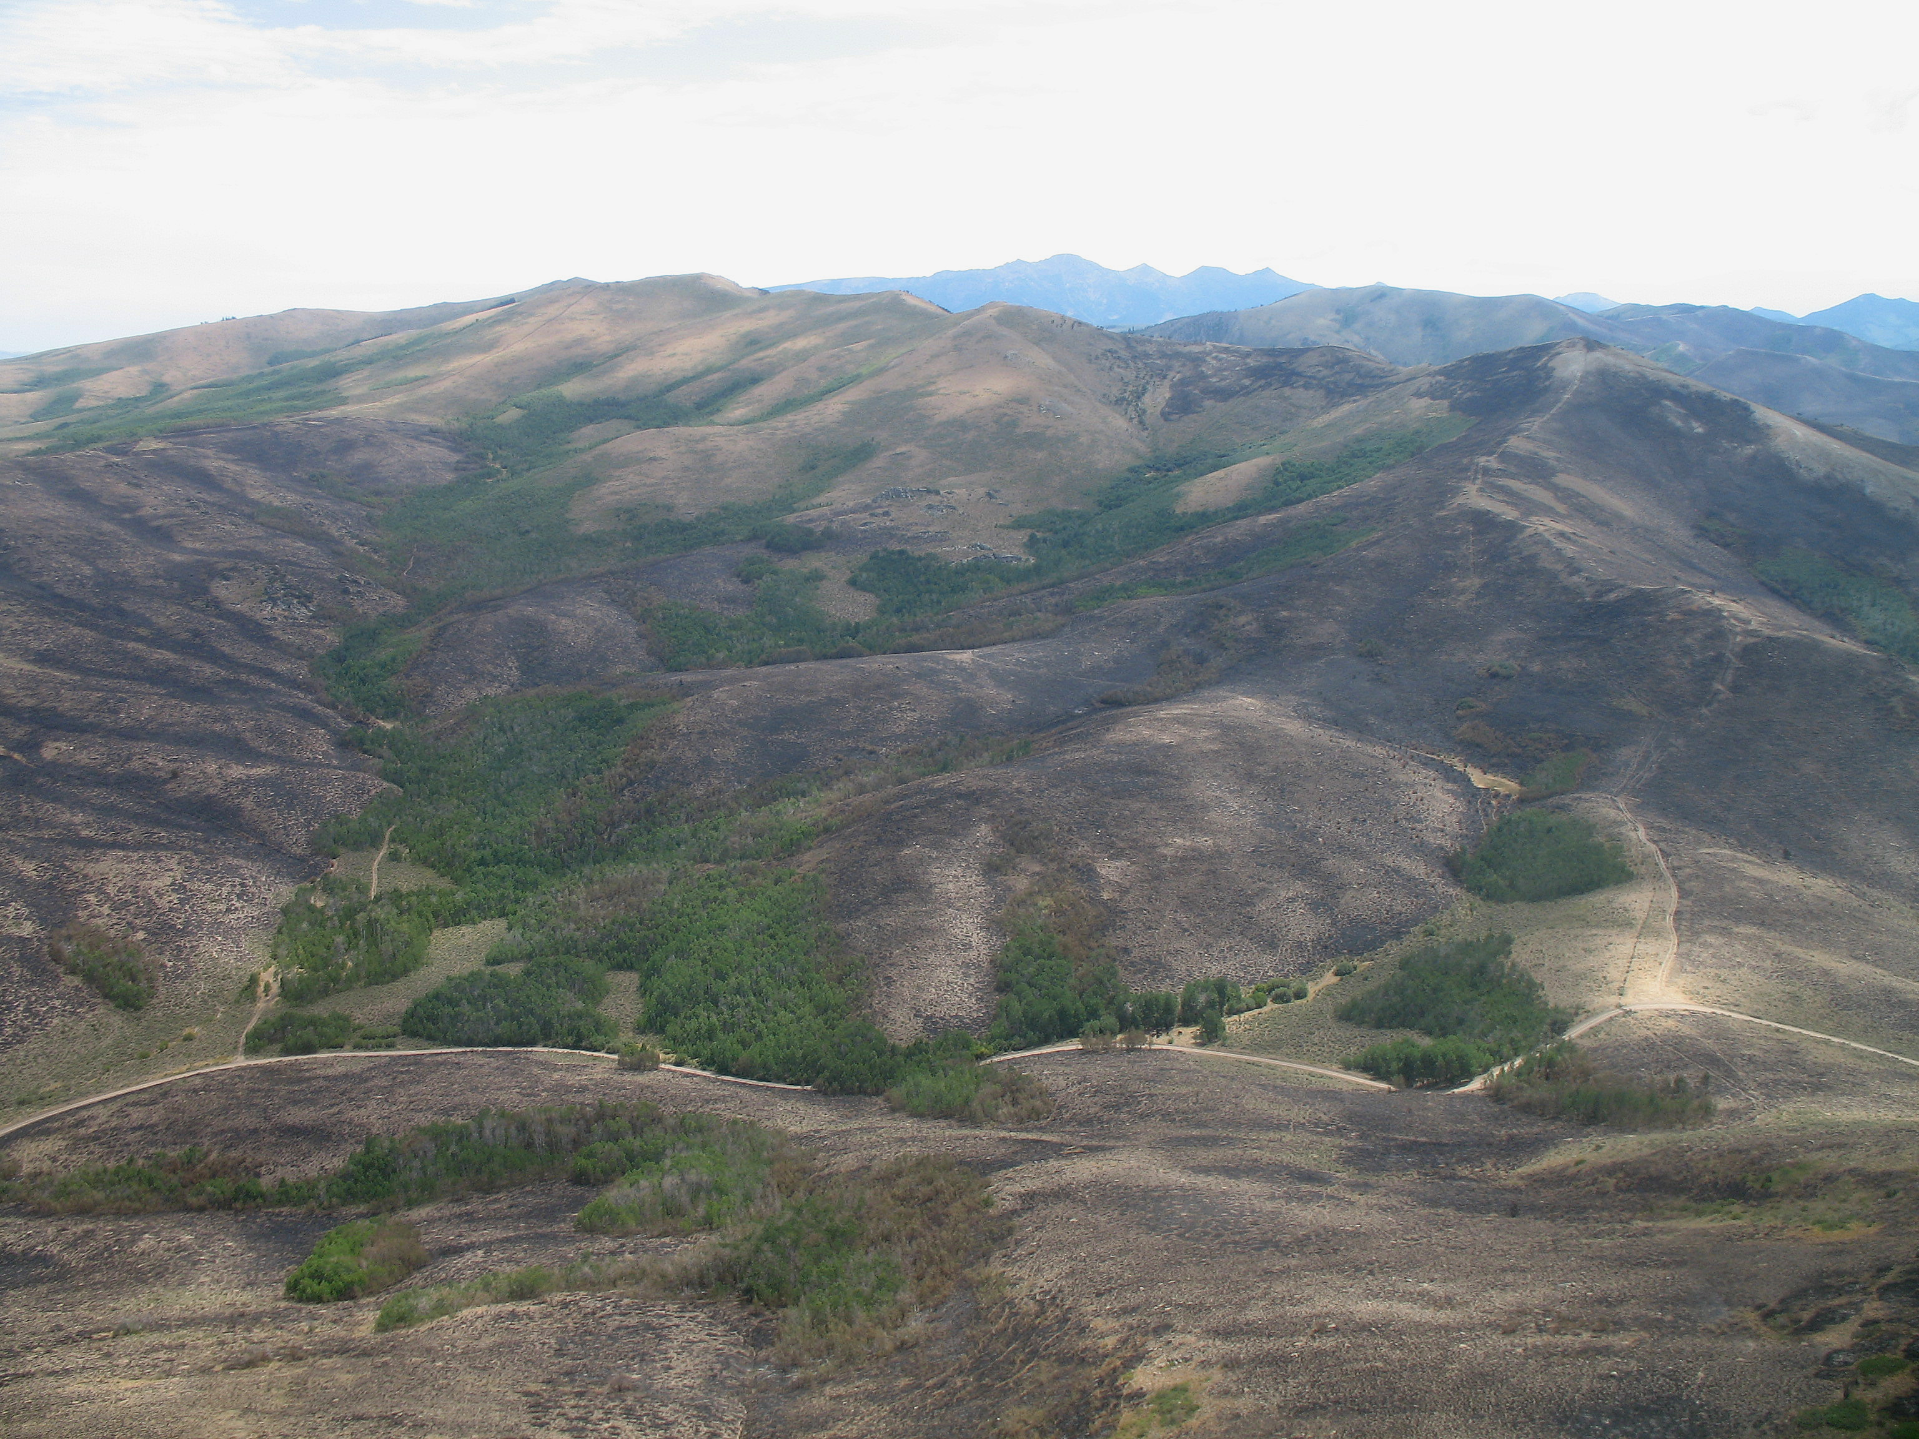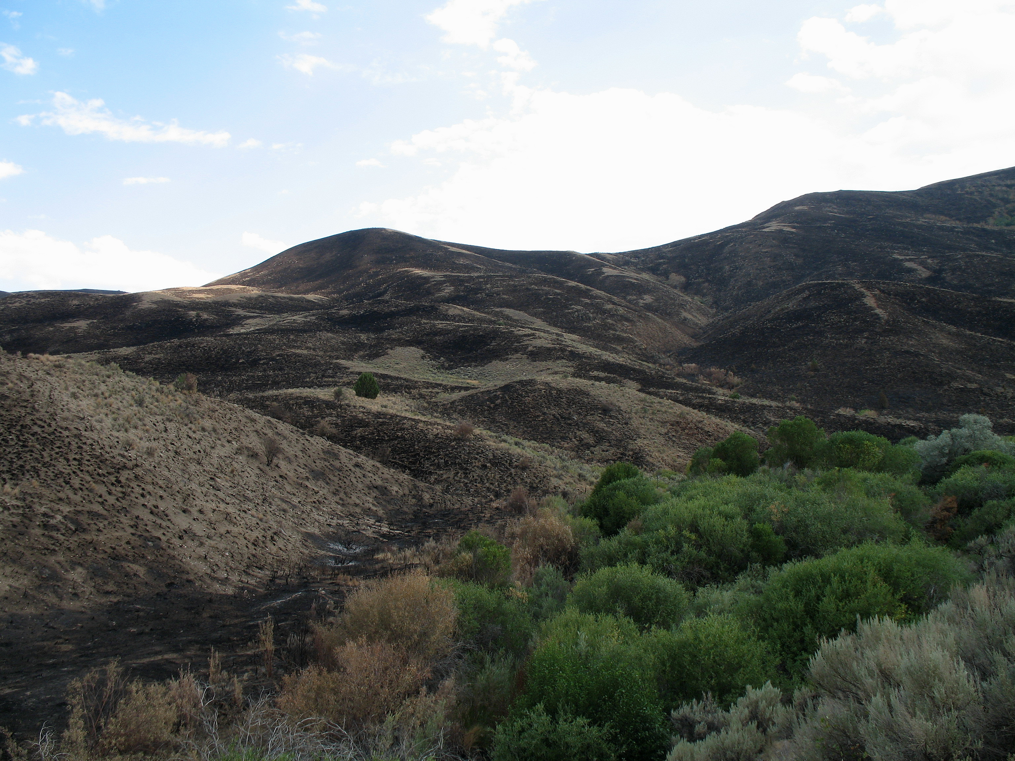

Mosaic of low soil burn severity with unburned along Mosaic of low soil burn severity and unburned areas
Road #751

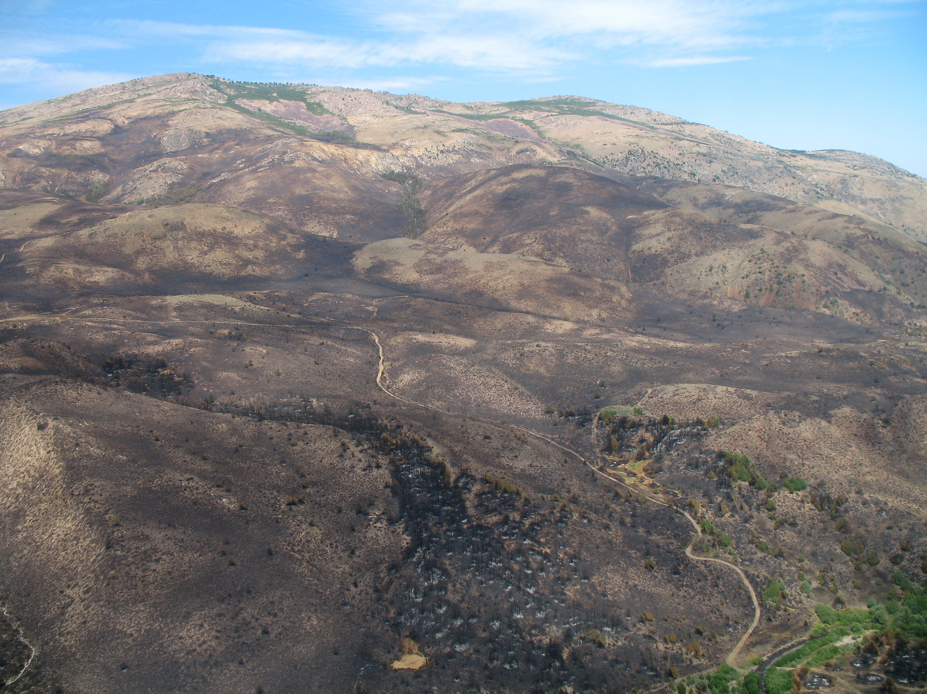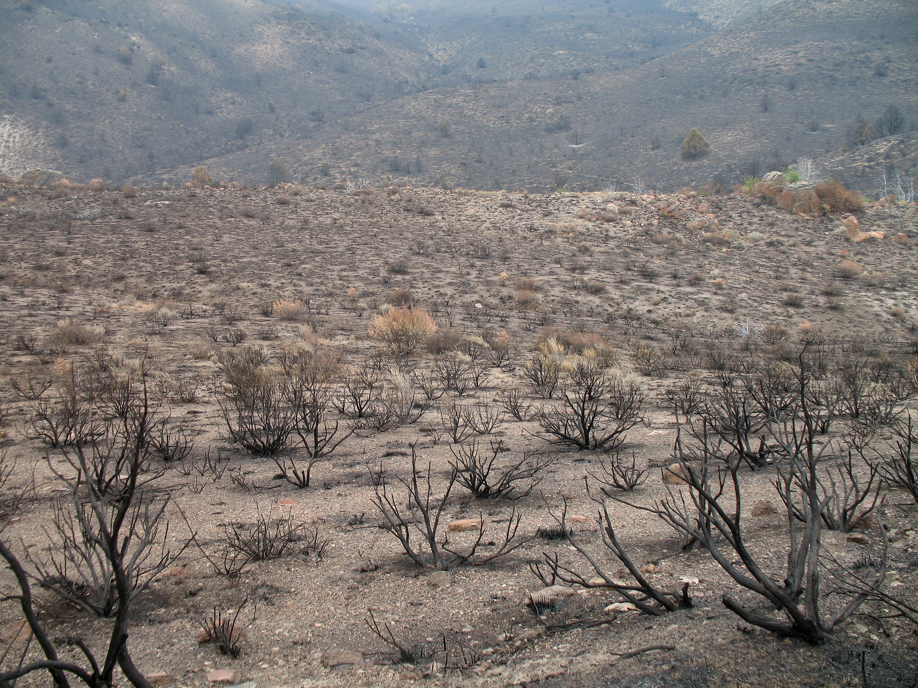

Mosaic of low and moderate soil burn severity High vegetation mortality and low soil burn severity

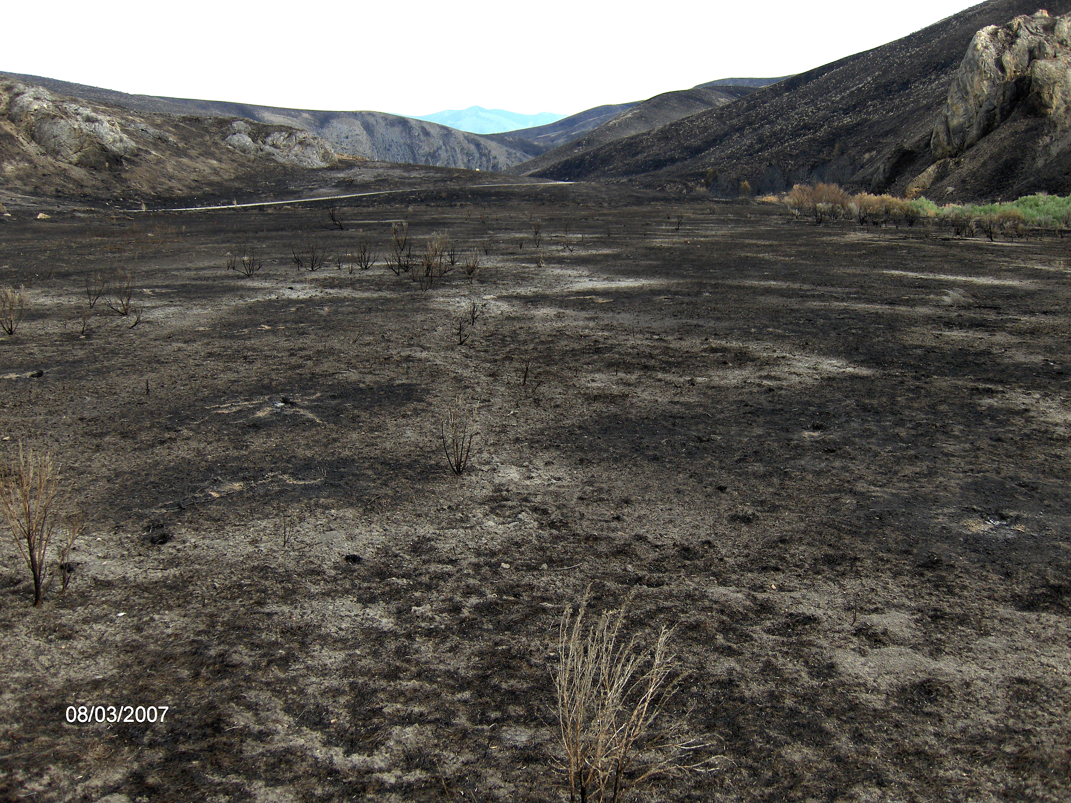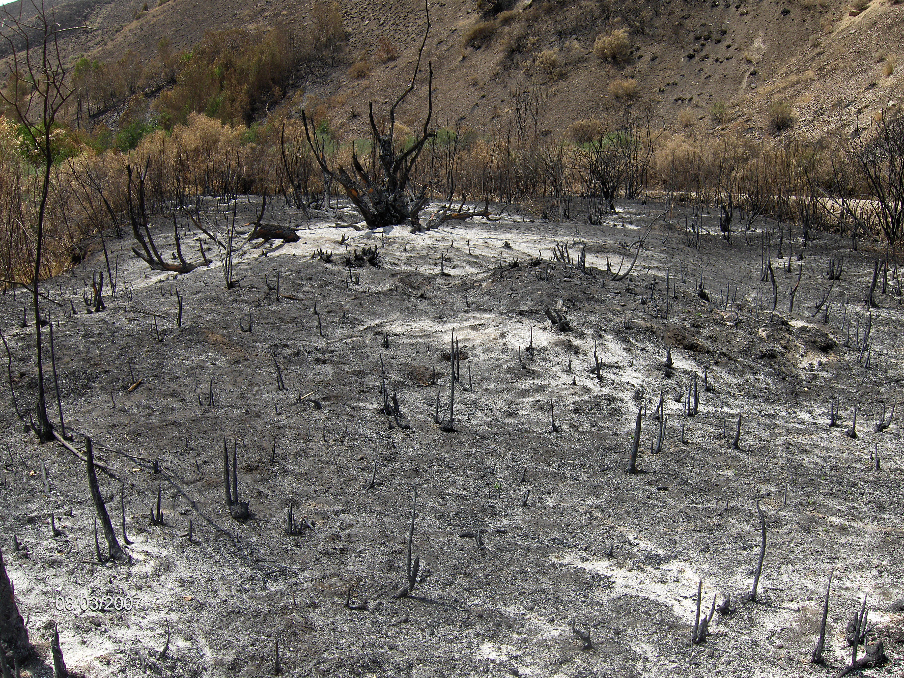

Low soil burn severity in upper Bruneau Canyon High soil burn severity and vegetation mortality on
Meadow Creek floodplain

