PHOTOS – SOIL AND WATERSHED

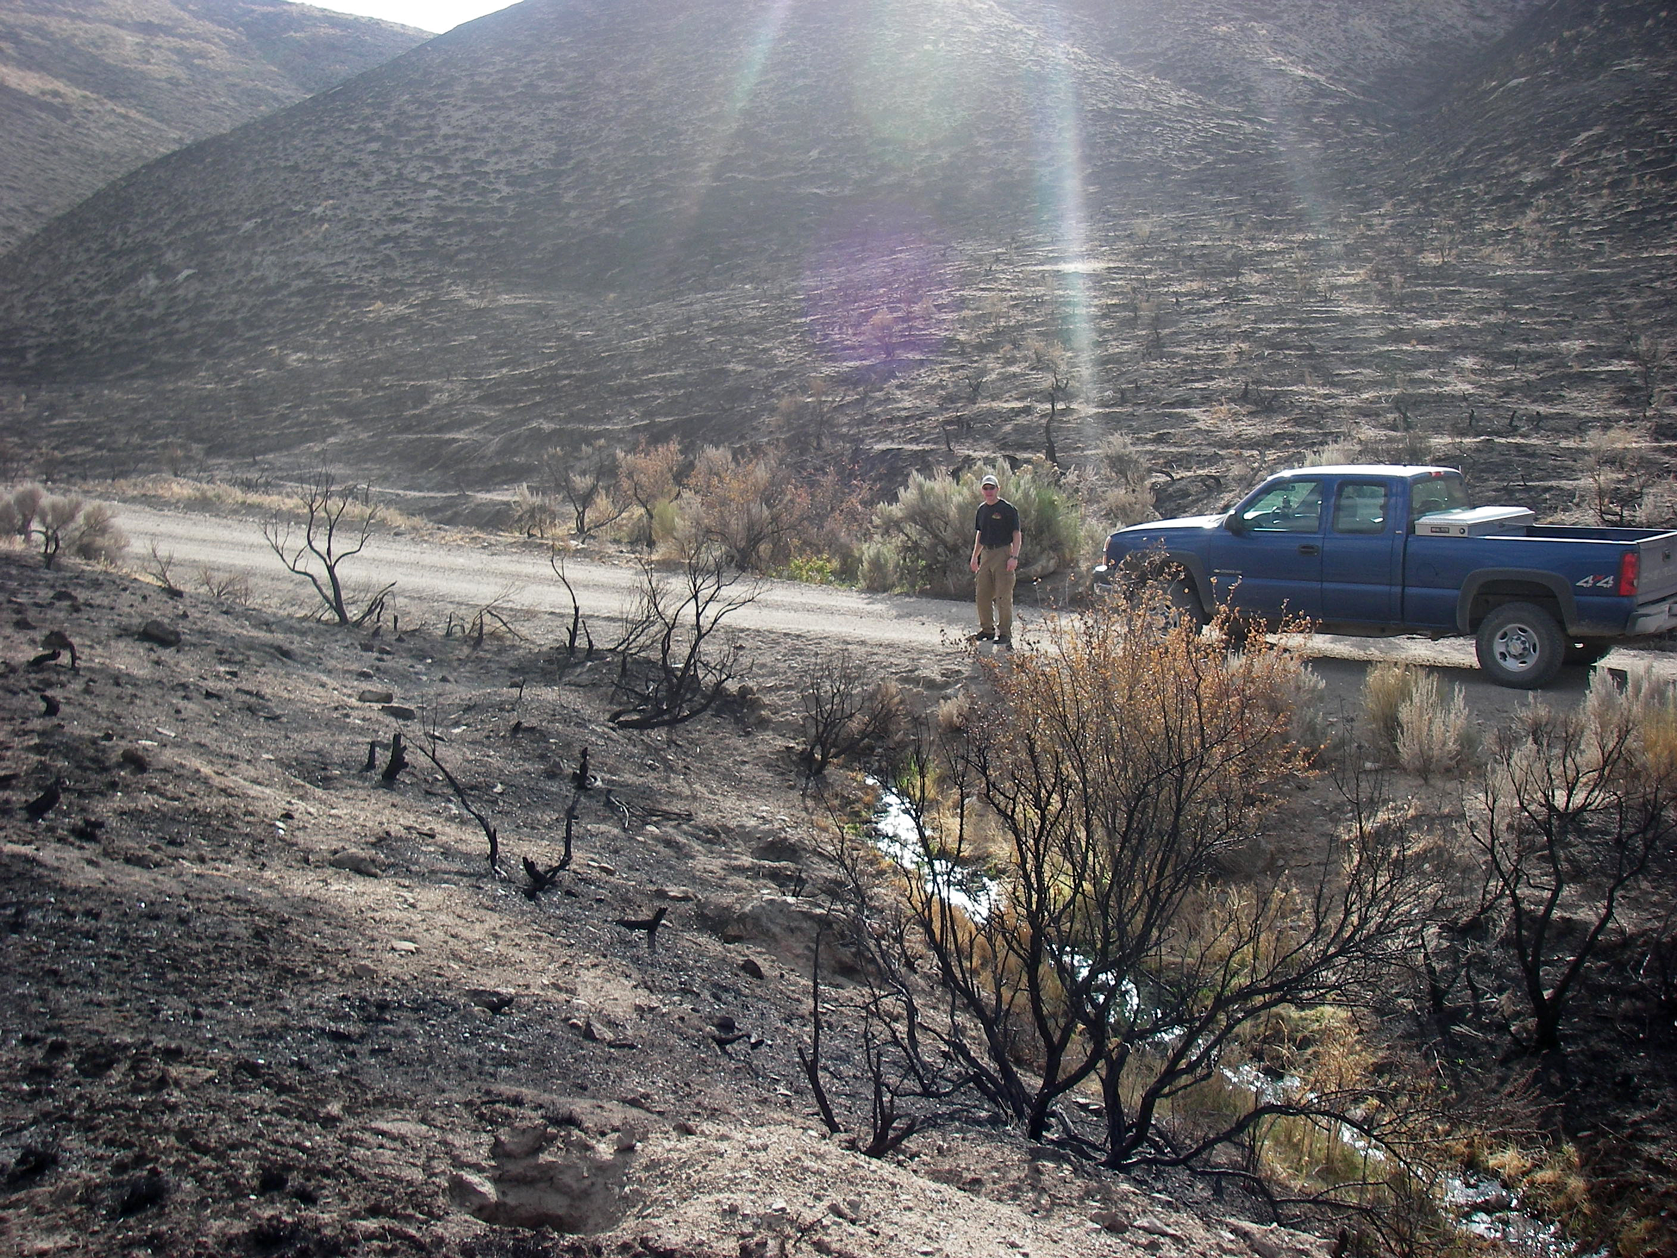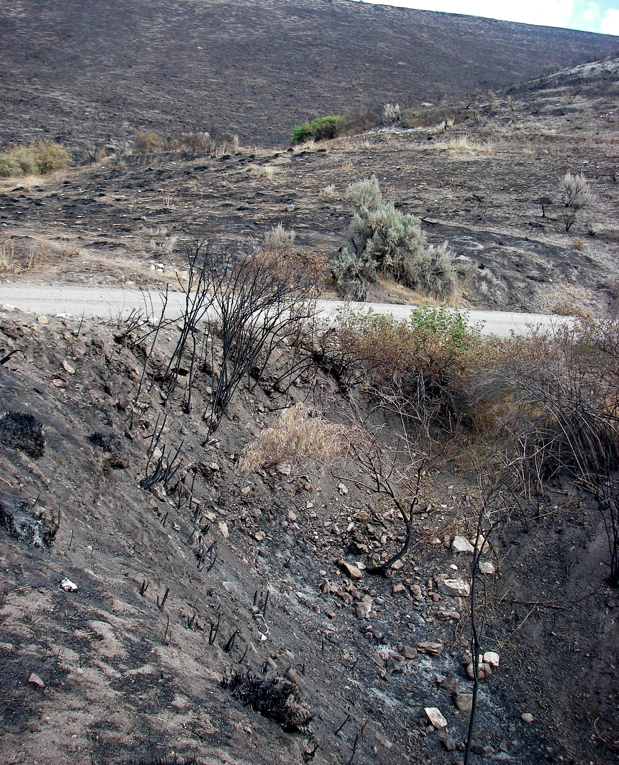

Road #751 stream crossing with plugged culvert (Treatment B) Road #751 headcut at mouth of tributary (Treatment B)
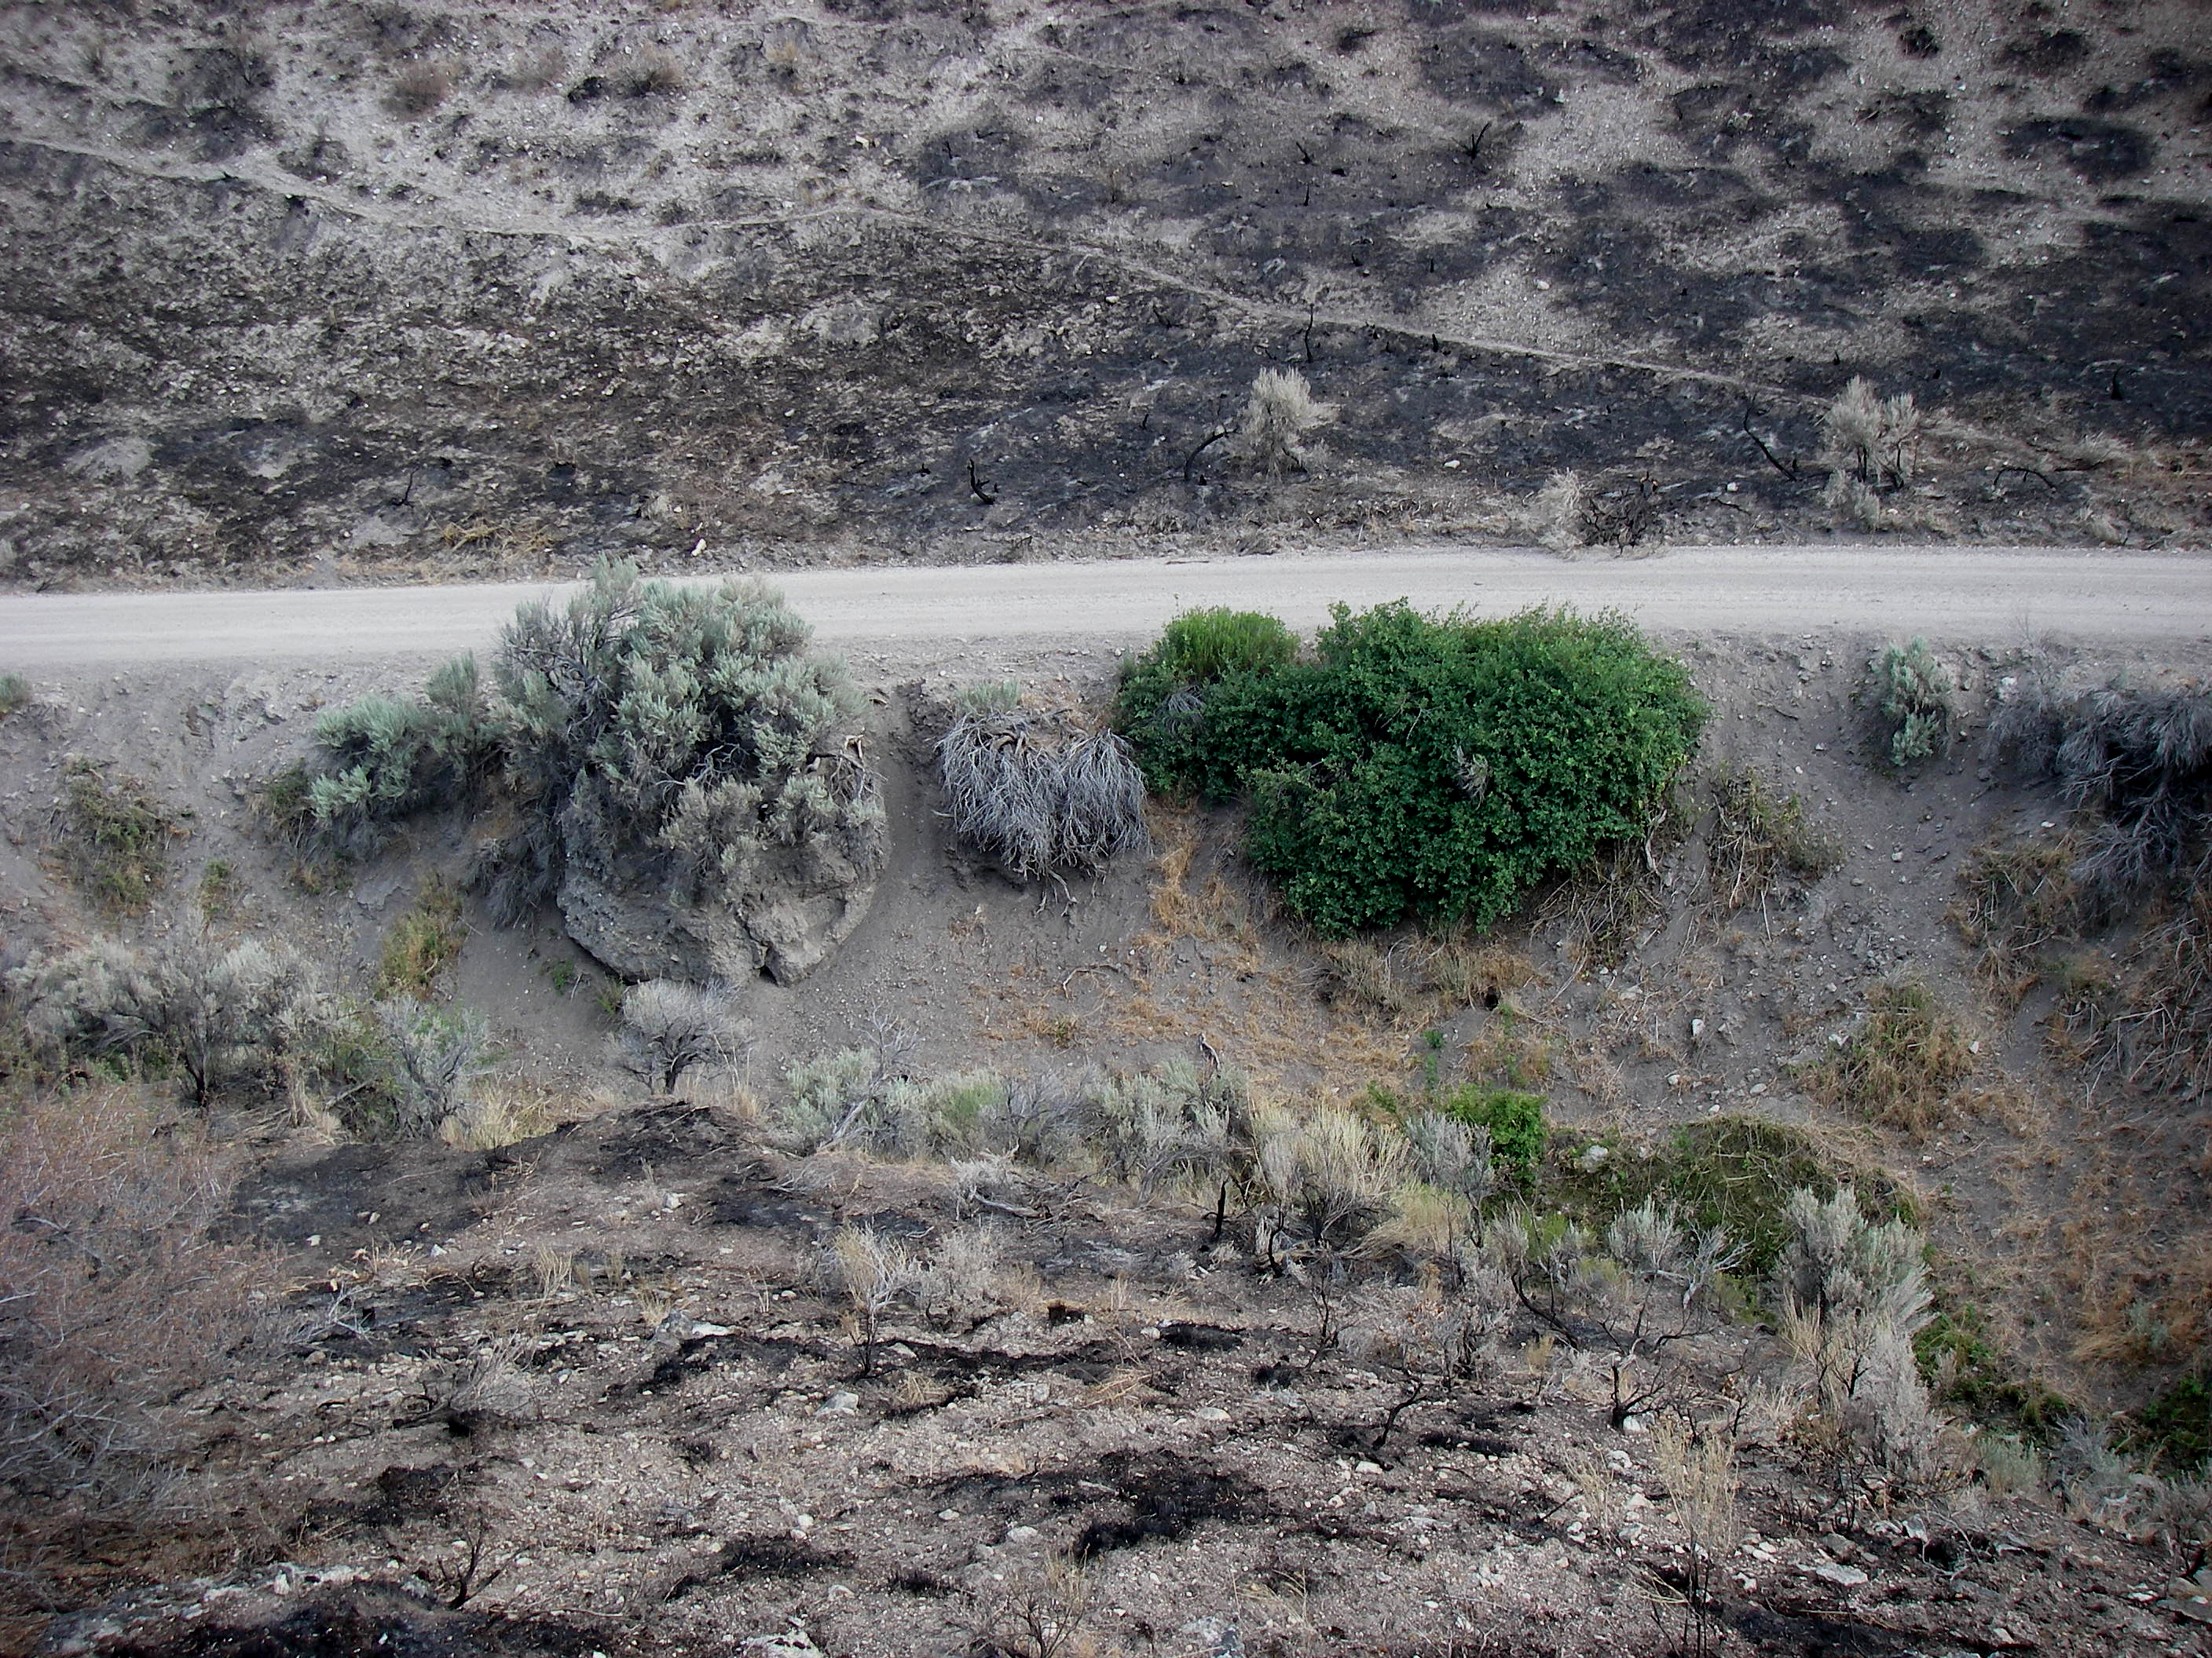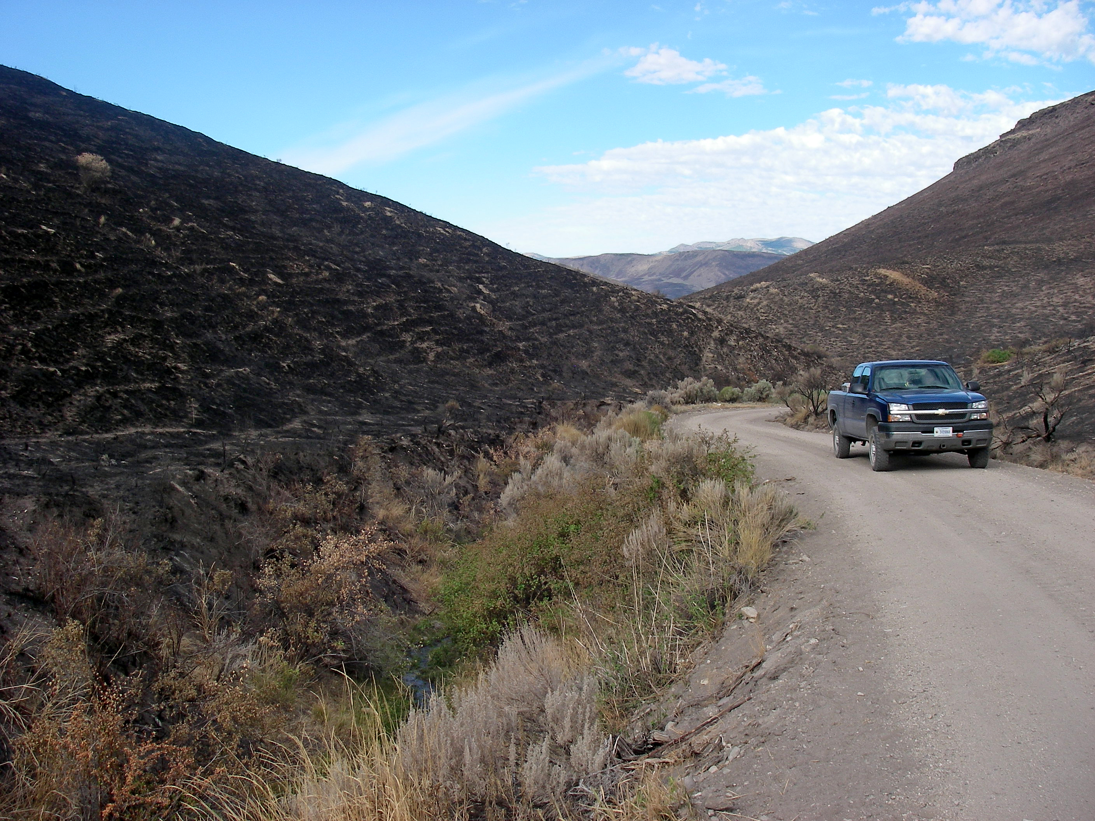

Road #751 downstream gully along road - 100 by 20 feet (Treatment A) Road #751 looking downstream at unstable section of gully along
road - 300 by 15 feet (Treatment A)

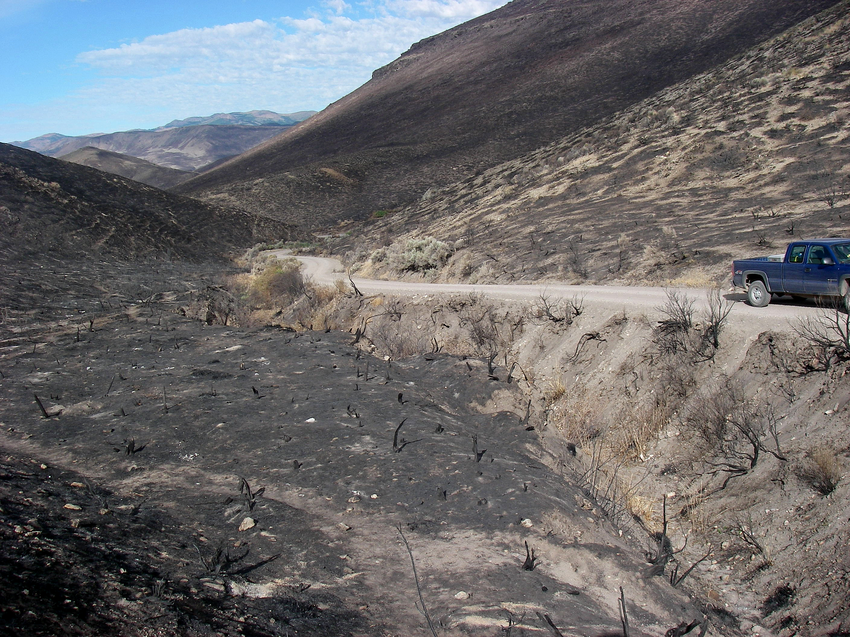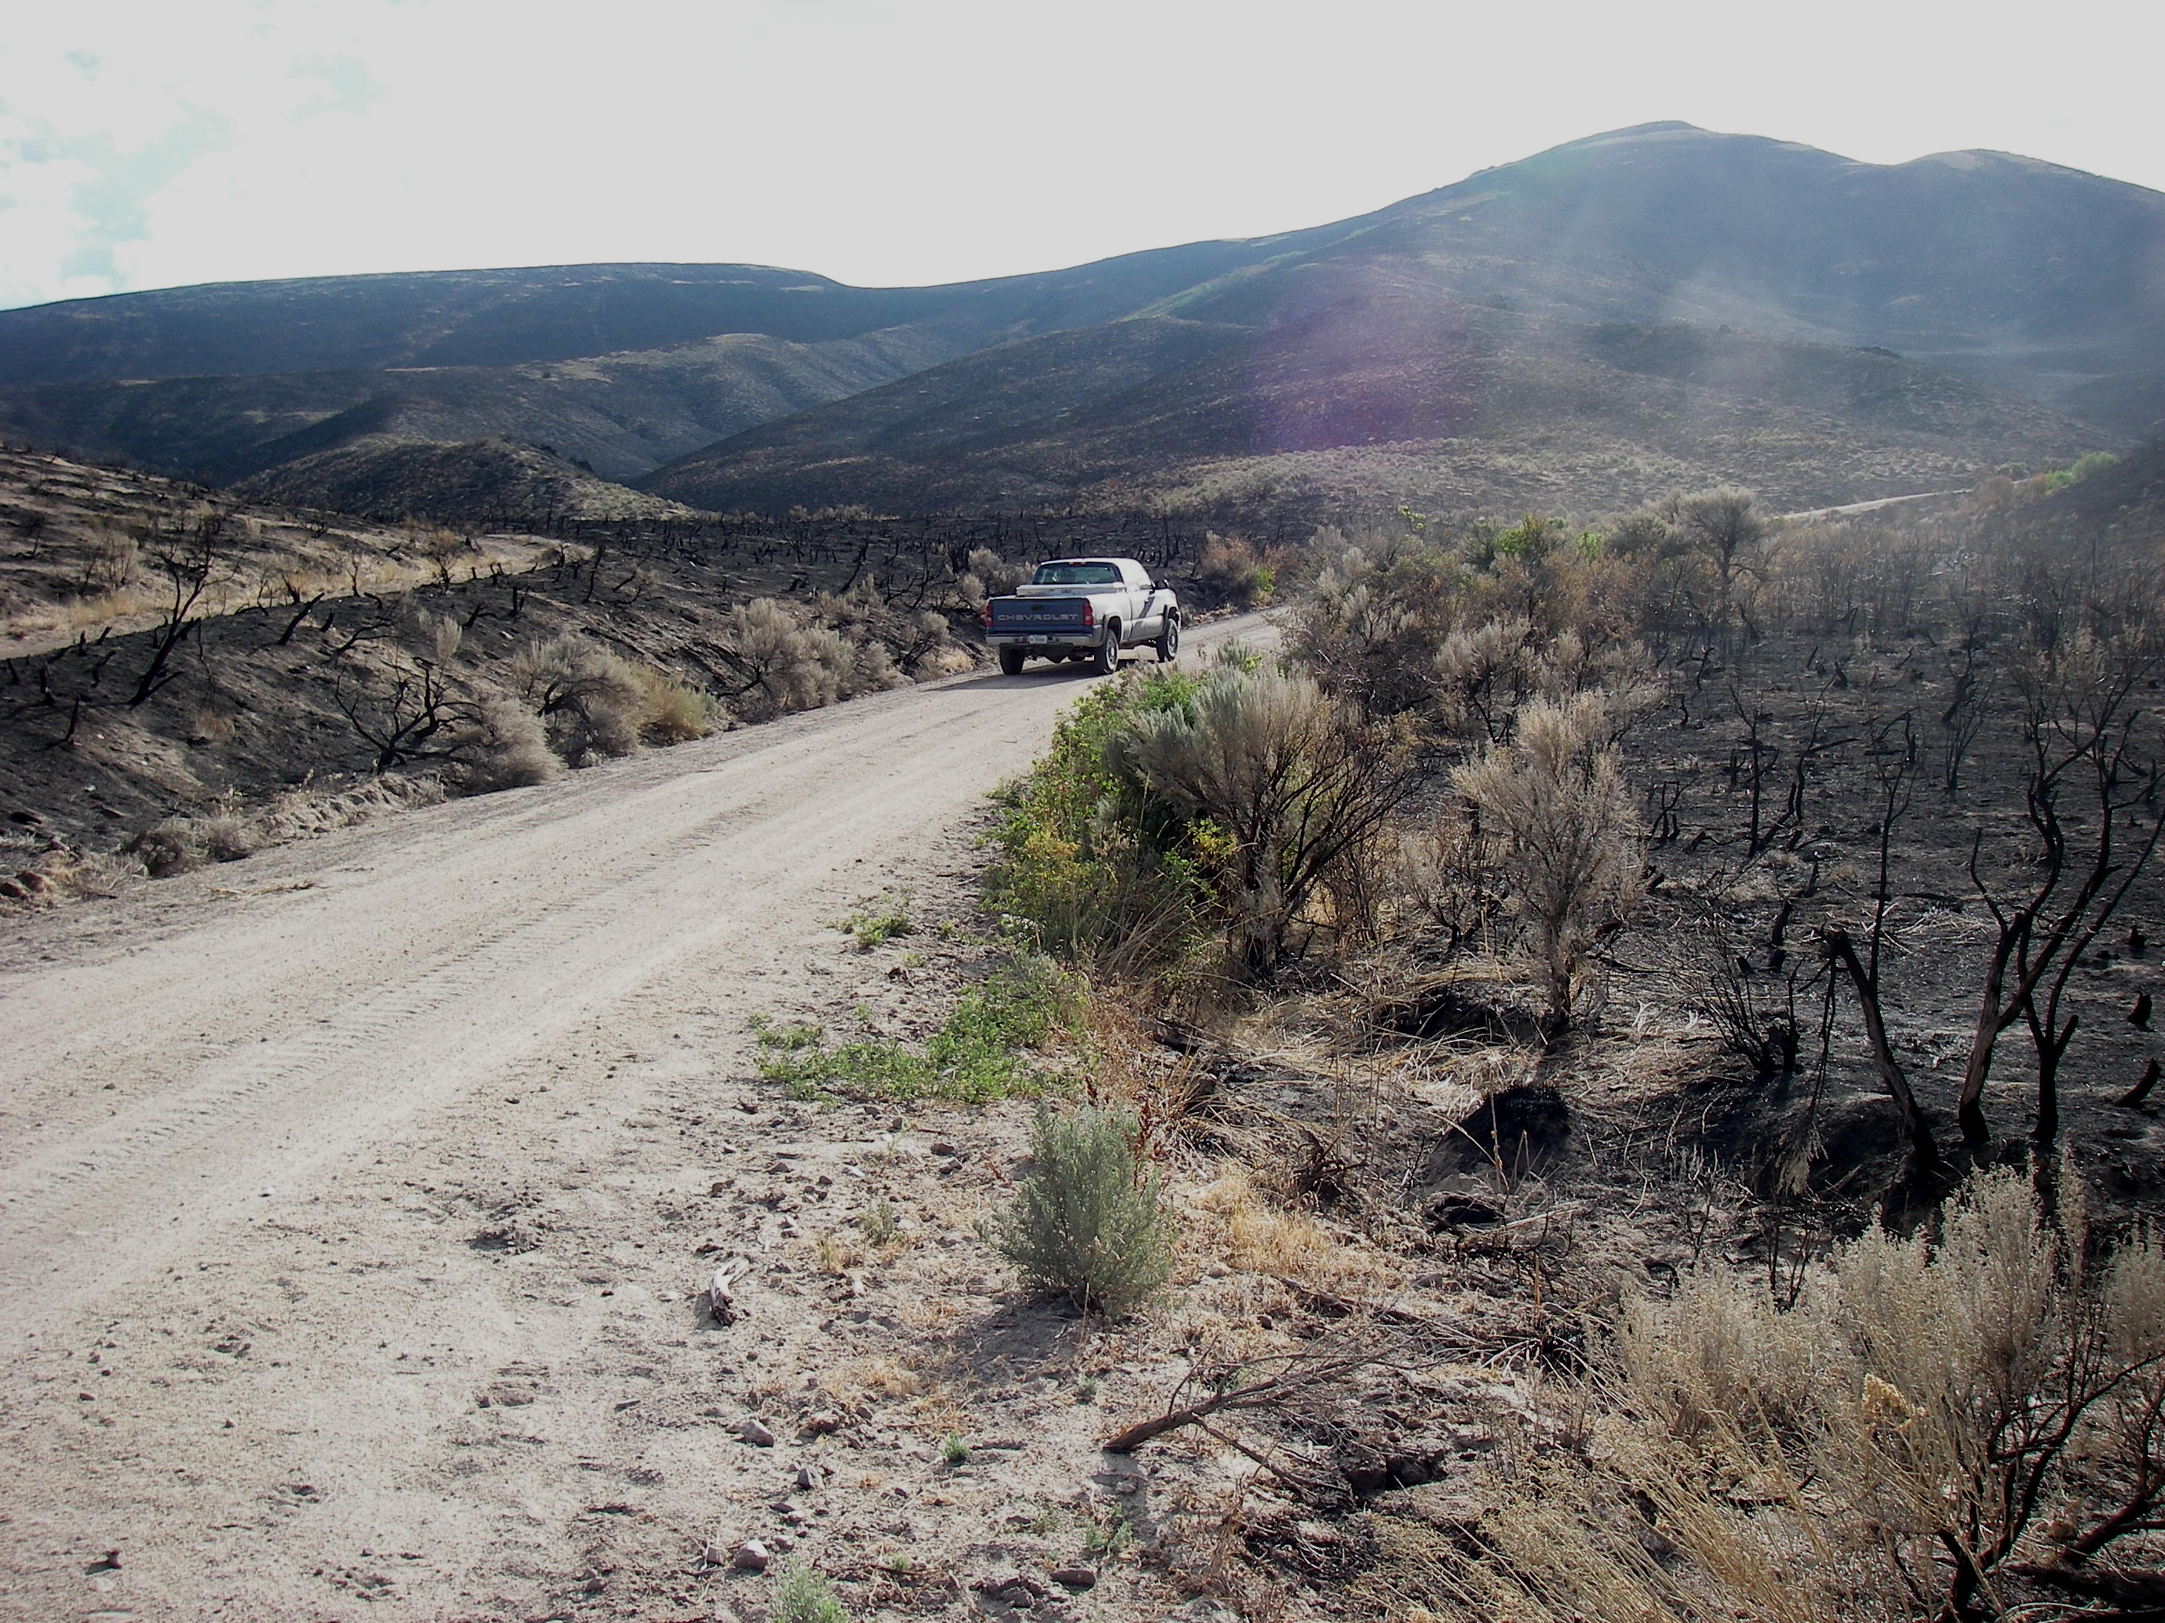

Road #751 looking downstream at 2nd section of unstable gully Road #751 looking upstream at tributary alluvial fan (Treatment B)
(Treatment A)

