PHOTOS – VEGETATION

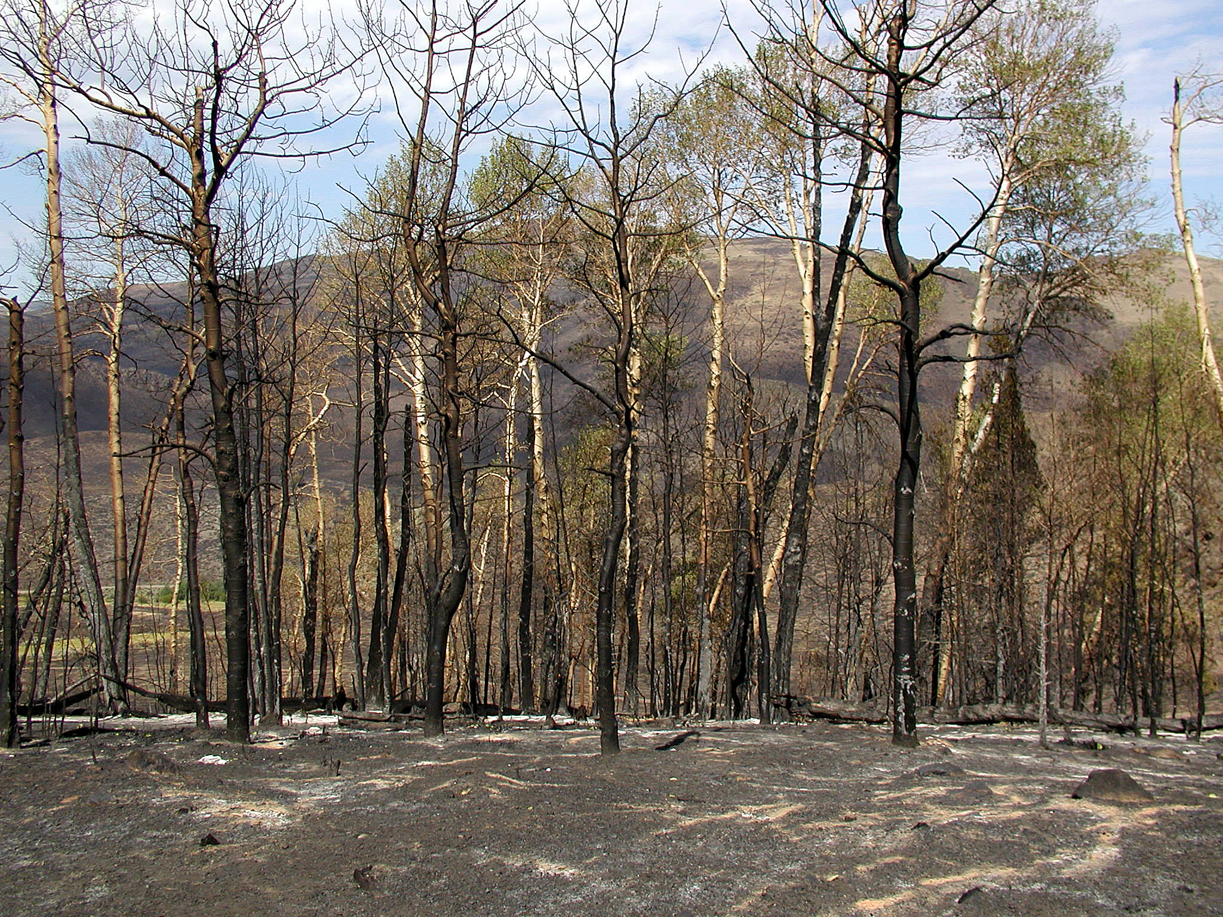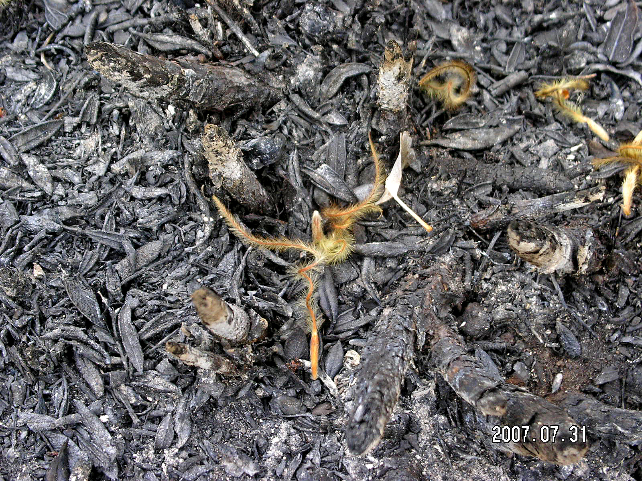

Aspen mortality Curlleaf mountain mahogany seeds

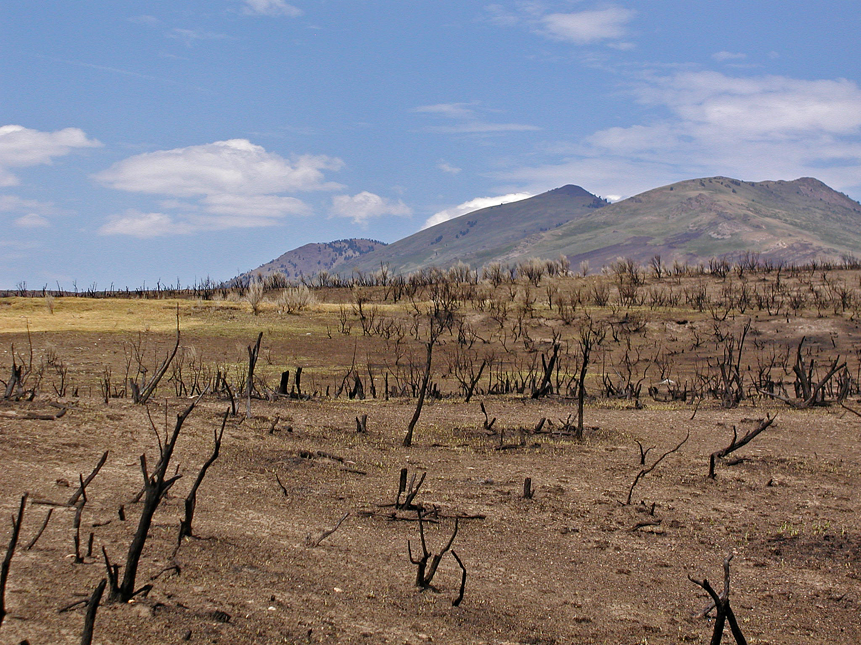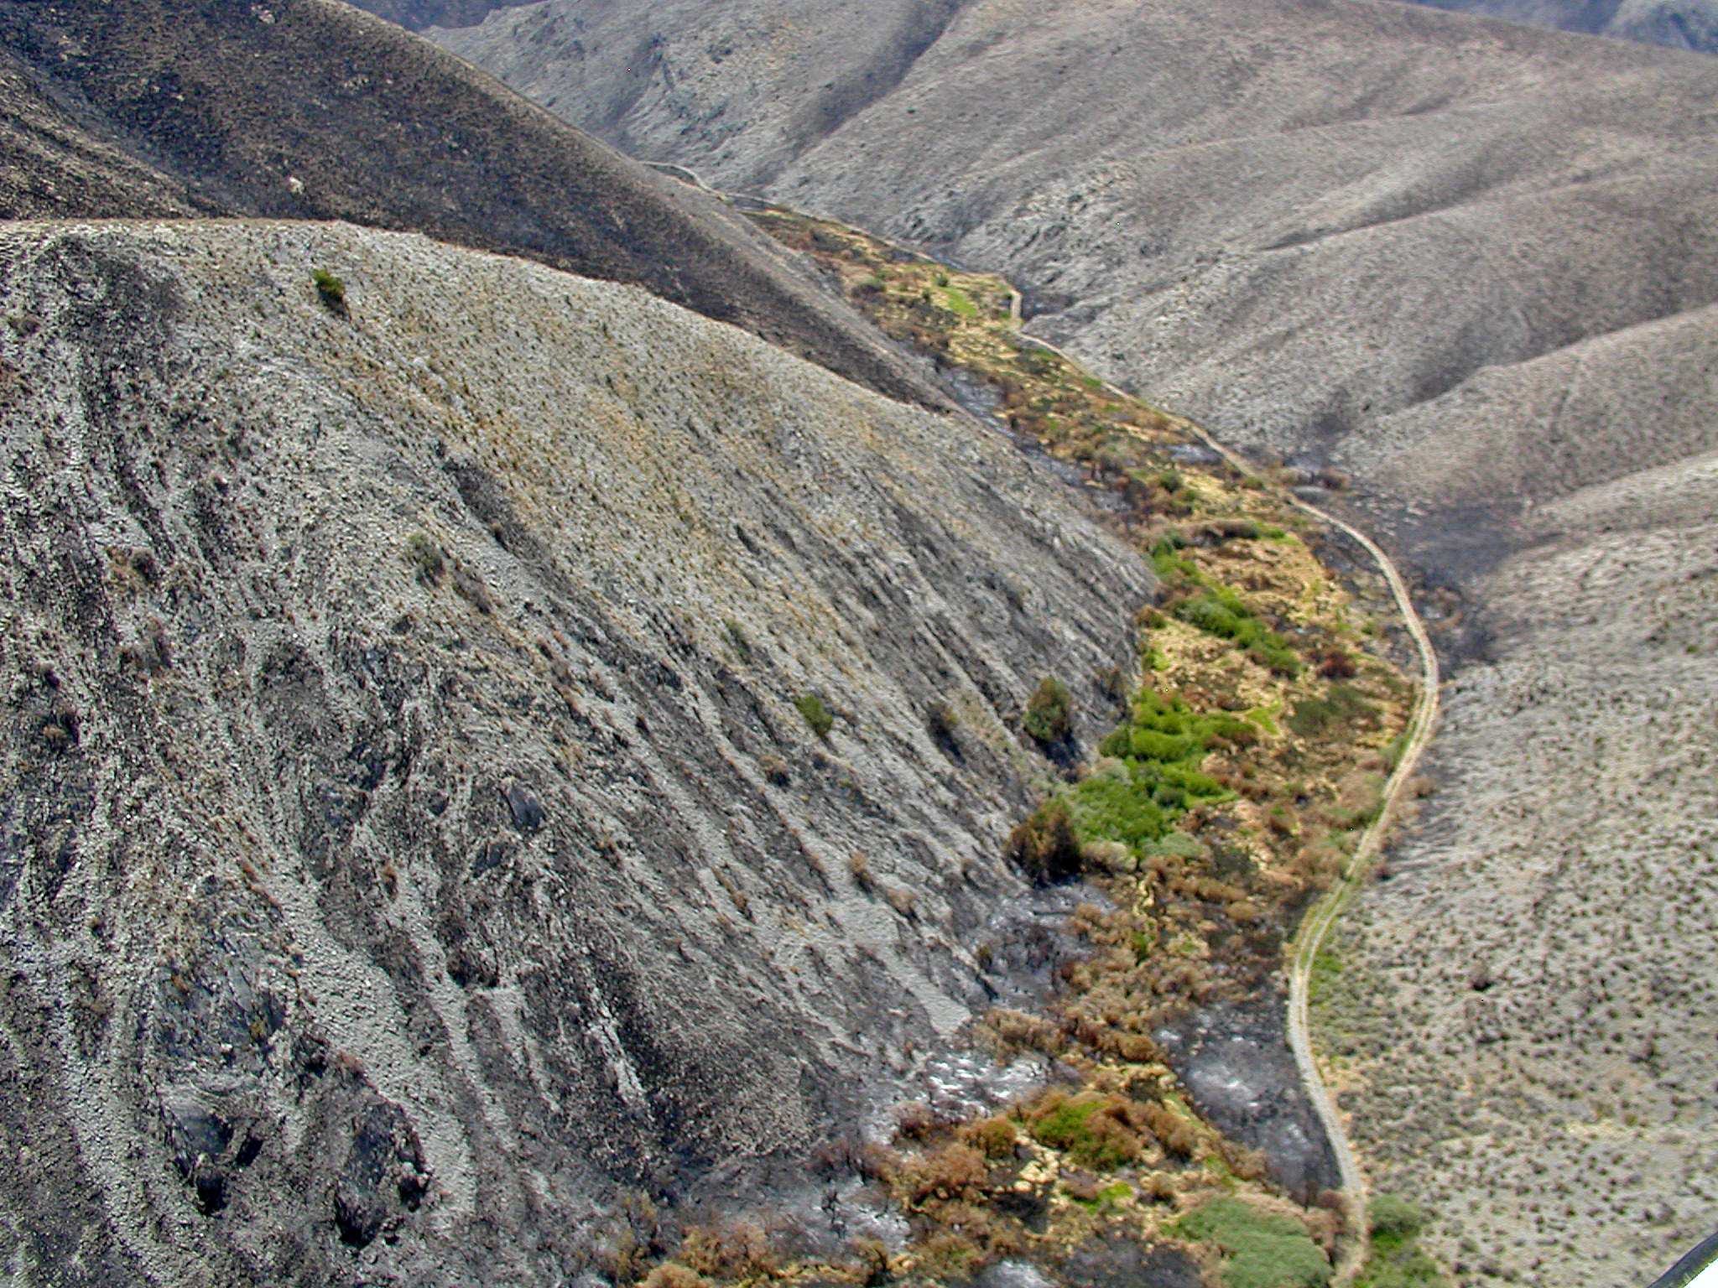

High sagebrush mortality with grass re-sprouts Mixed riparian and sagebrush mortality

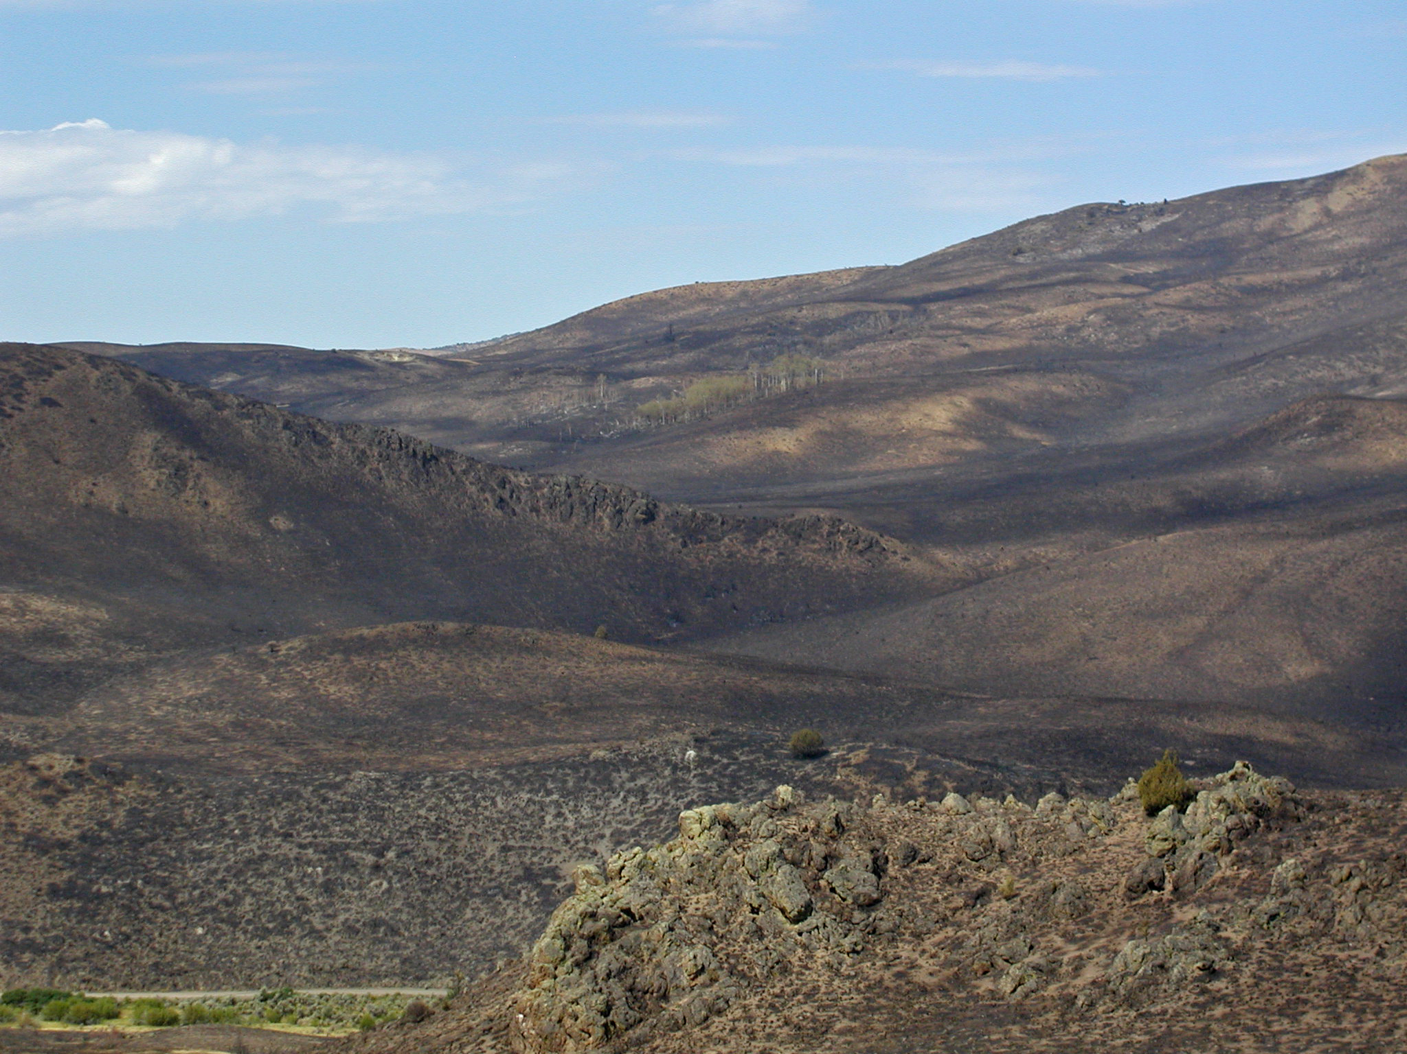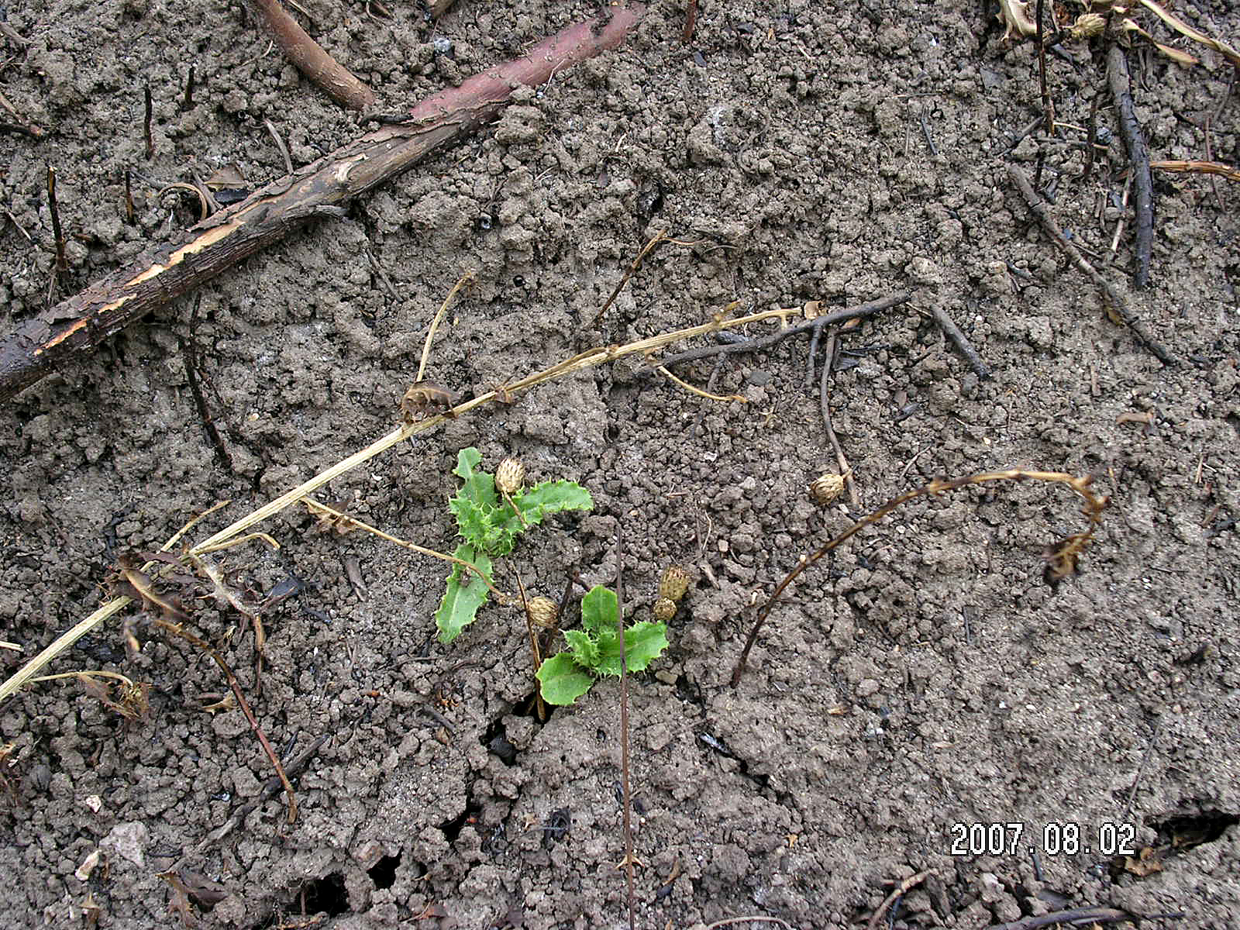

Mixed vegetation mortality Sprouting Canada thistle

