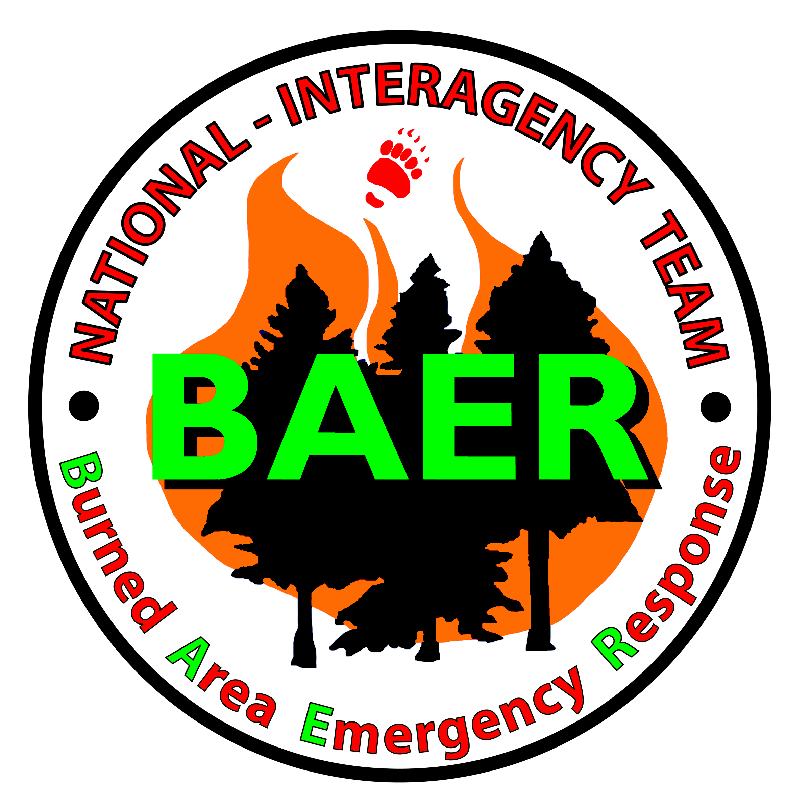
PRESS RELEASE
For Immediate Release

August 13, 2007

NATIONAL INTERAGENCY BURNED AREA EMERGENCY RESPONSE (BAER) TEAM
COMPLETES WORK ON THE MURPHY COMPLEX FIRE

The National Interagency Burned Area Emergency Response (BAER) Team arrived on the Murphy Complex Fire, Elko, NV, and began their fire assessments on Tuesday, July 31, 2007. The team’s primary mission was to assess potential threats to life, property, and critical cultural and natural resources as a result of the Murphy Complex Fire. The team assessed emergency stabilization needs for fire effects to both cultural and natural resources and infrastructure on Federal lands of the Humboldt-Toiyabe National Forest. In addition, the National BAER Team provided assistance to the Bureau of Land Management, Jarbidge Field Office BAER Team which was conducting assessments on BLM lands in Idaho on the Twin Falls District. Other agencies that worked in cooperation with the BAER Team included Nevada Division of Wildlife, Nevada Department of Forestry, and the Natural Resource Conservation Office. The Team also in conjunction with Forest Service personnel consulted with grazing permittees.

The fourteen team members represented the Bureau of Land Management, Bureau of Indian Affairs, National Park Service, and US Forest Service. The team was augmented by staff from the Humboldt-Toiyabe National Forest, Mountain City Ranger District. The disciplines on the team included: hydrologists, soil scientists, archeologists, wildlife biologist, vegetation specialist, forester, environmental compliance specialist, geographic information system specialists, and documentation specialists. The team was led by Erv Gasser, National Park Service, Seattle, Washington.

Due to burned vegetation and exposed soil on steep mountain slopes, there is a potential for increased runoff and soil erosion/sedimentation which results in several values at risk. There are numerous locations in the fire area that are at risk for potential flash floods, rock-fall and debris flows due to steep slopes and post fire runoff. Also, there have been road segments identified to have potential post-fire road surface drainage problems and /or undersized culverts unable to handle post-fire stream flows as a result of the anticipated increased runoff. One area that has already suffered storm damage is the Buneau River Road (067) creating threats to human health and safety because of the limited amount of areas to turn around as well as gullies and washouts which are hard to see especially at night. Public safety hazard signs have been installed on the north and south end of this road to inform the public of these hazards. The fire damaged Hicks Summit Bridge on FS road 745 has been replaced with a low water crossing in an effort to ensure public safety in this area. The public is asked to use caution in the Murphy Complex Fire area, and watch for falling rock, flash floods, and washouts.

Other emergency stabilization treatments identified that will be implemented on the ground include stream bank and road stabilization measures, post storm road patrol and maintenance, inspection and maintenance of culverts and bridges, cultural resource consultation, safety sign placement, fence replacement, and noxious weed monitoring and control. The primary objectives of the emergency stabilization treatments contained in the BAER Plan are to protect life and property, and further reduce resource damage caused by flooding as a direct result of the fire.

The completed Emergency Stabilization Plan covers the area within and down drainage from the fire on Forest Service and adjacent lands. The treatments included in the plan will now be implemented within one year and may be monitored for up to three years.

Contact: USFS Mountain City Ranger District – (775)738-5171

