BURNED AREA EMERGENCY STABILIZATION PLAN

NEOLA NORTH FIRE

AGENCY/UNIT: Bureau of Indian Affairs
USFS, Ashley National Forest

LOCATION: Neola, Utah

DATE: July 20, 2007

PREPARED BY: National-Interagency Burned Area Emergency Response Team (Gasser)

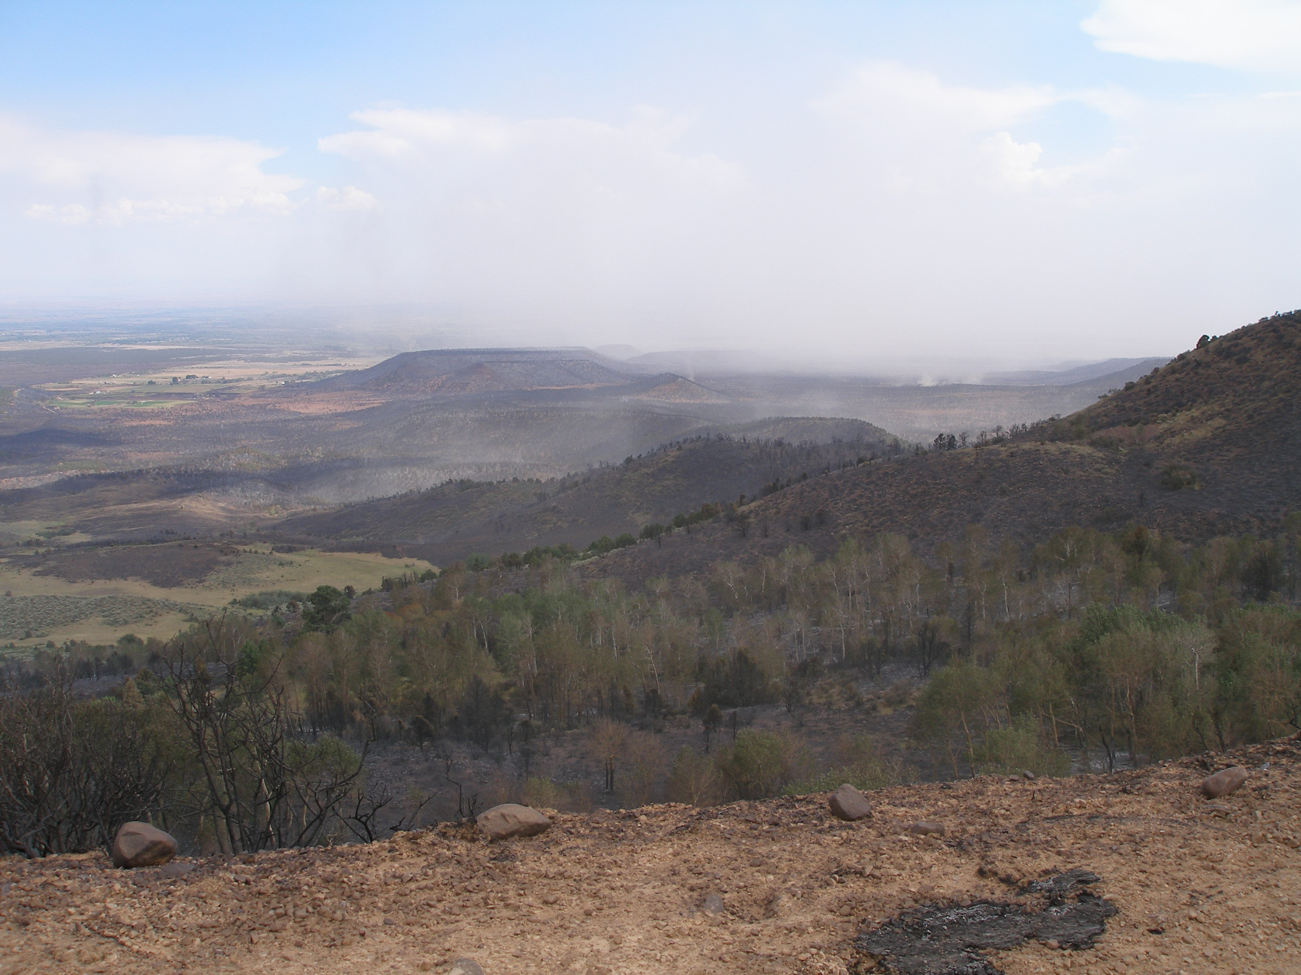

Submitted By: ____________________________________________________________________
Erv Gasser, DOI, BAER Team Leader, USDI National Park Service

