BAER TEAM
JULY 2007

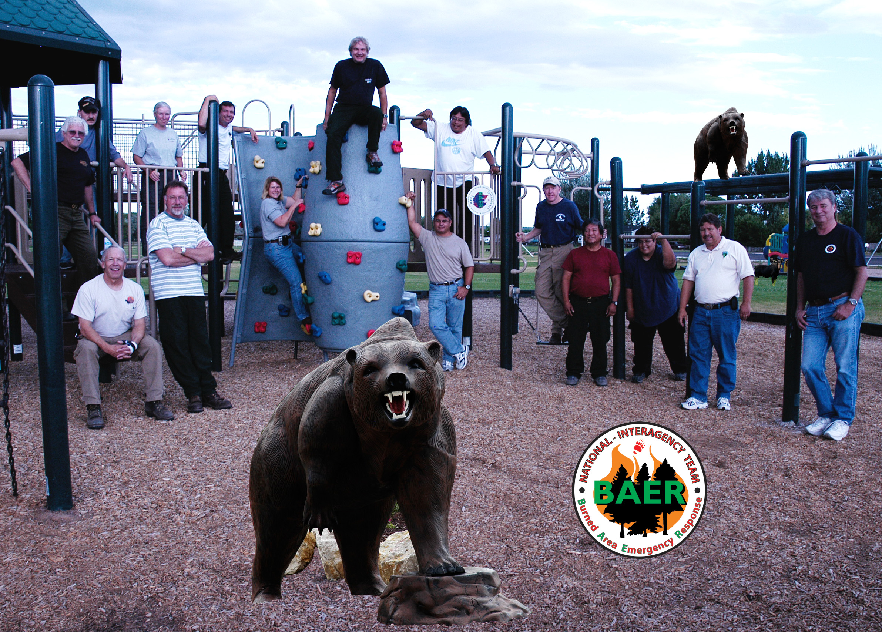
NEOLA NORTH FIRE

