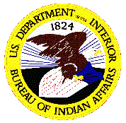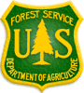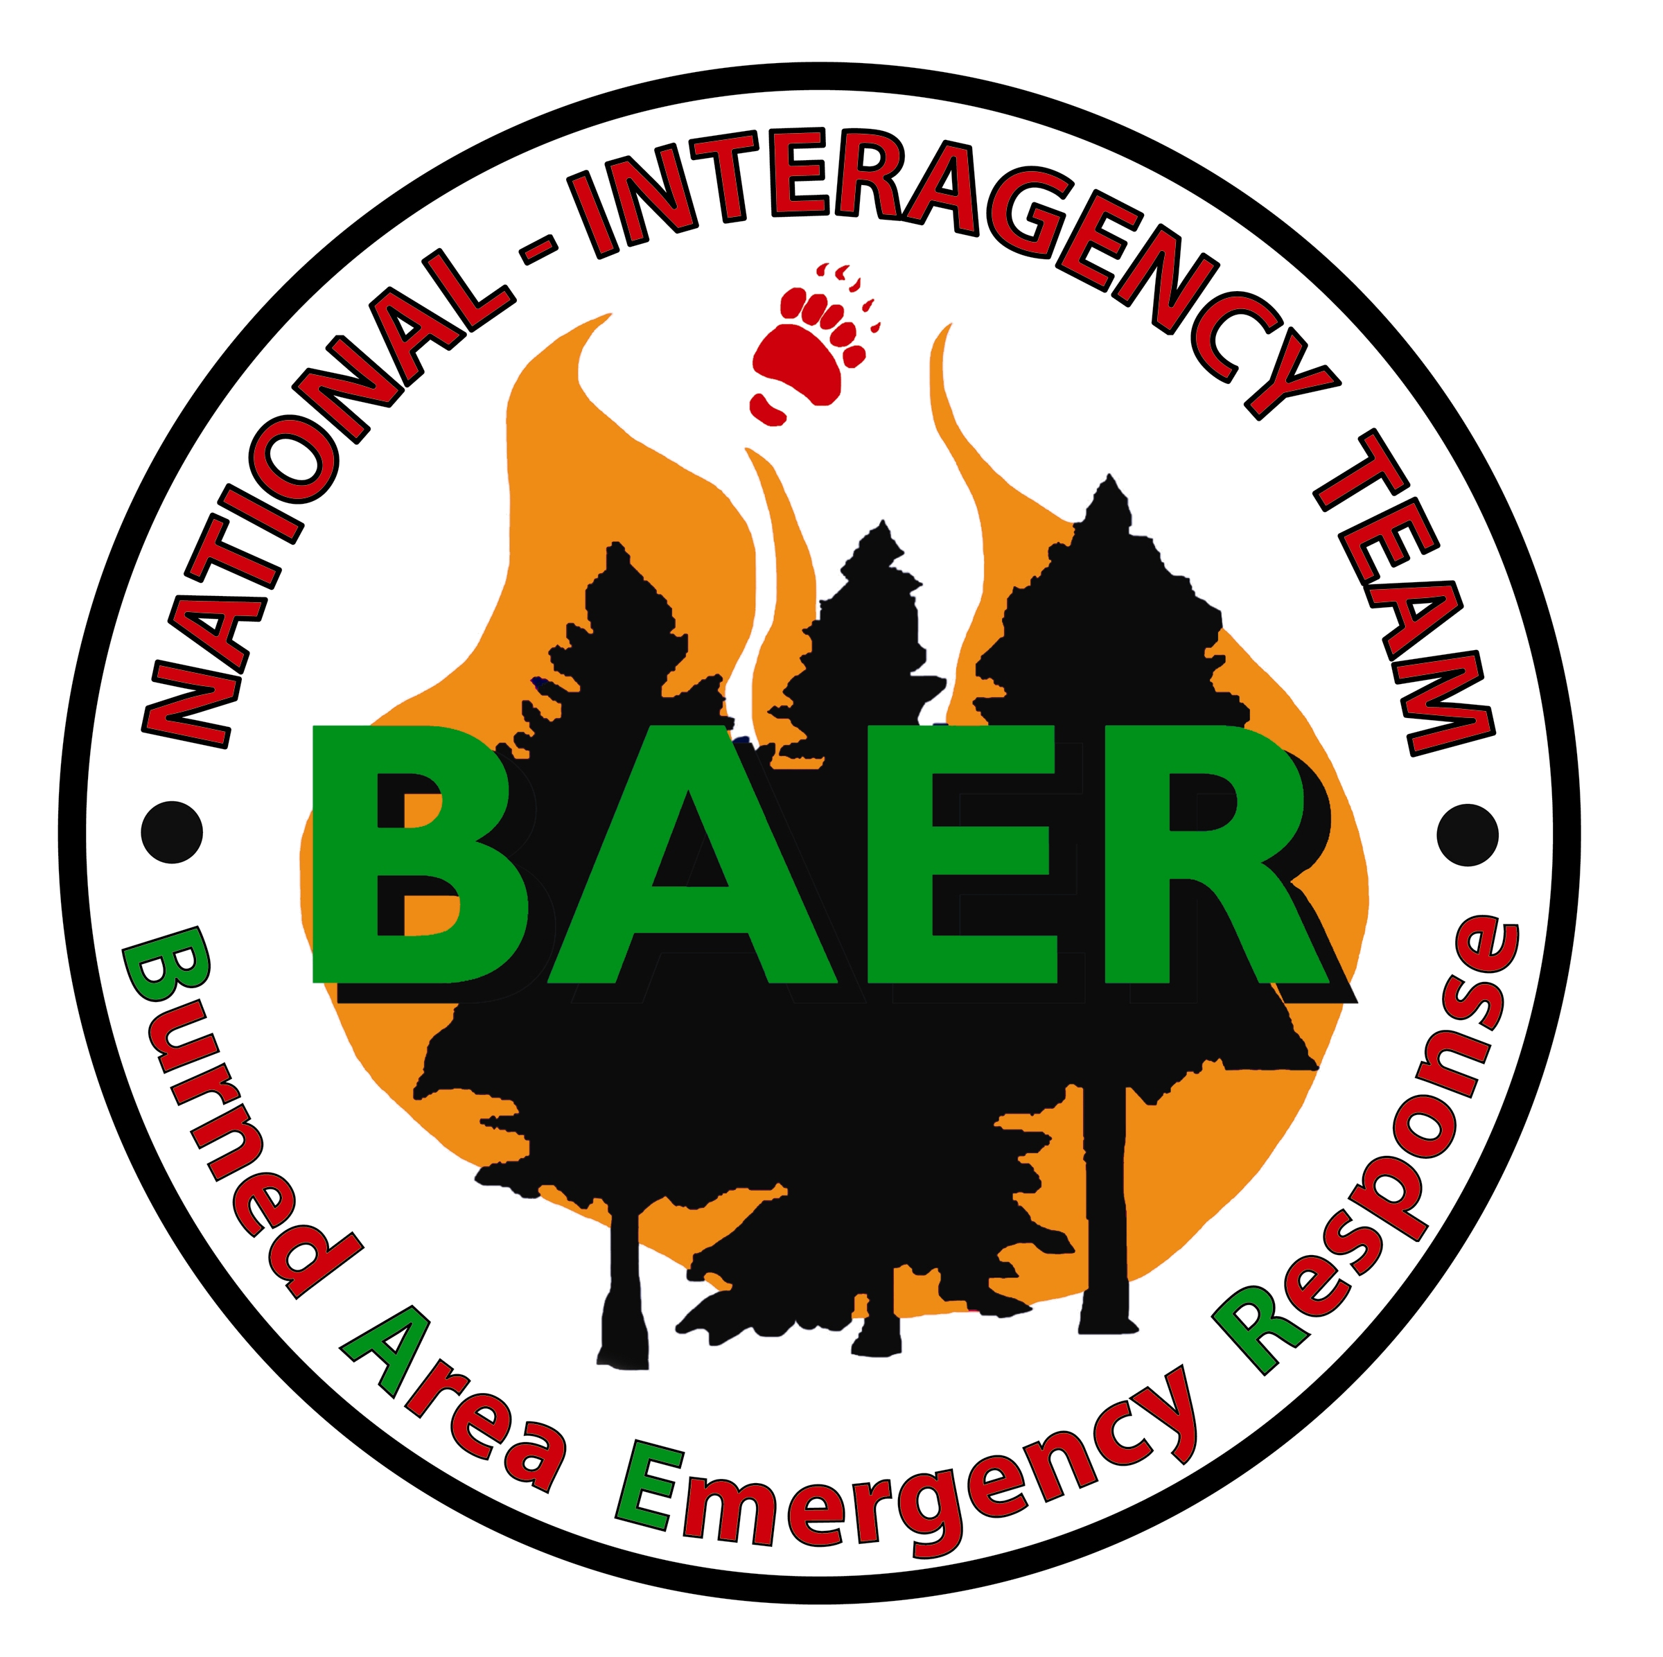

Neola North Fire

Bureau of Indian Affairs, Uintah and Ouray Agency
USDA Forest Service, Ashley National Forest
Ute Indian Tribe

National Interagency Burned Area Emergency Response Team
Close-Out Briefing
July 20, 2007 @ 10:00 am

Ute Indian Tribal Auditorium
Ft. Duchesne, Utah

Agenda

Welcome
Introduction |  | Darryl Martinez, BIA
Resource Assessments:
 | Operations | Gavin Lovell, BLM
 | Vegetation/Range | Dave Borland, BLM
 | Soil & Watershed | Becca Smith, USFS/BLM
 | Cultural | Dan Hall, BIA
 | Wildlife | John Henderson, BLM
Questions |  | All
Plan Status, Approval, Action Items |  | Erv Gasser, NPS
Closing Remarks
Tom

