PART F - INDIVIDUAL TREATMENT SPECIFICATION

TREATMENT/ACTIVITY NAME | Construct Asphalt Water Bar | PART E  FWS Spec-# | 13 FWS Construct Asphalt Water Bar
NFPORS TREATMENT CATEGORY* | Roads | FISCAL YEAR(S)  (list each year): | 2008
NFPORS TREATMENT TYPE * | Structure | WUI? Y / N | N
IMPACTED COMMUNITIES AT RISK | San Diego National Wildlife Refuge | IMPACTED T&E SPECIES | N
* See NFPORS Restoration & Rehabilitation module - Edit Treatment screen for applicable entries.

WORK TO BE DONE (describe or attach exact specifications of work to be done):
A. General Description: Water bars placed cross slope on a paved out-sloped single lane road used for access to F&WS property and multi-communication towers. Water bars are equivalent to 15 mph speed bumps extending to cut slope of the road and extending to the edge of the outside road slope. A 4 foot water bar (Spur) is installed 8 feet uphill of main water bar to reduce concentrated flow from the cut bank side of the road. Asphalt pad (Outlet) installed as a stable outlet for concentrated flow, from the water bar, across the earth road shoulder. Water bars on the asphalt roadway shall be painted white for safety. .

B. Location/(Suitable) Sites: Five sites on Millar Ranch Road, the nearest cross street is Campo Road, south of Jamacha Junction. See maps and GPS reference coordinates.

C. Design/Construction Specifications:

- Single asphalt bump is to be constructed parabolic in shape, covering 3 feet of street (width) with a height between 3 ¼ and 3 ¾ inches.
- Length to extend from cut bank to 6 inches past the top edge of fill slope set at an approximate 30 degree angle downhill from a line perpendicular to the road.
- Spur shall be constructed similar to asphalt bump on cut slope shoulder extending into the roadway a minimum of 3 inches.
- Outlet is to be constructed of asphalt to transition smoothly from the road to a minimum 6 inches down the fill slope and continuous to the asphalt bump. Width to be a minimum of 3 feet wide where it is attached to the road.
- New water bars, outlets and spurs are to be constructed to look similar to existing water bars. See example photo.
- Asphalt bump between existing fog lines to be painted white for visibility.

D. Purpose of Treatment Specifications (relate to damage/change caused by fire): Ash flows and sediment from the fire will create hazardous (slick) road conditions due to the steepness and out sloping of the road. Water bars will stop storm water flows in the road side ditches from accumulating water and depositing debris and ash over large areas of the roadway.

E. Treatment consistent with Agency Land Management Plan (identify which plan): Environmental Assessment and Land Protection Plan for Otay-Sweetwater Unit of San Diego National Wildlife Refuge, San Diego County, California; SDNWR Fire Management Plan.

F. Treatment Effectiveness Monitoring Proposed: Inspect waters bars and repair soil erosion after major storm events.

LABOR, MATERIALS AND OTHER COST:
PERSONNEL SERVICES: (Grade @ Cost/Hours X # Hours X # Fiscal Years = Cost/Item):  Do not include contract personnel costs here (see contractor services below). | COST / ITEM
TOTAL PERSONNEL SERVICE COST
EQUIPMENT PURCHASE, LEASE AND/OR RENT (Item @ Cost/Hour X # of Hours X #Fiscal Years = Cost/Item): Note: Purchases require written justification that demonstrates cost benefits over leasing or renting.
TOTAL EQUIPMENT PURCHASE, LEASE OR RENTAL COST
MATERIALS AND SUPPLIES (Item @ Cost/Each X Quantity X #Fiscal Years = Cost/Item):
Asphalt Water Bar, Spur, and Outlet @ $600 x 5 each x 1 FY (installed) | $3,000
TOTAL MATERIALS AND SUPPLY COST | $3,000
TRAVEL COST (Personnel or Equipment @ Rate X Round Trips X #Fiscal Years = Cost/Item):
Mob and De-mob @$1,000 x 1 once x 1 FY | $1000
TOTAL TRAVEL COST | $1,000
CONTRACT COST (Labor or Equipment @ Cost/Hour X #Hours X #Fiscal Years = Cost/Item):
TOTAL CONTRACT COST

SPECIFICATION COST SUMMARY
FISCAL YEAR | PLANNED INITIATION DATE (M/D/YYYY) | PLANNED COMPLETION DATE (M/D/YYYY) | WORK AGENT | UNITS | UNIT COST | PLANNED ACCOMPLISHMENTS | PLANNED COST
FY 2008 | 12/2007 | 02/2008 | S | each | $600 | 5 | $3,000
FY 2008 | 12/2007 | 02/2008 | S | each | $1000 | 1 | $1,000
TOTAL |  |  |  |  |  |  | $4,000
Work Agent: C=Coop Agreement, F=Force Account, G=Grantee, P=Permittees, S=Service Contract, T=Timber Sales Purchaser, V=Volunteer

SOURCE OF COST ESTIMATE
1. Estimate obtained from 2-3 independent contractual sources. | E, M, T, C
2. Documented cost figures from similar project work obtained from local agency sources.
3. Estimate supported by cost guides from independent sources or other federal agencies
4. Estimates based upon government wage rates and material cost.
5. No cost estimate required - cost charged to Fire Suppression Account
P = Personnel Services, E = Equipment M = Materials/Supplies, T = Travel, C = Contract, F = Suppression

RELEVANT DETAILS, MAPS AND DOCUMENTATION INCLUDED IN THIS REPORT:
See Watershed Assessment, Appendix I. See Watershed Treatment Map, Appendix IV

TOTAL COST BY JURSIDICTION
JURISDICTION | Poomacha | Harris | Witch | UNITS TREATED | COST
FWS |  | $4,000 |  | 5 | $4,000
TOTAL COST |  | $4,000 |  | 5 | $4,000

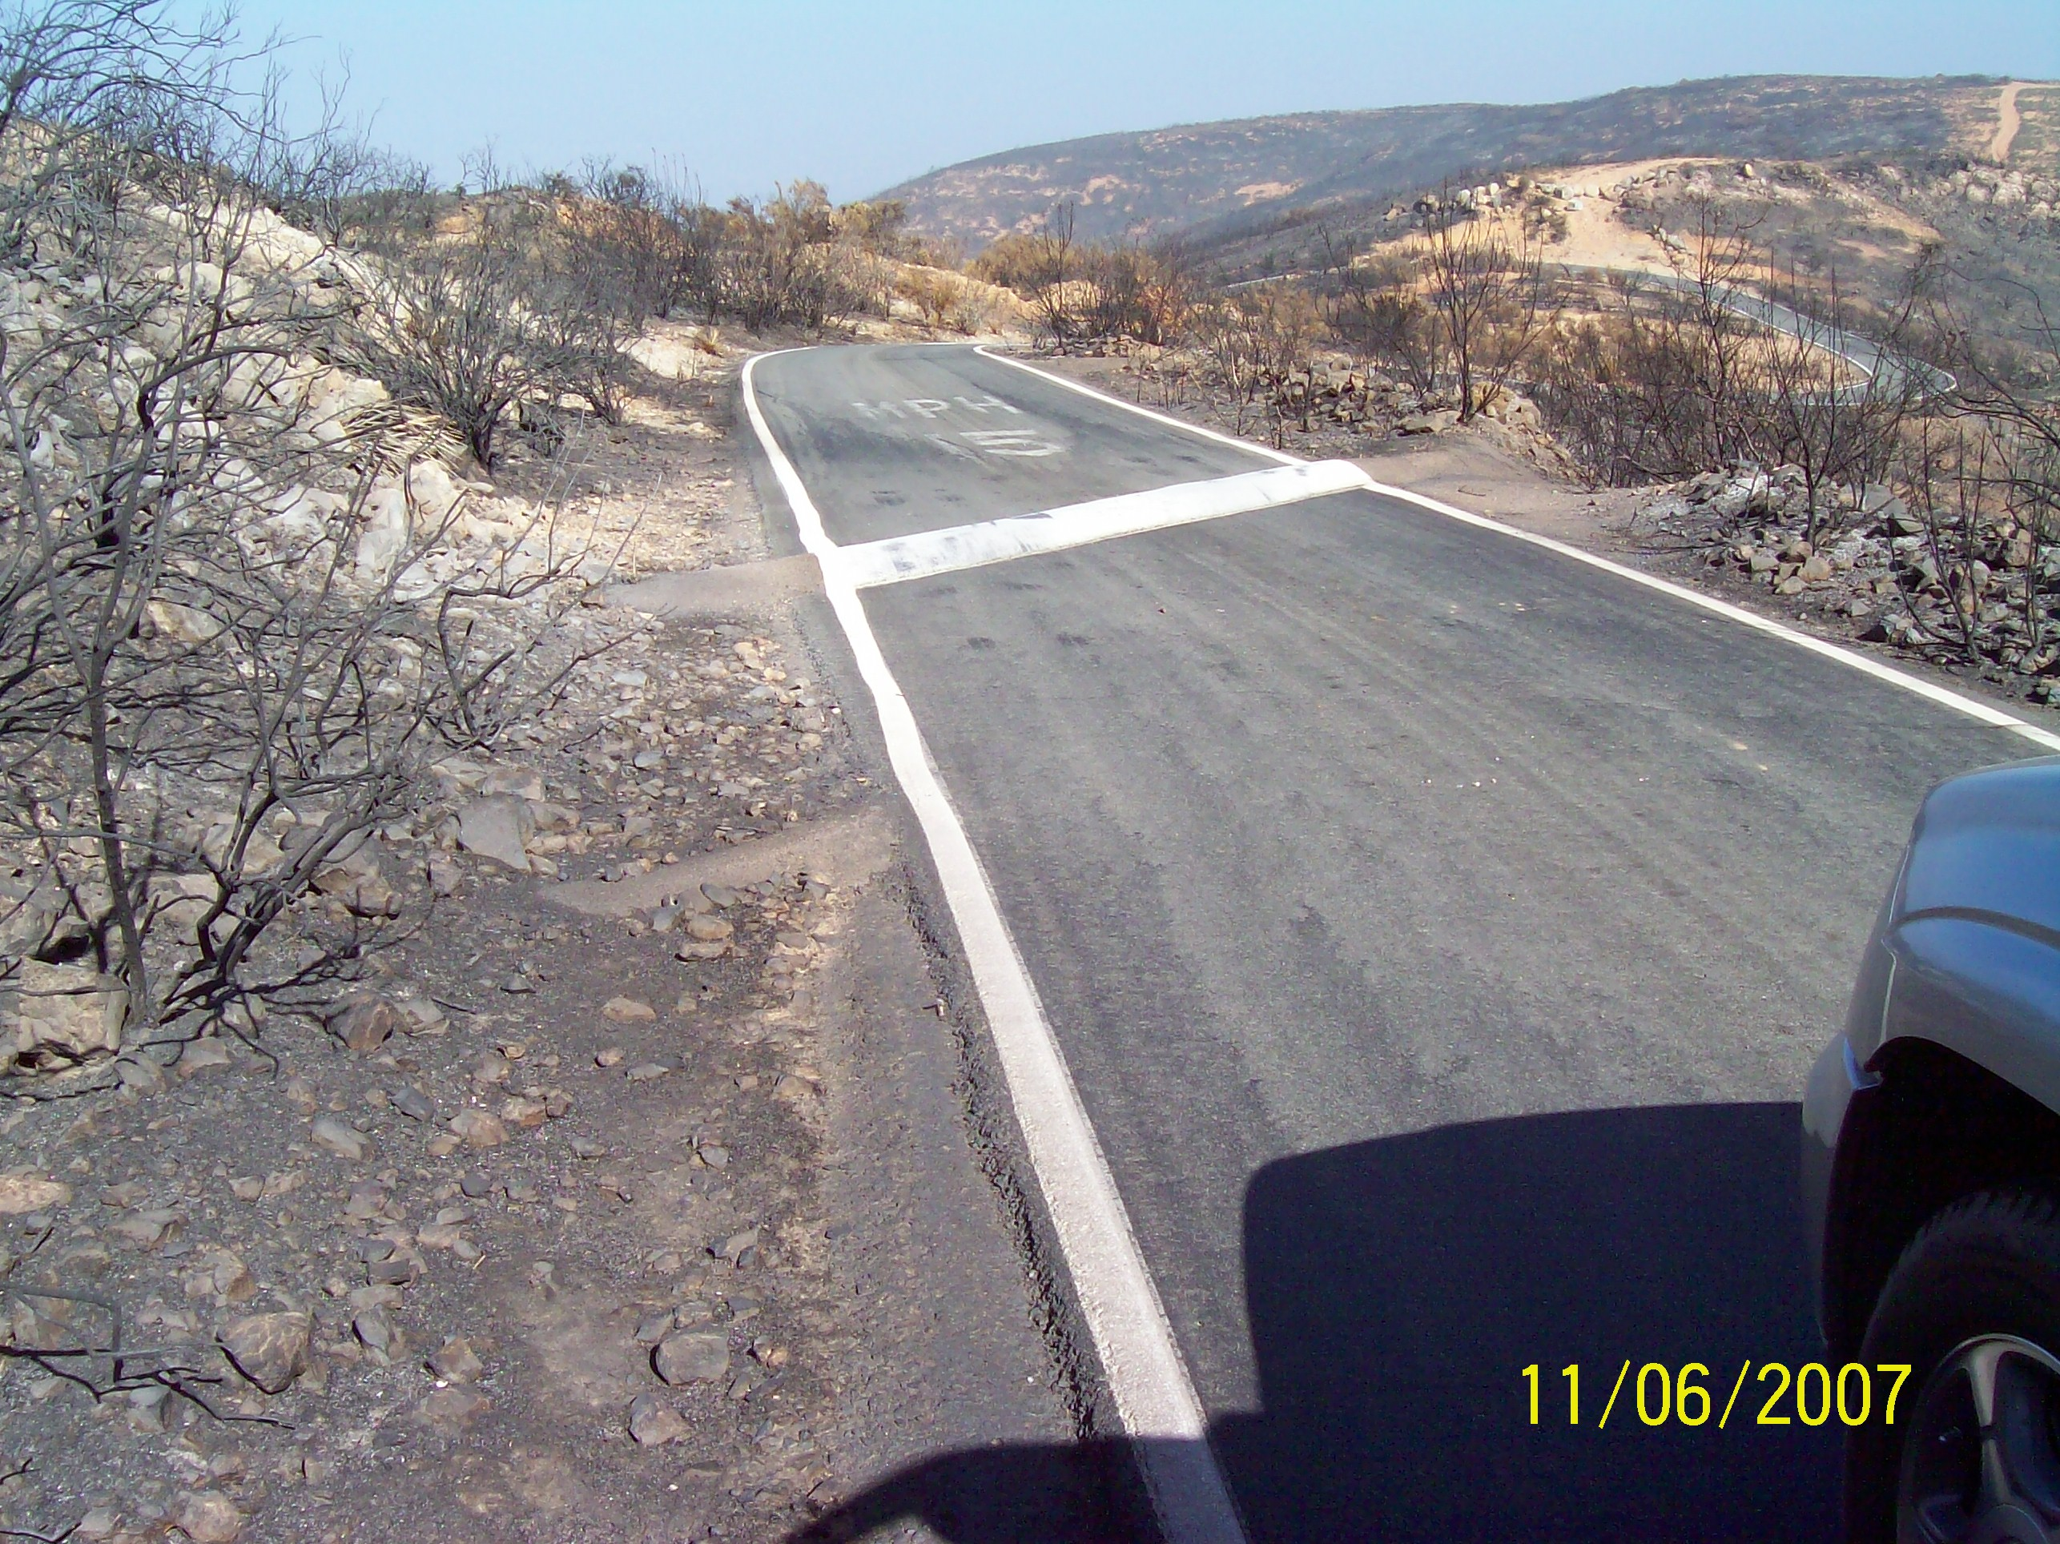
Example of typical asphalt bar, spur and outlet.

