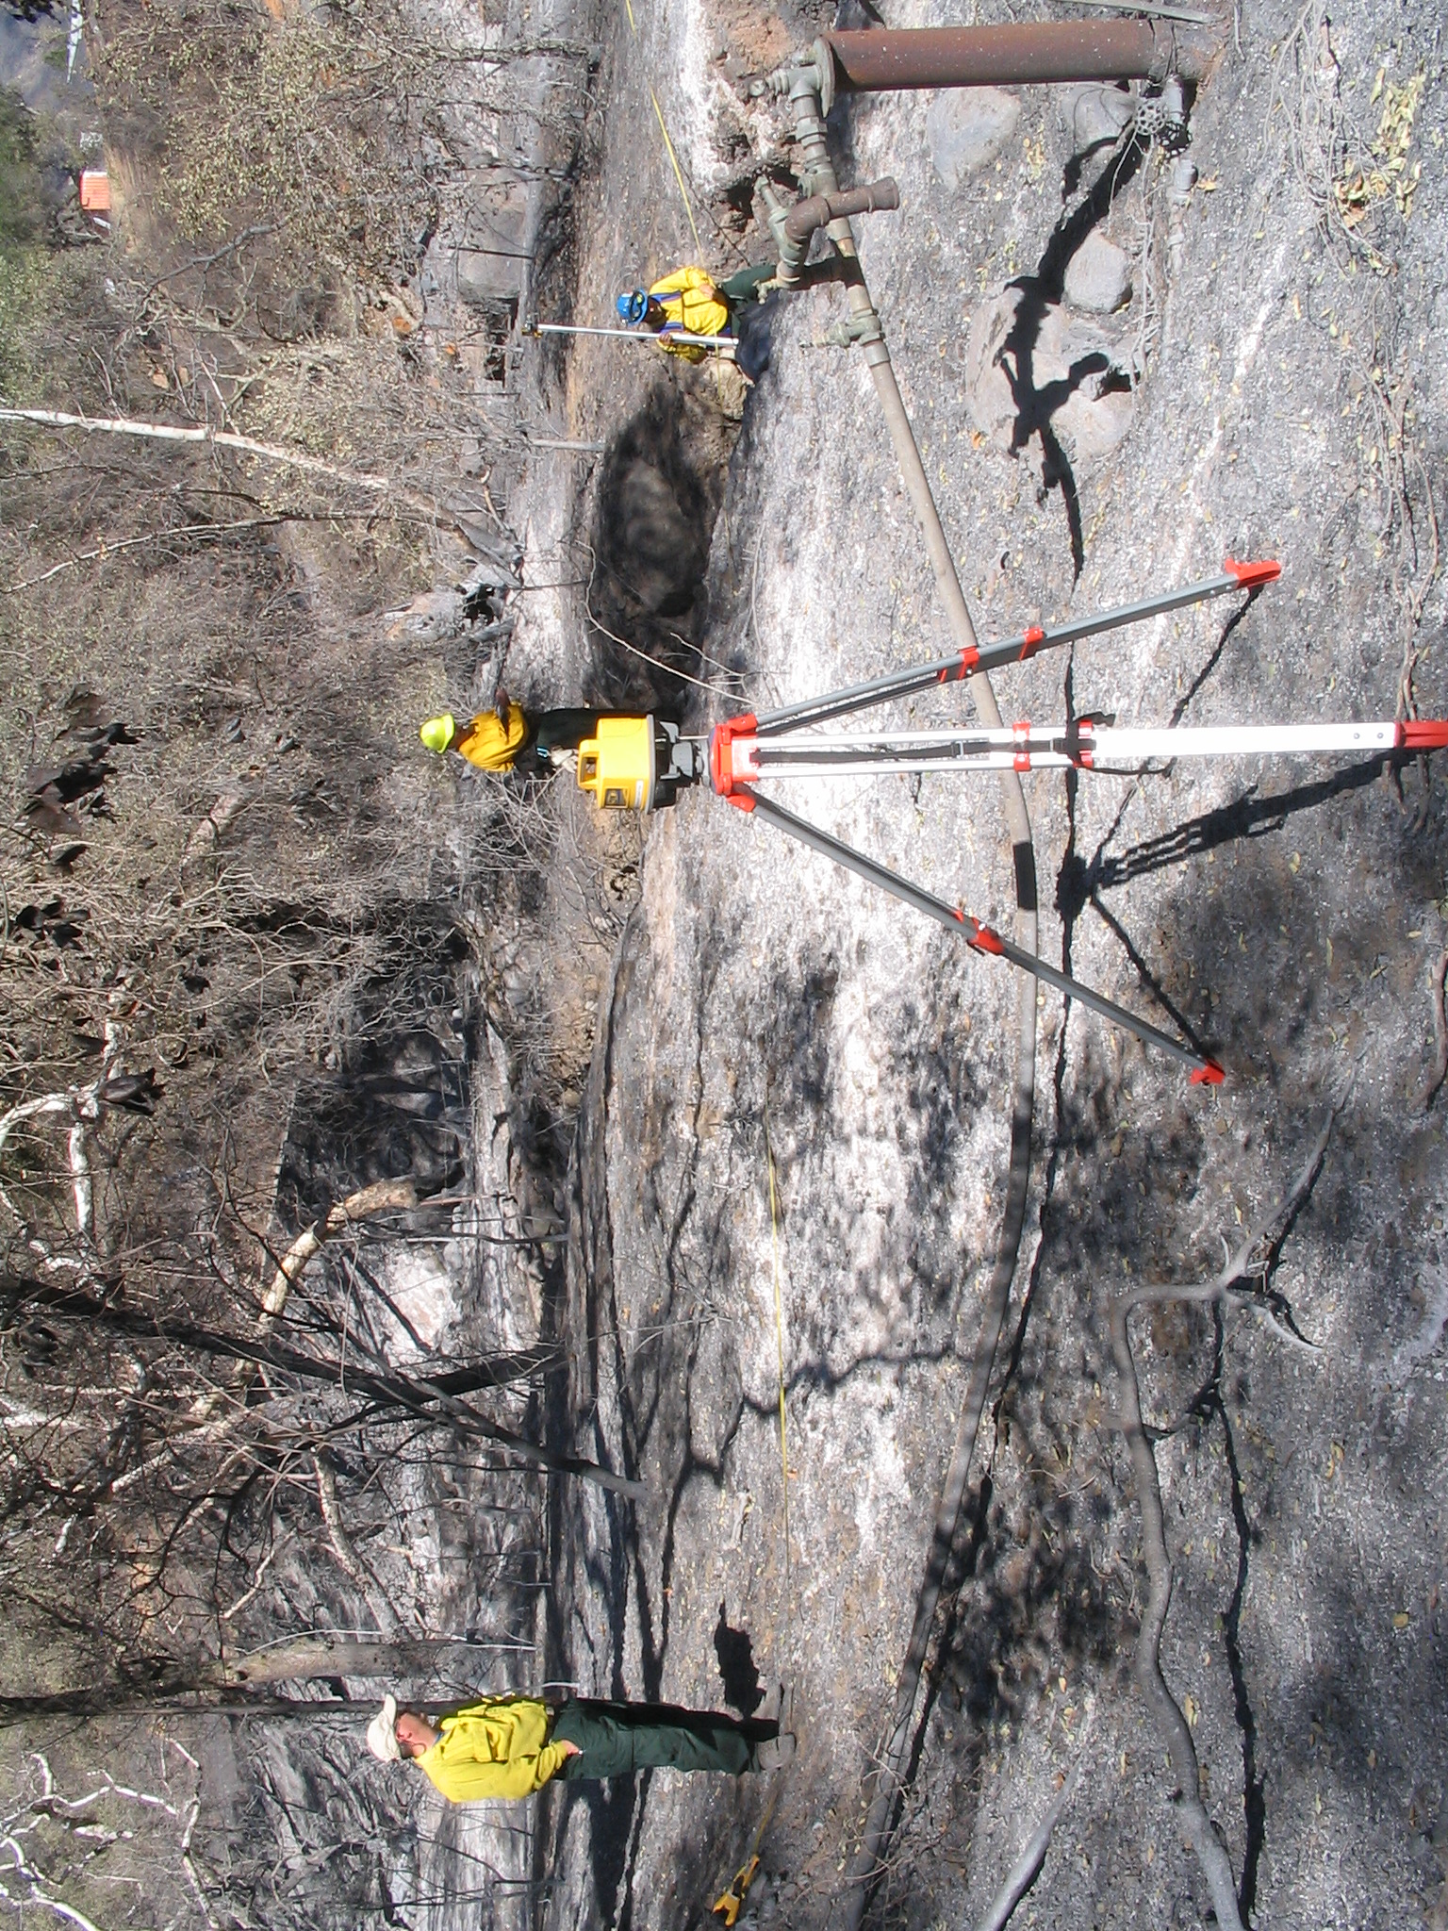
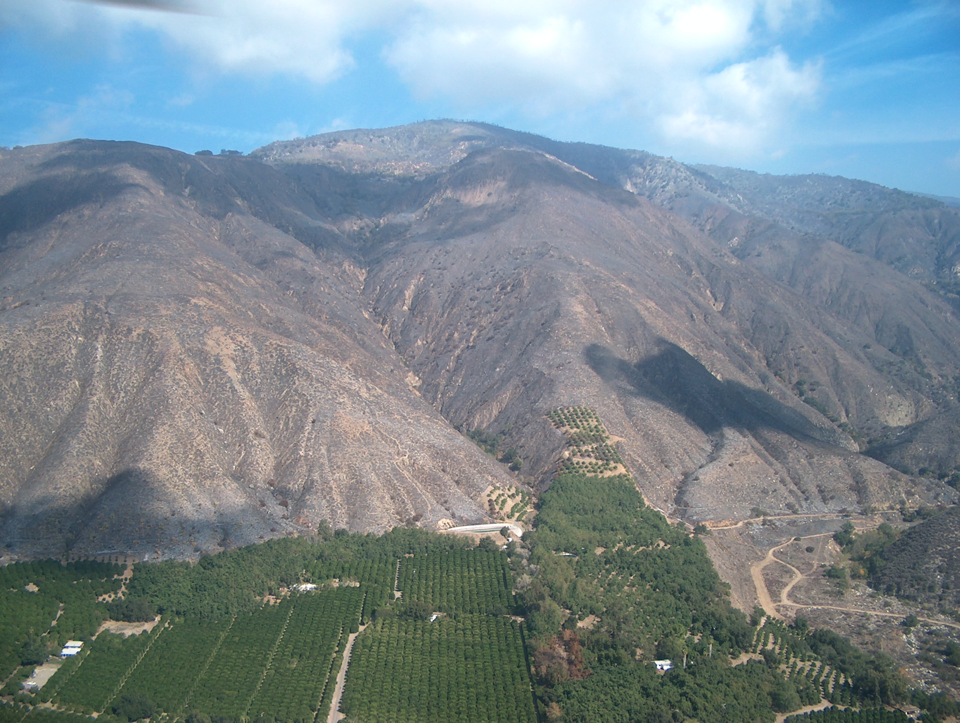
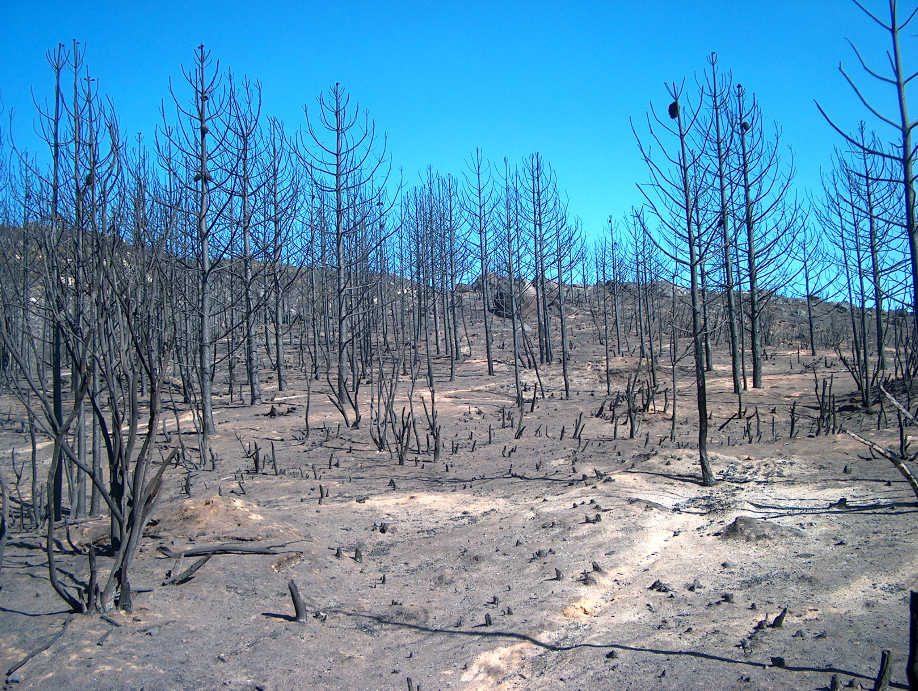
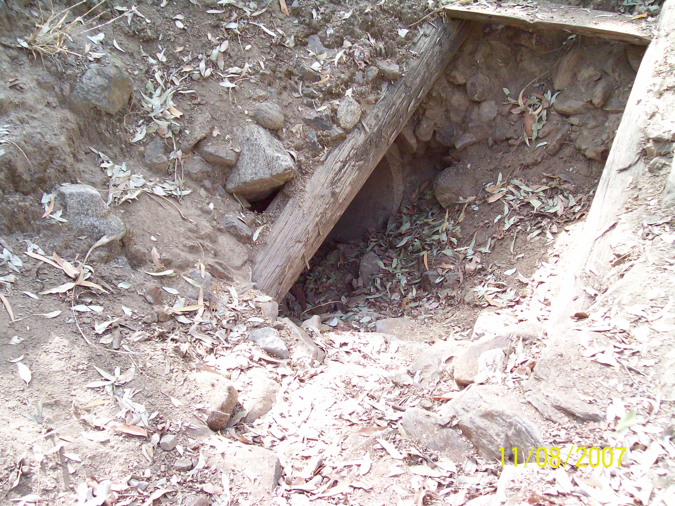
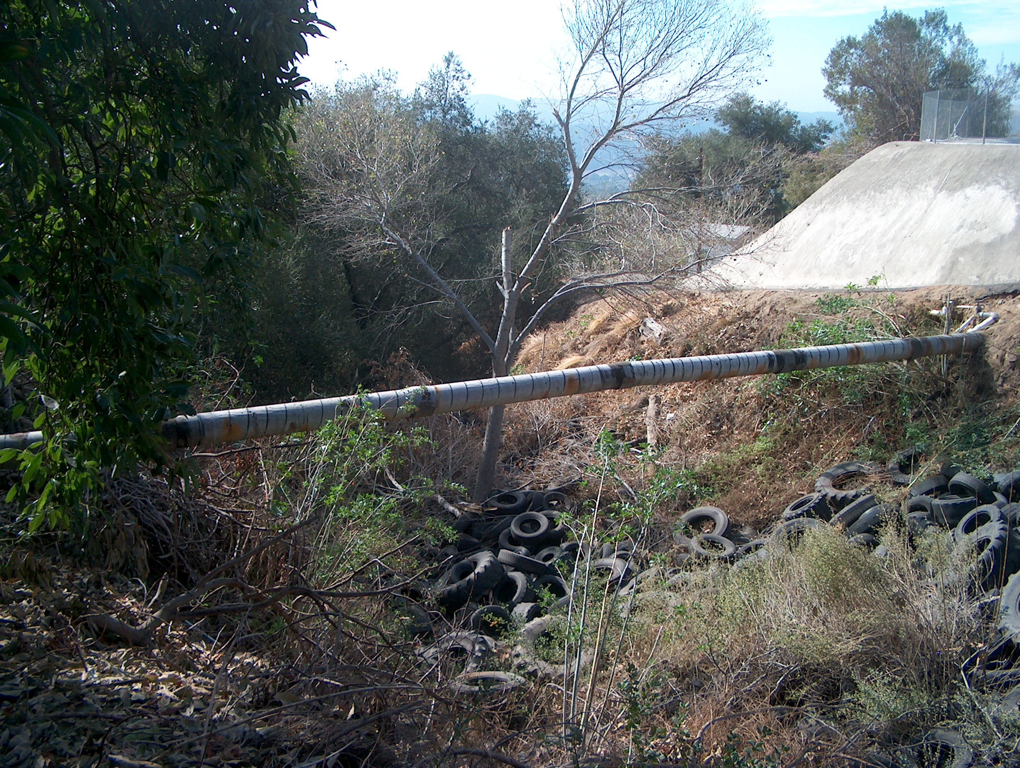
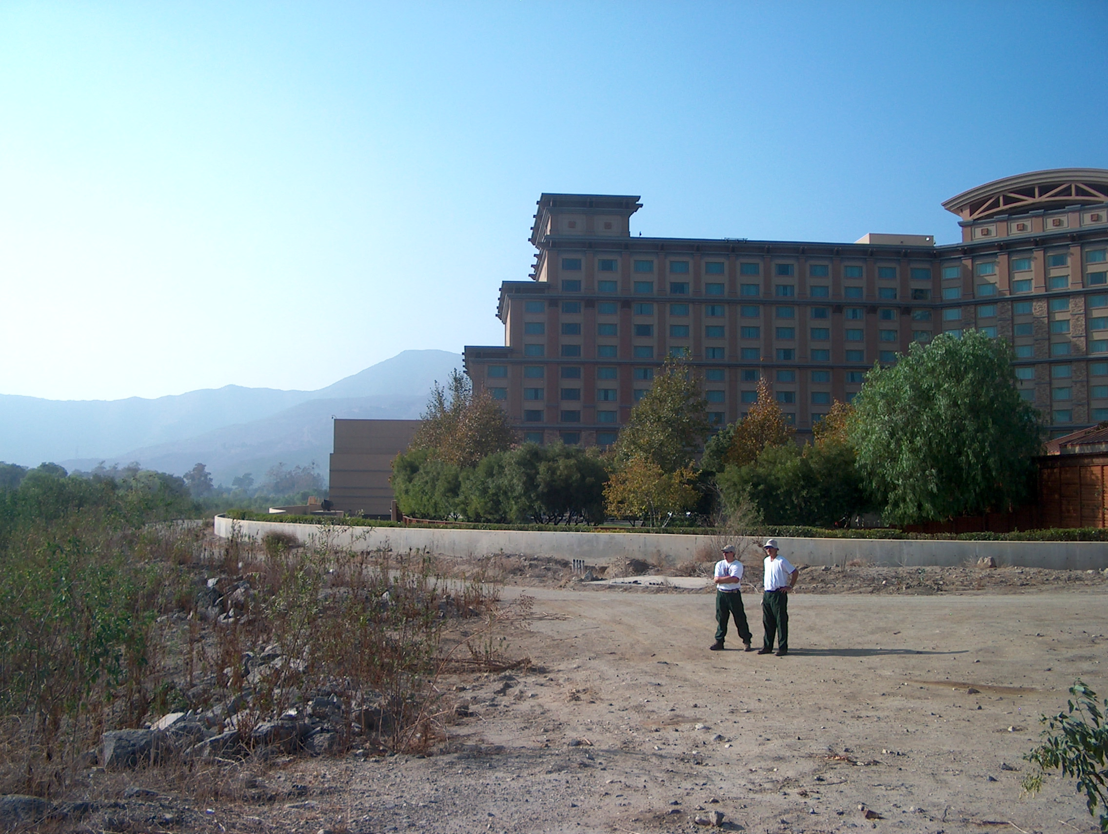
BIA soil burn severity high BIA culvert cleaning recommendation

BIA Pauma Reservation Reservoir Canyon BIA Pala Reservation casino

BIA La Jolla cross-section at Amago Creek BIA Pauma Reservation aerial view of Reservoir
Canyon

.

Watershed & Soil Issues

