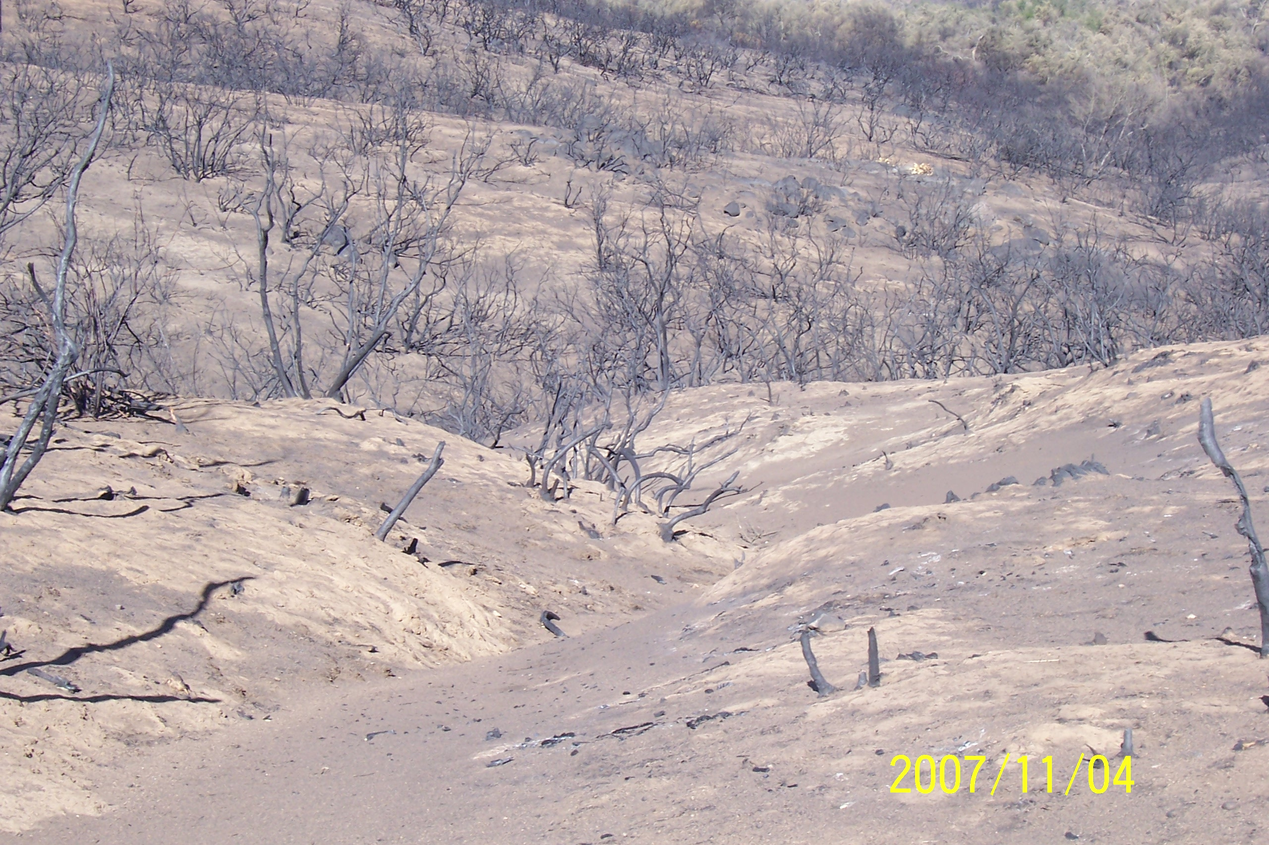
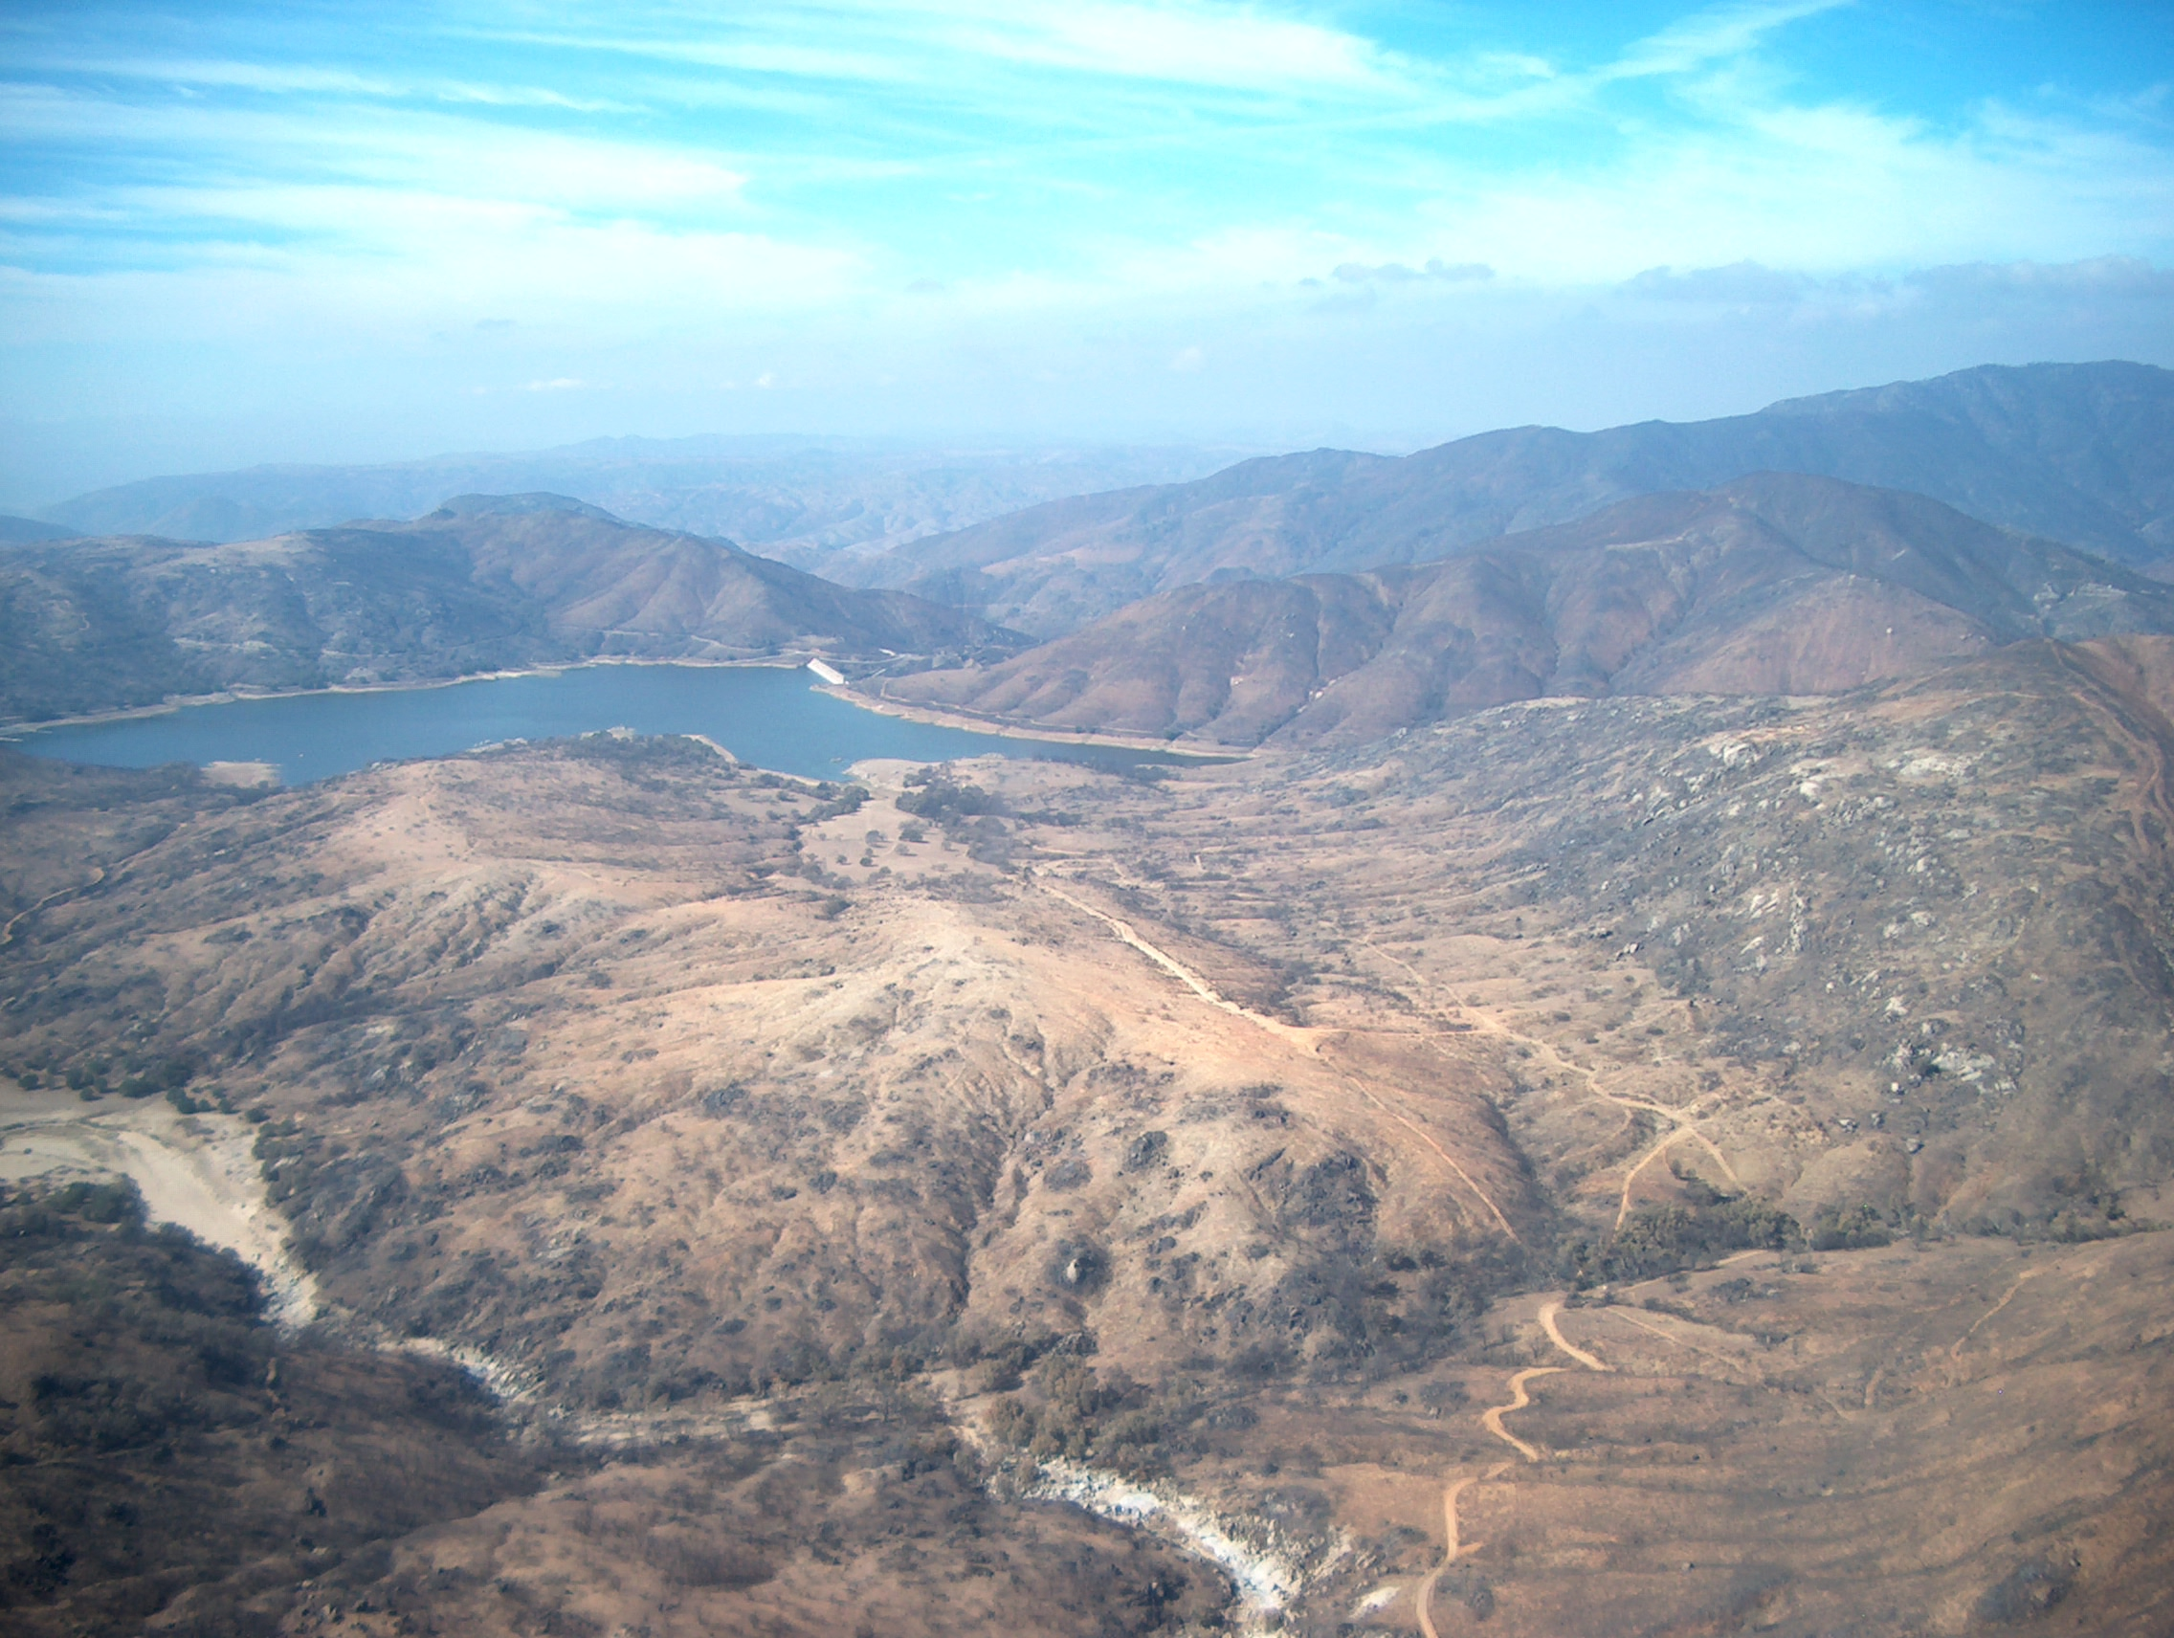
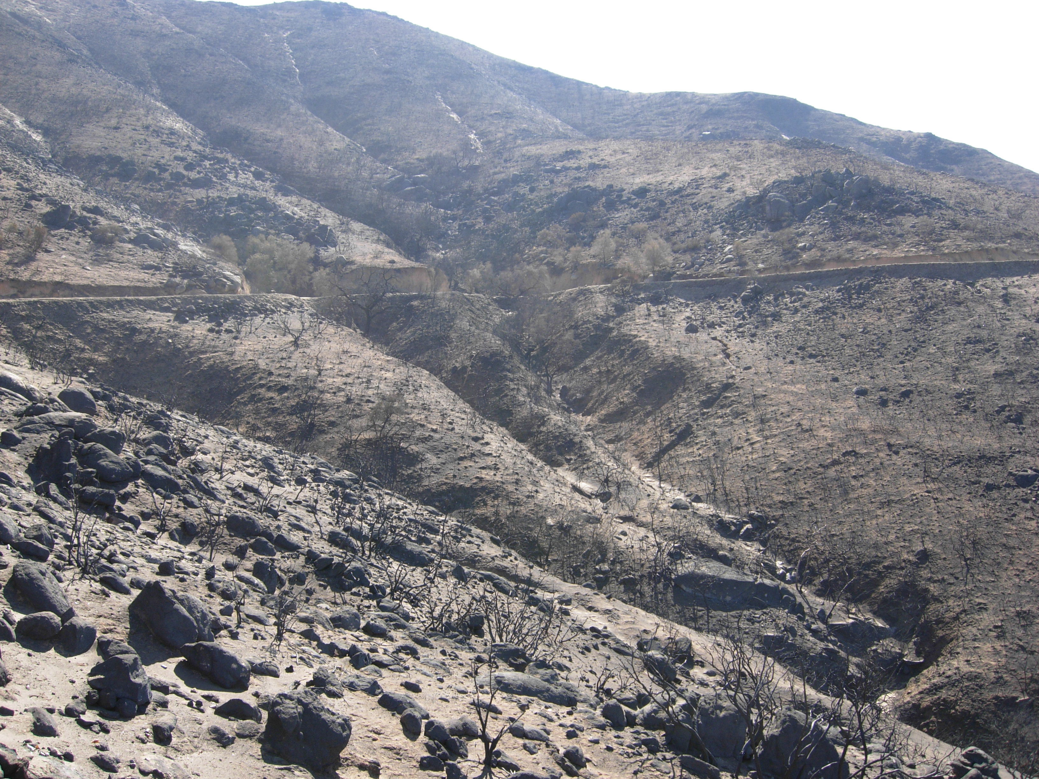
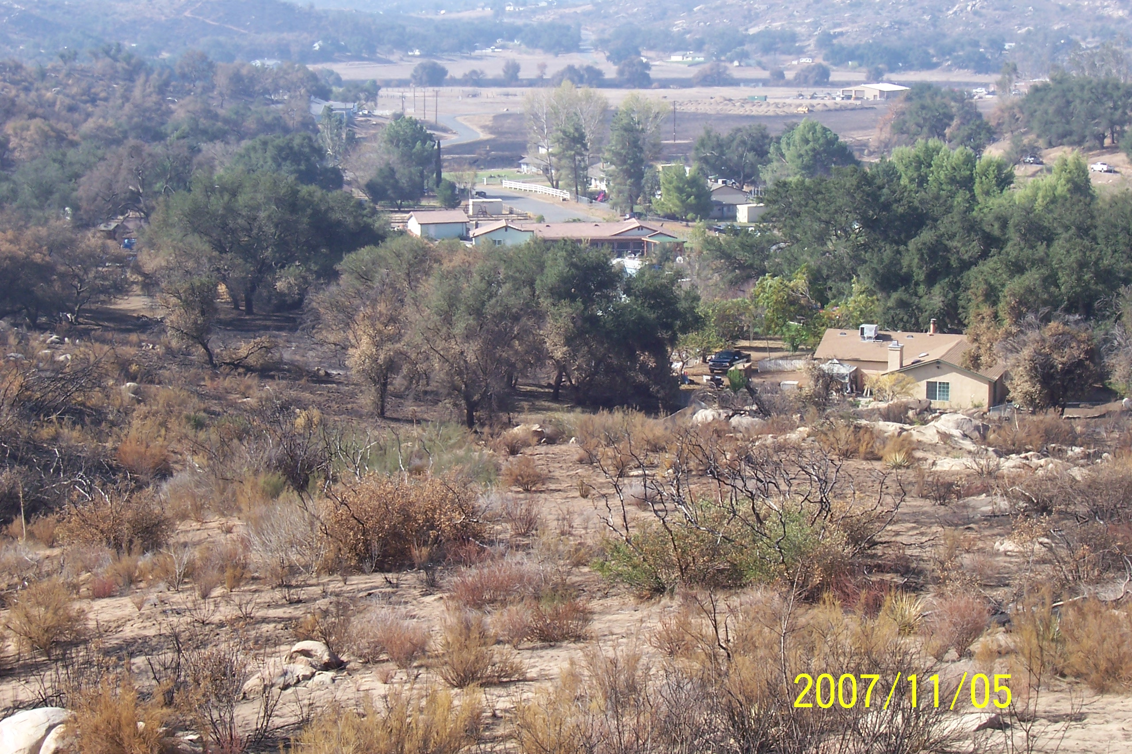
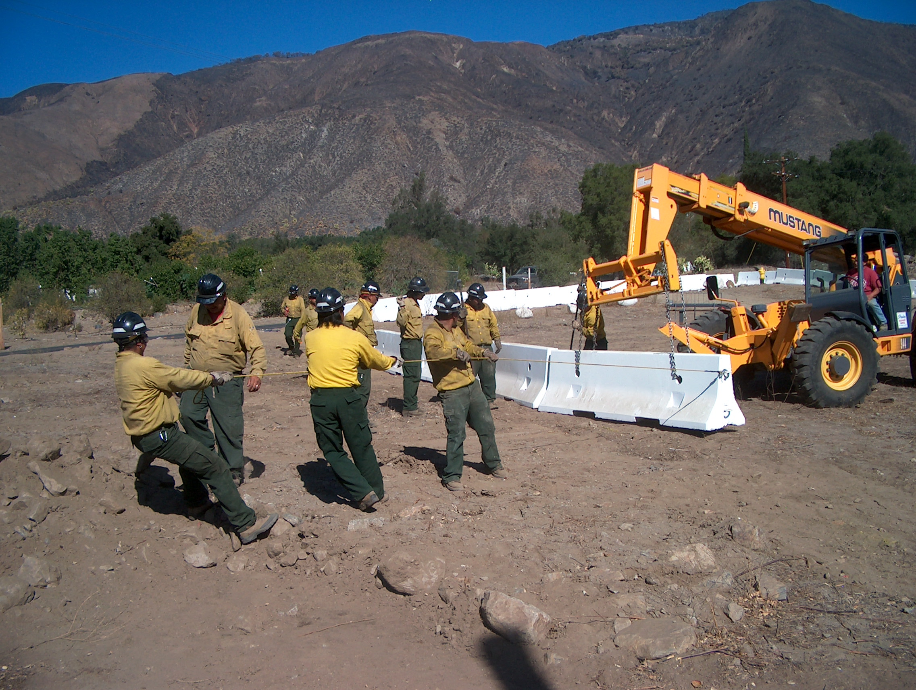
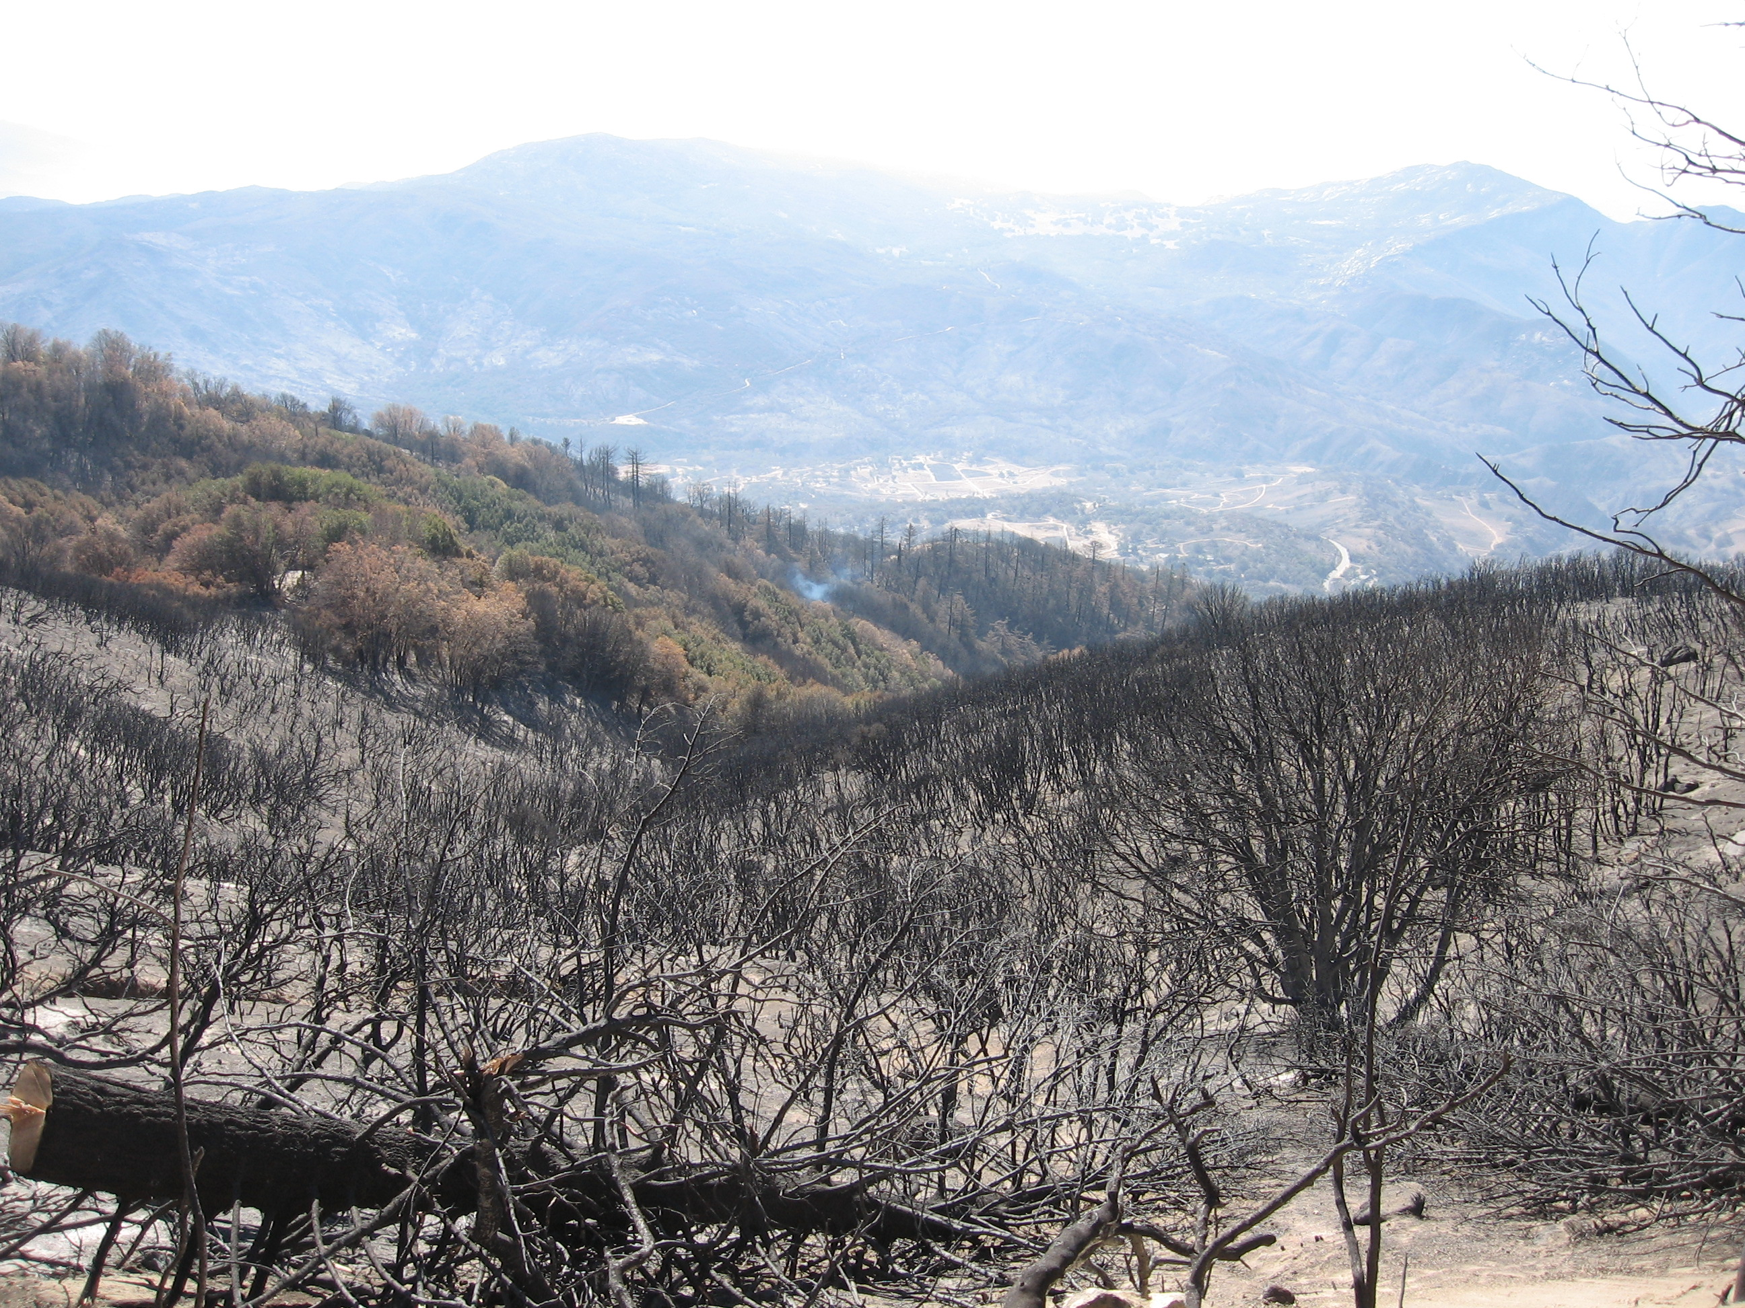
BIA Overview of Barona BLM Black Canyon road

Sutherland Lake privately owned Wind blown sediment at Bison Ranch

BIA Pauma Reservation downstream from BIA La Jolla Reservation Cedar Creek
Reservoir Canyon

.

Watershed & Soil Issues

