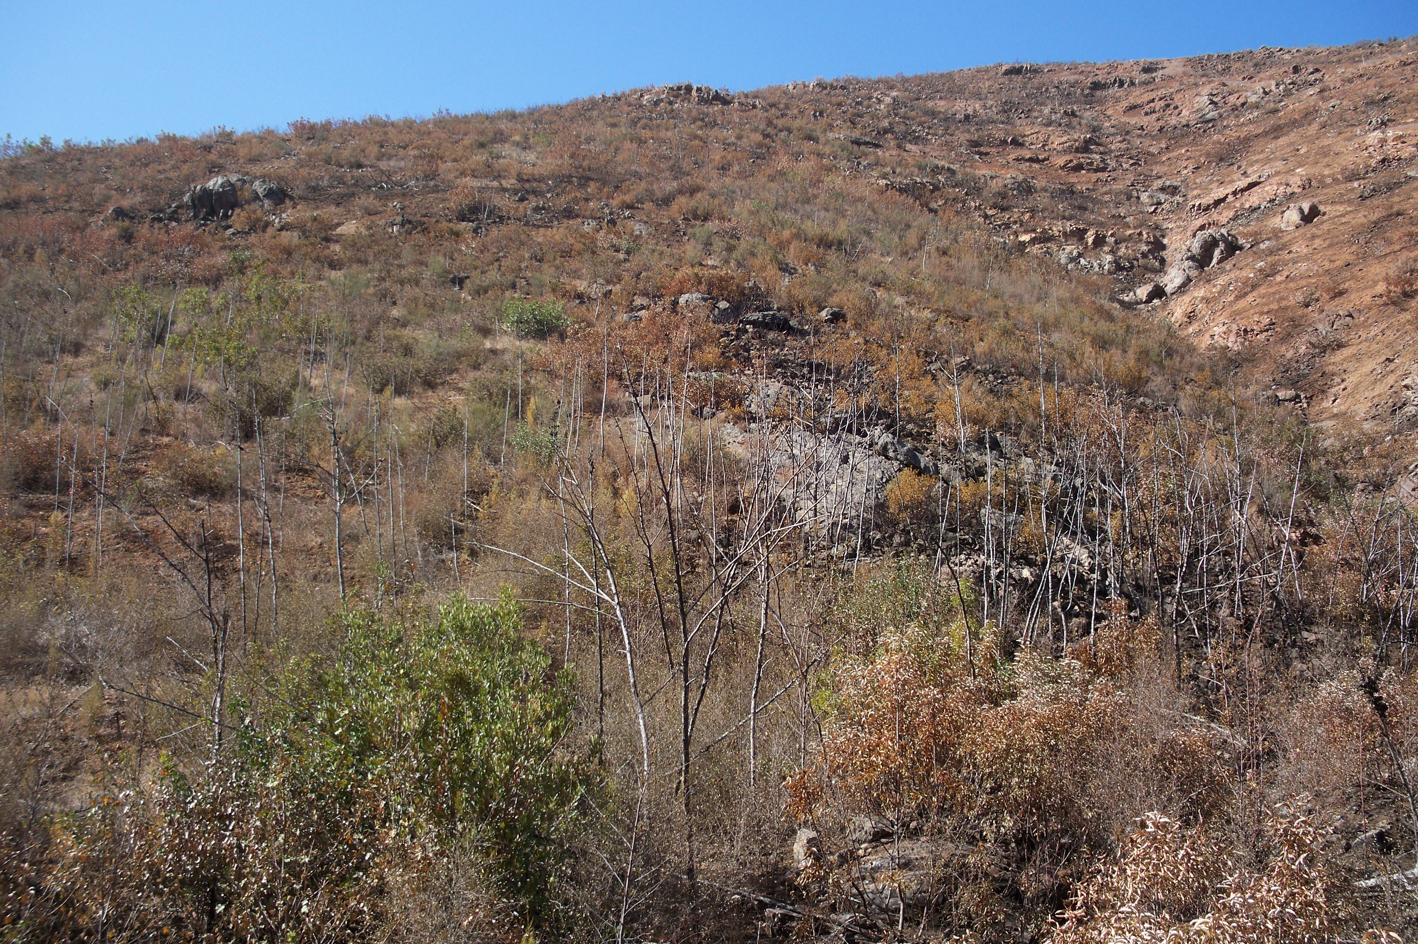
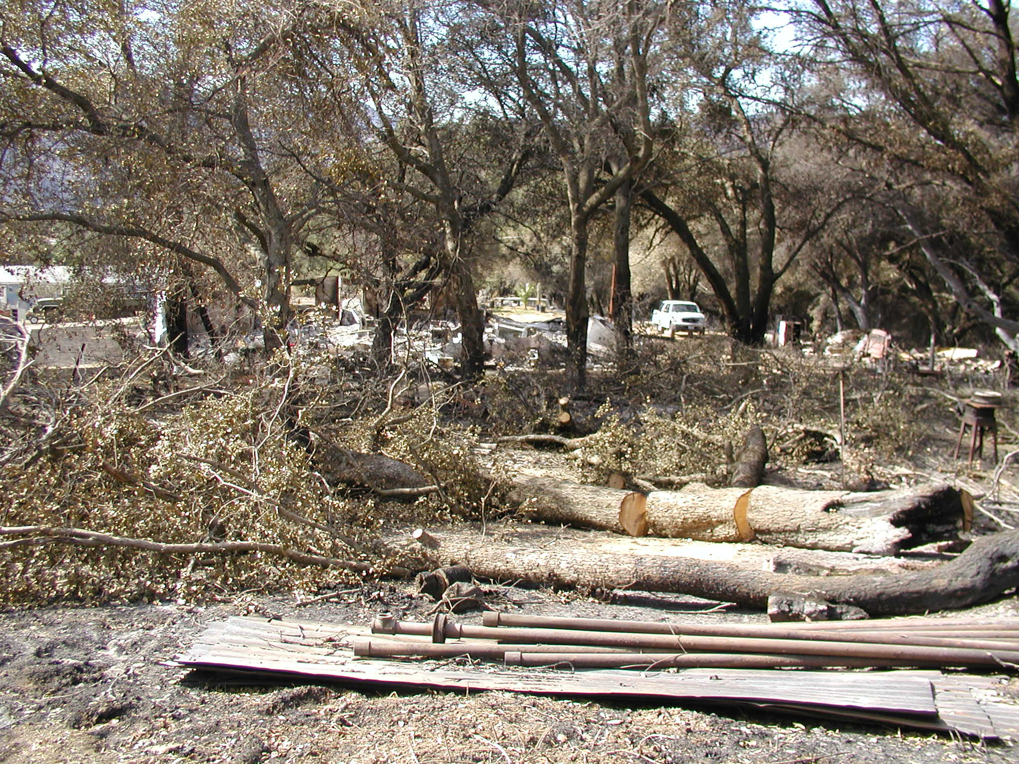
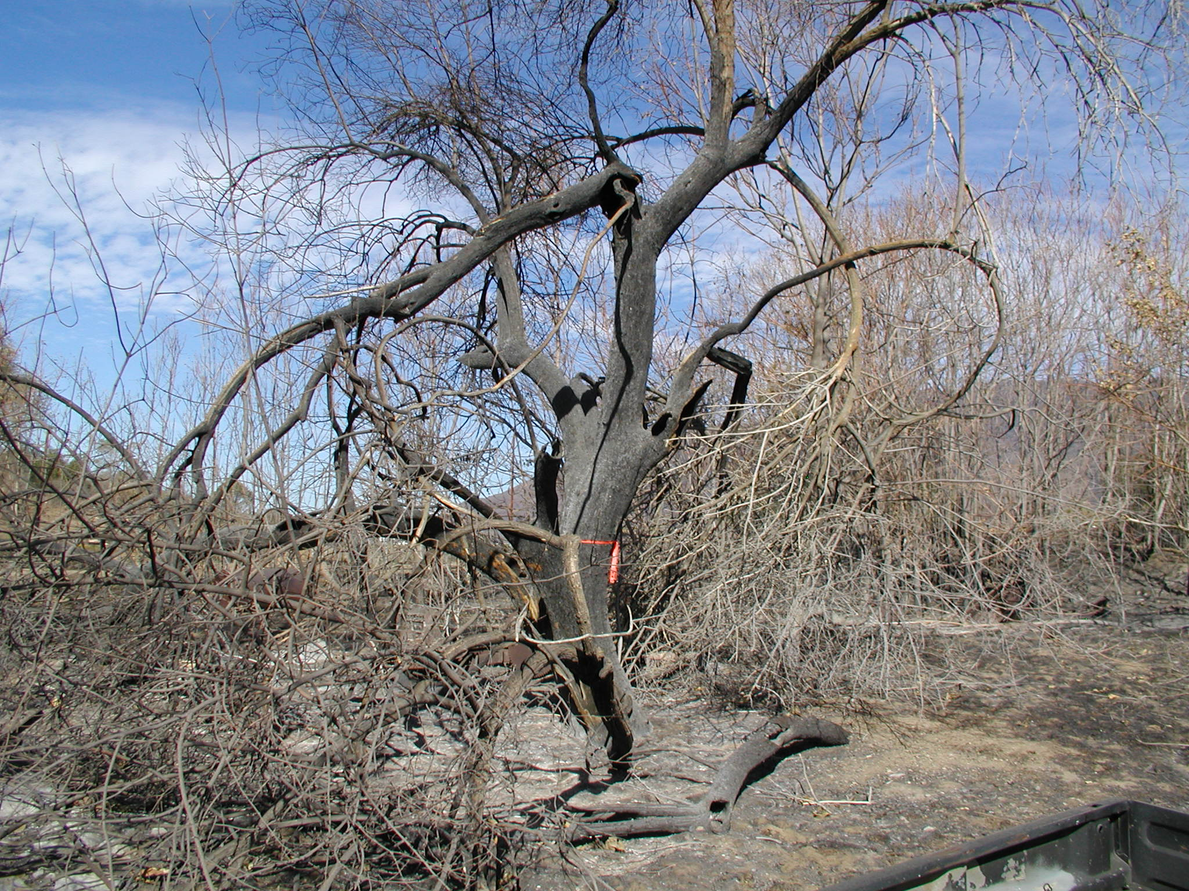
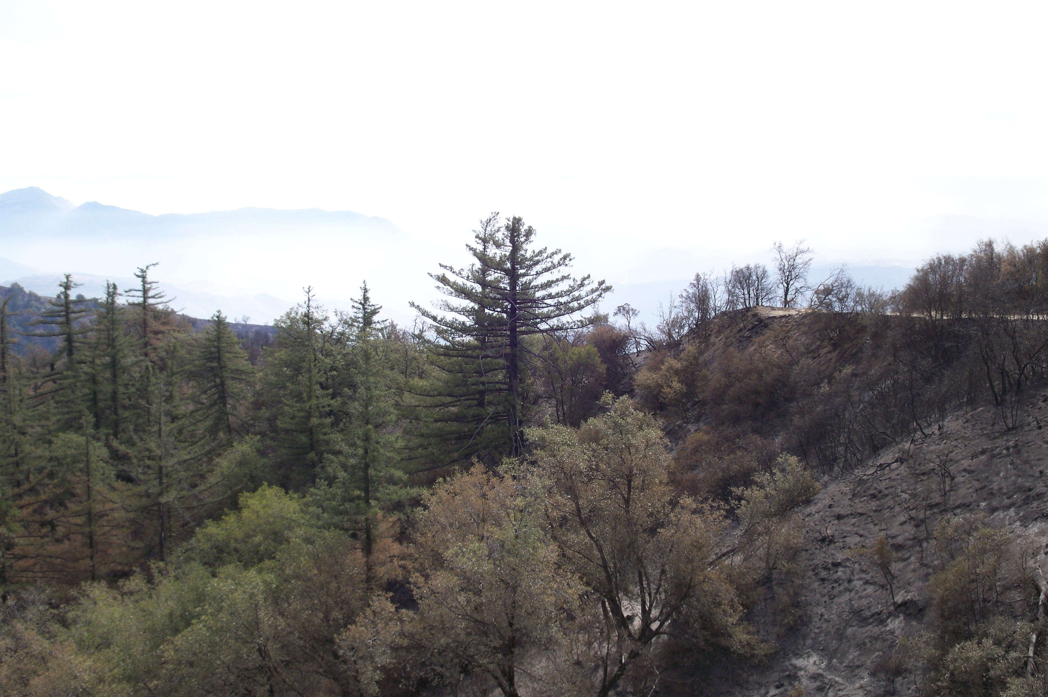
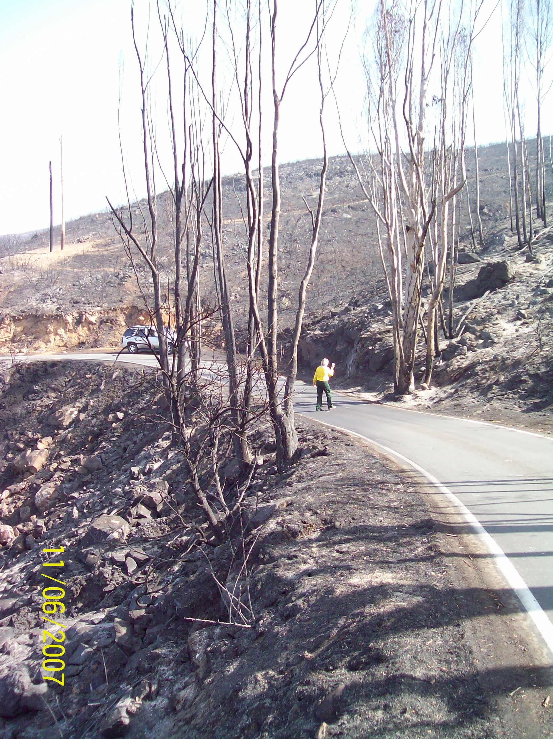
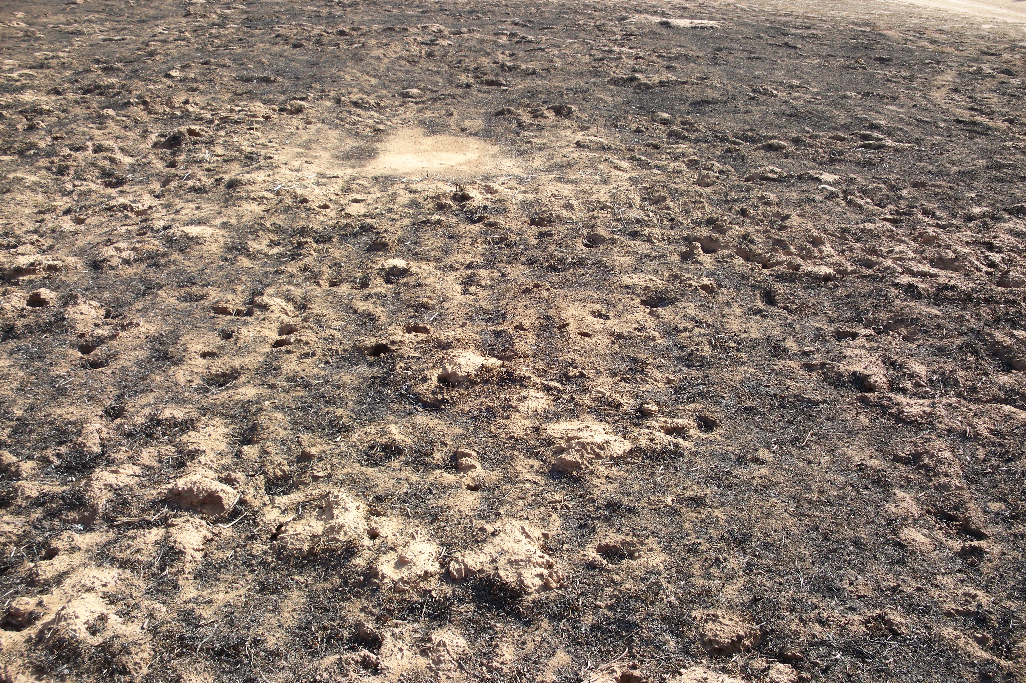
Hazard Tree – La Jolla-BIA Big Cone Douglas-fir – Pama Forest Reserve-BIA
Hazard Trees – San Miguel Road-FWS Re-burn of seeded area-BLM
2003 Otay Fire Vegetation Recovery Hazard Tree Mitigation – La Jolla - BIA
Vegetation/ Forest
Resources

