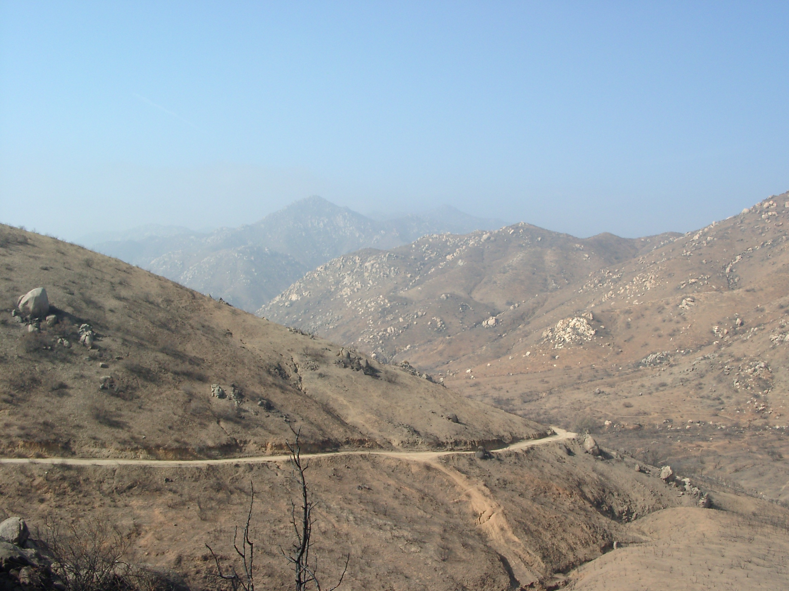
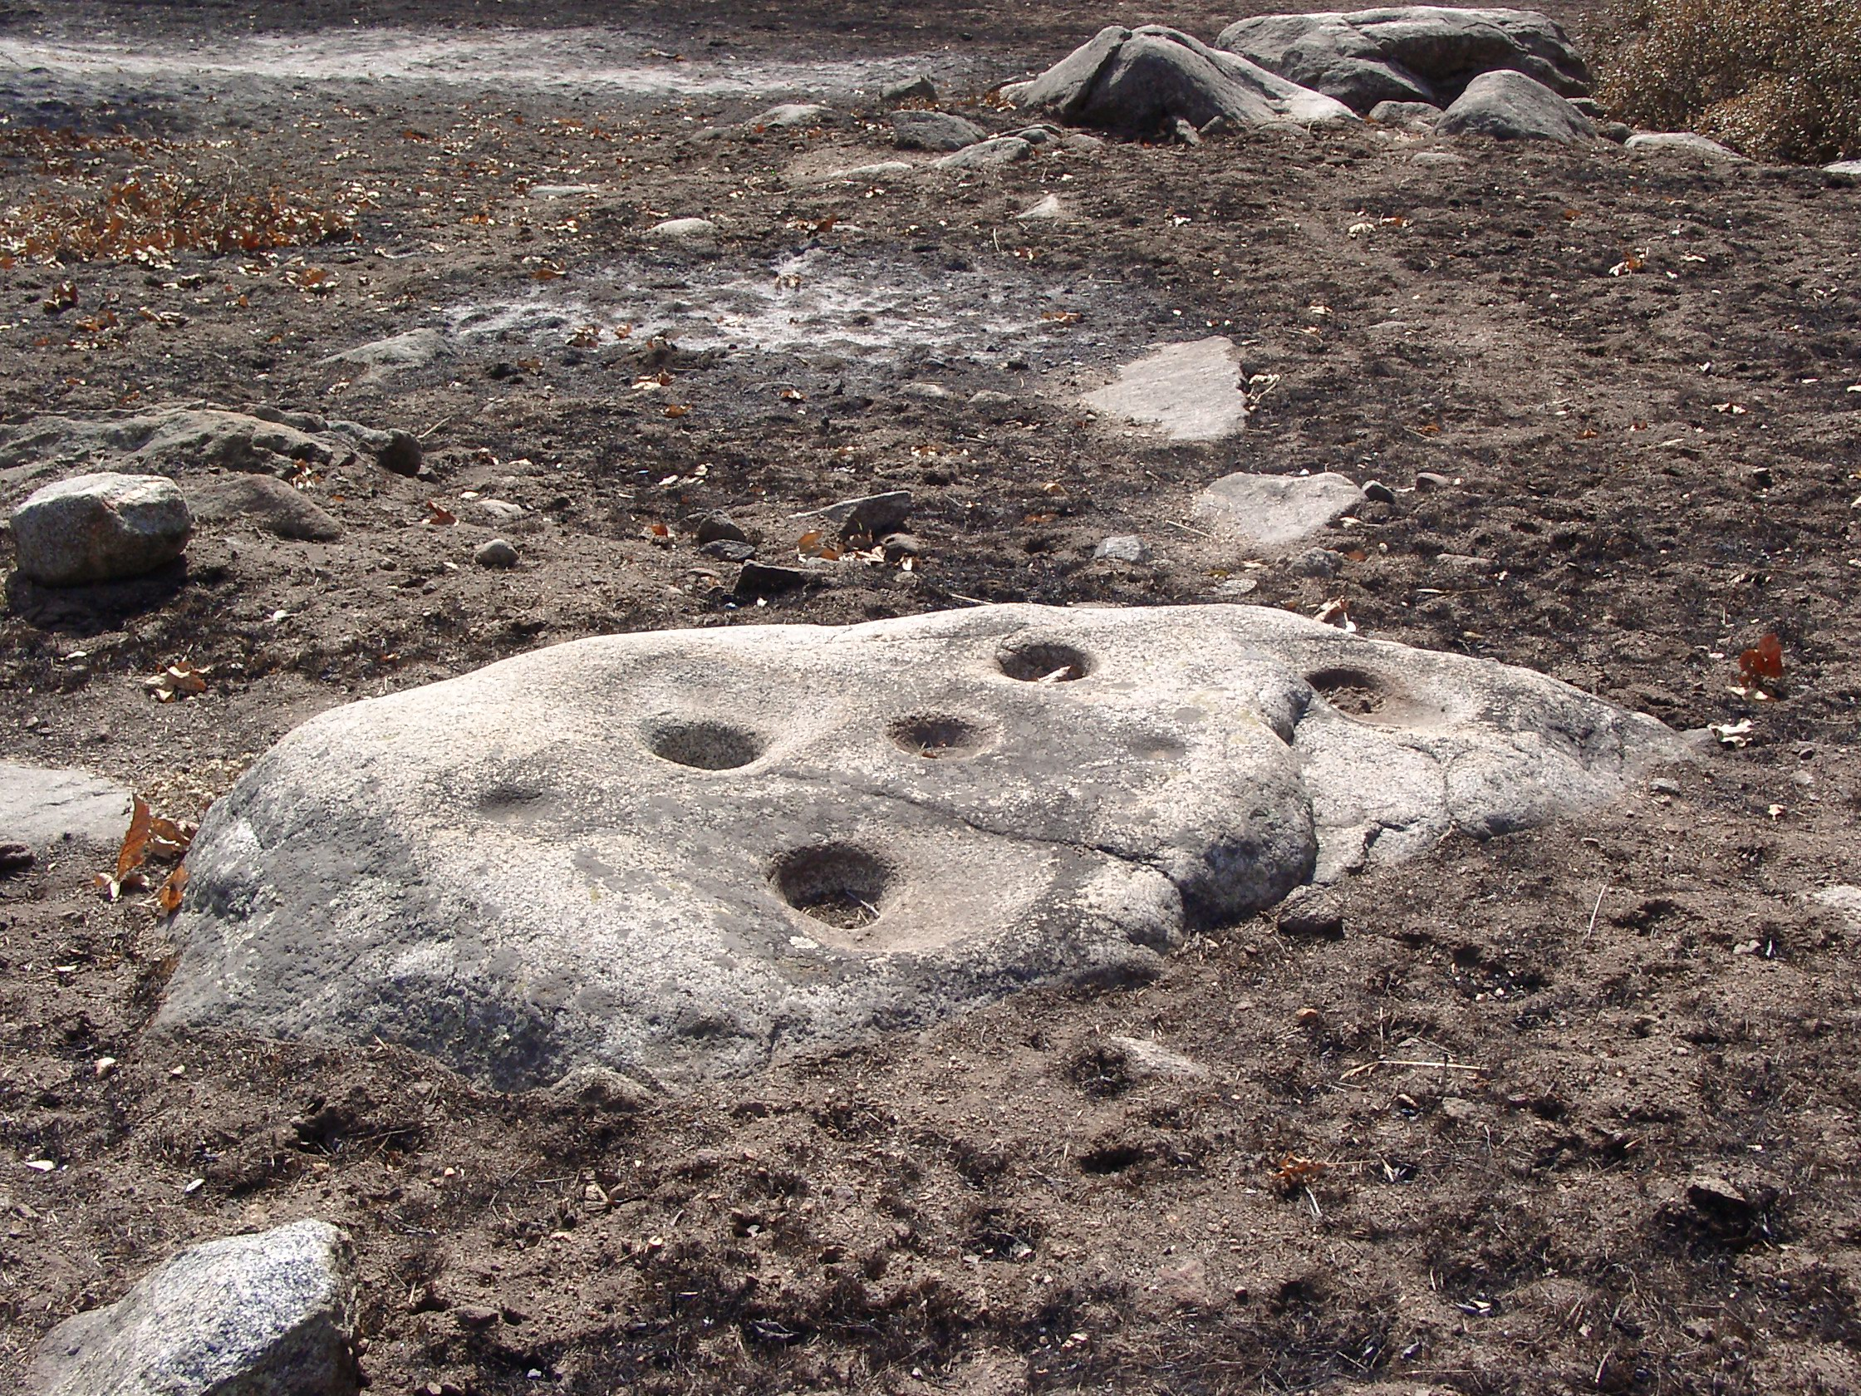
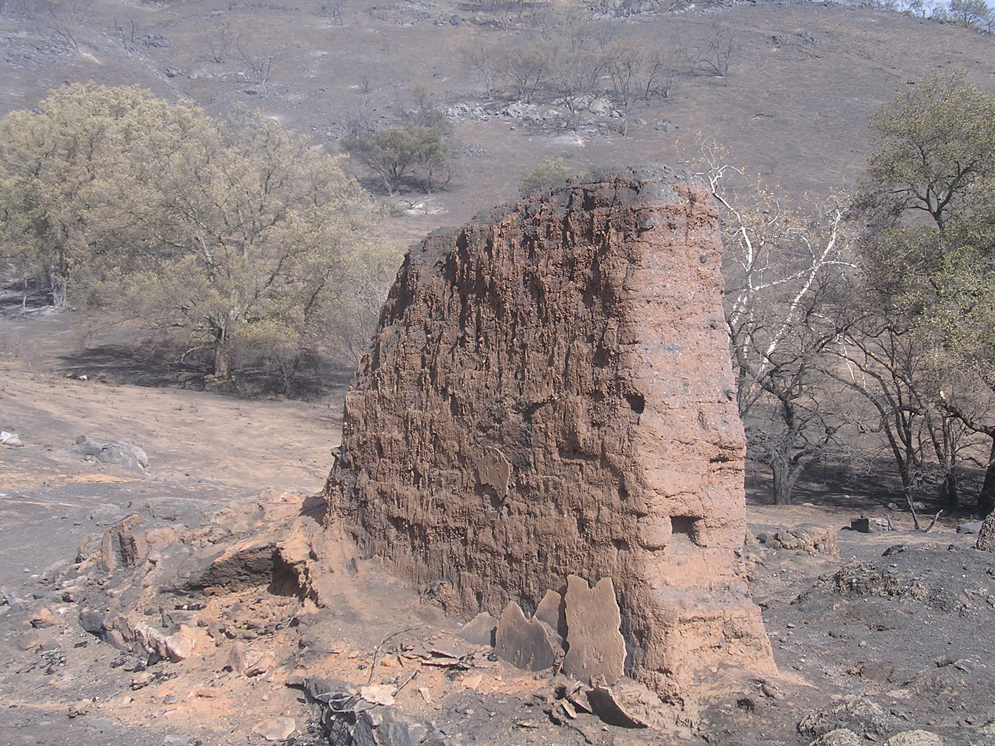
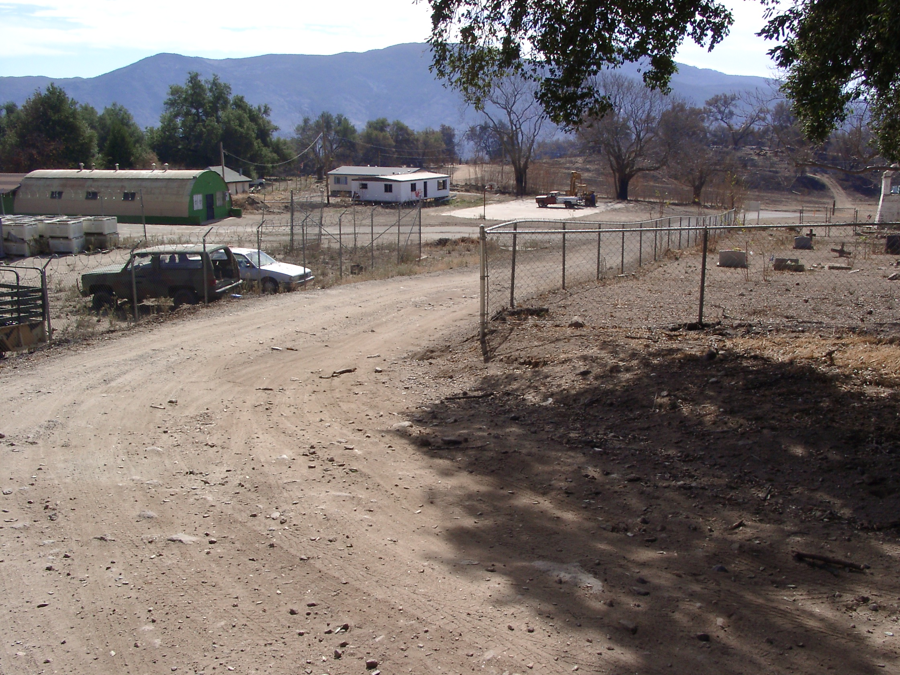
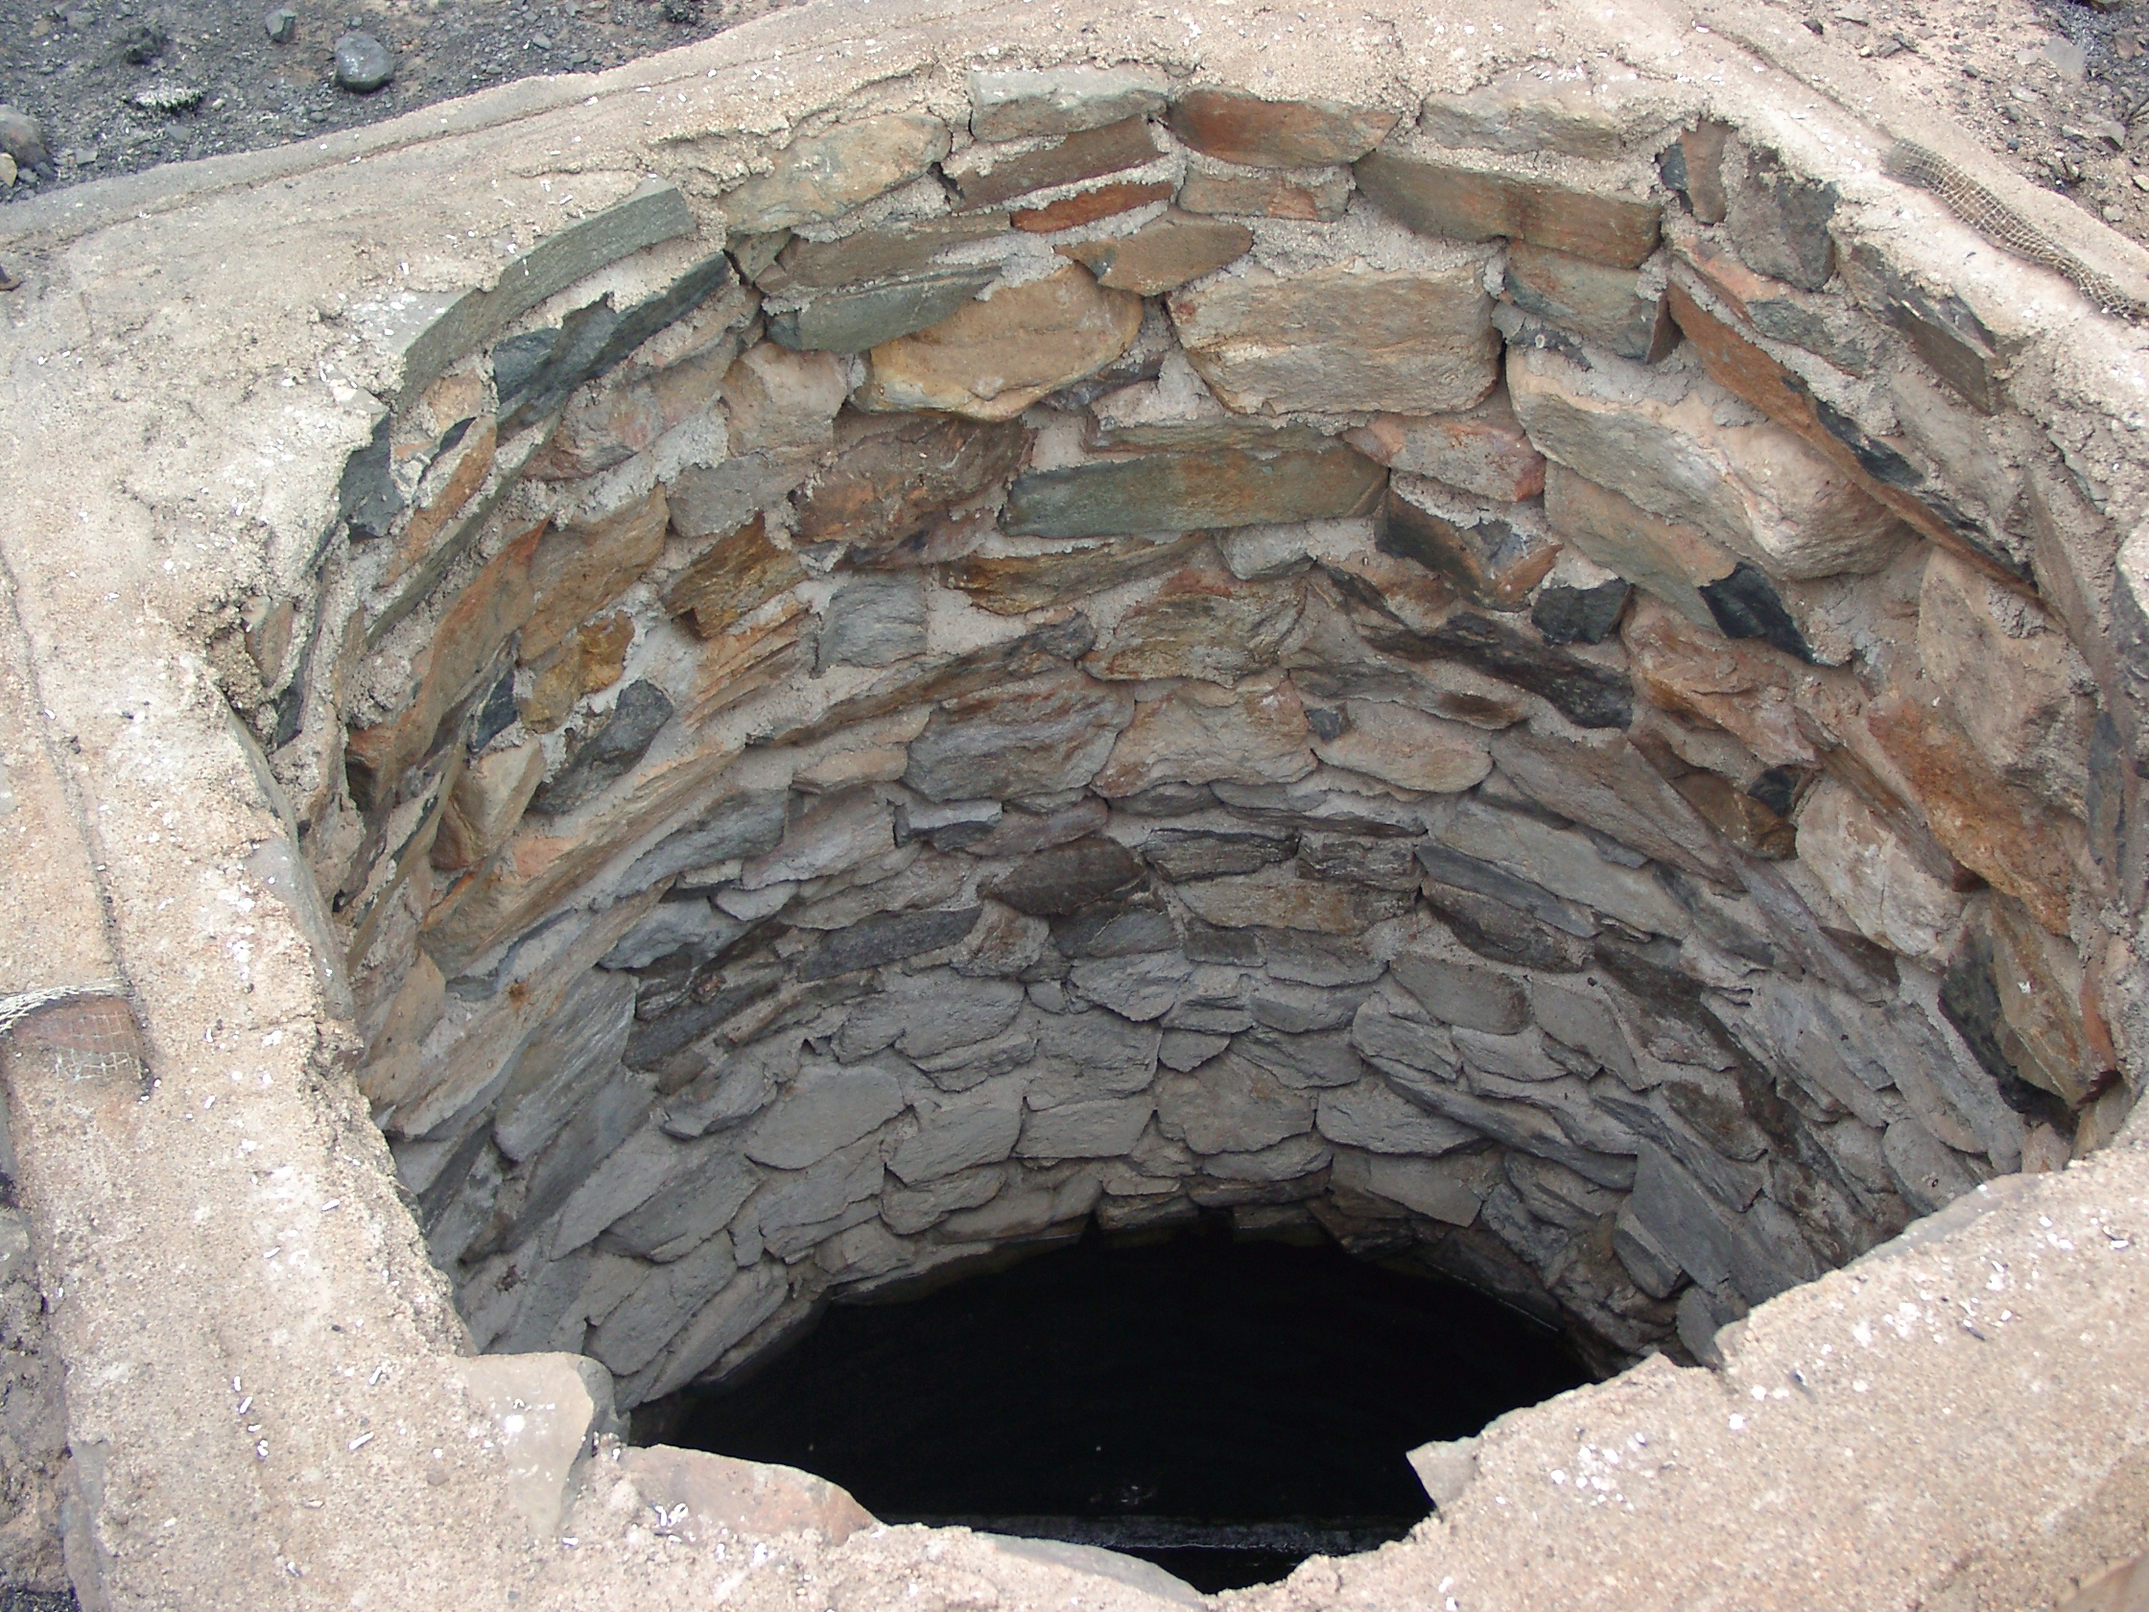
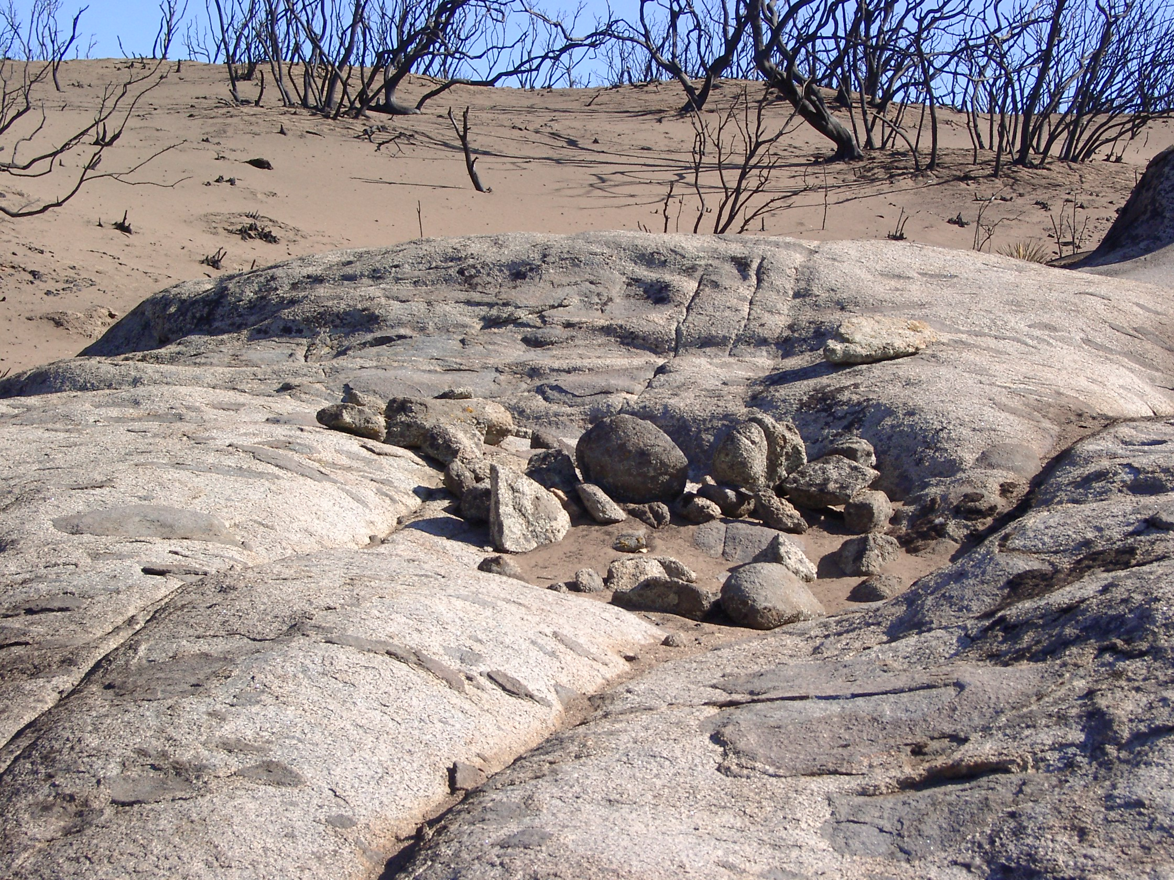
Burned Adobe-BIA Cementary Subject to Erosion-BIA
Historic Well - BLM Rock Ring - BIA
Barrett Stage Coach Road-BLM Bedrock Milling Complex- BIA
Cultural Resource Issues

