Wallow Fire
Burned Area Emergency Response Plan

WATERSHED RESOURCE ASSESSMENT

OBJECTIVES

- Assess overall soil and watershed changes caused by the fire, particularly those that pose substantial threats to human life and property, and critical natural and cultural resources. This includes evaluating changes to soil conditions, hydrologic function, and watershed response to precipitation events;

- Identify potential flood and erosion source areas and sediment deposition areas;

- Identify potential threats to life, property, and critical natural and cultural resources in relation to flooding, debris flows, erosion, sediment deposition;

- Develop treatment recommendations, if necessary;

- Identify future monitoring needs, if necessary.

ISSUES

Issues identified as possible post-fire watershed conditions that threaten lives and property include:
- Risks to human life from flooding along Black River
- Risks from flooding to the Bridge at Black River Crossing
- Risks from flooding to the Black River Pump Station
- Increased erosion and sediment delivery into streams affecting water quality
- Campground and recreation impacts along Black River
- Loss of road infrastructure and access

Two issues for watershed response threats to critical natural and cultural resources were identified.

- Increased sediment delivery to Soldier Springs Creek
- Increased sediment delivery to Bear Wallow Creek

OBSERVATIONS

Background

The purpose of a burned area assessment is to determine if the fire caused emergency watershed conditions and if there are potential values at risk from these conditions. Identification of values at risk occurs through consultation with individuals, state, tribal, and federal agencies, and through field investigation. Not all values initially identified are determined to be at risk. If emergency watershed conditions are found, and values at risk are identified and confirmed, then the magnitude and scope of the emergency is mapped and described, values at risk and resources to be protected are analyzed, and treatment prescriptions are developed to protect values at risk.

The most significant factor leading to emergency watershed conditions is loss of ground cover, which leads to erosion and changes in watershed hydrologic function in the form of decreased infiltration and increased runoff. Such conditions lead to increased flooding, sedimentation and deterioration of soil condition. Values at Risk are human life and property located within or downstream of the fire that may be subject to damage from flooding, ash, mud, debris deposition, and hillslope erosion.

Physiography/Geology/Climate

The Wallow Fire is located in the White Mountains of east-central Arizona and burned on the eastern side of Fort Apache Indian Reservation (FAIR), administered by the White Mountain Apache Tribe (WMAT), and San Carlos Indian Reservation (SCIR), administered by the San Carlos Apache Tribe (SCAT) in Arizona. The burned watersheds of the FAIR drain into the Black River and the SCIR drain in both the Black River and Eagle Creek. The fire burned 12,959 acres in the FAIR and 9,162 acres in the SCIR. The fire also burned the Black River watershed, administered by the USFS, upstream of both Indian Reservations.

The landscape is a stream dissected plateau with mountain ridgetops, mountain slopes, foothills, alluvial fans and alluvial valley bottom landforms. Cretaceous and Permian formations (Kiabab and Supai) dominate the landscape in the burned area. The Kaibab limestone form cliffs and serve to preserve softer underlying siltstones and fine sandstones in the Supai (approximately 1300 feet thick) (Winters, 1963). Elevation ranges within the fire perimeter from 6,200 feet on the Black River to over 7,820 feet.

Mesozoic formations include unnamed Cretaceous sandstones, Kaibab Limestone, Coconino Sandstone, and the Supai Formation (Moore, 1968; McKay, 1972). The formations dip gently to the north-northeast, but deep incision south of Mogollon Rim exposes the stratigraphy across most of the burned area south of the rim. Tertiary “Rim Gravels” are superimposed across ridges in the western and northern portions of the burned area (Moore, 1968).

The climate of the burned area below the Mogollon Rim is characterized by a four season climate with moderate temperatures and bimodal precipitation distribution. Summer “monsoons” occur in July through early September. These intense, localized, short-lived storms result from orographic and convective uplifting combined with heavy moisture recruitment from Gulf of Mexico as high pressure develops over the Four Corners region.

Fall and winter storms associate with tropical storms in the Gulf of Baja and Pacific fronts can bring significant rainfall to the area. Rain from these storms is typically of low to moderate intensity but may persist for several days. Snowfall may occur between October and April over most of the area, and snowpack often melts between snowfall events. Rain-on-snow events are possible for this area, but are not common. Table 1 presents climate summary data for the three most pertinent climate stations in and around the fire.

Table 1 - Climate Data
Station | Avg. Monthly Max. Temp (F) | Avg. Monthly Min. Temp (F) | Avg. Annual Temp (F) (max/min) | Avg. Max. Monthly Precip (in) | Avg. Min. Mo. Precip (in) | Avg. Annual Precip (in) | Avg Max. Monthly Snowfall (in) | Avg. Total Annual Snowfall (in)
Greer | 75.6 Jul | 15.2 Jan | 58.2/29.9 | 4.39 Aug | 0.70 Apr | 22.39 | 5.9 Jan | 90.4
Alpine | 77.9 Jul | 11.9 Jan | 61.5/26.8 | 4.02 Aug | 0.60 May | 20.80 | 13.1 Jan | 55.0
Whiteriver | 90.2 Jul | 21.4 Jan | 71.8/38.1 | 3.25 Aug | 0.44 Jun | 18.04 | 4.5 Jan | 16.8

Soil Burn Severity

Soil burn severity mapping is intended to reflect the degree of effects caused by the fire to soil characteristics that affect soil health and hydrologic function, and hence erosion rate, and runoff potential. It is not a map of vegetation consumption. In mapping soil burn severity, the team evaluated the following parameters:

- Amount and condition of surface litter and remaining duff,
- Soil aggregate stability
- Amount and condition of remaining fine and very fine roots remaining
- Surface infiltration rate (water repellency)
- Ash depth
- Changes in soil color
- Pre-fire vegetation vs. post-fire vegetation conditions
- Pre-fire soil vs. post-fire soil conditions

All of these factors provide inferences specific to understanding how fire intensity has affected changes in the soil, which are reported in terms of three soil burn severity classed.

While soil burn severity is not based primarily on fire effects to vegetation, the team used post-fire vegetative condition as one of the visual indicators in assessing soil burn severity. In some cases there may be complete consumption of vegetation by fire, with little effect on soil properties, such as in a shrub ecosystem. Dense vegetation and/or heavy fuel loading with a deep litter and duff layer, results in greater heat transfer and longer fire residence time, hence more severe effects on soil properties. For example, deep ash is usually an indication of a deep pre-fire litter and duff layer, which generally supports longer residence times and heat transfer to the soil. Elevated transfer of heat energy depletes soil moisture, promotes the loss of soil organic matter, nutrients, microbes, and soil structure, which are important for resisting soil erosion, maintaining soil productivity. Dense vegetation, vegetation type, and heavy pre-fire fuel loading, also provide indications as to the extent of water repellent layers, subsequent to initiating analysis of soil hydrophobicity. The effect of water repellency generally produces increased runoff and soil particle detachment and transport by water and wind. Extreme cases of the conditions listed above almost always produce high soil burn severity conditions.

Conversely, sparse or light pre-fire vegetation, such as in grasslands or sparse shrubs, usually has thin litter layers which are consumed rapidly and produce little heat transfer to the soil. The result is very little alteration in soil organic matter with little or no change in soil structural stability. Water repellency, usually present under shrubs before the fire, may or may not be further exacerbated by the fire. Areas between shrubs or grass crowns, having very little fuel to burn, would be affected very little. Soils under these conditions would be placed in the low soil burned severity category.

In between these extremes, the moderate class of soil burn severity is far more diverse in observed soil conditions and can include various vegetation types, ranging from forests to shrub communities. In the case of a forest, the litter layer may be largely consumed, but scorched needles and leaves remain in the canopy. These leaves and needles will rapidly become needle cast and can serve as an effective mulch. This is important in re-establishing protective ground cover and soil organic matter. This factor can result in the classification of the area as moderate, rather than high. Generally, however, there will also be less destruction of soil organic matter, roots, and soil structure in an area mapped as moderate. In a shrub ecosystem, even where pre-fire canopy density was high, the litter layer is generally thin. In these cases, while the shrub canopy may have been completely consumed by the fire, the soil structure, roots, and litter layer may remain intact beneath a thin ash layer. Above ground indicators such as the size of unconsumed twigs help the team determine how long the heat may have persisted on the site. If only root stubs’ and large diameter twigs remain, it was likely a more intense fire with longer heat residence time, combined with other observations of soil conditions may result in a determination of high soil burn severity. More common in chaparral is a condition in which remaining small diameter twigs indicate a flashy fire with short residence time. Combined with other observations of soil conditions, this usually results in a classification of moderate soil burn severity even though the canopy was partially consumed.

Overall, areas mapped as unchanged/low and low soil burned severity have little effect on post fire watershed conditions; whereas areas mapped as moderate to high soil burned severity areas have increasingly greater potential to affect to post fire watershed conditions.

Soil Erosion

Soil erosion potential following a fire is generally increased over pre-fire potential. This is largely due to loss of soil cover (forbs, grass, leaf, and needle litter), surface horizon soil organic matter responsible for structural stability, and in some cases, increased water repellency at or near the soil surface. The amount of increase over pre-fire condition is related to the degree of soil changes. The degree of soil alteration influences the potential of post-fire soil erosion and debris flow process.

The factors most affected by fire are: 1) the amount of effective soil cover, 2) the inherent susceptibility to soil particle detachment by wind, water, or gravity (a function of soil texture and structural stability), and 3) the surface infiltration rate. Areas of high soil burn severity can be expected to show a larger increase in sediment production than an area of low soil burn severity due the concomitant decrease in soil cover, increase in susceptibility of soil particle detachment, and decrease in the infiltration capacity of the soil. It is important to understand pre-fire erosion behavior when assessing post-fire erosion, since some areas have water repellant surfaces and inherently high erosion potential even before the fire.

The hazard from rockfall and falling debris on very steep slopes may be increased below burn areas due to spalling of rock, and loss of vegetation and roots supporting logs, rocks, and other debris. Spalling of rock occurs as a result of unequal heating of rocks in fire that causes rocks to shatter into potentially more mobile pieces. Rock, soil, logs, and other debris often accumulate behind trees and other vegetation on steep slopes. Loss of this vegetation during a fire can destabilize this material leading to an increased potential for mobilization downslope.

Watershed Response

Overland flow occurs as a result of rainfall that exceeds soil infiltration capacity and the storage capacity of depressions. On the unburned forest floor, overland flow is often absent, though when it does occur flow is forced to follow a myriad of interlinking paths that constantly change as organic material (litter and duff layers) and inorganic material (rock) are encountered. Consumption of the forest floor by fire alters the path of overland flow by reducing the overall length of the flow path, resulting in the concentration of flow into a shorter flow path. This concentration of overland flow increases the hydraulic energy of the flow and can result in rill erosion. At the watershed scale, the reduction of hillslope flow path lengths and the formation of rills that have a high water conveyance capacity reduce the times of concentration or the amount of time for overland flow to reach a defined point within the watershed.

Overland flow is also increased if there is an increase in water repellency (hydrophobicity) of the soils because of the fire. This can reduce infiltration and increase overland flow (runoff). In general, fire-induced hydrophobicity is broken up during the freeze-thaw cycle of many winters or is sufficiently eroded away to expose the soil beneath this layer. However, once soil cover and vegetative canopy begin to recover, this persistent water repellency becomes less significant to the runoff response as litter and canopy quickly restore protection of soil and obstruction of overland flow, thus enhancing infiltration and reducing energy for runoff and erosion.

Raindrops striking exposed mineral soil with sufficient force can dislodge soil particles and is known as splash erosion. These dislodged particles can fill in and seal pores in the soil thereby reducing infiltration. Further, once soil particles are detached by splash erosion they are more easily transported in overland flow. Surface erosion is defined as the movement of individual soil particles by a force (wind, water, or gravity), and is initiated by the planar removal of material from the soil surface (sheet erosion) or by concentrated removal of material in a downslope direction (rill erosion). Surface erosion is a function of four factors: 1) susceptibility of the soil to detachment, 2) magnitude of external forces (raindrop impact or overland flow), 3) the amount of protection available by material that reduces the magnitude of the external force (soil cover), and 4) management practices that can reduce erosion.

On-the-ground field observations within and downstream of the burned area were conducted to determine potential watershed response. Channel morphology related to transport and deposition processes were noted, along with channel crossings and stream outlets. Observations included condition of riparian vegetation and the volume of sediment and floatable debris stored in channels and on slopes that could be mobilized.

FINDINGS

In order to assess the degree of threat to values at risk from post-fire watershed conditions, several environmental aspects need to be evaluated including: soil burn severity, erosion potential, and watershed response. The watershed assessment team conducted field reconnaissance of the fire area on June 22-30, 2011. Evidence gathered from field investigation, response from past fires, coupled with a Burned Area Reflectance Classification (BARC) map (Appendix IV, BARC Map) and input from local staff was used to prepare the following assessment of post-fire watershed conditions. The BARC was derived from post-fire Landsat 5 data collected on June 26th, 2011 and pre-fire Landsat 5 data collected on May 30th, 2011. This data was initially classified at the USGS EROS Data Center in Sioux Falls, South Dakota.

Soil Burn Severity

A soil burn severity map was derived from the BARC map through field calibration or ground truthing of soils in burned over areas (Table 2a, 2b, & 2c). Based on ground truthing, the BARC map provided a reliable approximation of soil burn severity within the fire perimeter.

Table 2a. WMAT Soil Burn Severity by Area and Percent Burned.
Soil Burn Severity | Acres Within Burned Area | Percent of Area
Unburned | 3,446 | 27%
Low | 9,100 | 70%
Moderate | 400 | 3%
High | 13 | <1%
Total | 12,959 | 100%

Table 2b. SCA Soil Burn Severity by Area and Percent Burned.
Soil Burn Severity | Acres Within Burned Area | Percent of Area
Unburned | 3,426 | 37%
Low | 4,828 | 53%
Moderate | 833 | 9%
High | 75 | 1%
Total | 9,162 | 100%

Table 2c. Black River Soil Burn Severity by Area and Percent Burned.
Soil Burn Severity | Acres Within Burned Area | Percent of Area
Unburned | 40,034 | 18%
Low | 113,450 | 50%
Moderate | 28,775 | 13%
High | 43,672 | 19%
Total | 225,931 | 100%

Erosion Potential

The wildfire occurred on steep-sided slopes and in broad meadows. Much of the high soil burn severity, throughout the greater burned area, was confined to areas of heavy fuel loading on upper back slope, shoulder, and summit positions on the ridges. Most of the Reservation lands did not experience high soil burn because of prior forest practices, which reduced fuel loading and subsequent fire intensity. Soil erosion is not expected to be greatly elevated during the first post-fire year and understory vegetation is expected to recover to pre-fire conditions within a short period of time on both the moderate and low soil burn severity areas on the reservations. The primary impacts related to soil erosion and increased flows in the major streams are expected to come from the high soil burn severity areas east of the reservations, within the National Forest.

Soil erosion hazard data for the soils on both the FAIR and the SCIR was obtained from National Cooperative Soil Survey data provided by Resource Specialists at each reservation. Additional information related to soil parent material and other related attributes was obtained from the USDA-Official Soil Series Description web site. This information was used to develop a matrix of soil burn severity and erosion hazard potential for each reservation (tables 3a and 3 b).

Affected soils on the FAIR are moderately permeable and developed in weathered volcanic ash, tuff, and colluvium from basalt, rhyolite, and cinders on ridges and hill slopes. Primary named soil series included the Luna, Ess, and Sponseller soils.

Table 3a. Fort Apache Indian Reservation Soil Burn Severity by Soil Erosion Class
Categories  (Acres) | Low Soil Burn Severity | Moderate Soil Burn Severity | High Soil Burn Severity
Low Erosion Hazard Soils | 3285 | 222 | 5
Moderate Erosion Hazard Soils | 4597 | 172 | 8
High Erosion Hazard Soils | 1218 | 8 | 0

Affected soils on the SCIR are moderately to slowly permeable and developed in ash, tuff, and basalt residuum on ridges and hill slopes. Smaller areas included gravelly alluvium on terraces and floodplains. Primary named soil series included the Cambern, Ess, Gavilan, and Paymaster soils.

Table 3b. San Carlos Indian Reservation Soil Burn Severity by Soil Erosion Class
Categories  (Acres) | Low Soil Burn Severity | Moderate Soil Burn Severity | High Soil Burn Severity
Low Erosion Hazard Soils | 804 | 77 | 5
Moderate Erosion Hazard Soils | 3998 | 756 | 70
High Erosion Hazard Soils | 26 | 0 | 0

Soils in the low soil burn category generally produce little additional sediment than was produced under pre-fire conditions. This is due to incomplete consumption of the protective duff layer and negligible changes in soil structure.

Soils in the moderate soil burn severity category will experience some ash and soil movement down slope, and possibly off site. This is related to fire consumption of the duff layer, degradation of soil structure and a reduction in the pre-fire vegetation cover. No significant increase in soil hydrophobicity over pre-fire conditions was noted during field investigations. The amount of soil movement and loss will depend on the magnitude of rainfall events, and on how quickly the site can re-establish ground and canopy cover. The Forestry Specialist on the Burned Area Emergency Response Team reported that timber mortality was high on both reservations within the moderate soil burn severity areas. While the vegetation component is important in intercepting rainfall and protecting the soil surface, incomplete consumption of the conifer needles is expected to provide a significant needle cast. This needle cast will provide an effective surface cover for reducing soil erosion. In addition, because of the presence of fine roots in the subsoil, it is expected that the forest understory vegetation will recover quickly and soil productivity will only be slightly affected in the short term.

Neither reservation experienced a high soil burn severity on highly erodible soils. The number of soil acres in the high soil burn severity category, on both reservations, was also small. Most of the soils in the moderate and high erosion hazard classes experienced a low soil burn severity and are expected to recover quickly with little or no site degradation.

Watershed Response

The effect of wildfires on storm runoff is well documented. Wildfires typically cause an increase in watershed responsiveness to precipitation events. Burned watersheds can quickly yield runoff due to the removal of protective tree and shrub canopies and litter and duff layers, thus producing flash floods. Burned areas often respond to the local storm events in a much flashier way. The amount of water yield increase is variable and it is often orders of magnitude larger than pre-fire events. Fires may also increase the number of runoff events, since it generally takes a smaller storm to trigger runoff until vegetation begins to recover. Peak flow increases from the fire may also be augmented by floatable and transportable material within the active channels.

Throughout the fire area, vegetation recovery is largely dependent on climatic cycles. If a wet monsoon occurs, vegetation recovery could be rapid, with forbs and grasses providing ground cover similar to that observed in unburned areas throughout the fires. If a dry monsoon season occurs in the first year, vegetation recovery should occur in early spring. By the second monsoon season, forbs, grasses, and re-established shrubs should provide sufficient cover to reduce any increase in watershed response to near pre-fire levels. Once sprouting vegetation begins to produce brushy crowns and a duff/litter layer, watershed response will be reduced further. However, if winters are dry, vegetation recovery will be slow, and thus the establishment of ground cover and shrub communities will be slow, and watershed response will remain slightly elevated over pre-fire conditions.

A consequence of significant runoff, erosion, and sediment and debris delivery is a short-term degradation of water quality as ash, sediment, and burned organic debris are delivered to streams within and downstream of burned areas during the first few storms. Post-fire effects are primarily dependant on storm characteristics (intensity and duration) and are tempered over time with vegetative recovery.

Post-fire rainfall within the Wallow Fire will result in elevated sediment delivery and peak flows. Field observations of the multi-discipline BAER Team predict the primary watershed response will include: an initial flush of ash, sediment deposition in low gradient stream reaches, and increases in peak flows that could cause flooding downstream of the burn. Increased flows and sediment deposition are expected to occur for several years after the burn.

It is anticipated that a moderate to large monsoon event in the first year (2011), could mobilize the loose soils and transport those sediments downstream as mud and ash flows to tributary streams and the Black River. Areas with unburned vegetation between the burned slopes and drainages will act as a buffer and disperse flows and energy. It is also anticipated that as flows move downhill, breaks in slope gradient and exposed rocks on the soil surface will further dissipated flows and energy and this is confirmed from field observation.

Post-fire storm events on FAIR and SCIR should have a slightly higher impact on the resources than pre-fire conditions due to the low percentage of high soil burn severity (less than 1% for FAIR and approximately 1% for SCIR). An increase in runoff and erosion will be noticeable when ash has been mobilized during the first storms and lessen over the first two years. The Soldier Spring Watershed’s predicted erosion rates of 0.6 tons/ac-yr pre-fire and 1.2 tons/ac-yr post-fire will typical for all the watershed on the reservations. These rates should decline rapidly back to pre-fire rates within 2 years after the fire.

Post-fire storm events on the burned area with the Apache National Forest should have a moderately higher impact on the resources than pre-fire conditions due to the percentage of high soil burn severity of approximately 20%. The percentage of high soil burn severity varies by sub-watershed within the upper Black Watershed. These sub-watersheds will respond and be routed through the Black River from the Apache National Forest to the boundary, defined by the Black River, shared by FAIR and SCIR. The discharges from the sub-watershed will combine but the peak flow hydrograph will be moderated over time and distance. The modelings of the storm events on the burned area show a strong flood flow response increase at the lower end of the burned area. As the peak flow moves downstream to the pump station, the modeled response is mild. By the time peak flow reaches the Black River Crossing, changes in flow over pre-fire become negligible.

Values at Risk

BAER assessments evaluate the effect of 25-year storm events. The ability for BAER to prescribe temporary treatments that withstand storm events greater than a 25-year magnitude becomes problematic. The nature of BAER activities allows for rapid assessment and rapid implementation of treatments to protect human lives, property, and critical natural and cultural resources. Design of treatments and implementation of treatments beyond 25-year storm events usually requires complex engineering and implementation that exceeds the rapid implementation of such treatments.

The following values at risk were evaluated, and the findings are presented.
Risks to human life from flooding along Black River
Rapidly rising stage in the Black river is possible during monsoon and winter storm events. The risk of occurrence will be the greatest during storm events for the first year and the risk will typically reduce to pre-fire levels after five years. Inside the fire boundary along the Black River will be subject to the most rapid and largest rises in stage. This effect will be moderated as flood event passes farther downstream on the Black River and may be negligible by the time the flow events passes Black River Crossing. People along the Black River may have difficulty reaching high ground due the steep and rocky canyon adjacent to the river. Also, turbid water, floating debris, and submerged features formed by the flood flows with create dangerous area in the water that will be difficult to detect for people in the water participating in swimming, rafting, fishing, etc.

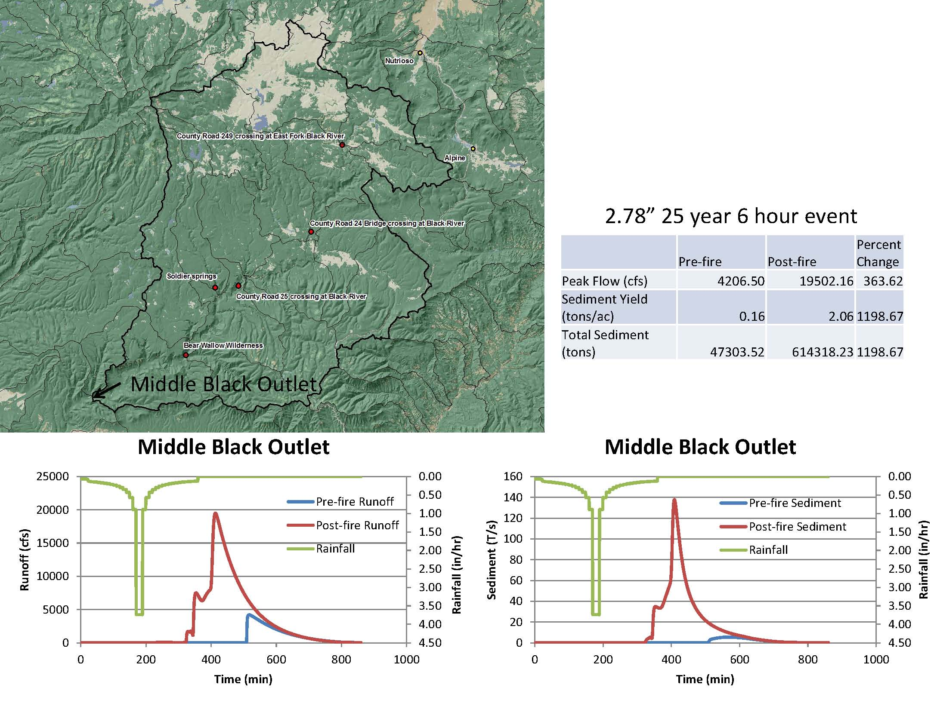
Campground and recreation impacts along Black River
Personal property such as vehicles, camping equipment, and other recreational items along the River will be subject to the same “Risks to human life from flooding along Black River”.

Risks from flooding to the Bridge at Black River Crossing
Rapidly rising stage in the Black river is possible during monsoon and winter storm events. The risk of occurrence will be the greatest during storm events for the first year and the risk will typically reduce to pre-fire levels after five years. Inside the fire boundary in along the Black River will be subject to the most rapid and largest rises in stage. This effect will be moderated as flood event passes farther downstream along the Black River and may be negligible by the time the flow events passes Black River Crossing. No structural treatments to the bridge are recommended.

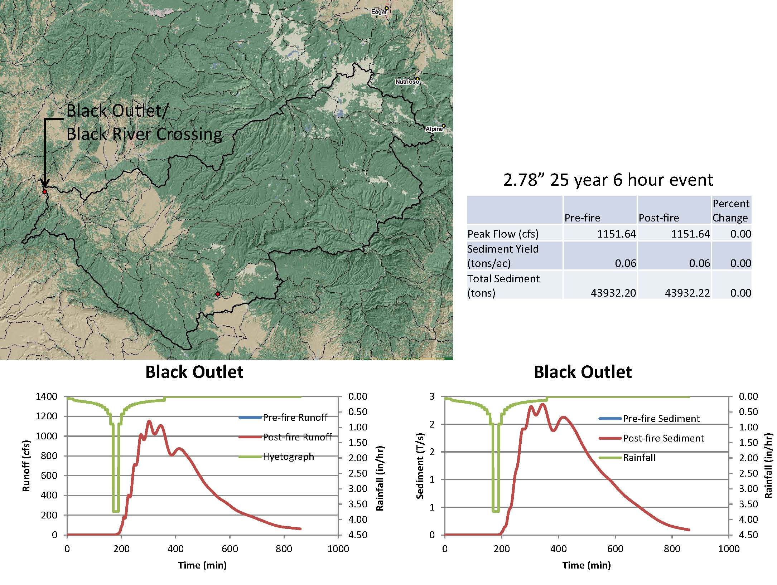

Risks from flooding to the Black River Pump Station
Rapidly rising stage in the Black river is possible during monsoon and winter storm events. The risk of occurrence will be the greatest during storm events for the first year and the risk will typically reduce to pre-fire levels after five years. Inside the fire boundary in along the Black River will be subject to the most rapid and largest rises in stage. This effect will be moderated as flood event passes farther downstream along the Black River and may be moderate by the time the flow events passes Black River Pump Station. However, fine sediments, ash and floating debris are expect to transported by the Black River to this area and further downstream creating operational and maintenance problems for the Pumping Plant. No hazardous materials are stored in or near the pump station. Biodegradable (vegetable based) lubricants are used for the pumps. Sediment and debris removal treatments to the pump station are recommended.

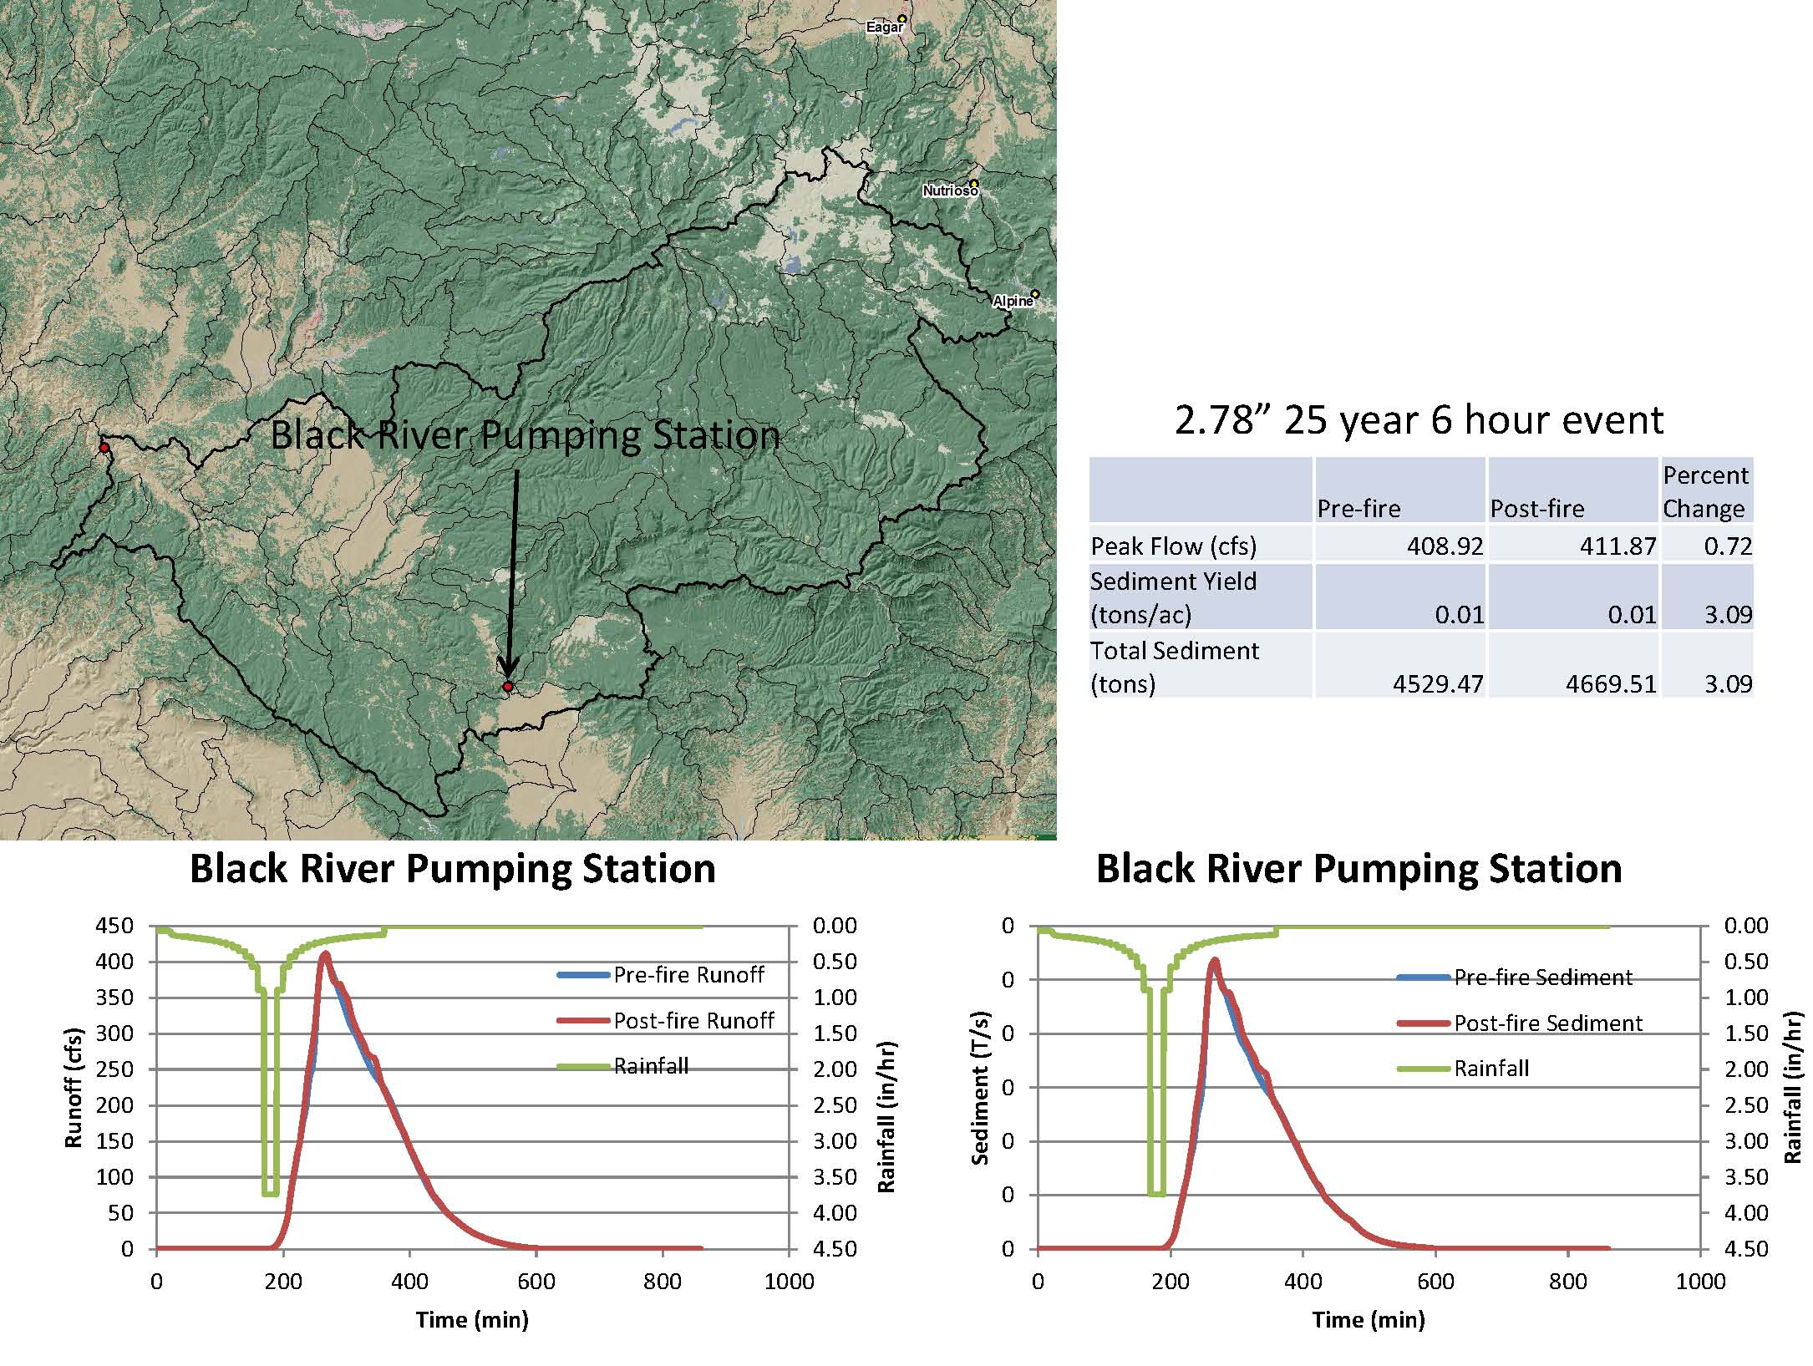
Increased erosion and sediment delivery into streams affecting water quality
The primary areas of erosion will be on areas with high soil severity. The fine material will go into suspension and increase the turbidity of the water. Course sediments will move as bed load through the river system. Ash flows will adversely affect water quality during the first storm events. After the initial flush of ash, the impact to water quality will be minimal. No hillslope treatments are recommended on land located in either reservation.

Loss of road infrastructure and access
Roads on the reservations and inside the burned area are typically graded dirt roads. The creek and drainage crossing are built to keep the water in the channel after crossing over the road. Very few culverts were seen. Annual and seasonal road maintenance should keep these open and passable. The low soil burn severity and mostly intact forest canopy will greatly moderate the risk of road damage due to storm events above what would normally occur in a well managed unburned forest. No treatments are recommended.

Critical Natural Resources
In consultation with BIA, WMAT, and SCAT resource managers, two critical natural resources were identified within or downstream of the Wallow Fire.

Increased sediment delivery to Soldier Springs Creek
Soldier Springs and creek lies mostly within the FAIR. The lower portion of the creek is within the Apache National Forest. The resource at risk is a genetically distinct population of Apache Trout. Pre-fire and post-fire hydrology was modeled on the watershed along erosion rates show a low risk to the Apache Trout in this watershed. Given the present and historic distribution of Apache Trout, it is apparent they are adapted to watersheds frequented by low intensity and/or mosaic fires. No treatments are recommended.

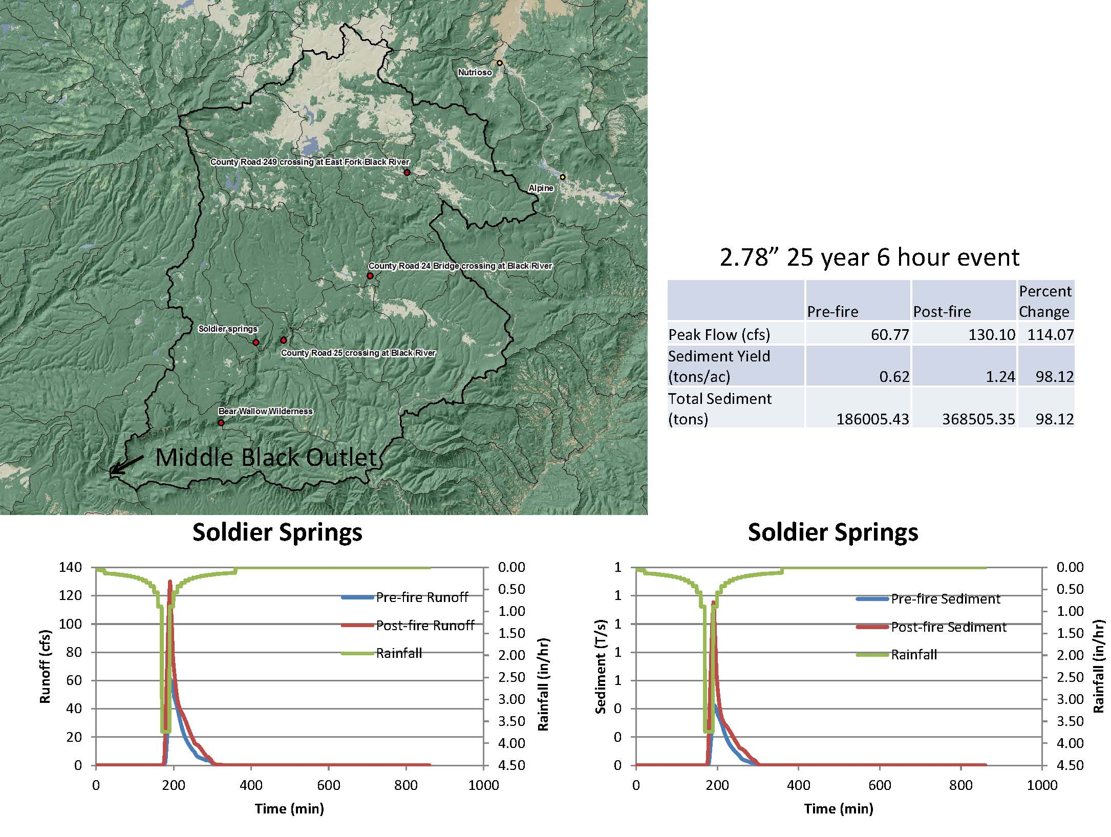
Increased sediment delivery to Bear Wallow Creek
Bear Wallow creek lies mostly within the Bear Wallow Wilderness Area and the creek outlet is on the SCIR. There is no vehicle access in the wilderness area. Visual assessment was done by helicopter to familiarize the BAER Team with the watershed and burned area characteristics. The resource at risk is a replicate population of Apache Trout. Pre-fire and post-fire hydrology was modeled on the watershed along erosion rates show a low risk to the resources of concern in the watershed. Given the present and historic distribution of Apache Trout, it is apparent they are adapted to watersheds frequented by low intensity and/or mosaic fires. No treatments are recommended.

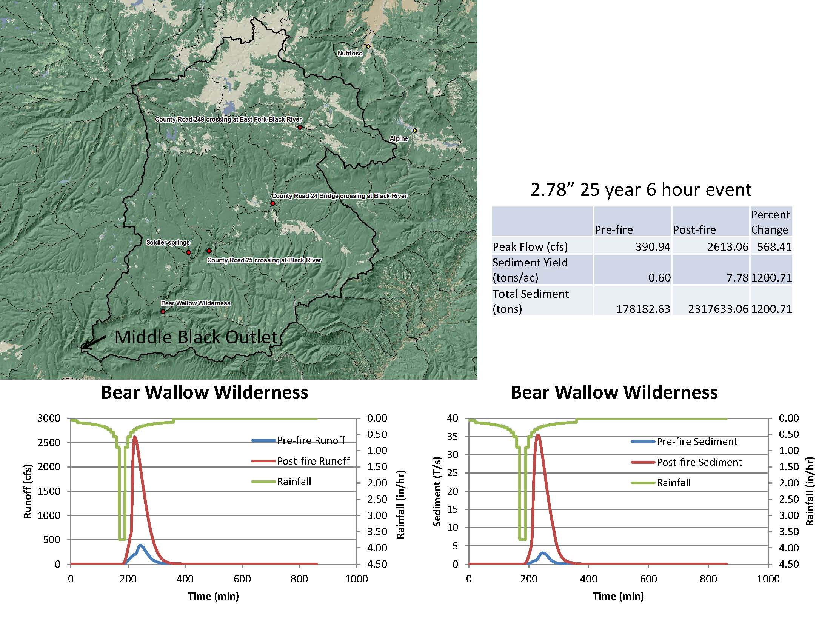
RECOMMENDATIONS

After field reconnaissance by BAER Team members have the follow recommendations (by issue):

Flood Warning Signs and Gates (Specification)
It is recommend that the area in and adjacent to the Black River boarding the two reservations be posted with flood warning signs as per the specifications. During periods expected rainfall and increasing flows, vehicle access roads be gated and closed as per the specifications. While the modeling does not show effects past the Pump Station, the model does not take into account debris flows and unstable blockages due to debris in the river. It is prudent to implement this specification to protect lives. It is also recommended that the roads and trails entering the burned area be posted with “Entering Burned Area” warning signs as per the specifications.

Pump Station Sediment Removal (Specification)
This specification includes the removal of sediment and floatable debris that will interfere with water flow in the intake channel for the pump station. The specification also includes the removal of sediment within the pump bays. This specification is only for one year after containment date of the Wallow Fire.

Non- Specification Management Recommendations

Public safety with in the river corridor of the Black River would make it prudent to close these areas to all access. It is recommended both Tribes closed these areas to the public and tribal members through the first monsoonal (2011) and winter storm season (2011-2012). Closure during the second monsoonal (2012) season should be evaluated in May/June 2012 to determine if the watershed within the Black River watershed have recovered sufficient to warrant this action.

REFERENCES

McKay, E.J. 1972. Geological map of the Show Low quadrangle, Navajo County, Arizona: U.S. Geological Survey Quad Map GQ-973, scale 1:62,500.

Moore, R.T. 1968. Mineral deposits of the Fort Apache Indian Reservation, Arizona: AZ Bur. Mines Bull 173, 321 pp.

USDA and DOI BIA – in cooperation with Arizona Agricultural Experiment Stations, 1981. Soil Survey of Fort Apache Reservation, Arizona – Parts of Apache, Gila, and Navajo Counties.

USDA-Forest Service, Southwest Region, 1983. Terrestrial Ecosystems Survey of the Apache-Sitgreaves National Forest.

USDA-NRCS, National Cooperative Soil Survey, Official Soil Series Description website,
https://soilseries.sc.egov.usda.gov/osdname.asp.

USDA-NRCS Soil Survey of the San Carlos Indian Reservation, Arizona, Parts of Gila and Graham counties, 2009. selected tables provided by the BIA-San Carlos Agency Natual Resource Staff.

Winters, S.S. 1963. Supai Formation (Permian) of eastern Arizona: Geological Society of America. Memoir 89, 99 pp.

Wallow Fire BAER Watershed Assessment Team:

Brian Rasmussen, Geologist, National Park Service (530) 242-3444
Steve Wangemann, Soil Scientist, Bureau of Indian Affairs (509) 961-2474
Chuck Jachens, Hydrologist, Bureau of Indian Affairs (916) 261-6756

