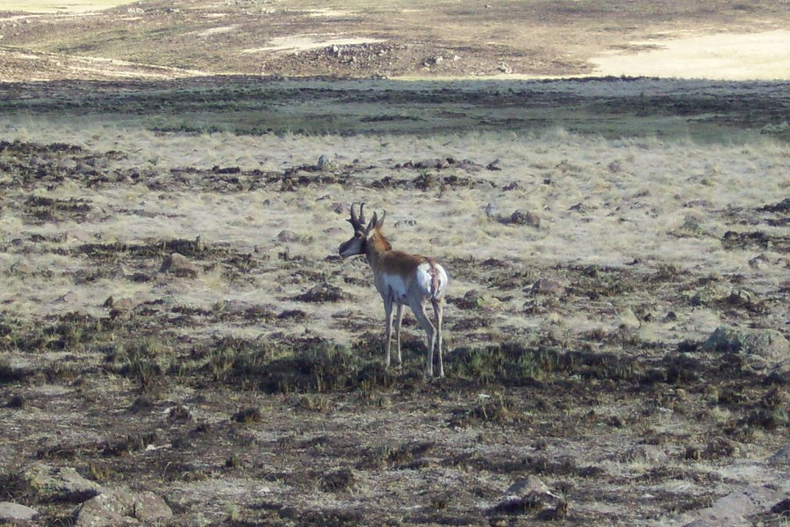
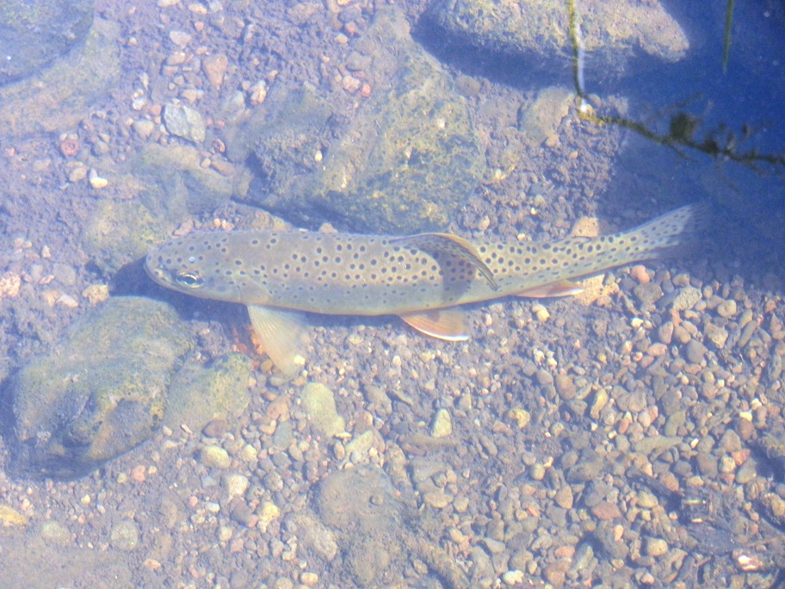
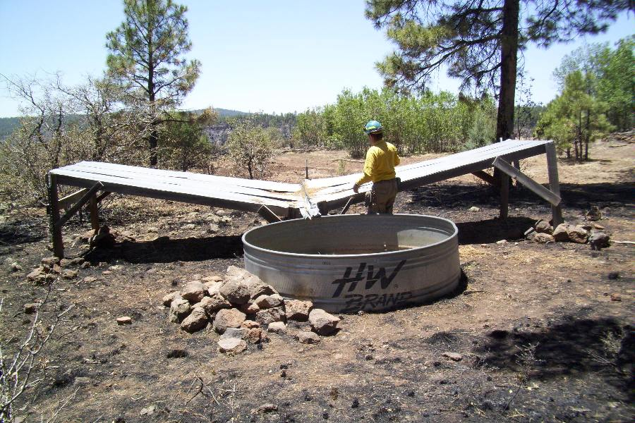
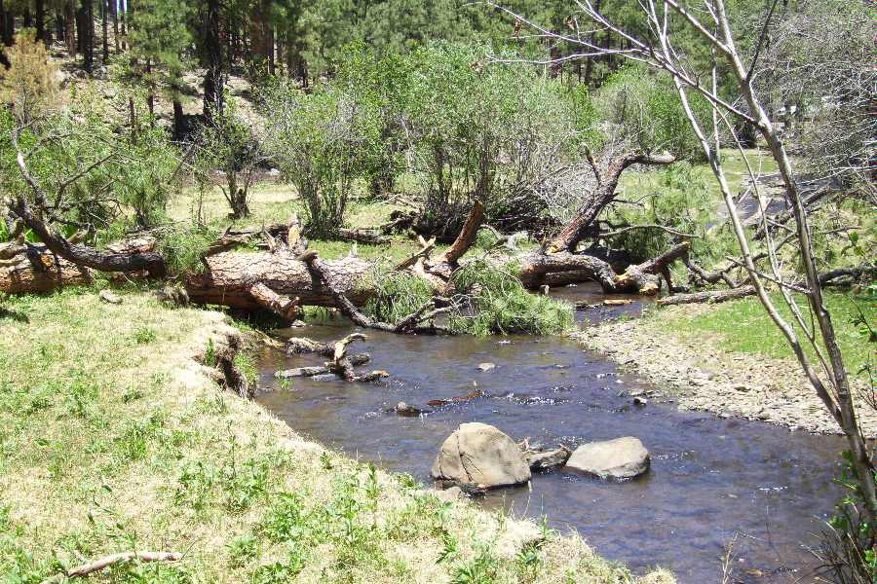
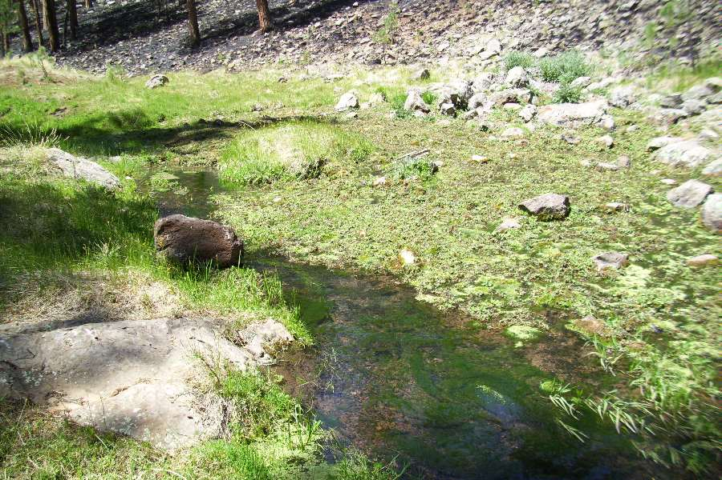
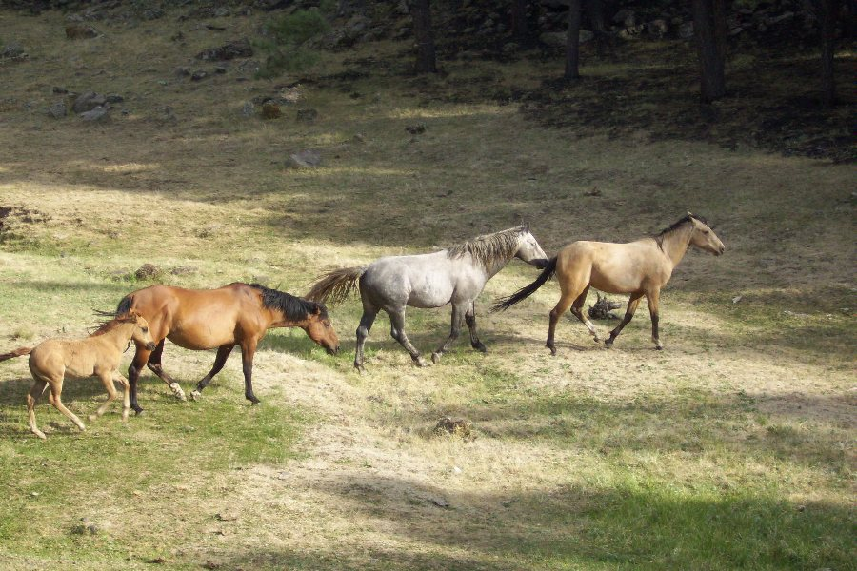
Bighorn Sheep Guzzler at Rattlesnake Point Large Woody Debris Recruitment_Pacheta Creek
Soidier Springs Apache Trout Habitat Unauthorized Livestock in Burned Cienega
Antelope Buck in Burned Cienega Apache Trout
Wildlife Resource
Issues

