Aircraft3 Support

Support Initiation
- The initial notification will come from Tom Mellin unless the Nat’l IR Desk has been activated, in which case the notification could come from me.
- Notify Joe by phone (571-557-6441). Send follow-up email to Joe and Gregg Heitcamp (current branch chief, Joe’s boss) with fire name and coordinates. CC email to USGS Lakewood analysts.
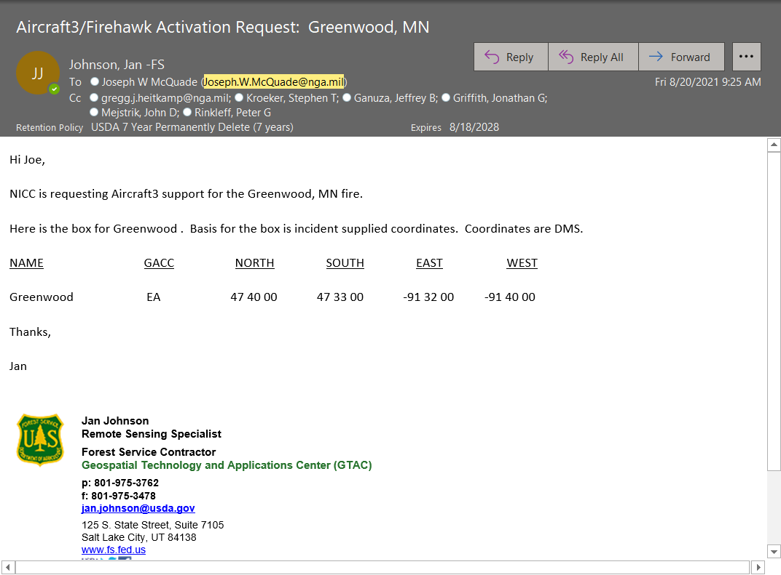
- Joe and the USGS analysts have access to the IR Online Ordering so if the IR request is posted, he can download the scan box. If there is no order, use MODIS and VIIRS detects to give Joe a coordinate box over the phone. Give him coordinates in DMS and be sure to give Joe the longitudes as negative coordinates.
- Send an email notification to the CAC, NICC, NIFC, FS, GTAC, cooperators for the GACC being supported. Also cc the GACC IR Liaison for the GACC where the fire is located as a courtesy.
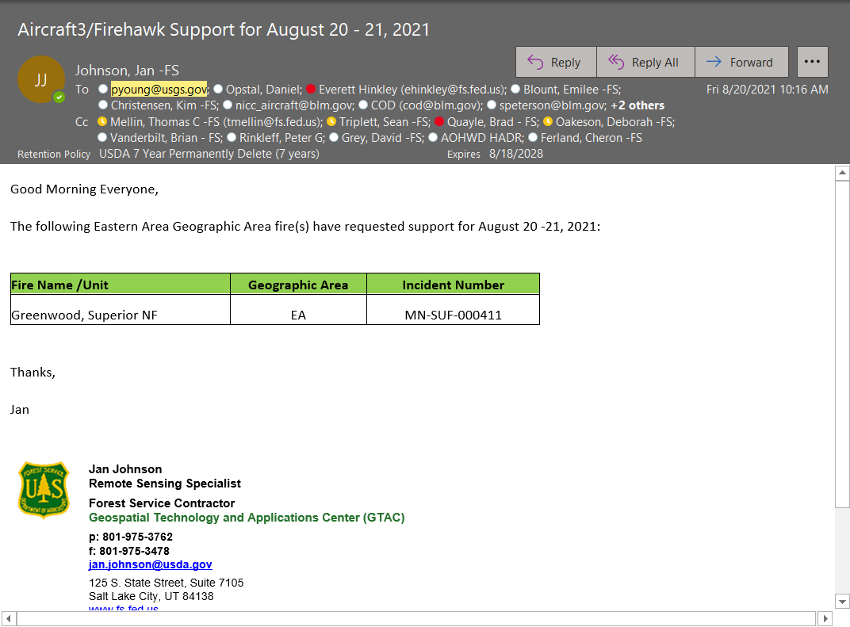

- Send a separate email notification to Frank Toomer, NRO. Frank is on the data acquisition side of Aircraft3 support and wants to be kept in the loop.
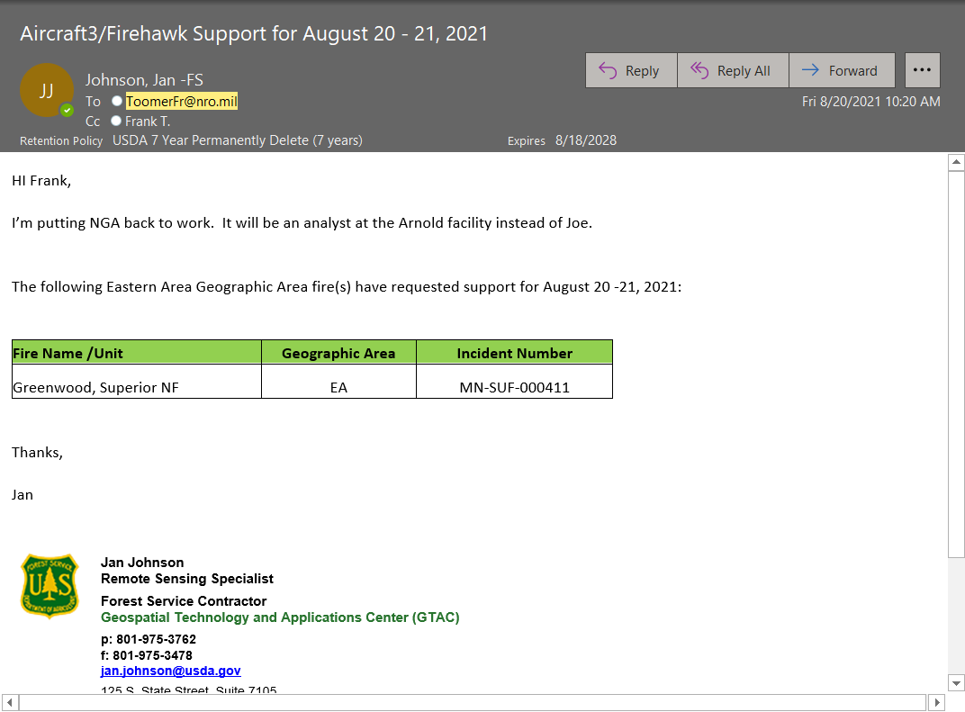
- Send an email to incident contact detailing Aircraft3 support to the incident. Follow up with a phone call.
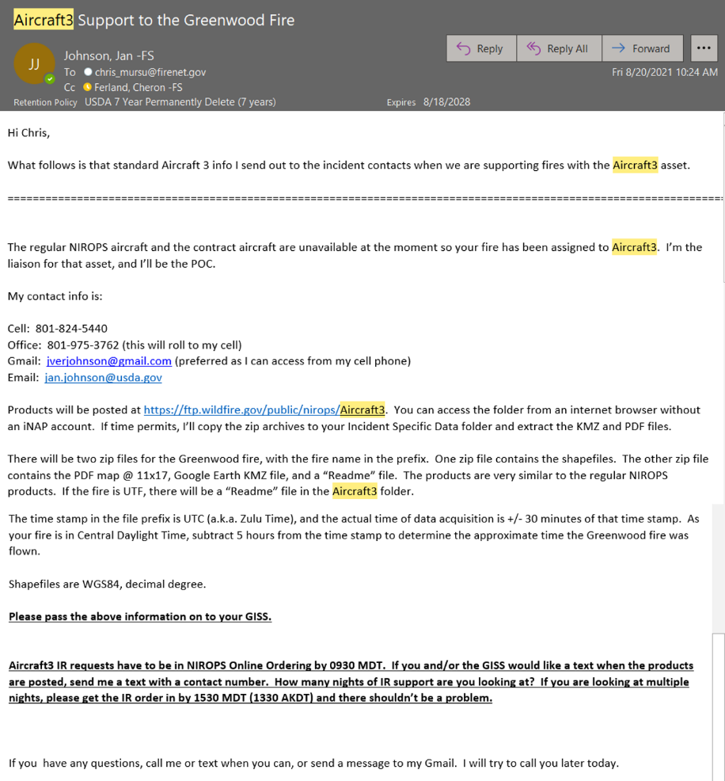

Daily Support Activities

Evening Activities
- Download the incident perimeter(s) from NIFS if available and edit out the extraneous attribute fields from the attribute table. I usually do this around 9 – 10 p.m. unless I get a text from the incident contact (GISS) indicating when the updated perimeter will be posted. If the incident says to use the previous perimeter as the starting point for the night’s interpretation, send an email to Joe and the USGS analysts saying they should use the previous night’s perimeter as the starting point for tonight’s interpretation work.
- The reason that the perimeters need to be edited for the Aircraft3 analysts is that Firestarter needs “clean” perimeter shapefiles as input. Firestarter is a Python script that the NGA and USGS analysts use to compile interpreted polygon and point features into their respective layers. Unlike the Phoenix or Overwatch TK-9 imagery, the Aircraft3 data is not interpreted in ArcMap or ArcPro.
- Perimeters from the NIFC Open Data website and from WFDSS would need to have the extraneous attribute fields removed as well if you have to utilize them. Perimeters from these websites only have date stamps, no time stamps and have fewer attribute fields to edit.
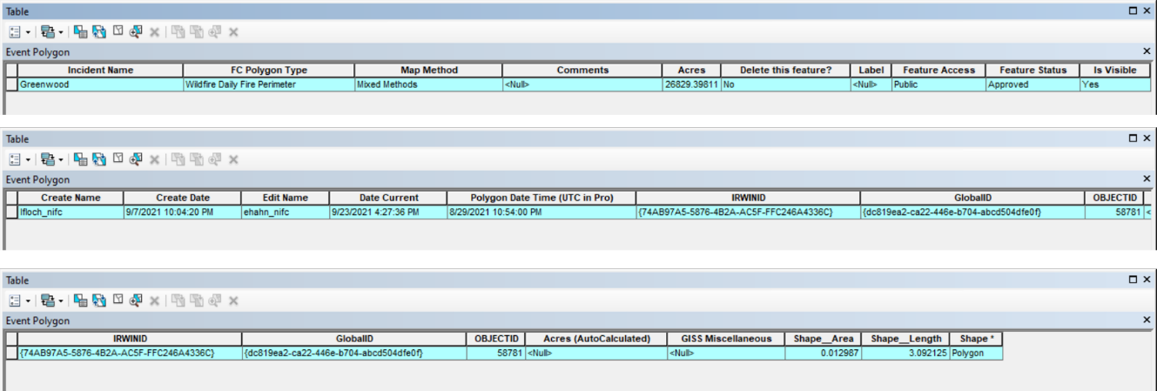
- The edited shapefile perimeter attribute table should look like the example below.
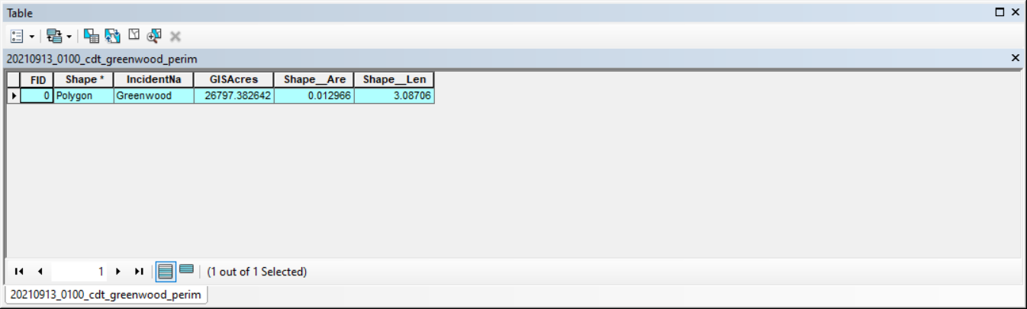
- Post edited perimeters to the Aircraft3 folder and email the zip archive to Joe and cc the USGS analysts. Make sure the zip archive has timestamp in prefix. Perimeter date/time can be found in “Date Current” attribute field. Note the date/time before exporting the perimeter as a shapefile. The “Time” part of “Date Current” field is truncated when exported to a shapefile and only the date is retained. Change the “.zip” suffix on the archive to “.piz” to get it through the NGA firewall.
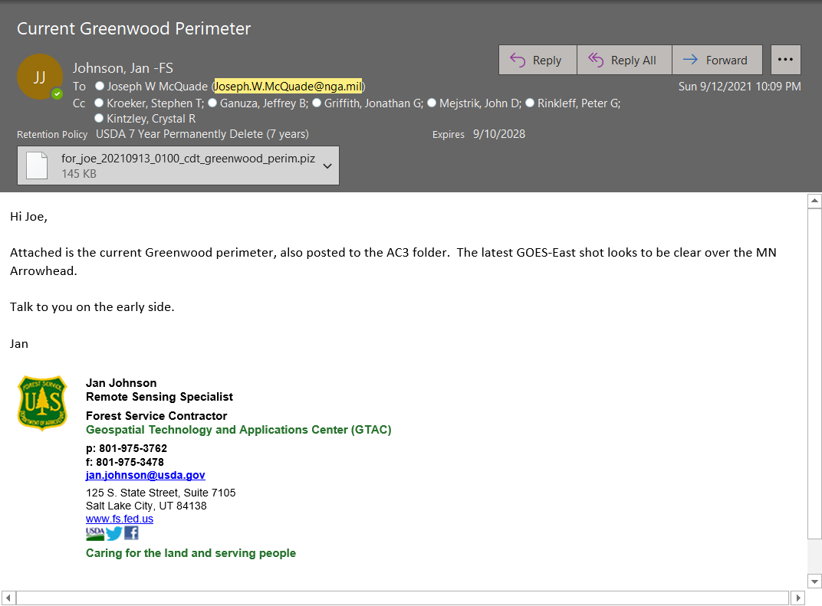

Morning Activities
- Timing: The GISS start looking for IR products around 0330 – 0400 local time. Alaska and Pacific time zone fires are easier as the time zones work in our favor. With Central and Eastern time zone fires it’s harder to make the desired delivery time to the incident.
- Download Aircraft3 zip archives to your local drive and unzip to do a quick QA/QC. One, this ensures the zip archives aren’t corrupted. Two, it gives you a chance to look at the PDF map, the readme, and the KMZ. If there are problems with the files, call Joe and let him know so the files can be reposted.
- Copy zip archives to Incident Specific Data IR folder if time permits. Copy PDF, KMZ and readme to the IR folder as individual files. Text the incident contact (GISS, SITL), if requested, that the products have been posted, or UTF’d. The incident may also want products to be emailed as well as posted to the Incident Specific Data folder. The incidents are usually pretty good about putting in the GISS contact number in the IR request in the User Comments block. Email addresses are usually entered in the Deliverables block.
- Update the Aircraft3 order status in the IR Online Ordering, i.e., “Completed”, “UTF”. If the incident is UTF, we have Aircraft3 specific reasons in the UTF pick list.
- Follow up with the incident contact after the 0600 local morning briefing. Things to check with incident about: IMET weather forecast; estimated IR support duration, especially if the fire goes into the weekend; will there be an updated incident perimeter later in the day, etc. If it’s something simple, like “IR tonight?” a text message works as well as a phone call.
- Follow up with Joe before 0930 Mountain with any incident feedback or changes in the scan box.
- As there have been analyst staffing issues the past two years, Joe will let you know about potential coverage gaps. If that occurs, let Tom and the incident know and note that in the update email.
- Send update email to CAC, NICC, NIFC, FS, GTAC, GACC IR Liaison cooperators. This is done daily while Aircraft3 is active.
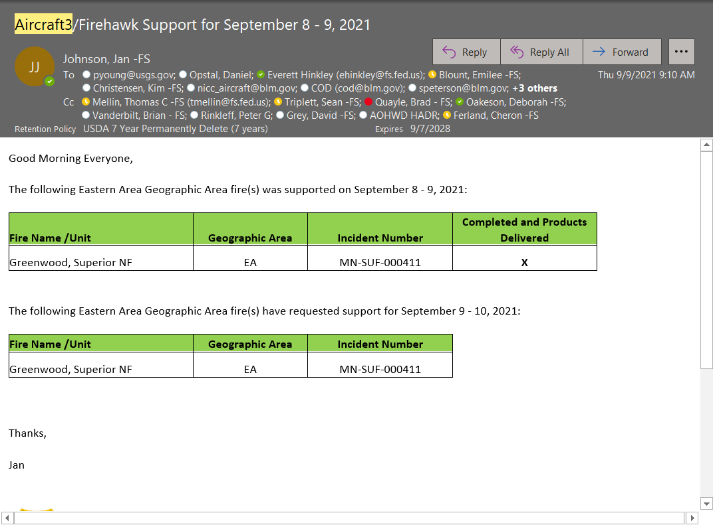
- Send a separate email notification to Frank Toomer, NRO. This is done daily while Aircraft3 is active.
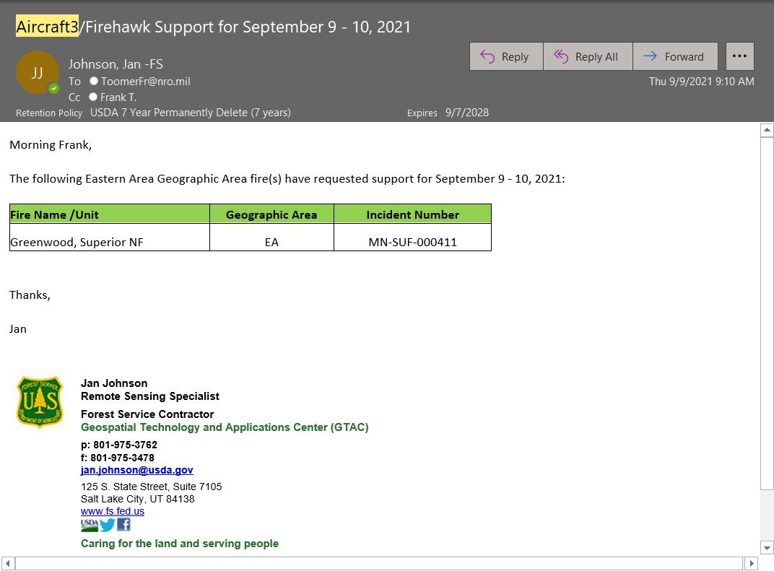
- Update the Aircraft3/Firehawk tracking sheet on Bubba.
- Delete previous perimeters from Aircraft3 folder before posting new incident perimeters to the folder. Do this in the late afternoon or in the evening before checking for updated perimeters.

