On-Board Processing (OBP) 2015 Manual

Table of Contents
Introduction 1
Overview 1
Basic Operation 3
About the System 3
AMS Data Format 3
Naming conventions 5
Running the System (see also the “Cheat Sheet” for running the system) 5
Set-up 5
Start up the ground system software 7
System Test 8
Collecting a target or mission pass 9
Targets of Opportunity 9
Concluding a Mission 10
Chat Client 10
Detailed Ground Gui Descriptions 10
The Main Window 10
The Log Window 12
The Target Display Window 12
The Image Viewer Window 13
Image Processing Bar 14
Product Descriptions 15
Fire Radiative Power 15
Normalized Burn Ratio 15
Hot Spots - Daytime 16
Normalized Difference Vegetation Index (NDVI) 16
Ground Temperature (GT) 17
Visual Product 17
The Checklist 17
17
Command-line Request Syntax 18
APPENDIX 18
Important Files onboard 18
Environmental Variables 20
The programs, scripts that run things 21
Database Management and Set-up 24
Detailed Table descriptions 25
Trouble Shooting Notes 26
Listing of segment sizes and nadir resolutions relative to scanrates and altitudes 28
Cheat Sheet for Running the OBP 29
REMOTE COMMUNICATIONS 32
Sending commands and monitoring the status of the on-board computer 32
Receiving products at the ground station 32
Error checking file transfer 32

(blank page)

On-Board Processing (OBP) 2015 Manual
S. Buechel swbuechel@comcast.net

Introduction

The On-Board Processing system (OBP) for the AMS scanner is a set of C and C++ programs designed to accept incoming AMS channels, create output products from the data and send them over telemetry to a map server in near real-time. The programs are designed to be used with any scanner type sensor using the AMS style data format and will easily support the addition of new data processing algorithms. The OBP is a Linux based system, currently running on CentOS 5.8 and 6.5. The on-board computer communicates with a "ground station" computer which manages the GUI interface (structures requests) and provides a QC display and segment mosaicing capability. The ground station may be run on-board or remotely (actually on the ground).

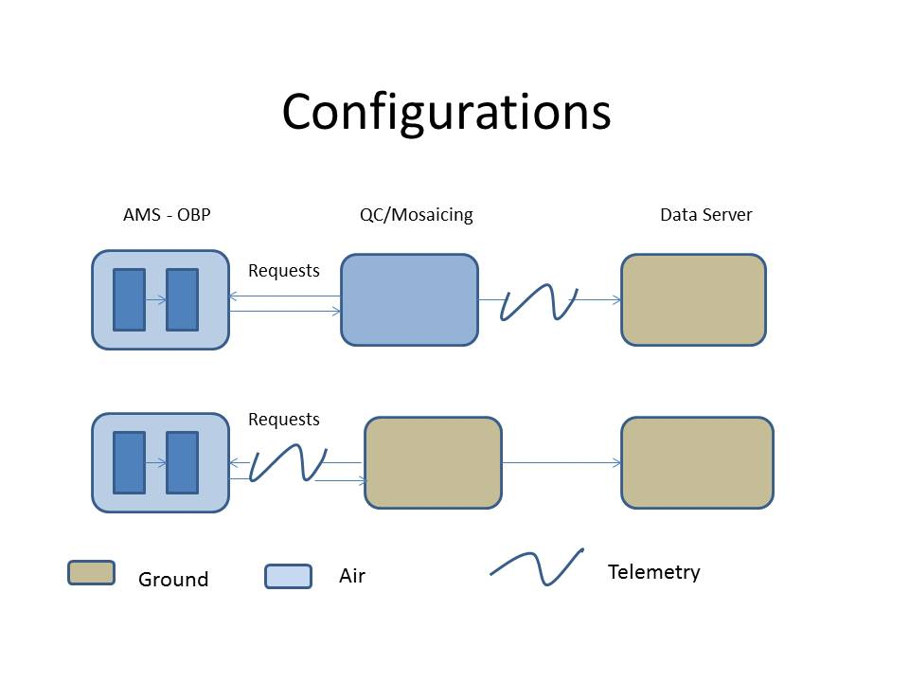
Fig. 1

Overview
The OBP system is designed to operate almost autonomously and the documentation will begin with this simplest perspective and proceed into greater depth and detail. The OBP system runs on an on-board computer called linkmod which is part of the AMS data processing functionality. This system receives data lines from another on-board computer which manages the scanner itself and integrates position and attitude information provided by a POS/AV system. When a request for a data product is received, the OBP triggers the processes required to create and send data segments and associated files to the ground station. This information can be reviewed and mosaicked on the ground station and sent on to a map or file server for access by an end user. For near real-time viewing, the individual segments can be displayed directly using Google Earth or some other image display capability. Developed initially for fire response, the current algorithms offer hot spot detection, NBR, and FRP product options. The processing time per segment is currently about .008 sec./line for a 3-band output product plus whatever telemetry time (this will vary by the system used). The products currently supported include:

Night time 1 hot spot detection (0)
1 band georectified image - AMS band 12,11
Shapefile of detected hot spots

Night time 2 hot spot detection (1 )
3 band georectified image - AMS band 12,11,11
Shapefile of detected hot spots

Day time 1 hot spot detection (2)
3 band georectified image - AMS bands 12,9,10
Shapefile of detected hot spots (1 - 3 classes)

Day time 2 hot spot detection (no product number)
3 band georectified image - AMS bands 12,9,11
Shapefile of detected hot spots (1 - 3 classes)

Visual BAER plus hot spot detection (3)
3 band georectified BAER image - AMS bands 10,7,9
Shapefile of detected hot spots

NBR image and Visual BAER (4)
3 band georectified BAER image - AMS bands 10,7,9
1 band georectified integer Normalized Burn Ratio image
AMS bands (7-10/7+10) * 1000 + 3000

FRP and hot spot detection (5)
3 band georectified image - AMS bands 12,9,10
1 band georectified Fire Radiative Power image (fire pixels only)
FRP * 1000

CIR and hot spot detection (6)
3 band georectified image - AMS bands 7,5,3
Shapefile of detected hot spots

NDVI with CIR (7)
3 band georectified image - AMS bands 7,5,3
I band georectified interger NDVI image
AMS bands (7 – 5/7+5) * 1000 + 3000

CIR and Ground Temperature map (8)
3 band georectified image – AMS bands 7,5,3
1 band georectified integer deg. Kelvin * 1000 derived from AMS channel 12 or 16

Generic - the user can select any set of 3 or single AMS band for output as a georectified image (up to 5 to include algorithm bands), for example just band 8 could be selected, or a real color image such as AMS bands 4,5,3 might be selected.

Note: for product 4, the normalized ratio bands can be specified to produce an arbitrary output by setting r1 and r2 in the map2.ini file appropriately. For the NBR, r1 and r2 are set to 10 and 7. The NDVI bands are hardcoded for product 7.

Basic Operation

In its simplest configuration, the OBP can be operated from a GUI on the "ground station". With proper database setup, this involves selecting START to begin the data collection and processing, and LINE END or DONE to complete a line(run) or "mission" (i.e. pass) respectively. The system will attempt to transmit the segments to the ground station as they are completed (if autosend is turned on in the startup.ini file).

A log file is written for each LINE END or DONE and its transmission triggers segment processing on the ground station in preparation for mosaicing and transmission to the final ftp server. Segments may be sent on from the ground station to a map server for real-time display and/or be mosaicked into "mission" lines or a full target mosaic.

Operation in the purely START/DONE mode, requires that the requested product for a "mission" box and its spatial extent be loaded into the flight database. For targets of opportunity, or changes in plan, a request may be specified from the GUI as well. This can be done by selecting, minimally, a product type and a target name. Other options may be specified as well, or a completely custom request entered.

The GUI assembles and sends the information for the triggering of a "request" for the operator. The system can also be operated directly from the command-line on the on-board system by entering the "request" manually, but the ground system also monitors the buffer status and start delay timings, so operation in this mode is more challenging.

About the System

The OBP consists of 5 processes running on the linkmod computer of the airborne system. The Buffer Manager reads the initialization files, accepts all 18 channels output by the AMS into a continuous ring buffer and organizes metadata needed by other processes. Upon receiving a request, the Map Manager extracts the requested bands and hands them off to the Mapper, queuing data if the Mapper is not available. The Mapper runs the data algorithms, georectification, output formatting and attempts transmission to the ground station of each segment it receives from the Map Manager (if autosend is selected). A separate process receives the ground station request,information and launches the actual Request which interacts with the Map Manager and monitors the timing for triggering multiple segment requests. The request formatting process also monitors the buffer status and queries the SQLite database relative to current position for automated request retrieval.

The "ground" portion of the processing consists of a set of processes which assemble the request information and communicate it to the on-board computer (linkmod), as well as processes which watch for incoming imagery/log files and initiate processing of incoming segments. There is also a set of processing programs allowing the operator to view and mosaic segments and shapefiles as desired. Data are forwarded on to the map server after QC by selecting one of the “SEND” functions from an image viewing window.

The system interacts with a spatial database (SQLite), to determine location relative to desired targets and to log requests and data collection history. Both the on-board and the ground system maintain a database which must be loaded with targets if automated identification is to be used. Use the checklist.tcl to load information from the flightdata.xml file on the ground station and then transfer the set up to the linkmod system.

AMS Data Format

The AMS data, as collected by the scanner, consists of 16 imagery bands and 2 bands of metadata for a total of 18 bands stored in band interleaved by line (BIL) format. A raw data line is 744 unsigned short integers across, 716 data pixels, and 28 additional line header pixels, times the 18 channels. A raw segment consists of 744 unsigned integer pixels across, by the the number of lines specified for a segment (see startup.ini, this has historically been set to 1200, but recently reduced to 600 and is set in the startup.ini file), by the specific channels specified in the request. This may be up to 5 channels. Raw segments are not saved unless the debug parameter in the map2.ini file is set to "2" in which case a non-georectified radiance or temperature image can be saved. (Note, all the raw data are saved to disk on the uavsys computer onboard). The final georectified segments will be of varied line/samples and are telemetered as a *.map file and a *.tfw file which are converted to GeoTiff format at the ground station. The processed segments are in "geographic" format with the lines, samples, bands, and band combination included as the last lines in the *.tfw file. Note that the pixels in the file are equal meters not equal degrees, though the tfw file spec requires that a degree value be used. A jpeg2000 optional final format can be supported with the addition of the Kakadu libraries (requires a license). This is not currently included with the system, but has been historically and could be.

Output products such as NBR, NDVI, FRP, and Ground Temperature (GT) also produce a single band file denoted as *.nbr, *.nvi,*.frp, or *.deg which are converted into *.c.tif, *v.tif, *.f.tif, and *.d.tif respectively. These files are unsigned integer in format and must be scaled or pseudo-colored for viewing. A scaled version of the integer data is automatically produced with the name *<code>sc.tif (e.g. *nbrsc.tif) for easy display when a segment is mosaic'd.

*.map georectified segment; either 1 or 3 bands (unless debug = 2, then 2 or 4)
A byte, band by band raster image

*.tfw tiff world file for the segment; includes two extra lines of information at the bottom;
lines, samps, number of bands
gpstime, bands in RGB order

*.nbr if NBR was selected as the algorithm, this file is produced; single band, unsigned int
NBR * 1000 + 3000

*.nvi if NDVI was selected as the algorithm, this file is produced; single band, unsigned int
NDVI * 1000 + 3000

*.frp if FRP was selected as the algorithm, this file is produced; single band, unsigned int
FRP * 1000; for pixels id’d as fire only; background value=0

*.deg if Ground Temp. was selected as the algorithm, this file is produced; single band, unsigned int
GT (deg K) * 100

<firename>_<pass>_<line>.log contains the segment name, footprint, and pass information
for segments collected between a START and LINE_END or
DONE; used by MOSAIC to organize segments.

e.g. of a “mission” log file entry containing two segments

Jan2713_1947_1_1.map 2 37.2189888,-116.9847663 37.2057889,-116.787766 0 3
Jan2713_1947_1_2.map 2 37.2058987,-116.9847888 37.2017889,-116.987871 0 3
DONE Test_vlt1 1 1

<segment> <algorithm> <upper left coord> <lower right coord> <debug mode> <bands>
DONE <firename> <pass> <line>

File trailer conventions after conversion to geotif format:

*.tif geotiff conversion of the map file
*.c.tif geotiff conversion of the *.nbr file
*.f.tif geotiff conversion of the *.frp file
*.v.tif geotiff conversion of the *.nvi file
*.d.tif geotiff conversion of the *.deg file
*_sc.tif geotiff conversion of a byte scaled file (generally an *.nbr, *.nvi, *.deg or *.frp file)
*_sc_color.tif geotiff conversion of a byte scaled, pseudo-colored file

Naming conventions

Individual segments are automatically named. The name consists of an operation name created using the date and time that the OBP session was started along with a line and segment number. For example, Oct1112_2046_5_16.map is the georectified segment collected during the Oct. 11, 2012 at 20:46 GMT session, as segment 16 of line 5. Whenever the OBP is stopped and restarted, a new time will be assigned and the segment sequence will start over.

The segment numbering is continuous for a session to make it impossible to produce a duplicate name. For example:

Start 1_1 1_2 1_3 Line_End...Start 2_4 2_5 Line End...Start 3_6 Done

would be an example sequence with 6 segments and 3 lines. Line 1 consists of 3 segments, Line 2 of 2, and Line 3 a single segment, while the "mission" or pass produced 6 segments. There would be 3 log files written for this sequence:

<Targetname>_pass<x>_1.log
<Targetname>_pass<x>_2.log
<Targetname>_pass<x>_3.log

The “pass” over a target is monitored by the database and automatically incremented.

When the ground GUI is used to trigger a collection, a target name is assigned to the set and any mosaics made from associated segments will be assigned the target name. The name may be entered by the operator or selected by location from the database. An example output name would be Eagle_Oct1112_2046_mosaic_pass1.tif, the first geotiff mosaic of the Eagle Fire from the flight on Oct.11, 2012 begun at 20:46. The associated segments would be listed in the log file(s) used to make the mosaic. These segment names are primarily set up for the automated system management convenience not for the operator and the operator can just deal with logfiles and mosaics which can be lines, or full target mosaics.

To support data management at the “line” level, mosaics made from a single log file retain a line number in the name to differentiate them from a full multi-line target mosaic. For example:

Eagle_Oct1112_2046_mosaic_pass1_1.tif

would be a mosaic of segments making up the first line in the first pass over the Eagle Fire, while

Eagle_Oct1112_2046_mosaic_pass1.tif

would be the full target multi-line mosaic.

Running the System (see also the “Cheat Sheet” for running the system)

Set-up

There is a new program called checklist.tcl to step you through the set-up process. Because the linkmod system has no gui on it, the Checklist must be run on the ground station and the modified files transferred to the linkmod. With the two networked, this transfer is a simple push of a button.

On the Ground Station (ams_grnd) -

- Check that .cshrc on the ground station has the correct address for $OBP_COMM (i.e. set to linkmod, or the address of linkmod (or the address for Inmarsat) It should be blank if you're running locally. This generally will only change if you've been running tests on the ground station. Type echo $OBP_COMM to see the setting.

- On the ground station, if the address of the linkmod telemetry system has changed, edit $HOME/firewall.txt to allow the airborne and ground stations to communicate if using autosend=1. This allows automated ftp access through the firewall just for the airborne system. If you have a static address for the remote platform you shouldn't have to edit it, but with a dynamic address, it will be new every time and you'll have to edit the file. You'll also need to set that address in the .cshrc file (see OBP_COMM, or edit the /etc/hosts file address for linkmod. probably easier to edit the .cshrc file, but you need to do that before you run start_grnd.scr). When you change the .cshrc file within a session, your must run source .cshrc and the new value holds only for that window.
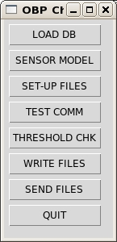Fig. 2 The Checklist (checklist.tcl)

- Select LOAD DB from the Checklist gui to load a flightdata.xml into the ground station database.The flightdata.xml should be placed in the $HOME/db directory prior to running this. The function will backup the current database (always flight1.db) to files called flt1_data<date>.txt and flt1_data<date>i.txt, and then will load the flightdata.xml information into flight1.db. The flight1.db file will be copied into the $HOME/db directory on linkmod when SEND FILES is selected if linkmod is available on the network

- Select SENSOR MODEL to view the current sensor model on the ground station. This is file $HOME/sensor_data/tch_li.sen and is relevant only on the linkmod system (unless running testing/post processing on the ground station), but can be selected on the ground station for tranfer to linkmod with the SEND FILES option.

- Select SETUP FILES to check the settings in the map2.ini and startup.ini initialization files. Only the settings which are commonly changed are included here. If happy with the settings, just quit. If you change settings, select Save to update the files. These files will be transferred to the $HOME directory on the linkmod when SEND FILES is selected.

- Run TEST COMM to test that the connection between the ground station and your server (the NIFC site in the case of the Forest Service) is working. You will see either Failure, or Success in the output window. If this is not working, the Send Img and Send file commands on the viewing windows will fail.
***Note that this is a different connection from the air to ground station link.

- Run THRESHOLD CHK to check the settings for the thresholds used in the CCRS algorithm. There are four values that can be set: Mid-IR Threshold, Far-IR Threshold, the Difference, and a Reflectance cut-off value. The Mid-IR value generally ranges between 360-390, though can be lower at night. The Far-IR value ranges between 280 – 290, and the Difference between 12 and 14. The Reflectance cut-off is generally .4 (reflectances higher than .4 are rejected). All these thresholds need further work on optimization for particular conditions, but these value ranges should give decent results unless its a nighttime flight (AMS has not often been used at night) or other special conditions. After confirming the desired settings, save them and the $HOME/sensor_data/thresh2.vals file will be transferred to linkmod when SEND FILES is selected. Note that these values can be changed in real-time during an operation using the ground gui so it is not critical to set them ahead of time.

- Run WRITE FILES to write the settings to a file (setup_lm.tar) for transfer to the linkmod .

- Run SEND FILES to transfer the selected settings to the linkmod. If linkmod is not available on the network, this will be stated and the transfer will fail. You must be networked to linkmod. If this is not possible for some reason, you can manually transfer and untar the setup_lm.tar file. This should be done from the linkmod's irin $HOME directory. If linkmod was found, you will get a “files updated” message and the remote update was successful.

- QUIT will quit the gui.

**Note that remote communication is dependent on ssh keys being set between ams_grnd or vlt and linkmod. This should already be set up for you.

On the Airborne System (linkmod) -

If you ran the Checklist on the ground station and SEND FILES was successful, you can skip this section. Continue below the _________________.

If for some reason SEND FILES failed and/or you don't have network access to linkmod, you can manually transfer and run the setup_lm.tar file. just transfer it to linkmod's irin $HOME directory and untar the file to update the necessary files.

If you did not run the Checklist and don't have a setup_lm.tar file, see the four next steps for manually checking the files.

- Check that you're running the sensor model you want (tch_li.sen in $HOME/sensor_data on the airborne system)

- Check that you have the startup.ini and map2.ini set-up as you want. The autosend and debug state are often changed. If running replays of data prior to 2010 from static segments where only 12 channels were pulled, you need to change the startup.ini to the "12" version. For operational use should be set to 16. (See the new checklist.tcl function for help in updating and checking on files on the ground station)

If running on a Ku link, set autosend (on linkmod) to 0; when using Inmarsat or Aircell, set it to 1. If you have sftp access and not ftp access, set it to 2 for scp <NT not using scp currently>. This is set in the startup.ini file

- Put the appropriate database in $WR_HOME/db. The file should be named flight1.db. See below Database Set-up for details on how to set-up the flight1.db file.
_________________

- The firewall on linkmod is generally shut off since its on a local network. If you have comm problems, check this first ( sudo /etc/init.d/iptables status) . To shut it off, use sudo /etc/init.d/iptables stop

- Check that the hostname for the ground station (vlt or ams_grnd for the Forest Service) in the /etc/hosts file on linkmod has the correct ground station address. It is generally set to 10.0.6.13 for running the ground station on-board. If running remotely, this will change.

Start up the ground system software

Run start_grnd.scr on the ground station. This script runs the firewall script, checks for and deletes old files, checks that vsftpd is running and starts all the ground gui programs.

Your screen will look similar to this:

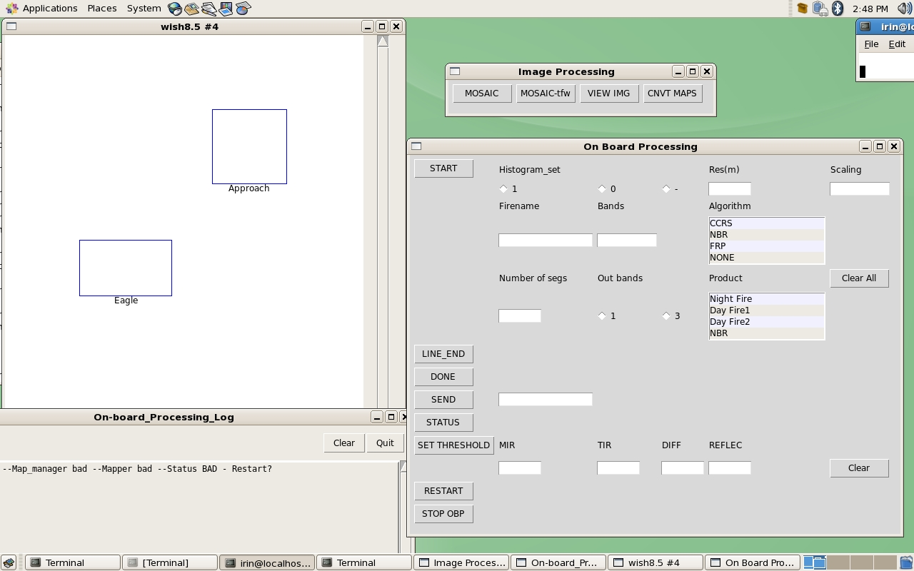

Fig. 3 Ground station GUI layout (note that the SEND button is now the TRK button 3/14)

There are 4 parts. The main request window, a “target display” window, a log window, and an “image processing” bar. The main window interacts with the on-board system. The target display shows the targets of interest that are loaded in the database. It will also display the footprints of segments downloaded from the airborne system, and optionally displays shapefiles. The log window receives comments and information from the on-board system. The image processing bar allows the operator to mosaic and view the imagery.

Once the airborne system is up, select STATUS to confirm communication. "All good!" or "Bad status" should appear in the log window if the communication is linked up. Generally you’ll get “Bad status” the first time because the linkmod processes are not automatically started. If this is the case, select RESTART to start up the on-board system. RESTART is used to startup or and to restart the OBP. You will see a shutdown message (if processes weren't running you'll get an error comment which you can ignore). Reselect STATUS. "All good!" should appear in the log window and you're ready to go. It will be either “Data In All good!” if sensor packets are being received by the linkmod, or “No Data All good!” if data are not incoming. If no data is incoming, check that the otf program on uavsys is running. Once “Data In All good!” is the status, you are set to map.

Select SET_THRESHOLD to see what the current fire detection threshold settings are if you didn't update the file with the Checklist. The values will print out in the log window. To change the threshold, just enter new values and reselect SET_THRESHOLD. Note that the values in the file are scaled to the data values (temperature * 100), while the units printed out are scaled to be easily readable , 390 K for example.

System Test

If you want to test the system and data flow before a target, just enter a custom request for example, set the custom request parameters for Test1 for 1 seg, or use the TRK button to collect a single segment with no delay. The TRK option collects a Ground Temperature image and reports the value range back. This may be useful in the future for determining optimal threshold values for the CCRS algorithm. Use the TRK function to see where you are on the flight path or check ground temperatures.

You should see comments from the mapping in the log window. If the data transfer is successful, the footprint will appear on the canvas <and the segment will be automatically displayed. CHANGED to NOT automatically display each segment but this could be set back if desired>. The log window will report the mapping completion and whether the image/logfile send were successful or not. When the logfile has arrived, the footprints will turn from brown/purple to orange. The arrival of the logfile triggers the conversion of the segments to geotifs and they will be available for viewing/mosaicing at that point.

Collecting a target or mission pass

Select START to begin processing segments. There will be a delay as the system waits half a segment to orient over the location selected. If a database box is not found, or the buffer isn’t full yet, it will report this to you. Watch the log window for information. Buffer filling only happens when first starting, or restarting the system. The program will wait 1 min. and then time out if the buffer hasn’t filled. Just reselect START to try again.
Messages will appear in the log window to inform you of the processing status. The particular comments will vary with the product selected. In particular, there will be a message if fire is detected when running any of the hot spot products.

To complete the line or pass, select LINE_END (line/run) or DONE (pass/mission) as appropriate. Watch the status log window to see when segments are completed and end after a segment is done rather than during processing. The system will collect one more segment to end at the selected location. You will then see the log file being sent. Once the log file is sent, the system is ready to start another collection.

Note:
If you select a small number of segments (e.g. 1, 2) just that number of segments will be collected. You should still select LINE_END or DONE when it’s completed to trigger the pass increment and set the histogramming flag. With a small number of segments you'll see “Autocomplete” comments in the log window. An extra final segment is not collected when running this way. If you have a small single segment target, this is more efficient.

If you leave the number of segments blank, it will default to a large number (100) allowing you to specify a "DONE" point.

When a segment is collected with autosend on, it is automatically ftp'd to the ground station. When the ground station detects a segment arriving, it will display the footprint in brown/purple on the flight plan display. When you end a collection (LINE END or DONE), the associated log file will be automatically sent to the ground station. Upon arrival, the footprints will change from purple to orange and will be available for mosaicing etc. (note if its a very large set of images, it may take a minute for the tif conversion to complete). You can view each segment using the View Imgs option on the processing gui and press “Send All” or “Send Img” on the image window to pass the image on to the map server for publication. Shapefiles, if hot spots were found, will display on the individual segments. You can also display any shapefiles collected on the target map. When you select “Send All” the image and all is associated files (product files, shapefiles, etc.) will be sent. “Send Img” will send just the image.

If you want to send lines of data, vs. segments to your map server, don't select “Send All” or “Send Files” from the image window. Select MOSAIC from the ground processing widget. Select the MOSAIC button on the pop-up and a list of log files will appear. Select the logfile(s) you want and they will be automatically mosaic'd and displayed. This mosaic can be sent just like a segment.< Note: the shapefiles aren't currently tied to the mosaic automatically, they are still named after the segments. Ideally they should be merged and named after the mosaic. TBD>

Targets of Opportunity

To run a "custom collection", for example for a target of opportunity, you'll have to select the product type and enter a target name, and optionally the other variables. Most have defaults, for example you don't have to select a resolution or “number of segments” if you're happy with the defaults. If you leave the “res” box blank, the system will calculate an average resolution for the first segment, and hold that over the set (a line, or lines if LINE END is selected). This may not optimize your resolution if there is a large gradient between the start and end of the set. Also if you want a constant resolution between two disjunct targets (e.g. if you are flying a calibration site) you should specify the desired resolution. The value should be entered in meters.

You can request that the resolution be calculated for each segment individually by setting the res entry to 0, but be careful. The current mosaic process doesn't rescale to a single resolution, so if you are planning to mosaic the segments, you should select a fixed resolution unless using another mosaicing program that can resample.

Concluding a Mission

To shutdown the OBP, just stop the software (click STOP OBP) and close the gui. There is no gui for the data backup at this time. There is a backup script you can run on linkmod called backup_lm.scr. This will automatically write two backup tar files that you can then sftp to the ground station. This script will backup and clear out the database, make copies of the log files in one file, and backup the image directory ($GEO_IMGS) in the other. It does not currently clean out the $GEO_IMGS directory for you, so there can be alot of data in $GEO_IMGS. We recommend that you clean it out after each mission to avoid overly large backup img files.

To manually accomplish the steps run by the backup script::
you can ssh into the linkmod, run clr_bkup_flt1.scr which will create two tables flt1_data<date>.txt and flt1_data<date>i.txt containing the records of the targets run, and clr_bkup_tbl.scr for segslog which will produce a text file of the log files written. Save these 3 tables and the segments in $GEO_IMGS if they weren’t sent to the ground station, and shutdown the system. You might want to save the mapper processing log as well (tm.log). This log file is appended to, so once saved, just delete it. The backup could be done later as well, after landing. Note: there is now a script, bkup_lm.scr that will back up the main files for you. Just ssh to linkmod and run bkup_lm.scr. This will write two files bkup_lm<date>.tar and bkup_lm_imgs<date>.tar which can then be saved to the desired medium.

To shutdown the computer, the command is sudo shutdown –h now. It may be alias’d to just shutdown, you can try that first.

Chat Client

When running from the ground, it can be helpful to be able to chat with those on-board. The chat client on wrapgcs is gaim (run gaim & to bring it up; You will need to know the rooms set-up for you ).

Detailed Ground Gui Descriptions

The Main Window

This window contains the main system commands, and the parameters for setting up a collection request if it is not already set up in the database. Along the left side, top to bottom are the basic commands. Adjacent to the START button are the options for setting up a custom request. Setting up a request is only necessary if the target is not logged to the database, or if you want to modify a database request. To set up a request, select a Firename and then a Product type. The product type will fill in many options for you. Leaving Res blank causes the system to calculate an average nadir resolution for the first segment, and then hold that value over a set (until DONE is selected). If you know the resolution that you'd like and its reasonable for the altitude, you can just set it by entering the desired value in meters. You can also set it to 0 which will calculate an average Res for each segment (not recommended unless just collecting 1 segment). The Histogram_set option either starts a new histogram, or continues with the previous one allowing better matching for a series. The system will manage this for you based on the selection of LINE END versus DONE. LINE_END defaults this parameter to 0 (continue the histogram), and DONE resets the histogram to 1. The Number of segs can be set to a value. If left blank, it will default to 100 allowing you to select an arbitrary end point.

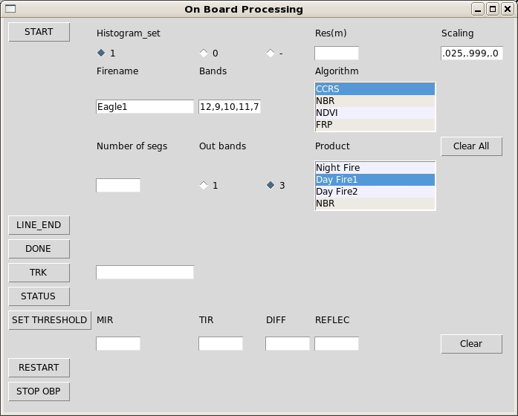
Fig. 4 Main GUI Window with a custom request set up

To begin collecting and processing data, select START. If the target is logged in the database, and the aircraft position is in the target box, the associated data request will be automatically selected and you will see the processing begin in the log window after a delay which lines the coverage up with the target. Each segment will be sent to the ground station as its collected and a footprint displayed on the Flight plan display. At the end of the line, select LINE_END if running multiple lines, or DONE if it’s the end of the pass. This triggers the writing and transmission of a log file for the series. When the log file arrives at the ground station, the footprints will turn orange. They are converted to geotifs and are available for viewing or mosaicing and to be sent on to the map server.

The other commands are fairly self explanatory. [ SEND can be used to send down a specific file, such as a processing log file (e.g. tm.log is the history of the mapper processing). A file name without a path will assume $HOME, otherwise specify explicitly. SEND has been replaced with TRK]

TRK collects a single segment with no delay and transmits the footprint for quickly tracking position relative to a target. It calculates a ground temperature from Channel 12 (FAR-IR) so may be useful for setting thresholds when using the CCRS algorithm. The temperature range will appear in the log window.

STATUS returns All good! in the log window if the three main processing programs are up and ready, or STA: Buffer bad --Map_manager bad --Mapper bad --Status BAD - Restart? if any or all are not up. It also indicates if data is incoming from the sensor or not: No Data All good! means data are not being sent from uavsys to linkmod. When data are being received it will report: Data In All good!

SET THRESHOLD either displays the current settings (in the log window), or sets the thresholds depending on whether values are specified in MIR TIR DIFF and REFLEC.

RESTART is used to start or restart the processing programs (buffer manager, map manager, mapper). An example of the output from a Restart is shown in the log window example below.

STOP OBP shuts down the three main processes on linkmod.

The Log Window

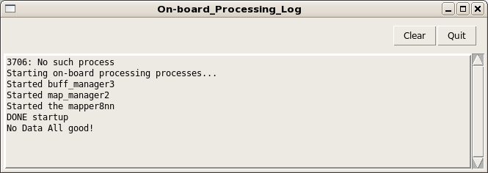
Fig. 5 the Log Window – displayed is the output from running RESTART followed by STATUS. In this case No Data indicates that linkmod is not currently received sensor data.

This window displays messages from the on-board processing so you know what its up to. Displayed in the example is what you would see after selecting RESTART and then STATUS with a successful start. It displays DONE for each segment as its completed. It will also inform you if fire was identified in a segment. It will indicate success or failure in transmitting segments and logfiles to the ground station.

The Target Display Window

The target display window, reads the flt1_data/flt1_index tables in the database, and displays the boxes for the targets that are loaded there. In the example, there are two boxes labeled Eagle and Approach. When segments from a collection arrive at the ground station, they are detected, converted to geotiff files, and the footprint box is displayed in brown/purple. When the logfile arrives, the footprints are changed to orange in this window. Shapefiles can also be displayed here upon request. To display hot spot shapefiles, select the … button, and pick one or more from the list. Then select Run to actually display them. They are displayed in green. <Note: the subclasses by temperature are not differentiated in this display> Use the Clear button to remove any displayed shapefiles.

This window has zoom capabilities like the image windows (+/- buttons and right mouse button click and drag to indicate a zoom area). The Reset button will return to the initial view.
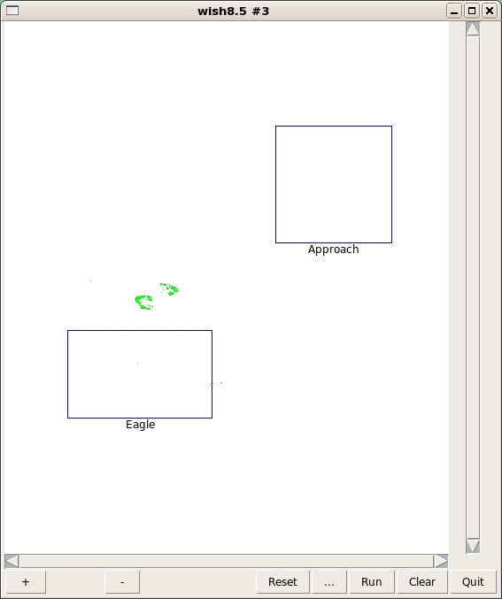
Fig. 6 the Target Display Window with shapefile hotspots displayed in green.

The Image Viewer Window

This window is automatically displayed when a mosaic is created. You can also launch it from the image processing bar (VIEW IMG). If running from the image processing bar, the … button brings up a directory listing to select a file to display. It defaults to images with today’s date, but you can pull down that menu to select a listing of all tiff files. You can also type an arbitrary wildcard string into the filename box. Note: when using the latter, the *.tif will not automatically be added.

An associated shapefile will automatically be displayed in yellow when an image is diaplayed and can be toggled on and off with the “shp on/off” button.

The + and – buttons zoom in and out, and a right mouse button click and drag will zoom to a location as well. Selecting “Send all” sends the segment, *.tfw and any associated shapefile onto the map/file server location. “Send img” will send the image and *.tfw file, but not the shapefile.

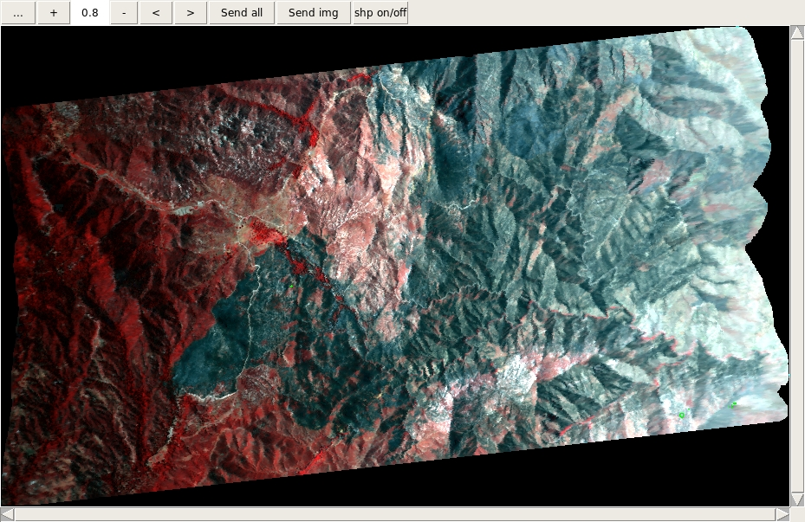
Fig. 7 Image Viewer Window - displayed in this example is a CIR 600 line segment from the Eagle Fire.

Image Processing Bar

This menu bar allows the operator to mosaic and view collected imagery. The MOSAIC button is the main mosaicking function. It works from log files. Upon selection, a list of available log files is displayed. One or more can be selected. You can easily see logfiles from a set as they will have the same Mission name, but you can actually select any set of logfiles that makes sense. Select Open, and the mosaicking begins. The mosaic will be automatically displayed on completion. The output file is automatically named using information from the log file and the input segments.
<target>_<operation>_mosaic_<pass>.map or <target>_<operation>_mosaic_<pass>_<line>.map if a single log file is mosaic'd.

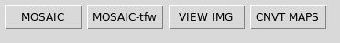
Fig. 8 Image Processing bar

The MOSAIC-tfw option allows you to mosaic any files with *.tfw files together rather than working from a log file. This is helpful if a log file is lost or there is a need to mosaic a set of segments not defined by a log file. With this option, a unique name must be specified in the Mosaic name entry box. There is no pass or target information, so be descriptive. The Description entry is a tag saved to the geotiff file, generally the name of the target. Selecting the MOSAIC button in the pop-up, brings up a list of *.map files available for mapping. Select your files, and then Open to initiate the process, and the mosaic will automatically be displayed when completed. The naming convention is: <Mosaic>_<operation>_mosaic.map

VIEW IMG brings up the image display shown above with no image displayed. See the Image Viewer Window discussion for details.

The CNVT MAPS option is useful only if the automatic tif conversion failed and you end up with *.map files. You will hopefully never have to use this. It allows you to manually convert the map files to tif files. This could be used if for some reason a logfile was lost or did not arrive at the ground station.

Product Descriptions

Fire Radiative Power
(see algorithm descriptions for details) requires AMS Bands 12,10,11,7

FRP Product - this single band output product consists of the Fire Radiative Power (FRP) calculated for each pixel identified as fire. The value is scaled * 1000 + 3000 to produce the unsigned integer image values. All pixels not identified as fire are assigned a 0 value. The original file is written as a *.frp file for transmission. To view this image, it must be scaled or pseudo-colored. The program scale2_2 can be used to accomplish this, which will result in a *.sc and/or *.sc_color file which can be displayed. For viewing this imagery a pseudo-color map was developed with these colors/value ranges:

0 - background is already black
1 - 100 black
101- 680 purple
681- 1260 blue
1261- 1840 green
1841- 2420 yellow
2421- 3000 orange
>3000 red

Normalized Burn Ratio
(see algorithm descriptions for details) requires AMS Bands 10 and 7

NBR Product - this single band output product consists of the normalized burn ratio value * 1000, truncated to an unsigned integer. The bands to be used for the calculation are set in the map2.ini file (see r1 and r2). The original file is written as an *.nbr image. To view the image, it must be scaled or pseudo-colored. The program scale2_2 can be used to accomplish this. This results in two more files, *sc.map and *sc_color.map and their associated *.tif files. For viewing this imagery a pseudo-color map was developed with these color/value ranges:

0 - 2990 Red
2991 - 3020 Orange
3021 - 3040 Magenta
3041 - 3075 Green
3076 - 3388 Background value
>3388 Background value

<NOTE: pseudocoloring is not currently automated. Needs input as to when it should happen.... at the seg level or at the mosaic level?? Or maybe just on the fly?>
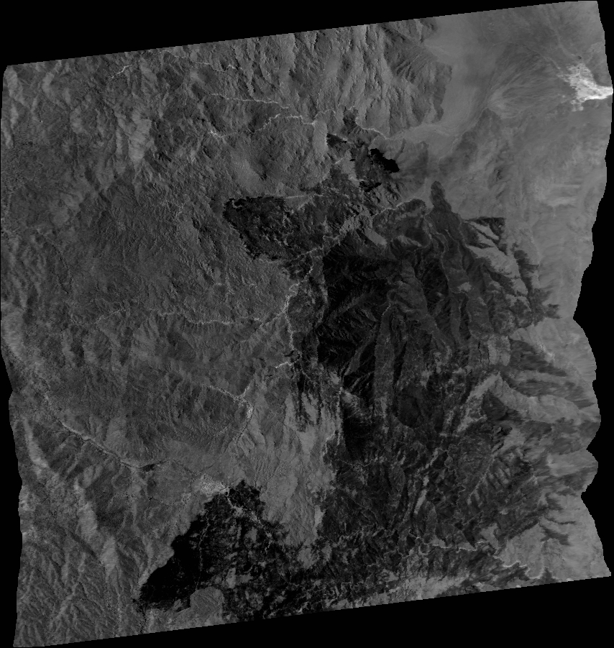
Fig. 9 This is an example of an NBR image from the Eagle Fire, scaled to byte for display. The product itself is a single band, unsigned integer file.

Hot Spots - Daytime
requires AMS Bands 12,10,11,7

The hot spot final product is actually a shapefile. The input data are processed to reflectance and temperature and the algorithm is run producing a "classification" file of 4 classes:

0 = no fire
1(255) = fire
2 = fire but excluded by band 7 as glint
3 = fire with a very high band 10 reflectance value
4 = fire with an extremely high band 10 reflectance value

This classification file is used to create a shapefile of the 3 fire classes (1,3,4). Classes 3 and 4 coincide with areas of more intense burning. This classification image is not saved unless the debug value in map2.ini is set to 2 which is not recommended for actual mission use. With debug set to 2, the classification file comes down as the first band of the visual product (it will be a 4 band, not 3 band file). Shapefiles are tagged with the "fire name" assigned at the time of collection.

Shapefile are automatically displayed for individual segments. They can also be displayed on the target map (select … and choose the file(s) from the list and select Run). NOTE: The shapefiles aren’t currently renamed for display with mosaics in the OBP software.

The visual product provided is 12,9,10

Note: the nighttime version of this uses bands 11 and 12, with band 12 providing the visual product, or a 3 band combination of 12,11,11 (RGB).

Normalized Difference Vegetation Index (NDVI)
Requires AMS Bands 7,5;
NDVI Product - this single band output product consists of the normalized difference vegetation index value * 1000, truncated to an unsigned integer. The bands to be used are hard coded to 7 and 5 and no longer use the map2.ini r1 and r2 values.. The original file is written as an *.nvi image. To view the image, it must be scaled or pseudo-colored. The program scale2_2 can be used to accomplish this. This results in an additional file, *sc.map and its associated *.tif files. The MOSAIC function will automatically write a scaled version for you for easy viewing. The visual product provided here is CIR.

Ground Temperature (GT)
Requires band 16 (or 12)

GT Product - this single band output product consists of the ground temperature in degrees K * 100, truncated to an unsigned integer. The band to be used is ideally 16 (can also be 12). The original file is written as a *.deg image. To view the image, it must be scaled. The program scale2_2 can be used to accomplish this. This results in an additional file, *sc.map and its associated *.tif files. The MOSAIC function will automatically write a scaled version for you for easy viewing. The visual product provided here is CIR.

Visual Product

A “visual product” is included in all the product options. It is a 3 or 1 band image to provided context and visual assessment of the target. The first 3 (or 1) bands of the “band input” string determine the bands used and the RGB order they occur in. The raw data are converted to reflectance or temperature for the algorithm, then scaled to byte with the specified clipping before writing the 3 or 1 band image for visual interpretation. In calculating the histogram for the byte scaling, all fire pixel are excluded.<cloud, cloud shadow,and water need to be excluded as well> The transmitted file is a *.map file with a *.tfw file which is converted to a Geotiff at the ground station. The *.map files are compressed prior to transmission (currently using gzip).

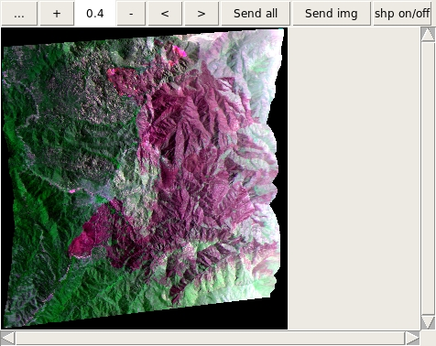
Fig. 10 An example of a BAER visual product (10,7,9) over the Eagle Fire.

The Checklist

This is an automated checklist for setting up the system parameters. The Checkist is run by typing checklist.tcl. Each button carries out or allows checking of various setup files. Using WRITE FILES and SEND FILES, a tar file (setup_lm.tar) of the referenced files is created and loaded to update the linkmod. These files include $HOME/db/flight1.db, map2.ini, startup.ini, $HOME/sensor_data/tch_li.sen, and $HOME/sensor_data/thresh2.vals. A more detailed description of each step appears in the Setup section.

Command-line Request Syntax

Send_request2 sends and monitors the actual request sent to the 3 main processing programs. The ground gui and get_firename organize this request for the operator, but it can as well be manually entered (that's how it was operated during the Ikhana missions). A start delay (for centering the target) based on the scanrate is automatically calculated.

Example of a database entry request:

1|Crown|1|1|10001|1|send_request2 10,7,9 4 30 1 0 3 - .02 .98 .02 .98 .02 .98|4|7/18/2011|8|

The parameters of the request itself include:

e.g
send_request2 10,7,9 4 100 1 0 3 8 .02 .98 .02 .98 .02 .98

band set up to 5 bands separated with commas; the first 1 or 3, based on the “number of bands” parameter, determine the bands for the "visual product" in RGB order.

algorithm number 0= none; 2=CCRS; 4=NBR 5=FRP (1 and 3 are obsolete)

number of segments >=1 (if left blank, defaults to 100 for a “continuous” stream)

line set 1=start histogram from scratch; 0=continue histogram
by continuing, the change is less abrupt; always start over (1) when changing band combinations, new target etc.

que saves requests and segments for processing if system gets overloaded
we've never had to use this and its not been tested in flight; set to 0;

number of bands for visual product; 1 or 3

resolution forces a particular resolution in meters; if set to 0, the system will calculate a good resolution for each segment; the problem is that segs of a set will differ slightly in res and the mosaic program doesn't handle that. -1 will calculate a resolution for a series and hold it.

scaling the clipping values for the byte scaling of the visual product;
two values per image; no clipping would be 0.0 1.0, a 2% clip
would be .02 .98; syntax here is just space separated sets of 2,
the system will sort it out. (note: in the front-end, each value
is separated by a comma .02,.98,.04,.999,.02,.98.)

APPENDIX

Important Files onboard
(see Checklist for easily editing these files)

$HOME/map2.ini (see map2.ini.12 vs. map2.ini.16, generally you want 12)

aflt opr_name
0 projection
83 nad
8 ellipse
99 zone
ams_grnd dem_name (NOTE: this is now used for the hostname of the ground station)
14.0 res
2 algorithm_code
12,9,10 default_bands_to_use
* 11 mir
* 12 tir
* 7 r1
* 10 r2
1 skip
1 num_imgs
.04 .20 .20 low_clip_percents
.98 .99 .98 hi_clip_percents
2.5 comp_quality_level
* 0 outformat_0=flat_1=jpg2_2=both
* 0 debug

Values with * are most important. Others are just defaults in case not specified elsewhere for some reason. mir indicates the band # that should be used for the mid-ir (2-3µm) information in the algorithms. tir indicates the
band # that should be used for the far-ir (10-12µm) information in the algorithms. r1 is the band # that should be used for the first value in a normalized difference equation, and r2 the band# that should be used for the
second value in the equation (e.g. r1 - r2 / r1 + r2)

For outformat, jpg2 isn't currently being supported (due to lack of the Kakadu library), so this should always be 0 for now.

Debug of 0 means no extra information or images will be output. For mission operations this should be 0. For testing and debugging, a value of 1 will output alot more comments and a value of 2 will output a range of intermediate image products, in particular, the raster classification as the first band of the visual product (which will then be 4 bands rather than 3).

$HOME/startup.ini (should be set to the "16" version for operation)

16 num_bands-sensor does not include the 2 meta-data bands
*1200 num_frames buffer size (must be num_lines + 600)
*600 num_lines segment size
1 seg_no start sequence numbering
0 line_no line sequence numbering
2 sensor_code AMS = 2
3 num_bands-outproduct just a place holder
716 pix_in_line data pixels in a line
28 line-hdr header pixels in a line
1 byte-order 1=msb 0=lsb
1 attitudeunits0=radians1=deg attitude units
2 altitudeunits1=feet2=meters altitude units
*0 roll_cor 0=off to 15deg. 1=on right -1=on left
-1 last_seg_head place holder
*0 autosend 0=off 1=on ftp 2=on scp

num_bands-sensor = the number of channels NOT including the meta-data channels (2 are assumed for AMS).
num_frames = full size of the buffer (currently must be 600 lines larger than the num_lines parameter
num_lines = the size of the buffer per segment.
seg_no and line_no -= just starting values for the seg and line numbers.
sensor_code = 2 indicates AMS (no other sensors are currently supported).
byte-order=1 indicates MSB, use 0 for LSB.
roll_cor=0 turns off roll correction until greater than 15 deg. because the sensor computer does its own roll correction up to that point. Other possible values are 1 (for left) or -1 (for right) corrections using the meta-data roll value. AMS is set-up for right-handed.
autosend=1 turns on an automatic anonymous ftp to the ground station as each segment is processed. Use 0 to turn this off if you want to send manually.

$HOME/obp_start2.scr (see also obp_start_static.scr for static processing) Starts the basic 3 mapping and mapping management processes Usually automatically started (see rc.local), or from the ground gui

obp_stop.scr Stops the basic 3 mapping and mapping management processes; cleans up shared memory if needed

wput-logs log files from datasends will be here and should be backed up; information on transmit times for analyzing telemetry are here.

Sensor model file ./sensor_data/tch_li.sen

716 .002094 2 85.92 4 0 samps e_ifov sensorcode fov clip_left clip_rt
0.0 0.0 0.0 0.0 0.0 0.0 offset params (roll pitch x y hdg alt)
.018172969 1800.44 band_dc_to_rad_slope incoming_rad for that band
.006062968 2022.03
.006805745 1830.71
.019488148 1713.52
.017765206 1624.49
.019554960 1426.05
.018407328 1148.83
.026439580 909.23
.020925132 220.16
.004259518 75.72
.942501 11.03
.956789 0.20
.004188659 220.16
.000906033 75.72
.942501 11.03
.956789 0.20

When replaying flight data, the appropriate sensor model file should be loaded to tch_li.sen as this file includes the conversion to radiance information as well as an irradiance value for calculating reflectance.

./sensor_data/thresh2.vals fire threshold values - use set_thresh2 to edit
37000 29000 1400 600 0 e.g. for CCRS algorithm B11_cutoff B12_cutoff
B12-B11_cutoff B7_radiance_cutoff B10_crossover_val
note: B10 vals are currently hardcoded

Environmental Variables

The code runs in the C shell (tcsh). Environmental variables are set-up in the .cshrc file. Some required ones:

$GEO_IMGS - processed segments and *.log files are put here
$SRTM - the location for the SRTM dems
OBP expects SRTM formatted DEMS using their standard naming convention.
Other DEM's could be formatting to fit into this, but change in resolution
from the 30m would require a code change.

$WR - the binary location for the OBP executables and scripts
$HOME - the operators home directory
$WR_HOME - the home relative to the OBP software; usually the same as $HOME but can be different

The programs, scripts that run things
* indicates on-board code

GROUND:
$HOME/start_grnd.scr - script that brings up all the GUI for airborne operations including starting vsftpd.

run_autod - manages the autodisplay gui communications

autodisplay.tcl - automatically displays the segs when they arrive at the iground station called by obp_watch
via run_autod and convert_maps

calc_irrad - standalone code for calculating the sun azimuth and elevation

imgp_gui.tcl - front-end for the mosaicing and viewing programs; called in start_grnd.scr

run_imgv - manages the imageviewer_shp.tcl in the contex of the ground gui

These are part of the imgp menu:
imgviewer_shp.tcl - display any image and its shapefile
mosaic_segs2 - mosaic's segs together; requires *.log file
mosaic_tfw - mosaic segs together without a *.log file.
convert_maps - lets you list and create geotifs from *.map.gz files that come
down before the log file

These are part of the checklist menu:
read_xml.scr
sen_model.tcl
edit_map2.tcl
edit_startup.tcl
edit_thresh.tcl
tst_geoconn.scr
geoconn.tcl
filesto_lm.scr
write_setup.scr

backup_lm.scr – script to automatically back up certain files in linkmod to *.tar files after a flight. Writes two tar files bkup_lm<date>.gar and bkup_lm_imgs<date>.tar

run_geotifs_raw - manages and runs multiple instances of the map2geo.geotifs script using the associated
*.log file

map2geo.geotifs - script that converts *.map files to geotifs

map2geo.sendall - script that sends imgs to the central ftp site

map2geo.sendfiles - like sendall, but doesn't send associated shpfiles

gtmetadata.txt - required file for the geotif writing; holds projection information

run_sendall - uses the logfile to automate the sending of multiple files to
the ftp site

obp_run_gui - manages the comm to the front-end gui

obp_gui.12ch.tcl - main frontend that uses old 12 ch syntax, band selection

obp_gui.16ch.tcl - main frontend that uses new 16 ch syntax, band selection (phasing this out)

obp_log.tcl - receives and displays output from the airborne platform

obp_watch4 - watches for incoming files; runs the tif conversion and displays segs for
QC and sending; displays the seg footprints on the target map;
launches the geotiff conversions and autodisplay of segments
as they arrive.

run_grnd_gui - this starts the ground processing menu (mosaic, viewing, etc)

shp_addfields - b. lobitz's program to add target name tags to the shapefiles

status_man - manages the comm. with the log gui which receives messages from OBP

tst_canvas_new.tcl - the new target basemap for obp_watch4 that displays shapefiles

myfileselect.tcl - tcl code for selecting a file to open; used by mosaic

static_buff - a program originally written by B. Slye (with LOTS of mods by S. Buechel)
for testing the OBP. It loads a buffer full of data from a file statically which
can then be mapped using the real-time processes. You can actually use this
program to map a long line segment as one piece by editing the num_frames and
num_lines parameters in the startup.ini file. The num_frames
needs to be 600 lines longer than the num_lines. Num_lines should be the actual
number of lines you want to map. NOTE: the startup.ini file is now automatically adjusted for the static image size.

make_req - this will formulate a raw request for you given: (OBSOLETE)
syntax: make_req knots scanrate target_length (nautical mi.) <request type> res <line_set>
tells you the start delay and inter-seg wait time as well

get_segsize – command line program that calculates AMS seg width and lengths from knots, grndspeed, alt.

Utilities for managing and using raw AMS datafiles (type the filename at the command-line to see the syntax):
NOTE: these functions have been incorporated into a front end gui. See Post Processing AMS files.

tch_in_sublines16n - for reading raw AMS datafiles with 16 channels and writing subsets that can be used with wild_tst3

tch_readmeta_new - reads and extracts the meta-data from raw AMS data files; useful for loading tracks into a spatial database, or checking dates on raw files (there is also a version tch_readmeta2_new that differs only in where files are read/written to)

tch_in_nofilln - removes fill from raw AMS data files; generally 352 bytes. This needs to be done if using the file for “replay” processing.

AIRBORNE:
*bm.log - output from the buffer_manager3

*buff_manager3 - controls the data incoming over the UDP connection to the AMS

*cleanshm.com - usually run from the code, can run manaully if you need to

*done - manages log file writing when a data collection is completed

*get_firename - formulates and manages requests sent to the OBP - talks to
the DB, tracks the buffer status

*map_manager2 - manages incoming requests; gets data from the buffer and
launches mappings

*mm.log - output from map_manager2

*run_telemg - manages the wput output and determines whether send was successful
(run_telemgt is a version with hardcoded address for testing)

*run_telemgs - like telmg, but set-up for the generic SEND option

*ob_killall.com - used by the code for shutting down;

*obp_restart - launches the on-board processing fns, optionally stopping if already running.

*obp_status - returns the status of the OBP fns. (chks whether they are running or not)

*send_request2 - manages the request; talks to the map_manager2; tracks the buffer

*send_request3 - when a request is stopped; runs one more seg to catch the end with no delay

*send_request4 - runs a single seg specific to the Trk request

*send_segs - manually request that any file be sent from air to ground. If a log
file is specified, all the segments and the logfile will be sent; logs
to the segs table if segments are sent. For a single file, if
no path is specified, it assumes $HOME as the location. [not currently used]

*set_thresh2 - changes the algorithm threshold settings in the file thresh2.vals which
is checked with each mapping.

*sm_pid.txt - a file used by the programs

*sr_stop - manages a stop request (line vs. pass)

*tm.log - output from the obp mapping function; this file is appended to, so can get big; remember to delete it if
you don’t specifically want to save it; contains the “mapper” processing history for each segment.
There is a lot of useful information in it if you need to debug, or are just curious.

*tmp66.txt -temporary file used by the programs

*tst_mapper8nn - the newest code with the FRP product option
using gzip for compression; depending on flag set in startup.ini will
automatically ftp completed segment sets to "wrapgcs" or “vlt” groundstation.
The location of wrapgcs can be set in the /etc/hosts file

*tst_mapper8wnn - a test version of the mapper which doesn't apply the cosine correction for
the radiance calculations.

*xmitm - the program which runs t.hildum code that transmits data via the Ku link when that option
is available. This currently has to be run "manually" due to some issues with the hardware.
Turn off the automatic send in the startup.ini file if you need to use this transmit option.

SQLite DB MANAGEMENT SCRIPTS:
Note: these are incorporated into scripts now, so you shouldn't have to run these directly for the standard setup.

clr_bkup_flt1.scr - writes backups files for and optionally clears the
flt1_data and flt1_index tables (these are the mission
targets); assumes you're running from $HOME

clr_bkup_tbl.scr - writes a backup file and optionally clears any table

add_box.scr - loads text files of targets into flt1_data and
flt1_index, for example if a target is added to a
mission - see the backup output syntax for the syntax
this can be used to load any flt1_data/flt1_index
formatted data. Files must be named anyname.txt and
anynamei.txt This also writes a *.kml file of the
boxes for use in GoogleEarth.

sqlitestudio-2.1.5.bin – freeware front-end for the SQLite database. Written by Pawel Salawa

read_xml.scr - see Checklist. This script loads a Forest Service flightdata.xml file to the database.

Example of a flight1.db database record:

1|Crown|1|1|10001|1|send_request2 10,7,9 4 30 1 0 3 -1 .02 .98 .02 .98 .02 .98|4|7/18/2011|-1.0 |

or, there is really no need to enter the explicit request if using a standard product:

1|Crown|1|1|10001|1| |4|7/18/2011|14|

Database Management and Set-up
(see the sqlitestudio front-end for easier management)

OBP uses the SQLite database to hold target boxes and associated desired products, as well as log requests that are sent. The targets must be setup prior to the mission and backed up, if desired, after the mission. There is a database on linkmod and one on the ground station. They are not synced automatically. The database file, flight1.db needs to be setup and put in $WR_HOME/db on both systems prior to a flight. See the Checklist for an automated way to do this. Here we describe database details and doing this manually.

OBP Database TABLE INFO (see also commands*.txt for how to create/load etc.)

There are 4 main sqlite3 tables in the OBP database:

Tables Defining the Mission Targets

1.flt1_data holds the firenames and the requests
2.flt1_index holds the lat/long boxes and is indexed to flt1_data

These tables must be populated by the user before a flight. Generally you will load the flightdata.xml using the Checklist. The following describes how to do this if you don't have an *.xml file.

Adding target boxes to the database:

The script add_box.scr will load "box" targets to flt1_data and flt1_index. It requires two correctly formatted text files as input. Only the file for flt1_data needs to be specified. The other file is automatically assumed to have the name <first_file>i.txt. The format for the first file is:

index | targetname| line | num lines | target_id | pass | request | request_code | date | res

e.g. of text files flt1_dataJul22.txt and flt1_dataJul22i.txt that add_box.scr will load to the database

flt1_dataJul22.txt - contains the target name and desired request information loads to flt1_data table

1|Crown|1|1|10001|1|send_request2 10,7,9 4 30 1 0 3 -1 .02 .98 .02 .98 .02 .98|4|7/18/2011|-1.0 |
2|Station|1|2|10002|1| |2|7/18/2011|14|

Note that the “blob” field was replaced with the “res” field in the current code (3/14)

flt1_dataJul22i.txt - corresponding target boxes; note W - E - S - N order matters and the index must match the
information in the flt1_data table.

Index |min longitude | max longitude | min latitude | max latitude

1|-118.383331|-117.849998|34.166675|34.450000
2|-119.116775|-118.908302|37.929168|38.083332

To load the boxes into the database run:

add_box.scr <database> <text_file>

The script clr_bkup_flt1.scr will write a txt backup file and optionally clear the flt1_data/index tables after a flight. You can also use it to create a template file for setting up a new flight. Note: the new script bkup_lm.scr will run this automatically for you. See the “after the flight” notes for more details.

The Seglogs Table

The seglogs table is written by the OBP system during a flight. Completed sets/logfiles are recorded here. The information includes the request that was sent. A backup of this table at the end of a flight will provide a history of the data collected. See clr_bkup_tbl.scr to write a backup file and optionally clear the table for the next flight.
Note: the new bkup_lm.scr will backup this table for you automatically.

The Segs Table (not currently operational)

The segs table logs segs sent by the send_segs command (NT).
Note: The segs sent automatically aren't logged yet unfortunately.

Detailed Table descriptions

flt1_data description -

CREATE TABLE flt1_data(
id INTEGER PRIMARY KEY,
firename TEXT,
line INTEGER,
total_lines INTEGER,
fireid INTEGER,
pass INTEGER,
request TEXT,
req_id INTEGER,
date TEXT,
res REAL);

Sample insert statement (note the add_box.scr script will do this for you):
INSERT INTO "flt1_data" VALUES(5,'Test5',1,NULL,NULL,2,'send_request2 12,9,10,11,7 2 3 1 0 3 14 0.0200 0.9990 0.0200 0.9800 0.0200 0.9900',NULL,NULL,NULL);

flt1_index description

flt1_index(this is a virtual table indexed to flt1_data specifically for spatial data) -
INSERT INTO sqlite_master(type,name,tbl_name,rootpage,sql)VALUES('table','flt1_index','flt1_index',0,'CREATE VIRTUAL TABLE flt1_index using rtree(id,minX,maxX,minY,maxY)');

Example boxes:
minX maxX minY maxY
1|-119.019317626953|-118.572212219238|34.3636016845703|34.5900688171387
2|-117.57958984375|-117.321640014648|33.2718391418457|33.4924583435059
3|-116.830215454102|-116.405235290527|32.7314186096191|32.8449172973633
4|-121.989501953125|-121.400001525879|35.7999992370605|36.5270004272461

Seglogs table description

CREATE TABLE seglogs(
id INTEGER PRIMARY KEY,
filename TEXT,
date DATE,
sent INTEGER,
request TEXT);

Segs table description

Segs table is written to by the manual send_segs program which searches seglogs for logfiles not sent and sends the first one, or if a non-log file is requested, it simply sends that file. It doesn't have a way to confirm a successful send at this point, so if a send attempt is made, it will be logged here:

CREATE TABLE segs(
id INTEGER PRIMARY KEY,
segname TEXT,
sent INTEGER,
other INTEGER);

Trouble Shooting Notes

- The resolution selected for mapping is important. If you select too high a resolution, the images created will be very large and bog down the system processing. If you select a resolution too low, its possible to confound the processing (though it must be way off, lowering the resolution is actually a way of speeding up the system and creating a quicklook). It doesn’t have to be exact, but it needs to see close to the actual nadir resolution. There are a couple ways to figure out what is a good resolution to pick if not using the database “boxes” set up with the desired request and you have no other information on the request:
- Check the “Cheat sheet of segment sizes” table which has some examples.
- Leave the resolution box empty (system will try to pick a reasonable resolution based on an average ground adjusted altitude for the initial segment and use that for the whole mission).
- Enter “0” and the system will calculate a custom resolution for each seg based on an actual average elevation adjusted altitude for the segment. This is way cool, but you will end up with segments of slightly different sizes which is not currently handled by the mosaicking process.

NOTE: 12/14 the system will now printout the calculated average inherent resolution to the log window for the operator to see.

- Be careful a about selecting PRODUCTS vs. filling in parameters manually. In general, you should not change the parameters that are automatically set by a product selection. These are the bands and the algorithm. There are PRODUCT number, and there are ALGORITHM numbers. Don't confuse these two.

- No data coming in to linkmod - otf running? Firewall problem? The firewall between uavsys and linkmod should be turned off.

- Files not coming in to ams_grnd - did firewall.txt get set up right? This file should be in the $HOME directory and is run in the startup_grnd.scr. Is vsftpd running? Does the file already exist on ams_grnd (wput will not overwrite an existing file and will return an error)?

- Mosaic's don't line up spatially – did you select 0 as your res or different res for different segments? This will cause gaps and misalignments which are not really there in the data.

- Fire not detected over known fire? - check your threshold settings on board (not from the checklist).
They should be ballpark to 380 290 14 .4, but may need to be much lower at night. Use the TRK function to get a background temperature measurement for band 12 (TIR) for your local area.

Listing of segment sizes and nadir resolutions relative to scanrates and altitudes

SEG LENGTH (nm along track) for a 1200 line segment - 3nm target:

Knots:140.00 scnrt:22.00 seglength(nm):2.12 num_segs:2
Knots:150.00 scnrt:22.00 seglength(nm):2.27 num_segs:2
Knots:160.00 scnrt:22.00 seglength(nm):2.42 num_segs:2
Knots:170.00 scnrt:22.00 seglength(nm):2.58 num_segs:2
Knots:180.00 scnrt:22.00 seglength(nm):2.73 num_segs:2
Knots:190.00 scnrt:22.00 seglength(nm):2.88 num_segs:2

Knots:140.00 scnrt:11.00 seglength(nm):4.24 num_segs:1
Knots:150.00 scnrt:11.00 seglength(nm):4.55 num_segs:1
Knots:160.00 scnrt:11.00 seglength(nm):4.85 num_segs:1
Knots:170.00 scnrt:11.00 seglength(nm):5.15 num_segs:1
Knots:180.00 scnrt:11.00 seglength(nm):5.45 num_segs:1
Knots:190.00 scnrt:11.00 seglength(nm):5.76 num_segs:1

Knots:140.00 scnrt:9.00 seglength(nm):5.19 num_segs:1
Knots:150.00 scnrt:9.00 seglength(nm):5.56 num_segs:1
Knots:160.00 scnrt:9.00 seglength(nm):5.93 num_segs:1
Knots:170.00 scnrt:9.00 seglength(nm):6.30 num_segs:1
Knots:180.00 scnrt:9.00 seglength(nm):6.67 num_segs:1
Knots:190.00 scnrt:9.00 seglength(nm):7.04 num_segs:1

Knots:140.00 scnrt:7.00 seglength(nm):6.67 num_segs:1
Knots:150.00 scnrt:7.00 seglength(nm):7.14 num_segs:1
Knots:160.00 scnrt:7.00 seglength(nm):7.62 num_segs:1
Knots:170.00 scnrt:7.00 seglength(nm):8.10 num_segs:1
Knots:180.00 scnrt:7.00 seglength(nm):8.57 num_segs:1
Knots:190.00 scnrt:7.00 seglength(nm):9.05 num_segs:1

SEG WIDTH (across track)

MSL width(nautical miles nm) res at nadir
6500' 1.99 nm 5m
7500' 2.29 nm 5.7m
8500' 2.61 nm 6.5m
9500' 2.91 nm 7.2m
10500' 3.21 nm 8.0m
15000' 4.60 nm 11.4m
18000' 5.52 nm 13.7m
20000' 6.13 nm 15.2m
23000' 7.05 nm 17.5m

Cheat Sheet for Running the OBP

1. If running missions, load your flightdata.xml into the /home/irin/db directory on ams_grnd
If you are running a test flight and don't have a flightdata.xml file, you can edit targets and
landmarks manually into a text file and load it using the add_box.scr (see details in the manual).

***Note: If you've manually set your database up do NOT run LOAD DB, as it will clear the tables and look for a flightdata.xml file to load. If you have an old one lying around, it will load it.

2. Run checklist.tcl on ams_grnd to confirm the settings you want for important parameters.

LOAD DB – this will back up the current db and load the flightdata.xml file into the database
Note: for viewing/editing the db run sqlitestudio*

SENSOR MODEL – view the current sensor model and make sure its the one you want.
/home/irin/sensor_data/tch_li.sen

SET-UP FILES - view your settings and make any desired changes
allows editing of important parameter in the map2.ini and startup.ini files
Note: you will not generally need to change these except for special situations.

TEST COMM – run to check that your connection from ams_grnd to the file server (NIFC) is working. Will report success or failure. Runs the tst_geoconn.scr script.

THRESHOLD CHK – check your CCRS threshold values at startup (you can also do this in real
time while running the system.) This edits the thresh2.vals file in the
/home/irin/sensor_data directory.

WRITE FILES – writes the files edited above to setup_lm.tar

SEND FILES – checks whether linkmod is available on the network and if so copies setup_lm.tar there and untars it to update/sync the key files with the ground station. If linkmod is not available it will fail and you would need to repeat this step after getting access.

QUIT – quits the checklist.

Note: the settings for map2.ini, startup.ini, thresh2.vals, and tch_li.sen are most important for linkmod.
If you change anything on ams_grnd, you must update linkmod to see the effects. The flight1.db file is used by both systems and must be set the same on both.

3. Make sure the firewall.txt file on ams_grnd is set up for the correct IP address. It should be the IP address of linkmod, or the portal to linkmod if using AirCell or InmarSat. The firewall.txt will be automatically run by the startup script. This allows incoming files from linkmod to ams_grnd.
Note: if there were problems here, in a pinch you can edit start_grnd.scr to just turn off the firewall. This is done by running /etc/init.d/iptables stop. This is not recommended though.

4. Make sure the $OBP_COMM environmental variable in the .cshrc on ams_grnd is set properly.
(ssh linkmod, or ssh <ip address> will be the usual). This allows the command exchange between the request on ams_grnd and linkmod. This variable is in the .cshrc file in the irin home directory on the ground station. If you modify it, you must run source .cshrc to set the environment in the window you run the start_grnd.scr.

5. Run start_grnd.scr on ams_grnd to bring up the software frontend.

6. Select STATUS to confirm the connection to linkmod. You should get a response saying:
Buffer bad --Map_manager bad --Mapper bad --Status BAD – Restart?
This just means that the processes aren't running and you need to start them. It confirms that your communication link to linkmod is set-up properly.

7. Select RESTART to startup the three main processes on linkmod. You'll see something like this:

STOPD OBP, SHM CLEAN...
31076: No such process
ipcrm: invalid id (1572875)
ipcrm: invalid id (1605644)
ipcrm: invalid id (557056)
Starting OBP processes...
Started buff_manager3
Started map_manager2
Started the mapper 8nn
DONE - startup script

8. Select STATUS again and you'll see:

No Data All good! - meaning the data stream from the sensor is not coming in (perhaps the otf function hasn't been started) but confirms communication with the linkmod.
or
Data IN All good! - meaning you're all set to collect as soon as the buffer fills up

9. You're ready to collect data now. There are tthee main options:

* Select TRK if you would just like to see where you are on the map. This will collect a single segment with no delay and display the footprint for you. There is no starting/stopping with this option. This also samples the ground temperature and will display the temperature range as well (for future use in selecting CCRS thresholds).

* Simply select START. This will look in the database for a “box” for the current location. If a record is found, the request will be assembled from that and any entries in the widget (for example you can override the database values for num_imgs or res or the scaling values if you like. If you are not in a box, it will tell you that. You may be just outside, and can just select START again in a bit (see TRK to see where you are relative to the target.

* Select a firename and a product type then START Either select or leave blank the num_imgs and res options. A blank res will default to calculate a res for the first segment and then hold that value over the “set” (a line or series of lines). You can also select 0 which will calculate a res for each segment, but this is not recommended unless you are collecting a single segment. If you know a good resolution for your target, you can enter that value in meters. After you set up your request, select START. If you are in a box, the custom settings will override the database box.

* For either START option, select LINE END if ending a line in a multi-line target, or select DONE if you've completed your target. If you left the num_imgs blank, the system will collect a Final Seg after you end to make sure all the area is covered, so remember to wait for that. If you selected a number of images which completed on its own (autocomplete) a Final Seg will NOT be collected. In the latter case, you should still select LINE END or DONE to indicate whether the target is completed.

Once the logfile has arrived and the segment footprints have turned to orange on the display, the segments should be available for mosiacing.

10. Select MOSAIC from the Image Processing menu bar, then select Mosaic from the pop-up. This will present you with a list of logfiles for selection. Select the desired file(s) and then select Open. The mosaic will immediately launch and display the file automatically when completed. Select Send All or Send Img (doesn't send the shapefile) from the display window to send the image and associated files to the indicated server.

11. At the end of the flight, select STOP OBP to shutdown the obp processes. You will see:

STOPD OBP, SHM CLEAN

12. Run backup_lm.scr on linkmod to backup the database files, the log files, and the collected segments and mosaic's into two tar files. Write these file to your favorite backup medium.

Run - ssh linkmod
bkup_lm.scr

writes files: bkup_lm<date>.tar and bkup_lm_imgs<date>.tar
e.g. bkup_lm_12_4_14.tar and bkup_lm_imgs_12_4_14.tar

Note: if not regularly cleaning out the $GEO_IMGS directory it can get very full in which case bkup_lm_imgs<date>.tar can get very large, so watch out for that. We recommend cleaning out $GEO_IMGS after each flight. The script does not currently delete files for you at this time.

REMOTE COMMUNICATIONS

The ground station (ams_grnd) can be used locally or remotely to run the on-board processing. The set-up differs slightly between the two cases as illustrated in Fig. 1. This is a summary of the files which set-up the communications and control where files are sent.

Sending commands and monitoring the status of the on-board computer

The communications described here are the commands to start data collection, stop data collection, and check the status on linkmod via the ground station (ams_grnd). ams_grnd and linkmod are able to communicate seamlessly due to ssh keys set up on both machines.

The communication address between ams_grnd and linkmod is set, prior to bringing up the front-end, in the environment variable $OBP_COMM in the .cshrc file of the irin user on ams_grnd. This is generally set to “ssh linkmod”. The address for linkmod is set in the hosts file (/etc/hosts). Editing the hosts file requires you to be root or have sudo priviledges. This address will differ if you are running locally (you'll be on the “10” network) or remotely (the address will be determined by the AirCell (or Inmarsat) address as the case may be. You do not have to use the “linkmod” name in the $OBP_COMM variable. You can instead enter an explicit address, e.g.
“ssh 192.121.408.066”. Since the address will likely not be static for remote communications, you will probably want to enter it explicitly.

Note that routing may be required to access the AirCell address from the amg_grnd static address.

Receiving products at the ground station

The data transfer described here is the transmission of the real-time imagery product segments from the linkmod to the ground station (ams_grnd). Anonymous ftp, using wput, is used to seamlessly transfer the files. When running locally this occurs over the “10” network. When running remotely, the data are transferred over the AirCell connection. The automatic transfer of files is a settable parameter as is the name of the ground station.

If autosend is set to 1 in the startup.ini file (also see Fig. 2 SET-UP FILES on the Checklist), processed segments will automatically be ftp'd to the location specified in the hostname parameter in the map2.ini file (actually called dem_name in the file...). The address for the “hostname” will then be determined by the /etc/hosts file on linkmod, so this will need to be reset when running remotely. With the current static address at NIFC, this should not change during or between remote communications. (Note: the hostname may be set to a numerical address, avoiding the need to edit the hosts file, but this hasn't been tested).

The data are sent from linkmod using anonymous ftp. The ground station firewall must be set to allow linkmod to send this data, to allow it in through the firewall. To set this up there is a file called firewall.txt in the irin home directory on ams_grnd which contains the basic syntax. You just need to edit the address allowed in. When using the AirCell, this address may change from flight to flight and firewall.txt will need to be edited prior to starting up the processing on ams_grnd. The firewall.txt file is sourced during startup to access the desired settings.

Error checking file transfer

Note that where the AirCell communication occurs differs between the two set-ups (local vs. remote).
In a remote set-up, the AirCell sends the segments as they are collected. It only tries one time and continues on if the send failed in order to keep up with the real-time processing. The system monitors the log file of the ftp process for the word “fail” and reports that to the operator, but files that fail currently must be manually sent by logging in to the linkmod. There is no checksum run for corrupted files, though linux has this capability using the md5sum utility. Wput is used to send the files, and it will not overwrite an existing file, so if a file was partially sent it must be deleted from the receiving site before retrying.

In the local set-up the AirCell is sending the mosaic'd segments (or Q.C'd segments) to the final ftp server (generally the NIFC site for this implementation). This is currently lacking in front-end error reporting, but is less time constrained than the real-time segment send.

