Setting For Page Scaling of NIROPS Tri-fold Brochure:

For Page Scaling, set to “None”. The default, usually “Shrink to …” will mess up the fold lines.

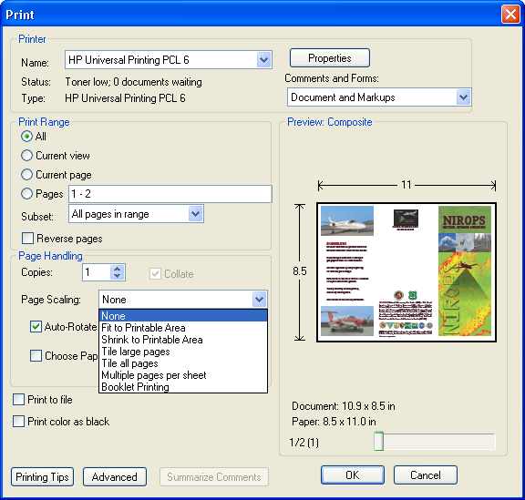

Setting For Two-sided Printing of NIROPS Tri-fold Brochure:

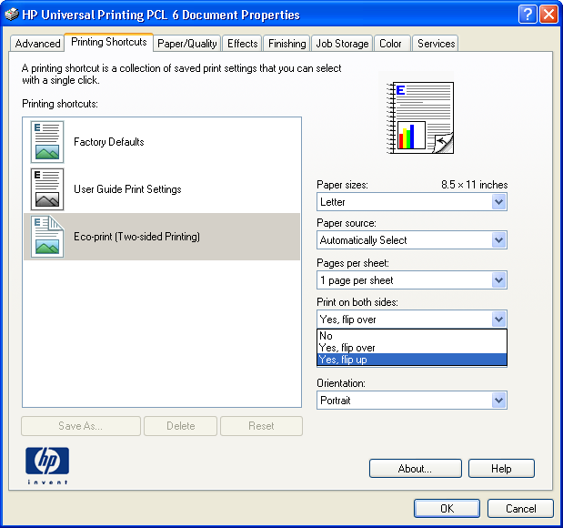
Some printers default to, "Yes. Flip Over" for two-sided printing. Change this to, "Yes Flip Up" so that the brochure will read correctly when folded. This setting can be found, at least on an HP Color LaserJet 4600dm, under Properties, Printing Shortcuts, Eco-print (Two-sided Printing). If nothing else, try a test print and see how it looks on your printer

