NIFS IR Event Layers 2022
IR_Polygon
Field | Options | Comments
OBJECTID | Auto-populated
Incident Name | Anything can be entered here | If there is no GIS event Polygon already set up (1st few nights of IR flights) enter the name on the scan order. It’s the IRWIN ID that links the data to the Event polygon. For complexes with named individual fires, put the fire name here and the complex name in the “Complex Name” field.
FC IR Polygon Type | 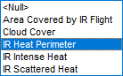 | IR Heat Perimeter is default,  Use Cloud Cover for imagery obscured for any reason be it clouds, fog, plume, data corruption etc.  Use Area Covered by IR Flight if only partial coverage, otherwise full coverage is assumed.
Map Method | 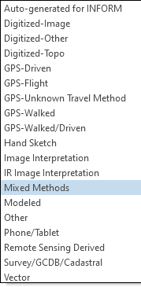 | Mixed Methods is the default. Use “Mixed Methods” for IR Heat Perimeter unless you are sure that only IR is being used for the perimeter.  Use IR Image Interpretation for:  IR Intense Heat  IR Scattered Heat  IR Isolated Heat Source  IR Possible Heat Source  Cloud Cover, and  Area Covered by IR Flight
Comments |  | Sensor/aircraft  Local time of flight and time zone  Complex/individual fire names and issues  Partial coverage  Projection of GISAcres
GISAcres |  | This is not autocalculated. Use the projection the IMT is using. If unknown use UTM.
FeatureStatus | 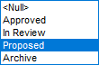 | Proposed is default and should be left at this.
CreateName | Auto-populated
CreateDate | Auto-populated | Time is UTC
EditName | Auto-populated
DateCurrent | Auto-populated | Time is UTC
IRIN ContactName |  | IRIN name
IRIN ContactEmail |  | IRIN official email
IRIN ContactPhone |  | IRIN official phone
PolygonDateTime |  | Time of flight in UTC as MM/DD/YYYY HH:MM, should match imagery time stamp
Complex Name |  | Enter Cx name if part of one. (Added back in for 2022)
IRWINID |  | Get from Event poly or at link below
GlobalID | Auto-populated | See link below if not already in event polygon. Should be entered with the curly brackets {}
Shape | Auto-populated
Shape_area | Auto-populated
Shape_perimeter | Auto-populated

For IRWIN ID
https://nifc.maps.arcgis.com/apps/View/index.html?appid=cd2741b5509145168b2d75b959a12fb0

IR Point
Field | Options | Comments
Incident Name |  | See IR Polygon comments
FC IR Point Type | 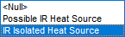 | IR Isolated Heat Source is default
Map Method | 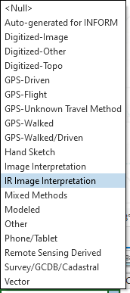 | IR Image Interpretation is default and should be left at this
Comments |  | Local time of flight
Latitude (LatWGS84_DDM) |  | Not required. If requested use script (ArcPro) or calculate geometry (Arcmap) for Y coordinate (ranges from 25 to 50 for CONUS) in Degrees Minutes DDD MM.mmm
Longitude (LongWGS84_DDM) |  | Not required. If requested use script (ArcPro) or calculate geometry (Arcmap) for X coordinate (ranges from -66 to -126 for CONUS) in Degrees Minutes DDD MM.mmm
FeatureStatus |  | Proposed is default and should be left at this.
CreateName | Auto-populated
CreateDate | Auto-populated | Time is UTC
EditName | Auto-populated
DateCurrent | Auto-populated | Time is UTC
PointDateTime |  | Leave blank
IRWINID |  | See IR Polygon comments
GlobalID | Auto-populated
OBJECTID | Auto-populated
IRIN ContactName |  | IRIN name
IRIN ContactEmail |  | IRIN official email
IRIN ContactPhone |  | IRIN official phone
Shape | Auto-populated

