Comparison of Capabilities

*Phoenix System is daytime capable but not currently utilized by NIROPS

Capabilities
Platform | IR and Color Capability | Day and Night Capability | Video | Real Time Link to Ground | Display Product on Fire Map | Air Attack Capability | Cost | Notes
NIROPS | Dual Band IR Only | Night Only * | No | Capable | Yes | No | $1250/hr King Air $1850/hr Jet | Covers 6 mile swath width at 10,000 feet
DRTI | IR, EO | Yes | Yes | Yes, range limited | Yes | No
MMA | IR, EO Wide and EO Narrow | Yes | Yes | Radio, text and email | Yes | Yes | @ $1500/hour
Night Watch AA51 | HD IR and color camera, Laser. | Night only | Yes |  | YES | ATGS assigned | $5060/day availability  $2249/hr. Flight rate
Firewatch Cobra | HD IR and color camera, Laser. | Day Only | Yes | Yes, BMS M/W data link, Rover units as well | Yes | ATGS assigned | 2,800 per FLT hr. includes ATGS, data van, on site GIS and complete support staff
Initial and Extended Attack Uses
Platform | IA Perimeter | Large Fire Perimeter | Monitor Burnout Operations | Monitor Impingement on MAPs | Spot Fire Detection | Direct Forces to Hot Spots | Monitor Effectiveness of Tactics | Locating People
NIROPS** | Not Real Time | Best Use | No | Not Real Time | Best Use | No | No | No
DRTI | Yes | Yes | Yes | Yes | Yes | Yes | Yes | Yes
MMA | Yes | Yes | Best Use | Best Use | Best Use | Best Use | Best Use | Yes
Night Watch AA51 | Yes | Yes | Yes | Yes | Yes | Yes | Yes* | Yes
Firewatch Cobra | Yes | Yes | Yes | Yes | Best Use | Best use | Yes* | Yes
**Phoenix System has capabilities not utilized currently by NIROPS

MMA Aircraft State of Colorado

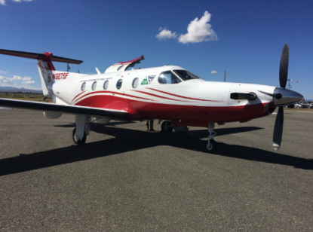

Most Effective Capabilities
- Initial attack and detection (utilizing lightning detection maps)
- Spot detection in support of burnout
- Able to walk crews right into the spot or heat
- Able to communicate directly with the ground resources
- Laser target for tanker and helicopter drops
- Locating people in a closed area ahead of a burn or fire
Figure 1: MMA Aircraft

DRTI Distributed Real-Time Infrared Aircraft

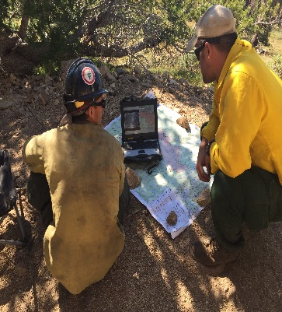

Most Effective Capabilities
- Perimeter detection/ updating previous perimeter maps on large fires.
- Spot detection Identifying and monitoring trigger points
- New fire detection
- Identifying and monitoring trigger points
- Live feed fire behavior analysis
- Hot Spot surrounded by unburned fuel
- Identifying Safety Zones
- Life and property detection/ Locating people ahead of a fire during evacuation operation
Figure 2: Ground crew looking at DRTI information
We observed some dissatisfaction with some products (MMA and DRTI) during field testing. It is important to note that much of that was a result of the lack of sufficient information provided on the request. We are accustomed to ordering NIROPS by just requesting to “fly the fire” and identifying a box that encompasses the extent of the burned area and a buffer region on all sides. Different sources and technology that do not utilize a line scanner or fly grids require additional information to get a good product. For example the Colorado MMA aircraft utilizes a three-lens sensor (IR/Color wide/Color narrow) that must be pointed at the target by the operator. Simply instructing them to “fly the fire” on a larger incident does not give them enough information to get the intended result. Producing an overview IR product on a larger incident is not the best use of this technology. The request should include either a kml (no kmz) with targeted areas identified as labeled polygons or a descriptive narrative such as “check for spot fires across the 498 Road” or “check for hot spots above the structures in the Parson Draw drainage in Division P”. Including a kml or hard copy of the Operations Map with the request is also a good idea.

More information can be found in the January 2017 Fire Imaging Operational Capabilities Report.

